|  |  |  |  |  |  |  |  |  |  |  |  |  |  |  |  |  |  |  |  |  |  |  |  |  |  |  |  |  |  |  |  |
| --- | --- | --- | --- | --- | --- | --- | --- | --- | --- | --- | --- | --- | --- | --- | --- | --- | --- | --- | --- | --- | --- | --- | --- | --- | --- | --- | --- | --- | --- | --- | --- |
| **臺北市政府捷運工程局**  **機電系統工程處**  **System-wide E&M Project Office,**  **Department of Rapid Transit Systems, TCG** | | | | | | | | | | | | | | | | | | | | | | | | | | | | | | | |
|  | | | | | | | | | | | | | | | | | | | | | | | | | | | | | | | |
| **臺北捷運環狀線(第一階段)**  **機電系統工程、軌道工程、自動收費系統工程**  **TAIPEI CIRCULAR LINE (PHASE 1)**  **E&M SYSTEM, Track Works, AFC SYSTEM**  **CF610/CF611/CF617** | | | | | | | | | | | | | | | | | | | | | | | | | | | | | | | |
|  | | | | |  | | | | | | |  | | | |  | | | | | |  | | | | | |  | | |  |
|  | | | | |  | | | | | | |  | | | |  | | | | | |
|  | | | | |  | | | | | | |  | | | |  | | | | | | 依業主審查意見更新Revised in response to client’s comments (YM-106T-06094-00) | | | | | | MAY 27, 2018 | | | B |
| N. Lin | | | | | D. Villa | | | | | | | S. Chen | | | | R. Kempanna | | | | | |
|  | | | | |  | | | | | | |  | | | |  | | | | | | 初次發行First issue | | | | | | JUN 21, 2017 | | | A |
| L. Liao | | | | | D. Villa | | | | | | | S. Chen | | | | R. Kempanna | | | | | |
| **編 製**  **Prepared**  **(MT)** | | | | | **校 核Checked**  **(SPE)** | | | | | | | **複 核Approved**  **(QM)** | | | | **核 准Authorized**  **(PD)** | | | | | | **說 明**  **Description** | | | | | | **日 期**  **Date** | | | **版 次**  **Revision** |
| **發行者：**  **Issuer** | | | | | | | **義大利日立軌道車輛及安薩爾多交通號誌系統 共同承攬Hitachi Rail Italy S.p.A.–Ansaldo STS S.p.A. Consortium** | | | | | | | | | | | | | | | | | | | **發行者編號：**  **Issuer Code** | | | |  | |
| **文件名稱：**  **Doc. Title** | | | | | | | | | | **通訊系統 - 其他文件**  **通訊多功能操作台 – 操作手冊**  **COMMUNICATIONS - OTHERS DOCUMENT**  **COMMUNICATION MULTI FUNCTION TERMINAL - OPERATION MANUAL** | | | | | | | | | | | | | | | | | | | | | |
| **廠商：**  **Contractor** | | | | | | | | | | **義大利日立軌道車輛及安薩爾多交通號誌系統　共同承攬**  **Hitachi Rail Italy S.p.A. – Ansaldo STS S.p.A. Consortium** | | | | | | | | | | | | | | | | | | | | | |
| **屬性Attributes:** | | | | | | | | | | | | | | | | | | | | | | | | | **送審文件編號Submittal Code:** | | | | | | |
|  | **ST** |  | | **AREA** | | | | | | | | |  | **PBS** | | |  | **ABS** |  | **TY** | | |  | | **TC1-67104-B** | | | | | | |
| **T** | **0** | | | | **0** | | | **0** | | **4** | | | **9** | **3** | | |
| **編號Code:** | | | | | | | | | | | | | | | | | | | | | | | | |
|  | **PROJECT** | | | | | | | |  | | **NUMBER** | | | | | | | | | |  | | **IRE** |  |  | | | | | | |
| **T** | **C** | | | | **1** | | | **6** | | **7** | | **1** | | | **0** | **4** | | **01** |
|  | | | | | | | | | | | | | | | | | | | | | | | | |
| **檔名：**  **File** | | | **TC1-67104-01-B Communication Multi Function Terminal - Operation Manual.docx** | | | | | | | | | | | | | | | | | | | | | | | | **頁碼：**  **Page** | | T**1 of** T**166**5 | | |

|  |
| --- |
| **內部修正紀錄表**  **INTERNAL AMENDMENT LIST** |

|  |  |  |  |  |  |  |
| --- | --- | --- | --- | --- | --- | --- |
|  |  |  |  |  |  |  |
| N. Lin | D. Villa | S. Chen | R. Kempanna | 依業主審查意見更新Revised in response to client’s comments (YM-106T-06094-00) | MAY 27, 2018 | 01 |
| L. Liao | D. Villa | S. Chen | R. Kempanna | 初次發行First issue | JUN 21, 2017 | 00 |
| **編 製**  **Prepared**  **(MT)** | **校 核**  **Checked**  **(SPE)** | **複 核**  **Approved**  **(QM)** | **核 准**  **Authorized**  **(PD)** | **說　明**  **Description** | **日 期**  **Date** | **版 次**  **Revision** |

|  |
| --- |
| **文件審查意見回覆表**  **RESPONSE REVIEW TRANSMITTAL** |

|  |  |  |  |  |
| --- | --- | --- | --- | --- |
| **A** | ■SEMPO | YM-106T-06094-00 | JUL 28, 2017 | N2 |
| **版次**  Revision | **審查單位**  Issuer | **審查文號**  Issuer’s SRT Reference | **審查日期**  Date Issued | **審查狀況**  Status of Approval |

| **項次**  No. | **圖說/章節/項次**  Extracting/ Chapter/ Item | **審查意見**  Review Comments | **答覆**  Reply Answer |
| --- | --- | --- | --- |
| 1 | 一般  GEN | 1. 本手冊應提供設備特性、額定值、及任何必要之操作限制等資料。 2. 有關安全之操作項目應提供相關之說明。 3. 請納入緊急應變之相關說明? 4. 請考量OCC及ROCC相關操作異同，並提出說明。 5. 有關雙電源輸入是否有牽涉到維修人員之安全疑慮，請特別說明。 6. This manual should provide information on device characteristics, ratings, and any necessary operating restrictions. 7. Relevant instructions should be provided for the relevant safety operation items. 8. Please include the relevant instructions for emergency response? 9. Please consider the similarities and differences between OCC and ROCC related operations and provide instructions. 10. Please specify if the dual power input is related to the safety concerns of maintenance personnel. | 1. CMFT設備屬一般伺服器及工作站，無特殊特性、額定值及任何操作限制。 2. CMFT設備無安全操作項目之需求。 3. 考量通訊系統為整體機電系統之一部份，有關緊急應變相關作業無法由CMFT單獨運作，故建議由機電系統進行整體緊急應變規劃，規劃ROCC切換作業程序，CMFT系統將配合調度處置。 4. CMFT在OCC及ROCC，僅有席位數量不同，並無任何功能操作上的差異。 5. CMFT維修時若需拆機，確保雙電源均已斷電即可。 6. CMFT equipment is a general server and workstation, no special features, ratings and any operating restrictions. 7. The need for a safe operation of the CMFT equipment. 8. Considering that the communication system is a part of the overall electromechanical system, the emergency related work can not be operated independently by the CMFT. Therefore, it is suggested that the overall emergency contingency plan be planned by the electromechanical system and the ROCC switching operation program be planned. The CMFT system will cooperate with the dispatching and disposition. 9. CMFT In OCC and ROCC, only the number of seats is different, there is no any difference in functional operation. 10. If the CMFT needs to be disassembled during maintenance, make sure that the dual power supplies have been powered off. |
| 2 | 一般  GEN | 1. 本手冊應包括各功能的詳細步驟說明。 2. 本手冊應包括軟硬體的數量及其說明。 3. 本手冊應包括硬體操作說明。 4. This manual should include a detailed step-by-step description of each function. 5. This manual should include the number of hardware and software and their description. 6. This manual should include hardware instructions. | 1. 詳細步驟已於章節4中說明. 2. 軟硬體的數量及其說明已經補充於2.3. 3. CMFT系統硬體部分僅直線電話(請參考4.5.1)、車站廣播面盤以及無線電廣播面盤，面盤操作部分僅需要進行口語廣播時，按下面盤上PTT按鈕，將開始進行語音發送，另外還提供喇叭音量旋鈕。詳細操作步驟請參考各子系統提供之硬體操作。 4. Detailed steps are described in section 4. 5. The number of hardware and software and their description have been added in 2.3. 6. The hardware part of the CMFT system is only a DLT telephone(please refer to 4.5.1), a station broadcast panel. When the panel operation section only needs oral broadcast, press the PTT button below to start voice transmission, and also provide the speaker volume knob. For detailed operation steps, please refer to the hardware operations provided by each subsystem. |
| 3 | 一般  GEN | 表3-1直接跳至表3-3未依順序標示請修正。  Table 3-1 directly jumps to Table 3-3. Please correct it without ordering. | 已重新排列。  Renumbered this document. |
| 4 | 一般  GEN | 請說明告警顯示資料ACK/NAK欄位，為修復後自動變更或需手動變更。  Please indicate the alarm display data ACK/NAK field, which will be automatically changed or need to be changed manually after repair. | ACK為按鈕圖案表示必須經過操作員手動變更後，始關閉相關告警音響和閃爍，NAK則僅顯示此告警不需要操作員進任何回饋。詳請請見4.2.5。  If ACK is a button pattern indicating, the operator must manually operated to change the button status to text, then the associated alarm sound and flash will be closed. NAK only displays, this mean the alarm don't need any feedback from the operator action. Please refer to 4.2.5 for details. |
| 5 | 一般  GEN | 請說明車站群組與列車群組設定加入車站或列車後可通用何種系統(PA、TETRA、DMD、DLT、CCTV)。  Please indicate what kind of system (PA, TETRA, DMD, DLT, CCTV) can be used after the station group and train group are set to join a station or train. | 列車與車站群組目前通用PA和DMD系統。無線電系統請參考無線電群組，DLT請參考直線電話，閉路電視參考攝影機範本。  Trains and station groups currently have been used to PA and DMD systems. For Tetra systems, please refer to Tetra Groups. For DLT, please refer to DLT Phone Book, CCTV Reference Cameras Templates. |
| 6 | 一般  GEN | 各項系統設定是否有防呆功能，如設定不存在之站別、列車、無線電群組、DLT號碼等，是否會顯示錯誤視窗訊息。  Whether each system setting has a fool-proof function, such as whether to set a station, train, radio group, DLT number, etc., which does not exist, whether an error window message is displayed. | 當功能目標項不存在時，將有告警視窗警示使用者。  When the function target item does not exist, an alarm window will alert the user. |
| 7 | 一般  GEN | 預錄語音名稱及內容是否直接由PA主機自動匯入或需人員手動輸入。  Whether the pre-recorded voice name and content is directly imported by the PA host or manually input by the personnel. | CMFT系統每日凌晨三點自動與PA主機進行檔案同步，任一預錄語音檔案第一次匯入時會自動帶入名稱及內容，人員後續可從CMFT主控台畫面進行修改，可參照4.2.6.1.2。  The CMFT system automatically synchronizes files with the PA host at 3 AM every day. When any pre-recorded voice file is imported for the first time, the name and content are automatically entered. The personnel can be modified from the CMFT console screen. Refer to4.2.6.1.2. |
| 8 | 一般  GEN | 空白頁面請刪除。  Blank page please delete. | 已重新排列。  Renumbered this document. |
| 9 | 一般  GEN | 圖3-26張貼錯誤請修正。  Figure 3-26 Posting errors Please correct. | 已修正。  Renumbered this document. |
| 10 | 一般  GEN | 顯示模式設定是否可針對字型大小進行編排。  Whether the display mode setting can be programmed for font size. | 目前沒有提供此功能。  This feature is not currently available. |
| 11 | 一般  GEN | 顯示模式設定針對字體顏色部份，可設定幾種顏色？  Display mode settings For the font color, can set several colors? | 請參考4.2.8.4之C章節，共三種顏色可設定。  Please refer to Item C of Section 4.2.8.4 for a total of three colors to be set. |
| 12 | 一般  GEN | 人員接聽PI通話時，能否能連的列車收音啟動錄音功能。  When a person answers a PI call, can he or she can connect to a train to start a recording function? | PI接通時，將自動啟動錄音功能。  When the PI is turned on, the recording function starts automatically. |
| 13 | P9  Page 9 | 「操作概述」之操作功能述中，漏列車站CCTV、列車CCTV及直線電話操作功能，請補正。  The operating functions of the "operation overview" are described. Please refer to the CCTV, CCTV, and direct-telephone operating functions of the missed train station. | CCTV請參考4.2.10，直線電話操作請參考 |
| 14 | P26  Page 26 | 有關「3.2.4.3.1車站群組設定」及「3.2.4.3.2列車群組設定」，請說明群組設定完成後，在CMFT操作使用之流程及時機。  Regarding "3.2.4.3.1 Station Group Settings" and "3.2.4.3.2 Train Group Settings", please explain the flow and timing of the CMFT operation after the group settings are completed. | 請參考章節4.2.7語音廣播以及章節4.2.9點矩陣顯示相關介紹。  Please Refer to Section 4.2.7 Pulic Address and Section 4.2.9 DMD Control. |
| 15 | P30  Page 30 | 請說明攝影機群組設定之相關條件：最多允許設定多少個群組？群組名稱允許中英文字元數之限制？每個群組中允許設定的攝影機數量為何？群組排列方式邏輯(依名稱或是依建置時間)？  Please explain the conditions related to camera group settings: How many groups can be set? Can the group name allow restrictions on the number of Chinese and English characters? What is the number of cameras allowed in each group? Group arrangement logic (by name or build time)? | 目前可設定之群組為4,096組，每個群組可設置攝影機數為16,384隻攝影機。攝影機名稱建議為中文總共六個字，英文總共10個字。群組排列方式目前依建置時間排序。  At present, there are 4,096 groups that can be set. Each group can have 16,384 cameras. The name of the group is suggested as a total of six words in Chinese and 10 words in English. The arrangement of groups is currently sorted by build time. |
| 16 | P34  Page 34 | 「所有語音資料皆來自PA主機，CMFT系統只能選取播放」，請說明若PA主機或連線狀態異常時，CMFT系統是否提出告警？是否有備援機制？  "All voice data is from the PA host. The CMFT system can only select playback." Please indicate if the CMFT system raises an alarm if the PA host or connection status is abnormal. Is there a backup mechanism? | PA主機異常或連線異常時，將提出告警訊息，所有語音資料將會下載至CMFT系統，故PA主機異常不影響音檔播放。  If the PA host is abnormal or the connection is abnormal, an alarm message will be raised. All the voice data will be downloaded to the CMFT system. Therefore, the abnormal PA host does not affect the audio file playback. |
| 17 | P42  Page 42 | 請補充「新增DMD訊息」之詳細操作流程步驟，並說明訊息允許中英字元數之限制？是否提供等級設定？  Please add the detailed procedure for the “Add DMD message” and explain the restrictions on the number of Chinese and English characters allowed in the message. Is there a level setting? | 請參考章節4.2.8.2，每一則訊息字元數最大為160，等級設定在播放時才提供設定。  Please refer to chapter 4.2.8.2 The maximum number of characters in each message is 160. The setting of the level is only provided during playback. |
| 18 | P54  Page 54 | 比對圖3-31-1及圖3-32-1，請補充說明進入「無線電」的「項目選擇」後，「來源」如何顯示為「群組」或為「無線電編號」？  Comparing Figure 3-31-1 and Figure 3-32-1, please add instructions on how to enter “Radio” “item selection”. How does “source” appear as “group” or “radio number”? | 此部分內容已修正，請重新參考4.2.2.3.3無線電群組編輯步驟與說明 。  This section has been amended. Please refer to 4.2.2.3.3 Tetra Group Editing Procedures and Instructions. |
| 19 | P59  Page 59 | 請說明「群組新增」是否為「車站選擇」後的次一階設定？「群組」是否只能選擇設定在同一個車站的攝影機？  Please indicate whether the "Group Addition" is the next-order setting after "Station Selection"? Can "Group" only choose cameras set up at the same station? | 此部分內容已修正及補充，請重新參考4.2.2.3.5攝影機群組輯步驟與說明 。  This section has been amended and supplemented. Please refer to 4.2.2.3.5 Camera Group Editing Procedures and Instructions. |
| 20 | P63  Page 63 | 「輪播設定」章節過於簡略；請說明如何設定攝影機的輪播、如何設定群組的輪播、進行輪播時CMFT是否可控制其他電視牆、進行輪播時CMFT是否可進行其他功能操作。  The section "Carousel Settings" is too brief. Please explain how to set the carousel of the camera, how to set the carousel for the group, whether the CMFT can control other TV walls during the carousel, and whether the CMFT can perform other functions during the carousel. | 此部分內容已修正及補充，請重新參考4.2.10.3。內容包含電視牆預設輪播清單規則，以及手動介入輪播清單步驟。  This section has been amended and supplemented. Please refer to 4.2.10.3 Content includes default carousel list rules and manual assigned carousel list steps.  輪播清單設定完成後將由CMFT伺服器於CCTV服務持續進行作業，不影響控制員進行其他功能操作。  After the carousel list is set, the CMFT server will continue to excute carousel task by the CCTV service without affecting the controller performing other functional operations. |
| 21 | P74  Page 74 | 1. 請說明「類型設定」中，「政令」、「一般」、「緊急」的差異。 2. 「播放次數」僅能設定「1-10」次不符合營運需求；一般及政令宣導訊息，應為可設定多則、無限次循環播放與播放起迄時間。 3. 請說明如何檢查車站月台、大廳DMD設備連線狀態？及其目前輪播訊息內容？ 4. Please describe the difference between "Government Order", "General" and "Emergency" in "Type Setting." 5. "Play times" can only be set to "1-10" non-compliance with operational needs; general and government declaratory messages should be able to set multiple, infinite loop playback and playback start and end times. 6. Please explain how to check the connection status of station DMD equipment on the platforms and halls. And its current rotation message content? | 1. 類型設定為播放的優先次序，請參考0與4.2.9.2章節中分別對列車與車站訊息類型優先播放權說明。 2. The type is set to the priority of playback. Please refer to section 4.2.9.1 and 4.2.9.2 for the priority of the right to play the train and station information types. 3. 播放次數已開放至99次，一般及政令宣導訊息可連續下達，將由各站DCU主機根據型態等級，優先播放次序，緊急訊息自動顯示無限次播放，無限次播放之訊息必須透過手動刪除才能結束播放。 4. The playback times can set up to 99 times. General and decrees messages can be orderd to DCU host consecutively, and the DCU host of each station would order to playback according to the type level. The emergency message is setted automatically for an unlimited number of times, and the message for unlimited playback must be manually deleted to end the playback. 5. 各車站之DCU連線狀態可由圖 4‑94  表格顯示，各月台或大廳DU若有異常則透過告警訊息通知。輪播內容由圖 4‑88顯示，但列車播放內容則僅展示最高等級-緊急(無限次)播放中的訊息。 6. The DCU connection status of each station can be displayed in the table of Figure 4‑94. If there is any DU abnormality in each platform or hall, it will be notified via the alarm message. The current playback content is shown in Figure 4‑88. But the played content on the train only shows the messages in the highest level-emergency (unlimited) play. |
| 22 | P81  Page 81 | 3.2.12.1「列車」語音廣播控制，但圖3-42-2-2「已選擇項目」顯示卻為「車站」，請釐清。  3.2.12.1 "Train" Voice Broadcast Control, but Figure 3-42-2-2 "Selected Item" shows "Station", please clarify. | 文件內容已修正。  Renumbered this document. |
| 23 | P86  Page 86 | 有關「操作人員按播放後，即可直接廣播」，請確認是否仍須按壓麥克風之PTT才可進行擴播？  Regarding “Operators can directly broadcast after pressing,” please confirm whether you still have to press the microphone's PTT to broadcast. | 若為口語廣播都必須按壓PTT 已進行口語傳輸。  If it is a spoken language broadcast, the PTT must be pressed to transmitte the oral broadcast. |
| 24 | P89  Page 89 | 有關「操作人員可點擊TETRA呼叫列表中的事件進行接聽」，請確認CMFT是否應設定為自動接聽以符合營運需求。  For the “Operators can click on the events in the TETRA call list to answer”, please confirm whether the CMFT should be set to answer automatically to meet operational requirements. | 請參考4.2.11.1.2章節描述，每個主控台可以設置兩組自動接聽。  Please refer to chapter 4.2.11.2. Each console can be set up for two sets of automatic answering. |

**目 錄**

**TABLE OF CONTENTS**

1 範圍SCOPE 13

1.1 目的Purpose 13

1.2 適用性Applicability 13

1.3 參考文件Reference Documents 13

1.4 名詞、略語、縮寫Terms, Acronyms and Abbreviations 13

1.5 自前版次變更說明Description of Changes From Previous Revision 14

2 系統概述System Summary 15

2.1 系統範圍System Scope 15

2.2 系統架構System Architecture 16

2.3 軟硬體配置說明Software and Hardwad Configuration Description 16

3 人機介面軟體設定與更新流程 Human machine interface on Console Setting and Updating Flow 20

3.1 主控台電腦的IP設定 The Setting of IP Address on Consol 20

3.2 主控台軟體版本驗證與更新 The Version of Consol Verification and Update 22

4 CMFT主控台軟體操作概述CMFT Console Operation Summary 25

4.1 監控工作站啟動Surveillance Workstation software Start 27

4.1.1 登入畫面 Login Page 27

4.1.2 帳號與密碼驗證 ID and Password Verification 29

4.1.3 密碼設定規則Password setting rule 30

4.1.4 進入主控台操作主畫面Enter Main Page of CMFT Console 30

4.2 功能列Function Bar 33

4.2.1 使用者設定Console users Setting 35

4.2.2 系統設定Basic System Setting 54

4.2.3 主控台狀態與記錄操作Console status and Logs monitoring 73

4.2.4 告警設定Alarm Setting 76

4.2.5 系統告警System Alarm Logs monitoring 79

4.2.6 廣播設定 Public Address Setting 80

4.2.7 語音廣播 PUBLIC ADDRESS 91

4.2.8 點矩陣設定 DMD Program Assign 102

4.2.9 點矩陣顯示 DMD Control 121

4.2.10 閉路電視 CCTV Monitoring 132

4.2.11 無線電 TETRA Communication 146

4.2.12 啟動Actived PI 153

4.3 無線電話事件處理 TETRA Call Event Process 156

4.3.1 TETRA 事件接聽 TETRA Call Receive 156

4.3.2 PI/SI 事件接聽 PI/SI Call Receive 157

4.4 DMD節能時間設定DMD Power Save Time Setting 159

4.5 直線電話顯示DLT Events Process 160

4.5.1 直線電話按鈕功能簡介DLT Function button Introduction 161

4.5.2 直線電話狀態即時顯示 The Status Display From DLT Event 163

4.5.3 直線電話紀錄顯示 DLT Process Log 165

# 

# 範圍SCOPE

本文件範圍包含說明OCC監控工作站CMFT系統功能之操作及其畫面。

Scope of this document contains a description of CMFT system for the depot work stations to monitor the operations and functions of the screen.

## 目的Purpose

本操作手冊用於說明CMFT系統監控工作站的軟體操作。

The operation manual will be used to introduce the CMFT system operation.

## 適用性Applicability

本文件適用於環狀線(第一階段)。

This document is applicable to the Taipei Circular Line Project phase 1.

## 參考文件Reference Documents

1. 捷運機電系統一般規範01704 1.7.6（2）B

Rapid Transit E&M System GS 01704 1.7.6（2）B

1. CF610機電系統標特別技術規範 16004 §2.4.9

CF610 E&M System PTS 16004 §2.4.9

1. 通訊 - 分項品質計畫 (TC1-60010)

Communications - Supportive Quality Plan (TC1-60010)

## 名詞、略語、縮寫Terms, Acronyms and Abbreviations

API 介面應用程式Application Interface

AT 自動電話 Automatic Telephone

ATS 自動列車控制 Automatic Train System

ROCC 備援行控中心Redundant Operation Control Center

BSS 主變電站Bulk Supply Substation

BS 基地台Base Station

CCTV 閉路電視 Closed Circuit Television

CDU 大廳點矩陣顯示器Concourse Dot Matrix Display Unit

CER 通訊設備房Communication Equipment Room

CMFT 通訊多功能操作台 Communications Multi-Function Terminal

CRS 控制室伺服器 Control Room Server

CTI 電腦電話整合 Computer Telephony Integration

DCU 點矩陣顯示器控制單元DMD Control Unit

DLT 直線電話 Direct Line Telephone

DMD 點矩陣顯示 Dot Matrix Display

EMC 電磁相容性測試 Electromagnetic Compatibility

EMI 電磁干擾 Electromagnetic Disturbance

EPABX 電子數位用戶交換機 Electronic Private Automatic Branch eXchange

GE 超高速乙太網路 Gigabit Ethernet Network

GUI 圖形使用者介面Graphic User Interface

HA 高可用度High Availability

HMI 人機界面 Human-Machine Interface

IP 網路協定 Internet Protocol

LAN 區域網路 Local Area Network

MCU 主要控制單元Main Control Unit

NVR 網路影像錄放影機Network Video Recorder

OCC 行控中心 Operation Control Center

PA 廣播系統 Public Address

PAO 旅客詢問處 Passenger Advisory Office

PGIS 旅客導引資訊 Passenger Guide Information System

PDIS 旅客資訊顯示系統Passenger Information Display System

PDU 月台點矩陣顯示器Platform Dot Matrix Display Unit

PI 旅客對講機 Passenger Intercom.

SCADA 監控資料蒐集系統 Supervisory Control And Data Acquisition

SCN 控制交換中心 Switching Control Node

SDH 同步數位階層 Synchronous Digital Hierarchy

SI 服務對講機 Service Intercom.

SNMP 簡單網路管理協定 Simple Network Management Protocol

TAPI 電話存取協定介面 Telephone Access Protocol Interface

TETRA 陸地中繼無線電系統 Terrestrial Trunk Radio System

VCS 影像控制伺服器Video Control Server

## 自前版次變更說明Description of Changes From Previous Revision

|  |  |
| --- | --- |
| ■首次發行無內容Not applicable for the first issue. | |
| □已納入下列修訂The following modifications have been introduced: | |
| **說明**  **Description** | **修訂段落 / 頁面**  **Modified paragraph / page** |
| 依業主審查意見更新Revised in response to client’s comments (YM-106T-06094-00) | 修訂章節2、3、4。  Revise chapters 2, 3, and 4. |

# 系統概述System Summary

## 系統範圍System Scope

CMFT系統監控工作站提供下列功能：

Surveillance workstation of CMFT system provides following functions:

* 提供及建立工作站及本系統操作人員安全管控層級並設定工作處理權限

To provide and build the safty levels for the authority work stations and members and setup their authority for events process.

* 監控相關警報及調整顯示設定

To monitor and response the related alarms and adjust the display setup.

* 管理及建立各次系統功能 (含建立關聯群組, DMD顯示/廣播內容, 無線電通訊…等)

To manage and build the functions of sub-systems.(Such as the car and stations groups, contents of DMD display/PA, and TERRA…etc.)

* 調閱全線車站及列車之CCTV影像

To playback whole stations and cars CCTV video image file.

* 車站及列車DMD顯示控制

To control the display contents of DMD in any/all station(s) and car(s).

* 車站及列車廣播控制

To control the PA system in any/all station(s) and car(s).

* 直線電話及無線電通訊處理

To process the DLT and TERRA communications.

## 系統架構System Architecture



圖 2-1: 行控中心CMFT硬體與網路架構圖。

Figure 2‑1: OCC CMFT Hardware & Network Architecture

## 軟硬體配置說明Software and Hardwad Configuration Description

通訊多功能操作台架構是由以下部份組成：

The CMFT architecture at OCC and ROCC is composed by following parts：

1. 通訊多功能操作台伺服器 CMFT Server

通訊多功能操作台伺服器將安裝在行控中心與備援行控中心通訊設備房。

其中在行控中心的通訊多功能操作台伺服器設有熱備援機制，以提高系統可用性。通訊多功能操作台伺服器將安裝軟體配置如下表 2‑1，包含行控中心使用虛擬位址與連接埠，ROCC因只有一台主機，所有的服務皆使用實體IP 10.7.0.121。

The CMFT Server will be installed at OCC and ROCC CER room, This server installs the communication multifunctional console system integration service software.

The CMFT Servers are designed with hot-standby mechanism at OCC to improve system availability.

The CMFT server will install the services software as shown in the following Table 2‑1, including OCC virtual IP configuration and Port.

|  |  |  |  |
| --- | --- | --- | --- |
| 編號 No | 虛擬位址 Virtual IP | 描述 Description | 連接埠Port |
| 1 | 10.7.0.200 | CMFT CLUSTER Service |  |
| 2 | 10.7.0.201 | CLuster. CMFT Services | 11121 |
| 3 | 10.7.0.202 | CLuster. ATS Agent | 11122 |
| 4 | 10.7.0.203 | CLuster. DLT Agent | 11123 |
| 5 | 10.7.0.204 | CLuster. CCTV Agent | 11124 |
| 6 | 10.7.0.205 | CLuster. PA Agent | 11125 |
| 7 | 10.7.0.206 | CLuster. DMD Agent | 11126 |
| 8 | 10.7.0.207 | CLuster. ALARM Agent | 11127 |
| 9 | 10.7.0.208 | CLuster. SCADA Agent | 11128 |
| 10 | 10.7.0.209 | CLuster. SDS ALARM Agent | 11129 |
| 11 | 10.7.0.210 | CLuster. PGIS Agent | 11130 |
| 12 | 10.7.0.211 | CLuster. CREATESHMAILBOX |  |
| 13 | 10.7.0.212 | CLuster. MiFET Services | 11132 |
| 14 | 10.7.0.213 | CLuster. ALARM Service | 11133 |
| 15 | 10.7.0.214 | CLuster. ATS Service | 11134 |
| 16 | 10.7.0.215 | CLuster. CCTV Service | 11135 |
| 17 | 10.7.0.216 | CLuster. DLT Service | 11136 |
| 18 | 10.7.0.217 | CLuster. DMD Service | 11137 |
| 19 | 10.7.0.218 | CLuster. PA Service | 11138 |
| 20 | 10.7.0.219 | CLuster. TETRAOTC Service | 11139 |
| 21 | 10.7.0.226 | CLuster. MSEEAGE Q |  |
| 22 | 10.7.0.227 | CLuster. DATAFILE |  |
| 23 | 10.7.0.228 | CLuster. MSSSQL |  |
| 24 | 10.7.0.229 | CLuster. MSDTC |  |

表 2‑1:伺服器服務/虛擬網路位址

Table 2‑1: Server Service/Virtual-IP

1. 儲存系統 Storage System

儲存系統是一個外接的磁碟陣列，通訊多功能操作台系統的資料庫資料將儲存於此。行控中心的兩台CMFT伺服器將會共同分享此儲存空間。

The Storage System is an external disk storage, the data of the CMFT system’s database will be stored in here. The two CMFT servers at OCC will share the storage of this storage system

1. 通訊多功能操作主控台 CMFT Console

多部通訊多功能操作主控台將安裝在以下位置：

* 行控中心5部
* 備援行控中心3部
* 通訊設備房1部
* 測試軌控制室 1部

CMFT Console will be installed in following places:

* OCC Room 5 sets
* ROCC Room 3 sets
* Maintenance Room 1 set
* Test Track Control Room 1 set

提供圖形的操作介面，讓使用者得以整合操作各通訊設備。通訊多功能操作主控台將安裝｢通訊多功能操作台系統整合操作軟體｣。

Multiple CMFT Consoles will be installed in OCC and ROCC which provide graphical user interface that allows users to integrate operations of the communications equipment. The ｢CMFT system integrated operating software｣ will be installed in the CMFT Console

1. 終端伺服器Terminal Server

終端伺服器將安裝在行控中心通訊設備房。終端伺服器透過EIA-422介面與位於行控中心的旅客導覽資訊系統控制台連接；CMFT與旅客導覽資訊系統控制台間之通訊方式為單向通訊。

The Terminal Server will be installed at OCC CER room. The Terminal will use EIA-422 interface to connect to PGIS Console at OCC. The communication between CMFT and PGIS Console is a one way communication.

1. 網路印表機 Network Printer

網路印表機將安裝在行控中心與備援行控中心，以滿足報表列印之需求。

The Network Printer will be installed at OCC and ROCC to meet the requirement for report printing.

1. 網路交換器 Network Switch

網路交換器將安裝在行控中心與備援行控中心通訊設備房連接到GE交換器。其中在行控中心設有兩部網路交換器互為備援，以防止單一交換器故障導致系統無法運作。

The Network Switch will be installed at OCC and ROCC CER room which are connecting to GE switches. At OCC, there are two redundant Network Switches to prevent a single switch failure resulting system does not work.

# 人機介面軟體設定與更新流程 Human machine interface on Console Setting and Updating Flow

## 主控台電腦的IP設定 The Setting of IP Address on Consol

1. 根據下表網域,配置內網設定：

According to the following table, configure the network settings：

| 編號 No | 網址  IP | 設備  Equipment | 安裝位置  Location |
| --- | --- | --- | --- |
| 1 | 10.7.0.1 | (SDC- 4MSH - 001) L2 Switch 1 | OCC CER |
| 2 | 10.7.0.2 | (SDC- 4MSH - 002) L2 Switch 2 | OCC CER |
| 3 | 10.7.0.20 | CMFT OCC AD SERVER | OCC CER |
| 4 | 10.7.0.21 | (SDC- 4MSR - 001) CMFT SERVER A | OCC CER |
| 5 | 10.7.0.22 | (SDC- 4MSR - 002) CMFT SERVER B | OCC CER |
| 6 | 10.7.0.31 | (SDC- 4MNP - 001) Terminal Server | OCC CER |
| 7 | 10.7.0.35 | (SDC- 4MPR - 001) CMFT OCC Printer | OCC Room |
| 8 | 10.7.0.51 | (SDC- 4MWS - 001) CMFT Console 1 | OCC Room |
| 9 | 10.7.0.52 | (SDC- 4MWS - 002) CMFT Console 2 | OCC Room |
| 10 | 10.7.0.53 | (SDC- 4MWS - 003) CMFT Console 3 | OCC Room |
| 11 | 10.7.0.54 | (SDC- 4MWS - 004) CMFT Console 4 | OCC Room |
| 12 | 10.7.0.55 | (SDC- 4MWS - 005) CMFT Console 5 | OCC Room |
| 13 | 10.7.0.56 | (SDC- 4MWS - 006) CMFT Console 6 | OCC Room |
| 14 | 10.7.0.57 | (SDC- 4MWS - 007) CMFT Console 7 | OCC Room |
| 15 | 10.7.0.101 | (YSC- 4MWS - 001) L2 Switch | ROCC CER |
| 16 | 10.7.0.120 | CMFTROCC AD SERVER | ROCC CER |
| 17 | 10.7.0.121 | (YSC- 4MSR - 001) CMFT SERVER C | ROCC CER |
| 18 | 10.7.0.135 | (YSC- 4MPR - 001) CMFT ROCC Printer | ROCC Room |
| 19 | 10.7.0.151 | (YSC- 4MWS - 001) CMFT Console 8 | ROCC Room |
| 20 | 10.7.0.152 | (YSC- 4MWS - 002) CMFT Console 9 | ROCC Room |
| 21 | 10.7.0.61~69 | 資訊人員測試用(For Test) | OCC Room |

表 3‑1: 硬體IP配置表

Table 3‑1: IP Configuration Of Hardware

1. 開啟網路連線->網路和共用中心->變更介面卡設定 (如下畫面) 。

Open the network connection -> Network and Sharing Center -> Change adapter settings (the following screen).

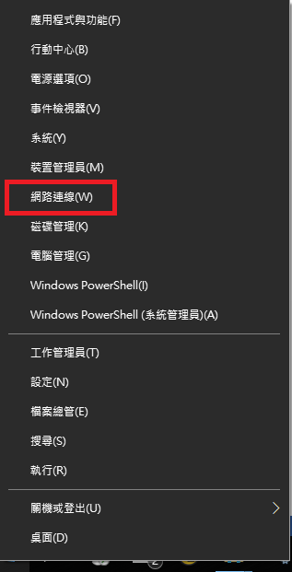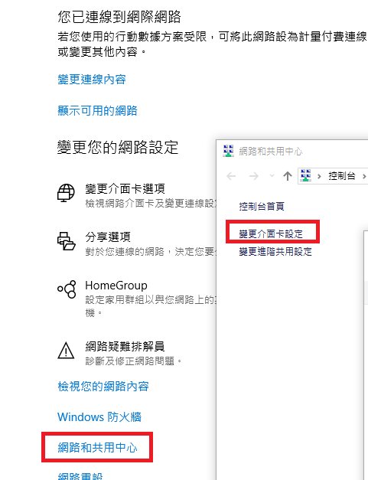

圖 3‑1: 電腦IP設定

Figure 3‑1: IP Address Configure

1. 『網際網路通訊定4版(TCP/IPv4)』後點選內容按鈕,設定IP位址 。

Select “Internet Protocol Version 4 (TCP/IPv4)” and press the Properties button to set the IP Address.

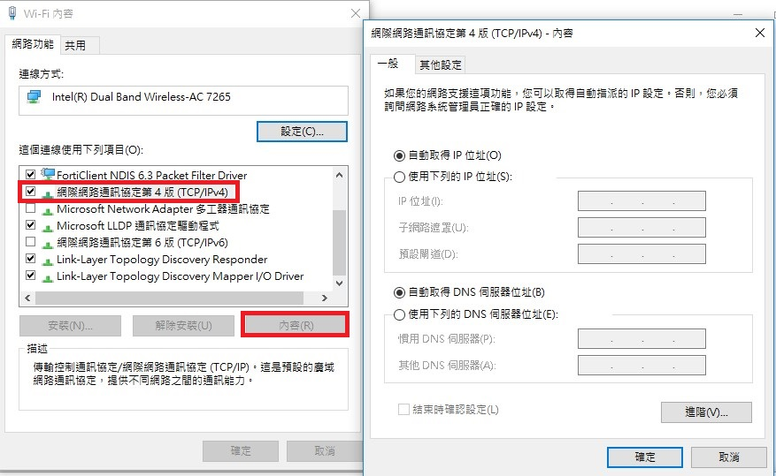

圖 3‑2: 電腦IP設定2

Figure 3‑2: IP Address Configure2

## 主控台軟體版本驗證與更新 The Version of Consol Verification and Update

1. 當版本有更新時，版本將以紅色字體顯示。

When the version is updated, the version will be displayed in red font.

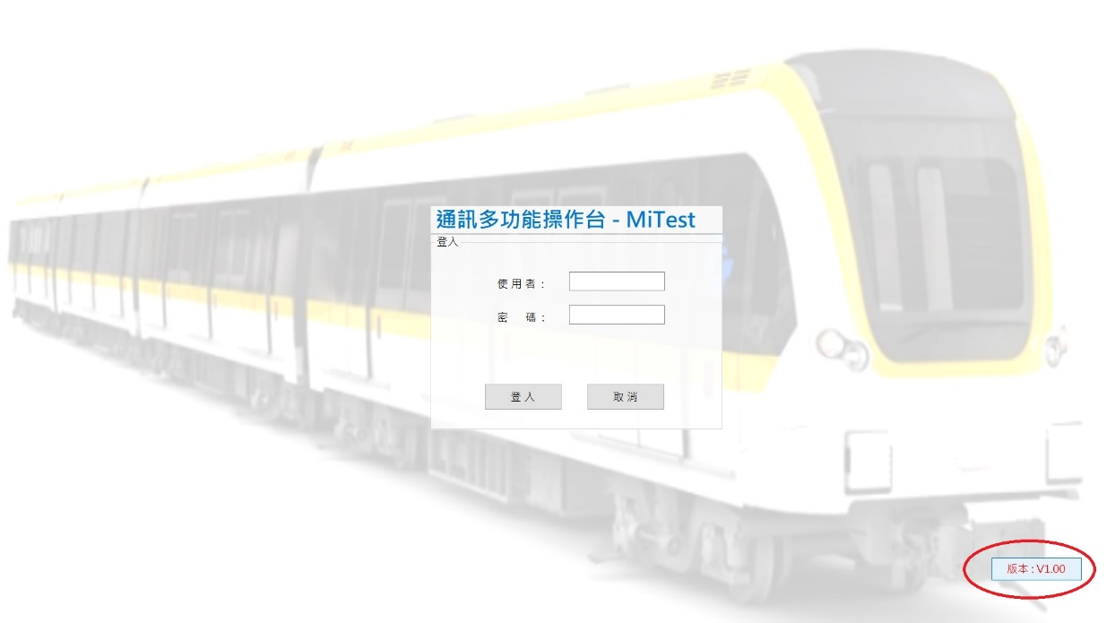

圖 3‑3: 有更新版告警圖

Figure 3‑3: New Version Existing Screen

1. 按下版本按鈕進行版次驗證與更新確認，如圖 3‑4，或者當第一次安裝Console時驗證發現非新版，如圖 3‑5。

Press the version button to verify version and confirm whether customer perform the update process, as shown in Figure 3‑4, or verify that the existing version is shown in Figure 3-6 when the Console is first installed, as shown in Figure 3‑5.

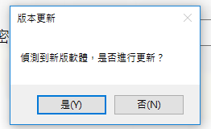

圖 3‑4: 更新確認

Figure 3‑4: Updated Confirmation

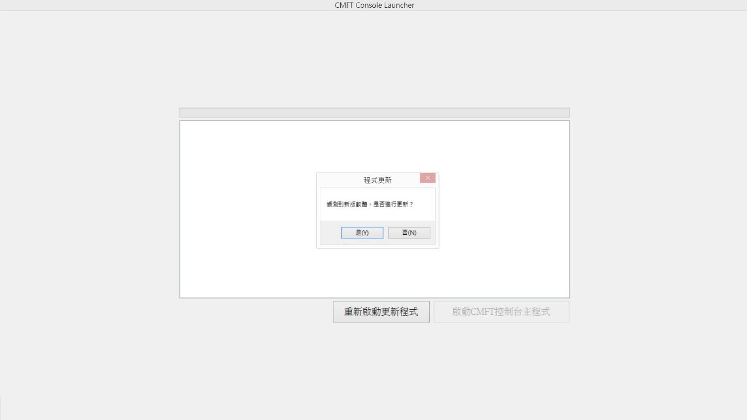

圖 3‑5: 更新確認

Figure 3‑5: Updated Confirmation

1. 驗證IP與目前版本並從伺服器端下載最新版本。

Verify the IP and Check the Version and Download the new version.

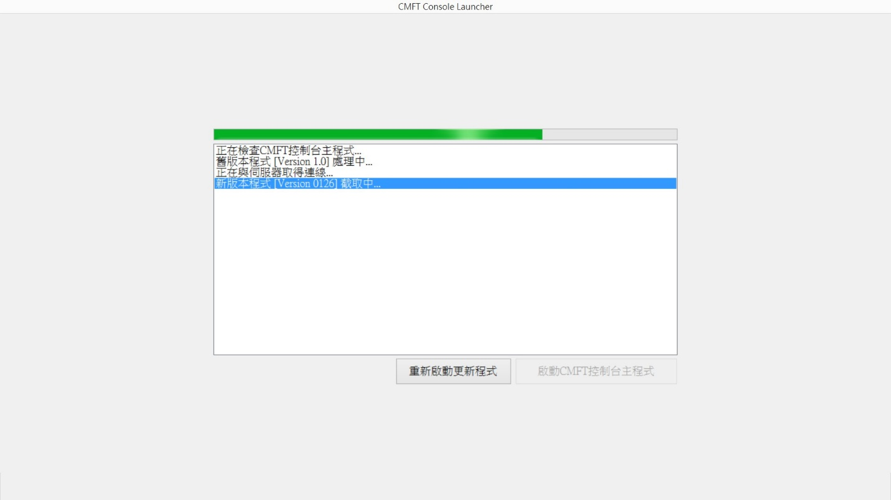

圖 3‑6: 安裝程式IP與版本驗證

Figure 3‑6: Verify the IP and Check the Version, and Download the new version.

1. 若更新失敗，可按下”重新啟動更新程式”，重新執行更新流程，或者按下”啟動CMFT主控台程式”，以舊版程式繼續執行。

If the update fails, press "Restart Updater" to re-execute the update process, or press "Start CMFT Console" to continue with the legacy program.

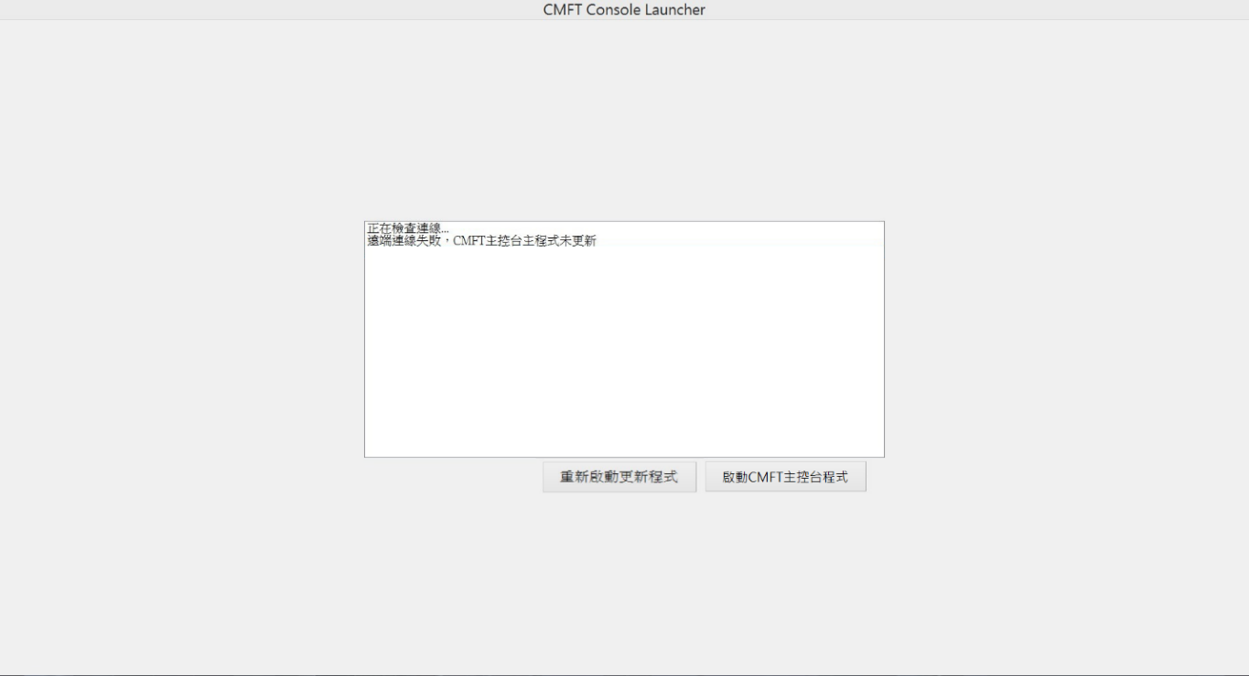

圖 3‑7: 更新失敗示意圖

Figure 3‑7: Update and Set the Software

1. 更新成功後，跳出登入畫面執行驗證登入程序After the update is successful, the login screen will be displayed to Perform the login process。

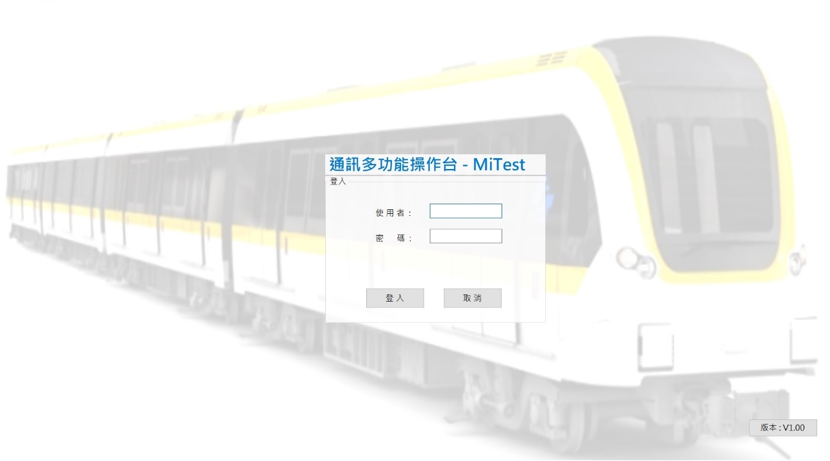

圖 3‑8: 登入畫面

Figure 3‑8: Login Screen

# CMFT主控台軟體操作概述CMFT Console Operation Summary

監控工作站提供給操作員的操作功能如下：

Surveillance workstation provides operating function for operator as following:

* CMFT基本資料操作含以下項目：

Operation of CMFT basic data includes the following functions :

* + 註冊工作站及使用人員

To register the consoles and users information.

* + 建立工作相關群組

To build work relative groups.

* + 系統環境設定(包含告警設定)

System environment Setting (includes alarm parameters setting).

* 警報管理操作操作含以下項目:

Alarm management operation include the following functions:

* 警報查詢與匯出

Inquiry and export of Alarms.

* 警報處理機制

Alarm acknowledge mechanism.

* 語音廣播相關操作含以下項目：

PA relative operation include the following functions:

* + 預存語音訊息管理

Pre-recorded voice messages management.

* + 廣播音量時段設定

The partition time of volume level Setting

* + 廣播功能參數設定

Parameters of PA function Setting.

* + 車站廣播樣本與排程設定

Pre-sample and schedule for the station Setting.

* + 車站/列車即時廣播處理

Station(s)/ Train (s) real-time messages display process.

* 點矩陣顯示器相關操作含以下項目：

DMD relative operation include the following functions:

* + ATS相關訊息顯示設定

Displayed message from ATS data setting

* + 預存訊息管理

pre-record messages management.

* + 點矩陣顯示模式參數設定

Parameters of DMD display-mode Setting.

* + 車站訊息樣本與排程設定

Pre-sample and schedule for station Setting.

* + 車站/列車即時訊息處理

Station(s)/Train (s) real-time messages display process.

* + 節能時間設定

Power saving time Setting.

* 無線電操作含以下項目:

TETRA relative operation include the following functions:

* + 主控台呼叫

Console call

* + 列車收音

Voice Monitoring on Train.

* + 無線電呼叫事件處理

TETRA/PI/SI call events process

* + 列車廣播

Broadcast on Train

* + 列車旅客資訊顯示

PIDS information on Train

* 閉路電視相關操作含以下項目：

CCTV relative operation include the following functions:

* + 電視牆及即時監控影像設定

TV-Wall and real-time image Setting.

* + 歷史影像調閱

Historical Image Playback and Review.

* + 球型攝影機操作

PTZ Operation.

* + 告警事件連動操作

Alarm events related CCTV operation.

* + 監控電視牆螢幕操作

Monitor TV-Wall screen operation.

* 直線電話紀錄顯示說明含以下項目：

Description of DLT communication display and record include the following functions:

* + 來電與去電顯示與紀錄

Call in, Call out display and record.

* + 三方通話

Conference calls display.

* + 轉接與等候顯示與紀錄

Display and record about Transfer and Hold on status

## 監控工作站啟動Surveillance Workstation software Start

### 登入畫面 Login Page

開啟主控台電腦後，系統將自動啟動並進入登錄頁面 ，如圖 4‑1，其中紅框部分為該主控台註冊的名稱，參考的依據為該主控的設定的網路位址，主控台的權限認證亦透過網路位址來驗證，故所有主控台端的電腦必須註冊其網路位址，才能登入CMFT軟體，管理者可以在章節4.2.2.1.1中如圖 4‑12畫面修改主控台註冊驗證的網路位址。

After boot on console, CMFT system will auto-enable user login page as Figure 4‑1. The red frame is the registered name of the console. The reference is based on the network address set by the console. The authority authentication of the console is also verified through the network address. Therefore, the console's network address of all the computers must be registered to access the CMFT software. The administrator can modify the network address of a console for registration verification in Chapter 4.2.2.1.1 as shown in Figure 4‑12.

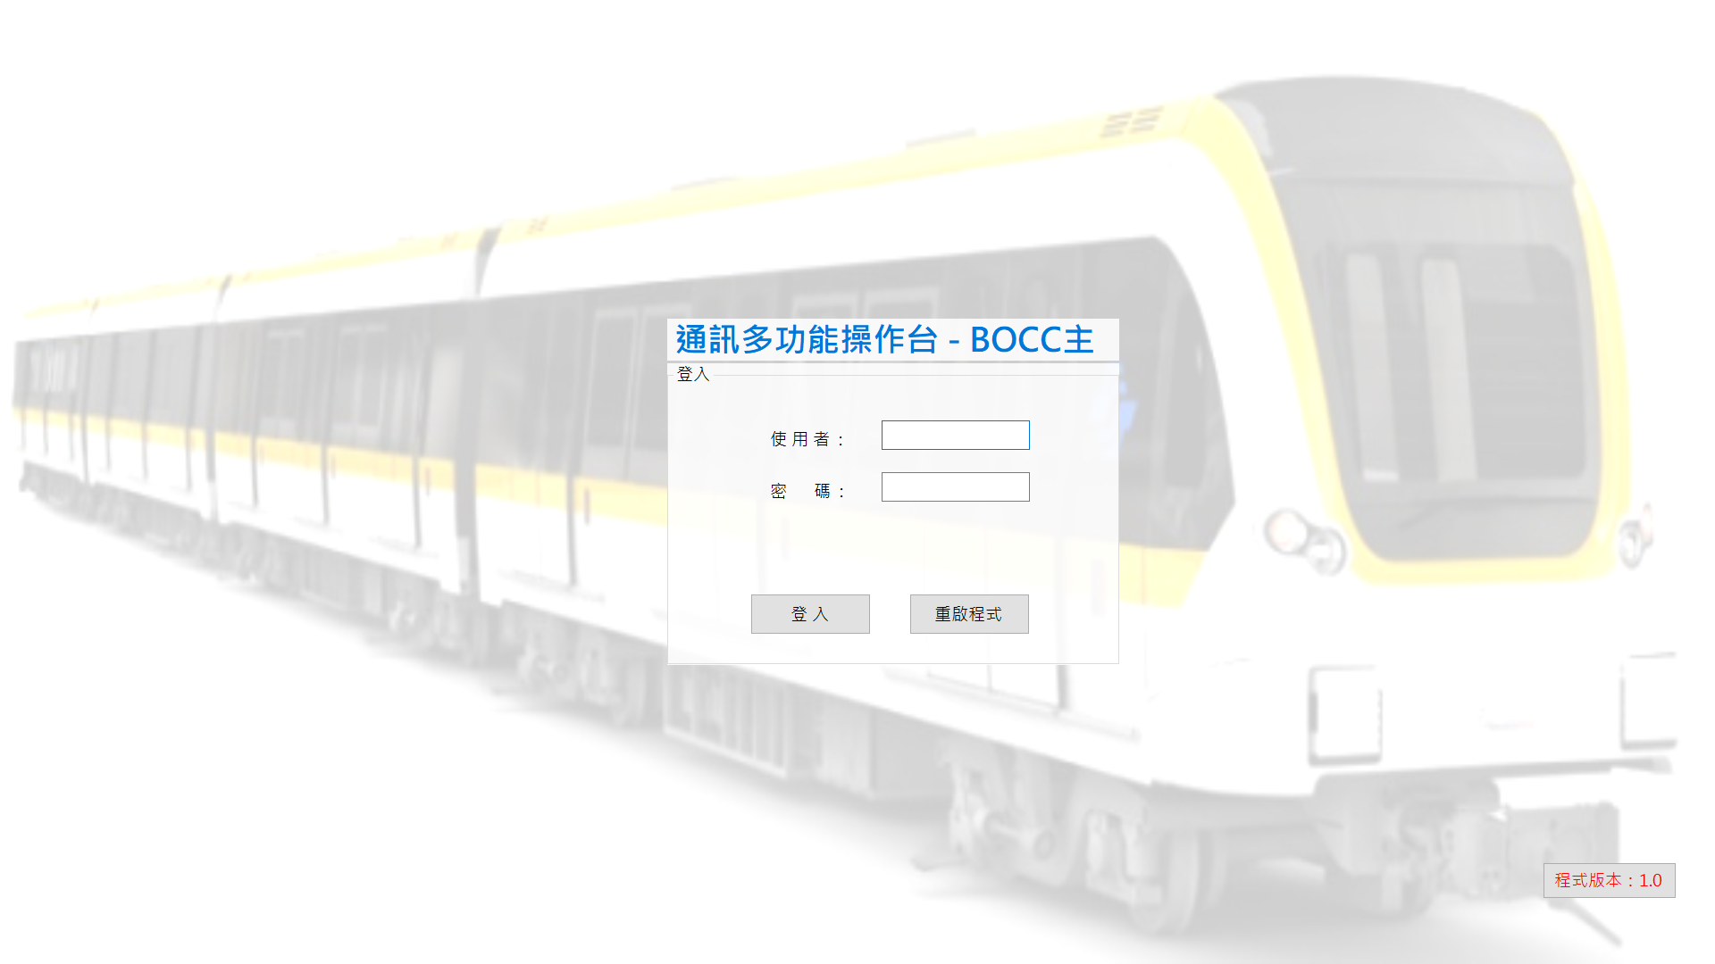

圖 4‑1: CMFT啟動登錄使用者

Figure 4‑1: Auto-start CMFT login page

### 帳號與密碼驗證 ID and Password Verification

第一次登入或者密碼已經使用超過三個月必須進行密碼修改，入帳號密碼後將出現如下畫面。

If that is the first login or password has been used for more than three months , the password must be modified again. After enter the account password, the following screen will appear for altering the modification of password.

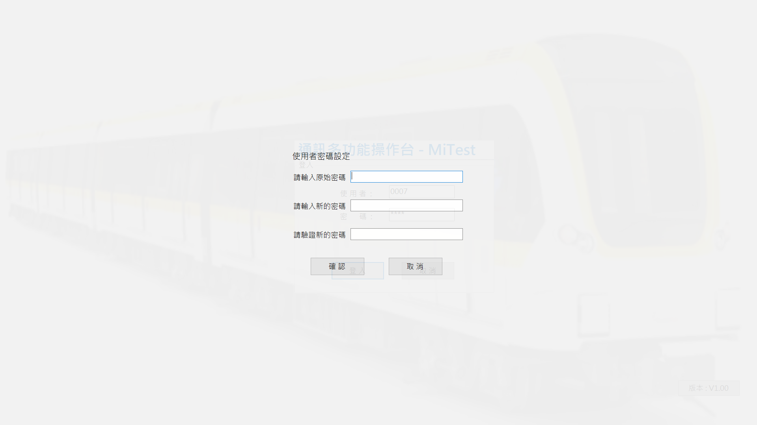

圖 4‑2: CMFT密碼更新

Figure 4‑2: CMFT Password Modification

### 密碼設定規則Password setting rule

帳號驗證規則Account Rule：

1. 每一系統帳號皆為唯一。
2. 初建帳號時密碼統一為預設密碼0000，系統管理員角色協助重設密碼時也為預設密碼0000。
3. 第一次登入時要強制使用者修改密碼。
4. 三個月未修改密碼者要強制該使用者變更密碼，三個月內若有自行修改過密碼則重算時間。
5. 密碼修改時，新舊密碼不可相同。
6. 密碼內需包含英文大小寫、數字，允許輸入空格以及特殊字元，密碼長度需於限制為8碼～16碼。

.

1. Each system account is unique
2. The initial password is unified default data-0000, when the administrator role to help reset the password, the password is the default password-0000.
3. When the password is modified, the old and new passwords can not be the same.
4. When account login first time, the user is forced to change the password. Three months without change the password to force the user to change the password, because the password has been modified by the re-calculation time each three months.
5. When the password is modified, the old and new passwords can not be the same.
6. Password needs to include English capitalization, numbers, allowing the entry of spaces and special characters, the password length to be limited to 8 characters to 16 characters.

### 進入主控台操作主畫面Enter Main Page of CMFT Console

登入並經認證通過後，CMFT會自行啟動並以預設樣板進行即時監控功能, 畫面配置如圖 4‑3。

CMFT system will be configure the function and run real-time surveillance by account privileges after getting certification successfully, the screen as shown as Figure 4‑3.

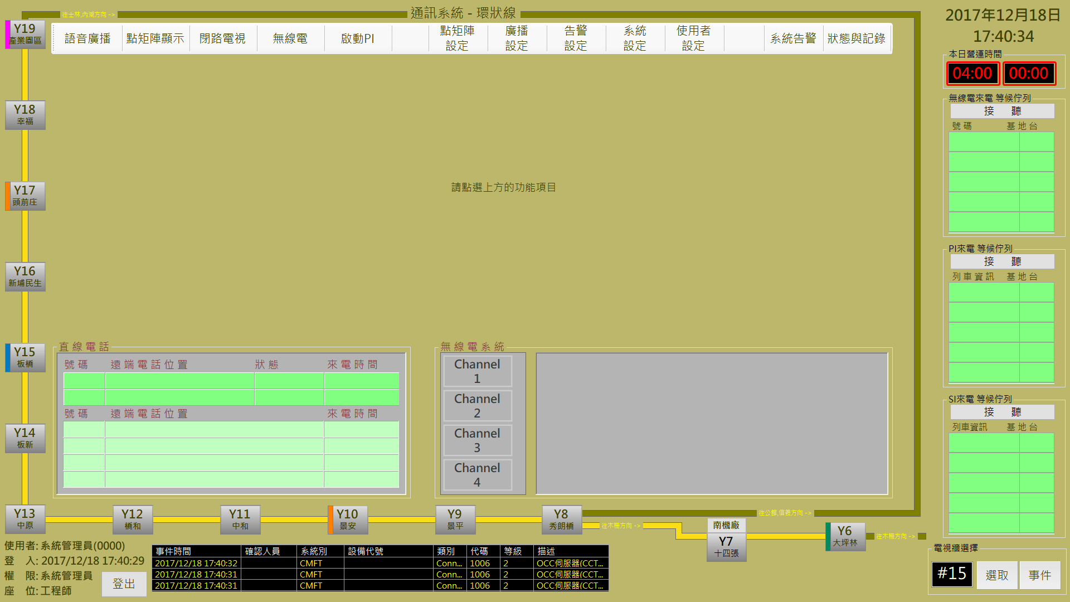

圖 4‑3: CMFT操作介面分割

Figure 4‑3: CMFT operation interface blocks

CMFT操作介面分為幾個部份如表 4‑1(詳細內容會於後續各章節內介紹)：

CMFT had been separated into several operation prats, list as Table 4‑1 (The detail operation descriptions will be introduced in the continuous pages):

|  |  |
| --- | --- |
| 編號  No. | 作業區塊名稱  Operation Area Name |
| 1 | 功能列區  Function Bar Area |
| 2 | 主要操作區  Main Operation Area |
| 3 | DMD顯示時間 (節能目的)  DMD Working Time (for p56T56T56T56Tower save purpose) |
| 4 | 待接無線電區  TETRA Income list area |
| 5 | 直線電話事件顯示區  DLT Events Status Display Area |
| 6 | 無線電/語音頻道轉換區  Radio/Audio Channel Switch Area. |
| 7 | 無線電/語音頻道通訊區  Radio/Audio Channel Communication Area. |
| 8 | 車站及列車營運路線指引與告警資訊閃爍燈號  Stations and Train Line Direction and the Flashing Light About Alarm information. |
| 9 | 即時警報區  Real-time Alarm Block |
| 10 | CCTV事件連動調閱與監控電視牆功能  CCTV link function including Event dispatcher and TV-Wall monitoring |
| 11 | 帳號資訊以及登出功能  Account of login user Information and Logout function |

表 4‑1: CMFT頁面作業區塊一覽表

Table 4‑1: CMFT operation block description

## 功能列Function Bar

功能列提供各種功能設定及操作的快速切換,各項功能如表 4‑2所述。

Function Bar provides switch in each function setting and operation quickly. The function and setting has been described as Table 4‑2.



|  |  |  |
| --- | --- | --- |
| 編號  No. | 作業名稱  Function Name | 功能簡介  Function Description |
| 1 | 狀態與記錄  Console status and logs monitoring. | 提供主控台操作記錄及目前狀態資訊  Provide the console status and process logs information. |
| 2 | 系統告警  System alarm logs monitoring | 提供警報記錄查詢並進行處理回應  Provide the system alarm logs and process. |
| 3 | 使用者設定  Console users settings | 提供系統使用人員及工作站管制設定  Provide the system user and console registration and authority management Setting. |
| 4 | 系統設定  System settings | 提供相關系統參數設定及/或內容排程建立  Provide the related sub-system parameters Setting, to build the basic data, permission configuration and Groups settings. |
| 5 | 告警設定  Alarm settings | 提供警報層級及顯示模式設定  Provide the alarm level and display mode Setting. |
| 6 | 廣播設定  Broadcast settings | 提供建立廣播樣板、排程、執行播放的主控台和廣播時段設定等功能  Provide function to build the broadcast samples, schedule, the equipment of schedule executed and broadcasting time setting. |
| 7 | 點矩陣設定  DMD settings | 提供DMD-ATS顯示內容建立及樣板與排程設定，及典矩陣顯示模式配置功能  Provide the functions of building DMD-ATS display contents, samples and schedule Setting, and the display mode configuration.. |
| 8 | 啟動PI  Actived PI | 提供列車透過PI進行收音功能  Provide record function for the voice monitoring from actived PI. |
| 9 | 無線電  TETRA communication | 開啟/關閉無線通訊頻道，建立無線電即時通訊和發送簡訊功能  Open/Close the TETRA channel for real-time communications and SDS. |
| 10 | 閉路電視  CCTV function | 開啟/關閉CCTV記錄檔案，進行即時影像監控  Open/Close CCTV file for real-time image monitoring. |
| 11 | 點矩陣顯示  DMD function | 提供對列車或車站即時傳送點矩陣顯示內容功能  Build/Change the DMD message for real-time display. |
| 12 | 語音廣播  PA function | 提供對列車或車站建立即時廣播播放功能  Build/Change the PA orders for real-time broadcast. |

表 4‑2: 系統功能列說明

Table 4‑2: Function Bar description

### 使用者設定Console users Setting

本作業主要是提供主控台人員帳號管理作業，本作業分為**使用者分類**管理、**使用者帳號**管理及**使用者密碼**管理三個項目。

This assignment is used to manage user account. It include three items: **User Group** management, **User Account** management and **User Password** management.

使用者使用操作CMFT人機介面軟體前必須先登入個人帳號，系統會依據帳號的角色權限配置適當的操作環境供使用者操作。每一系統帳號皆為唯一，必須由系統管理員來執行帳號之新增。

Users must first login using their personal account before operating CMFT HMI software, and the system will allocate an appropriate operating environment based on the role permission of the account for user operation. Accounts in the system are all unique, create a new account must be performed by the system administrator.

系統管理員群組裡的帳號為全部開放不受任何限制

優先權: 系統管理員群組>主控台權限>群組權限>個人權限

The system administrator group account for all open without any restrictions

Priority : System Administrators> Console Permissions> Group Permissions> Personal Permissions

#### 使用者密碼管理User password management

本頁面為進入使用者設定的預設作業項目，提供使用者進行**使用者密碼**管理作業 (如圖 4‑4)，主要提供使用者進行變更自身帳號密碼。

This page displays the user-setting default page, and provide user password management(as Figure 4‑4), mainly to provide users to change itself account password.

1. 操作人員需輸入一次舊密碼以驗證身份，新密碼需經由兩次的輸入驗證並確認儲存才算完成操作，如圖 4‑4。
2. Operator need to input the old password once for certification, two times new password verify and click “**確認**(Confirm) “ button to store then can finish this function，as Figure 4‑4.
3. **驗證與儲存：**按下”**確認**” 按鈕後，將驗證密碼是否符合章節4.1.3中密碼設定規則，通過驗證後新密碼於下次登入後啟用。
4. **取消：**”**取消**” 按鈕則會清空所有的輸入欄位。
5. **Verification and Save**：After pressing the “**確認**(Confirm) “ button, it will verify whether the password complies with the password setting rules in Section 4.1.3. After passing the verification, the new password will be enabled after the next login.
6. **Cancel**： “**取消**(Cancel)” button will clear all the input fields.

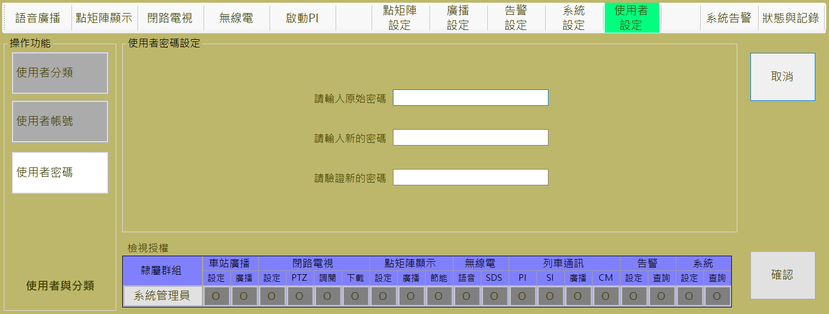

圖 4‑4: 使用者密碼設定作業

Figure 4‑4: User password Setting assignment

1. 使用者密碼頁面亦提供系統管理員進行其他帳號重設密碼功能(如圖 4‑5)，”**重設密碼**”的按鈕只有在使用者為系統管理員分類時可見，按下”**重設密碼**”按鈕後，將跳出如下圖小視窗，操作員可由下拉選單選擇欲進行密碼重社的成員，重設密碼為0000，執行重設密碼的帳號下次登入CMFT系統時，必須重新設定一組新密碼，(如章節4.1.2)。 重設密碼視窗功能如下：
2. The user password page also provides the system administrator to reset the password of other accounts (Figure 3 5), the “**重設密碼(**reset password)” button only visible when the user is classificated as the system administrator, press the “**重設密碼(**reset password)” button, The following window will pop up. Operators can select the other account who wants to reset the password by the drop-down menu. Reset the password to 0000. The next time, when the reset account login to the CMFT system, the account must reset a new password (as Chapter 4.1.2). Reset password window functions as follows：
3. **重設成員**：選擇操作成員，並按下”**確認**” 按鈕，所選擇的成員密碼將被重設為預設值。
4. **取消**：按下”**取消**” 按鈕關閉此視窗並且不做任何異動。
5. Reset Members：Select the member to be reseted, and press the “**確認(**Confirm)” button, the selected member password will be reset to the default value.
6. Cancel：the “**取消(**Cancel)” button closes the window and does not make any changes.

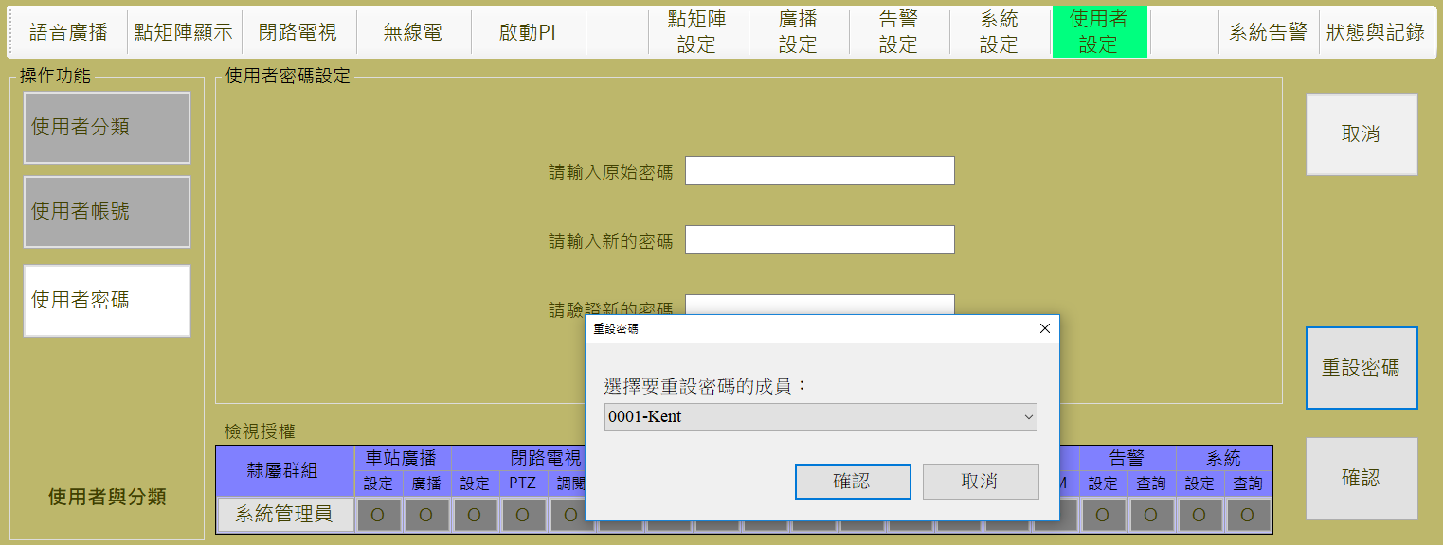

圖 4‑5: 系統管理員修改重設其他帳號密碼作業

Figure 4‑5: System administrator reset other account password job

#### 使用者分類管理User Classification management

本頁面主要功能是建立/刪除人員分類，並依人員分類設定/變更本系統的可操作作業項目。 每個使用者帳號均歸屬某一個人員分類，其最大權限受限於該分類允許的權限範圍內。(如圖 4‑6)

The main function of this page is to establish / delete personnel classification, and set the operational items of the system for each personnel classification. Each user account belongs to a certain personnel classification, the maximum authority is limited within the scope of the permissions allowed by the classification.(as Figure 4‑6)**.**

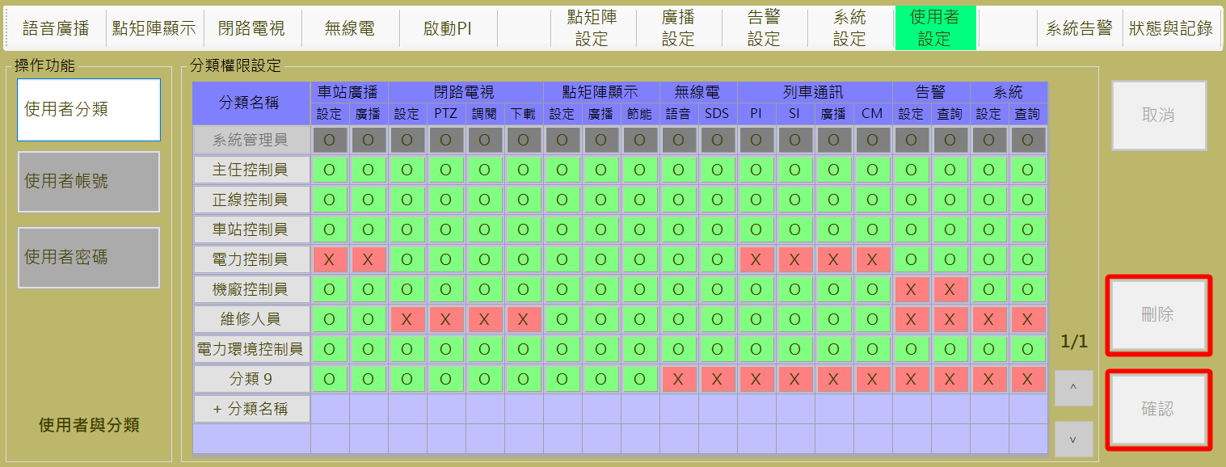

圖 4‑6: 使用者分類管理作業

Figure 4‑6: User Classification management assignment

當操作員欲變更使用者分類設定時，按下欲變更的分類名稱，如上圖紅色框部分，按下任一個分類名稱，即可進行權限異動，同時歸屬該分類裡的相關人員也會同步修正權限，其中系統管理員權限為全開不可異動，故顯示底色為灰色表示不可修改。

1. **新增分類**：操作人員可透過**分類名稱**下方的 “**+分類名稱**” 按鈕來建立新分類。
2. **確認：**”**確認**” 按鈕是用來儲存設定值。
3. **取消：**”**取消**” 按鈕則是復原尚未儲存的設定值。
4. **刪除：**”**刪除**” 按鈕則是用來刪除指定分類。刪除某一分類前，若該分類中還有隸屬的人員將無法被刪除，系統將跳出警示視窗如(圖 4‑7)

When the operator want to change the user classification settings, press the category name you want to change, as shown in the red box above, press any one of the categories Name, you can carry out permission changes, at the same time belong to the relevant personnel in the classification will also be amended simultaneously permissions., except for system administrator permissions are fully open and can not be changed, so the background is gray to indicate that can't be modified.

1. **New Classification**：The operator can create a new classification by clicking the “**+分類名稱(Add Classification Name)**” button below the classification name.
2. **Confirm**：”**確認(Confirm)**” button is used to save the setting value.
3. **Cancel**：”**取消(Cancel)**” button is to restore the settings that have not been saved yet.
4. **Delete**： “**刪除(Delete)**” button is used to delete the specified category. If there is any member in this category, it can not be deleted, the system will pop up a warning window (as shown Figure 4‑7 )

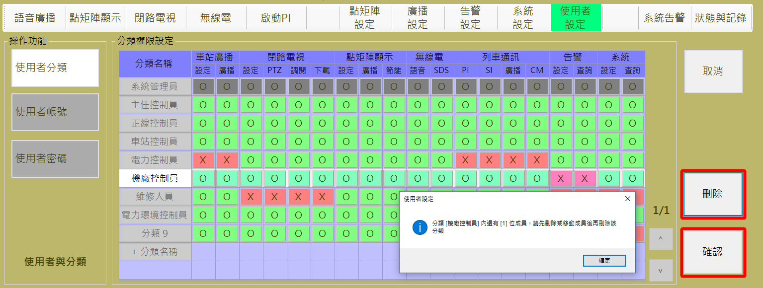

圖 4‑7: 使用者分類刪除警示

Figure 4‑7: Delete User Classification Failed Alarm

人員的功能限制除了上方功能列無顏色提示，主要針對紅框或橘框功能，橘框按鈕的橘色框線只呈現於當操作人員無此權限時，限制提醒操作此功能需進行帳號轉換與驗證，若為紅框功能無論登入的人員是否有權限，都必須再次經過帳號驗證，橘框功能如圖 4‑8。：

The function limitation of the staff is mainly for the red frame button or the orange frame button function. The orange frame of the orange button is only presented when the operator has no such authority. This function is limited to be changed and verified. If the red button features regardless of the login staff have the permission, must be verified by the account again, Orange box function shown in Figure 4‑8

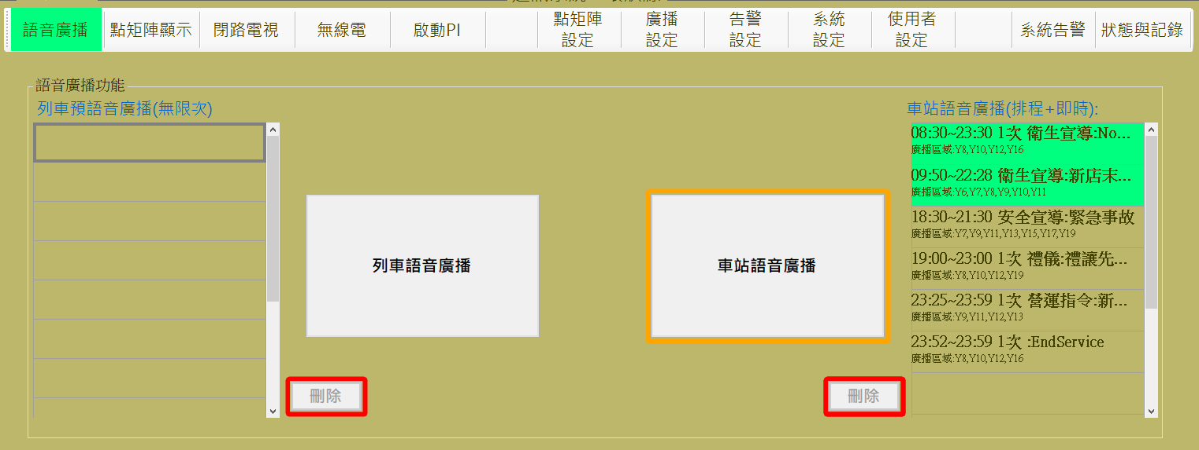

圖 4‑8: 登入人員無車站語音廣播權限的橘框圖示

Figure 4‑8: Login staff doesn't have the permission to make the Broadcast to Station using Orange frame icon

以下顯示各個人員權限所限制的紅框或橘框功能截圖：

The following shows a screenshot of the red or orange frame that is limited by each person's permissions:

1. 車站廣播 PA on the Station：
2. 設定 Setting：

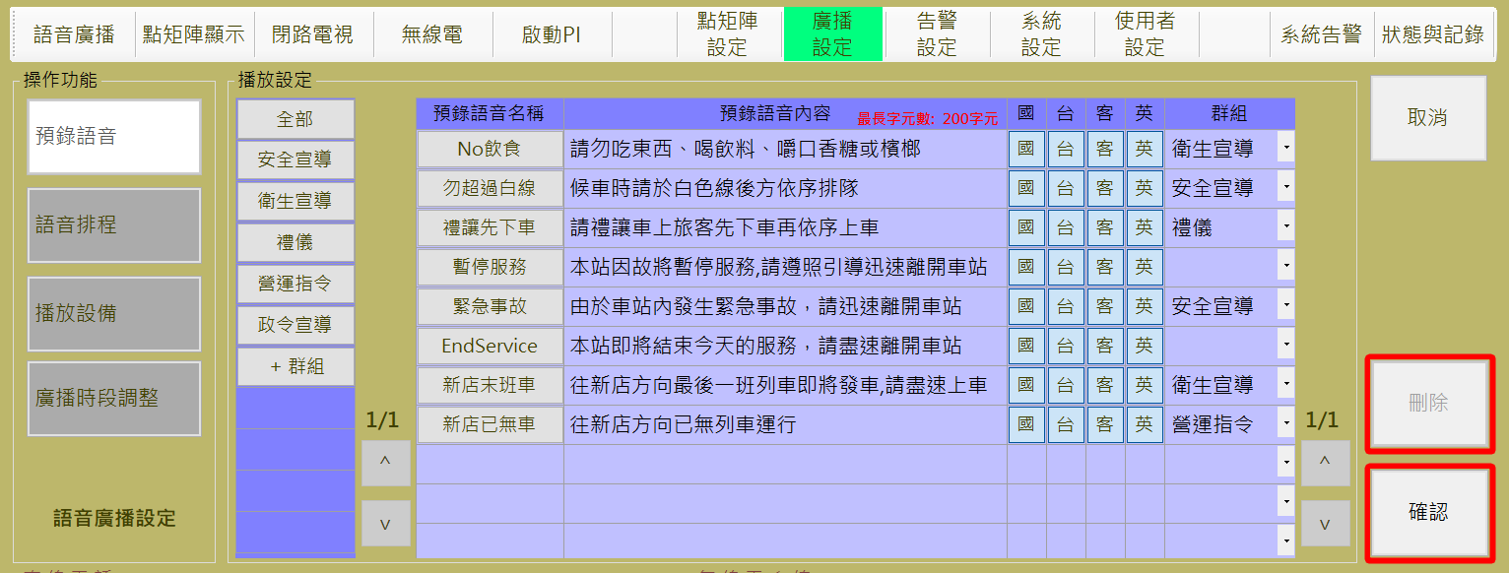

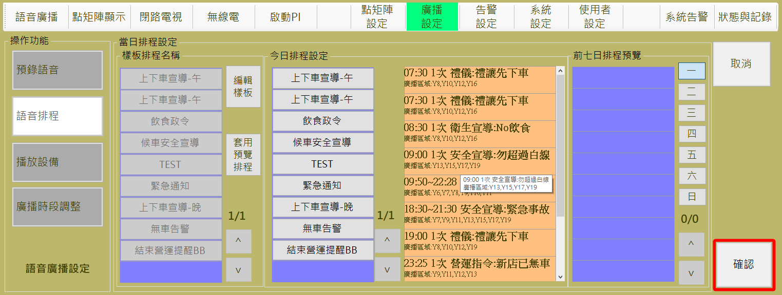

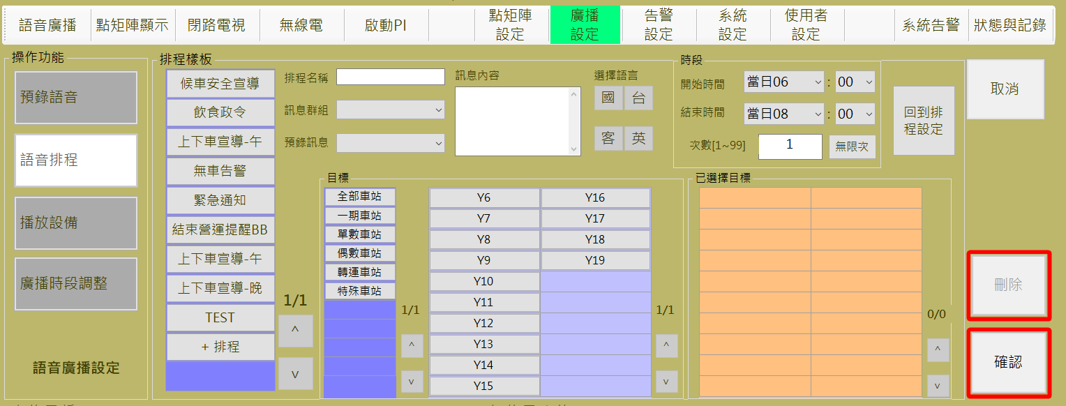

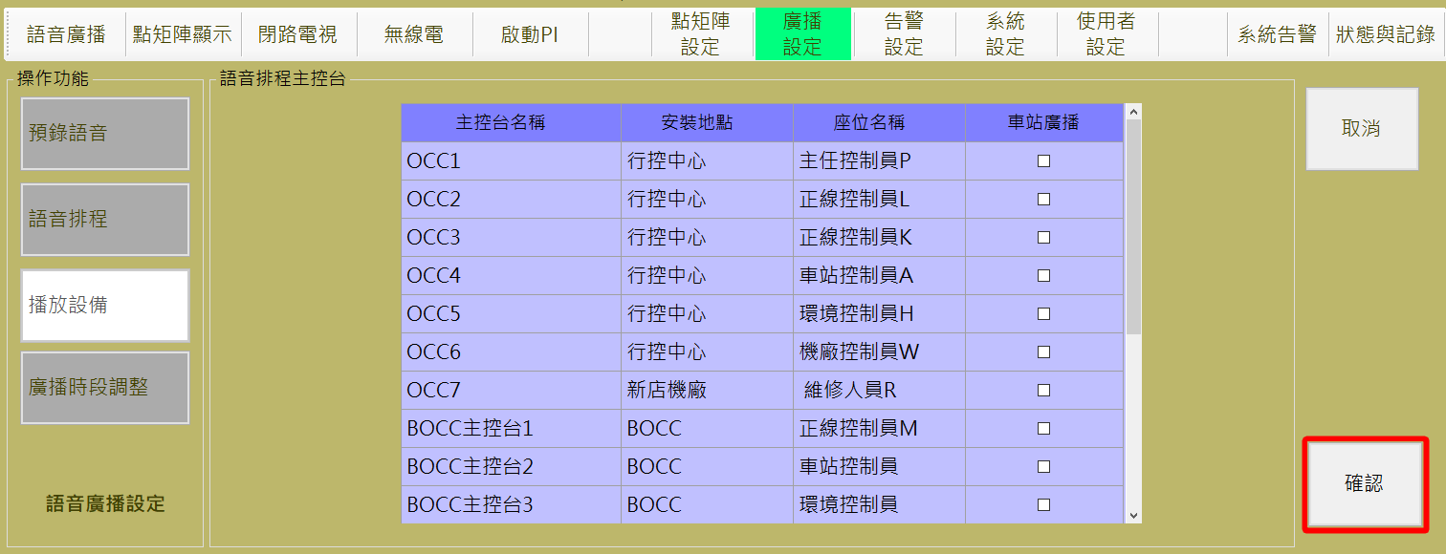

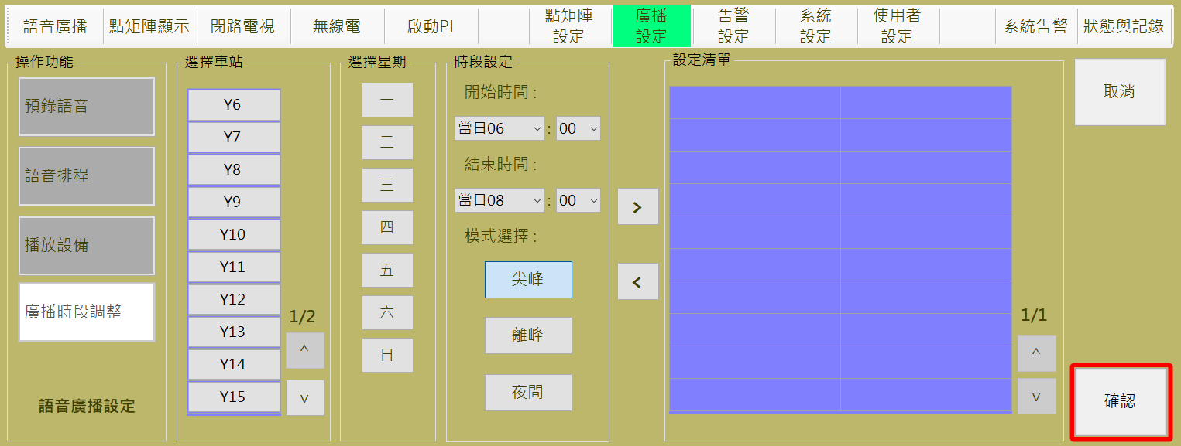

1. 廣播 Broadcast to Station：

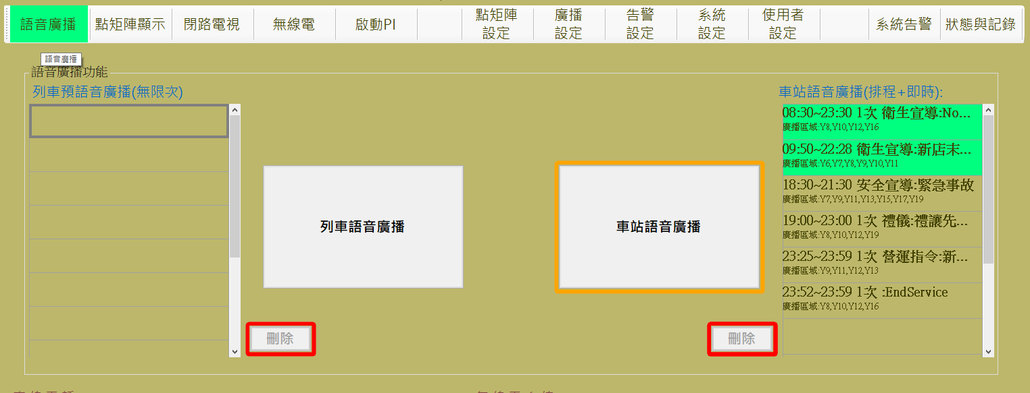

1. 閉路電視CCTV：

其中(1)(2)(3)項為紅框操作，但只要有一項經過驗證，當操作者僅在閉路電視功能內操作時，都無須再進行驗證。

Among them, items (1), (2) and (3) are red-framed operations, but as long as one has been verified, no further verification is required when the operator only operates within closed-circuit television functions.

1. 設定 Setting：

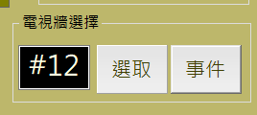

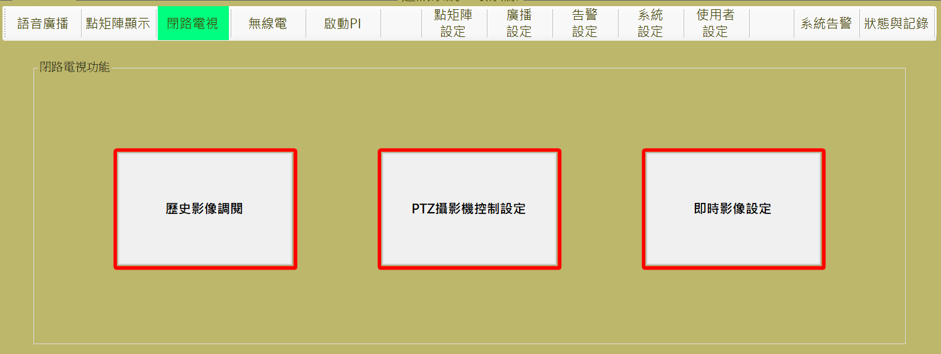

1. 球型攝影機控制設定PTZ Control Setting：
2. 調閱 Historical Video Review：



1. 下載 Historical Video Review and Download：

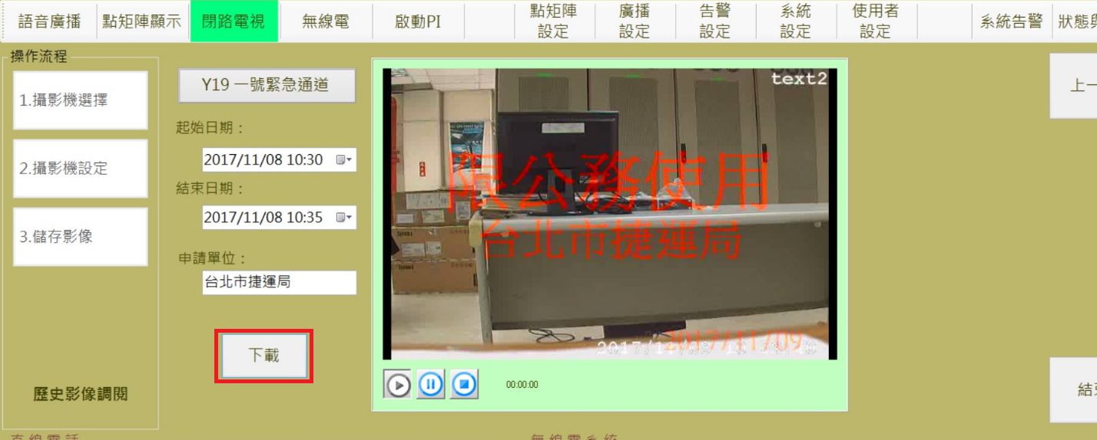

1. 點矩陣顯示 DMD Display：
2. 設定 Setting：

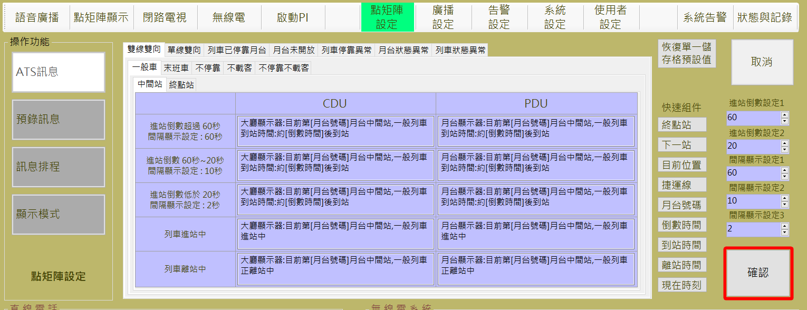

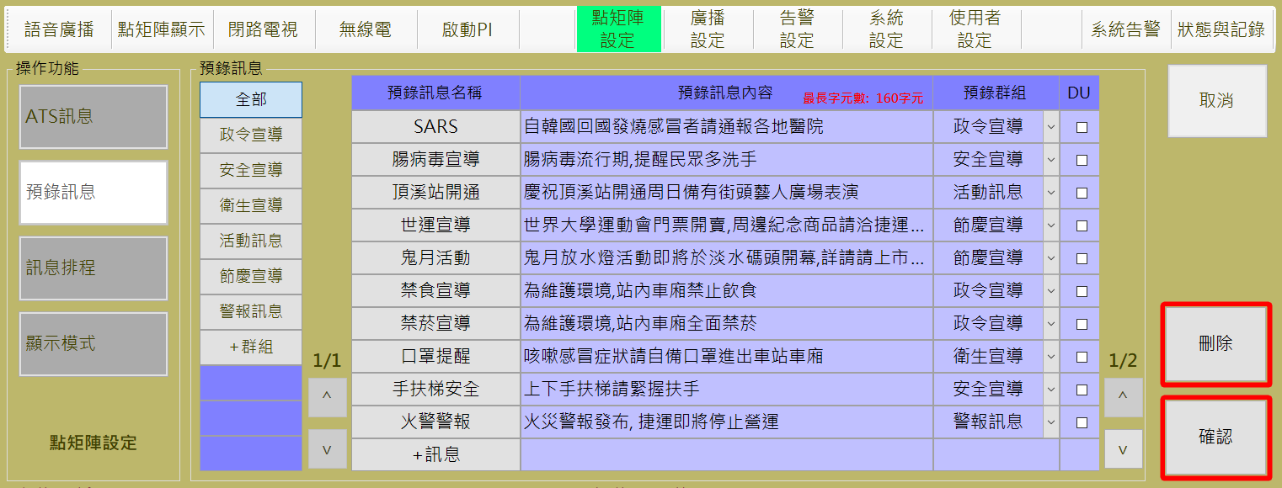

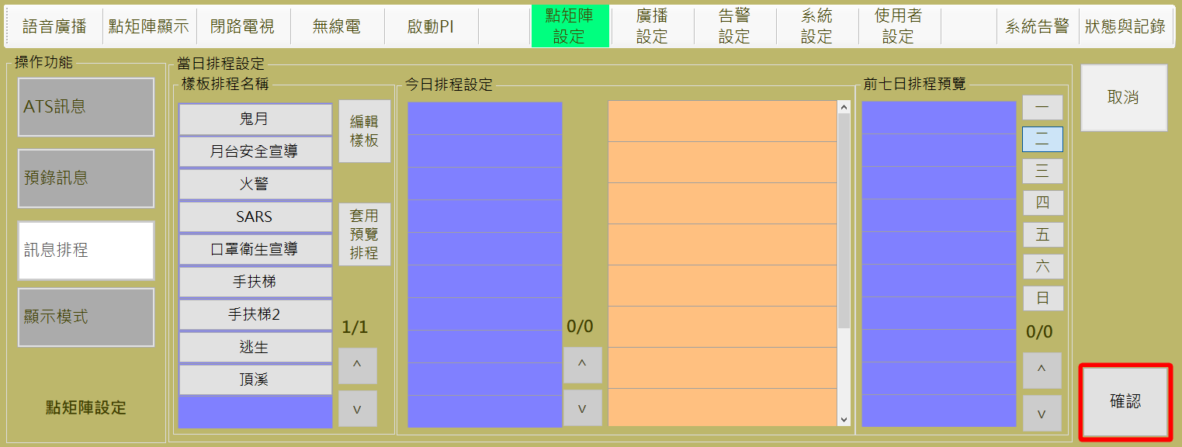

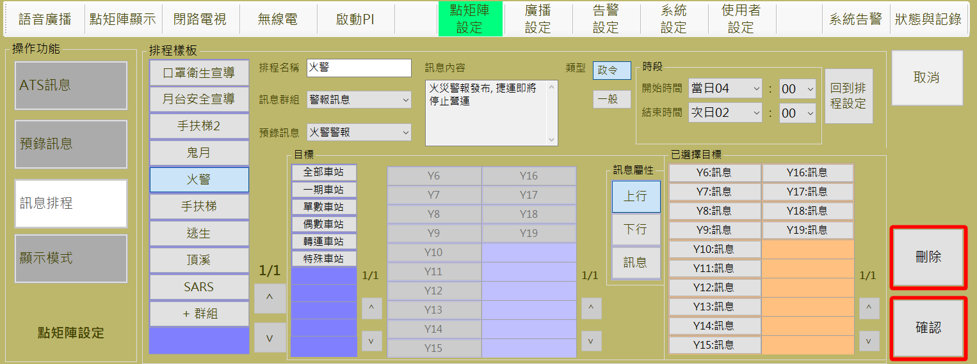

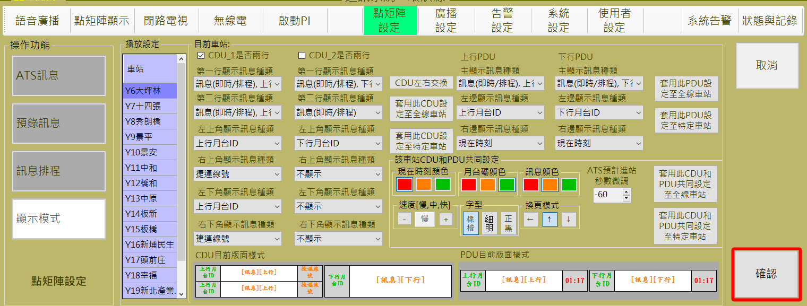

1. 廣播 Broadcast on the Station’s DMD：

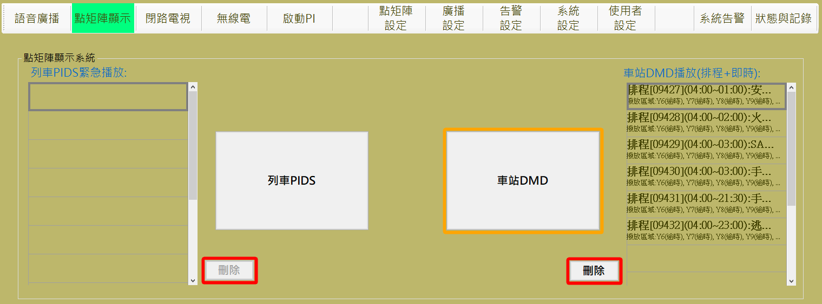

1. 節能 Energy-saving on DMD：

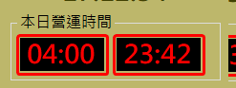

1. 無線電Tetra：
2. 語音 Voice：若使用者沒有無線電權限，則來電等候佇列中的接聽為橘框。

Voice：If the user does not have the Voice of radio permission, the pick-up button on incoming call waiting queue area is an orange frame

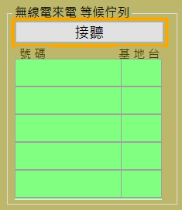

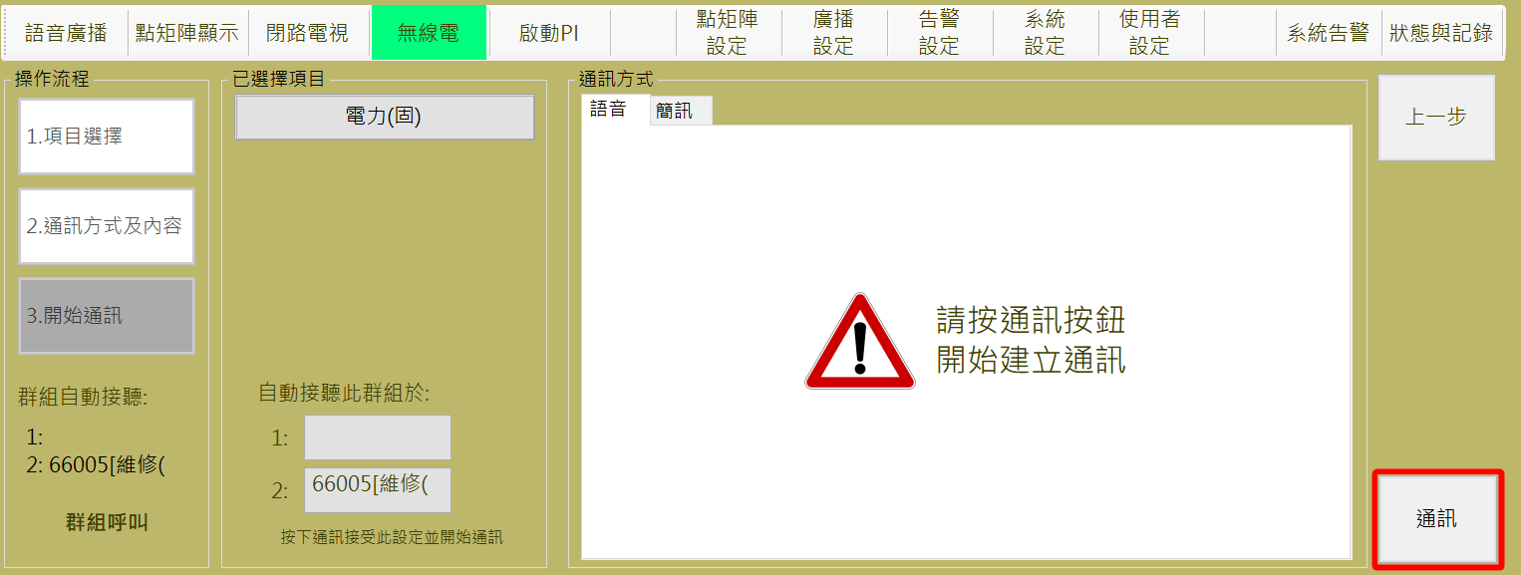

1. SDS：

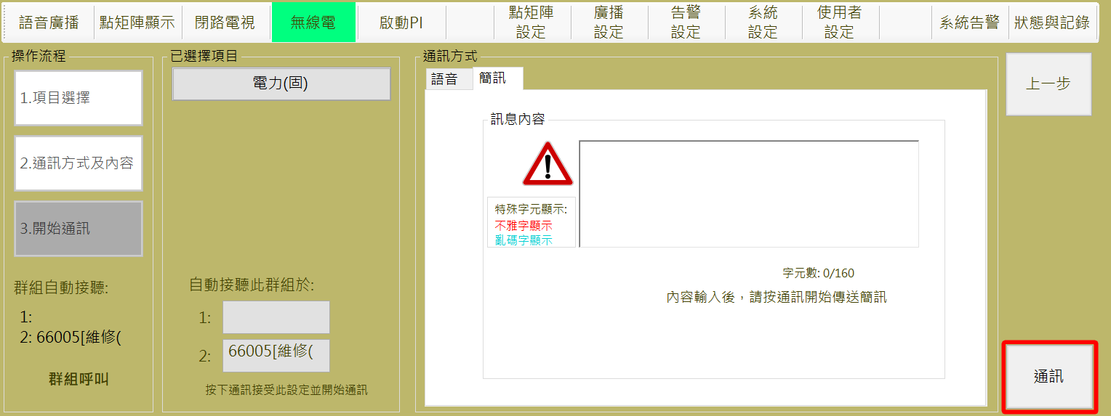

1. 列車通訊：
2. 乘客緊急對講機：若使用者沒有操作PI的權限，則來電等候佇列中的接聽為橘框。

PI：If the user does not have the PI permission, the pick-up button on incoming call waiting queue area is an orange frame

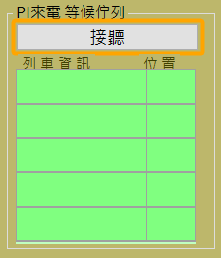

1. 司機緊急對講機：若使用者沒有操作SI的權限，則來電等候佇列中的接聽為橘框。

SI：If the user does not have the PI permission, the pick-up button on incoming call waiting queue area is an orange frame

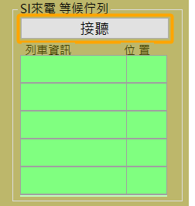

1. 廣播 Broadcast for PIDS or PA on the Train：

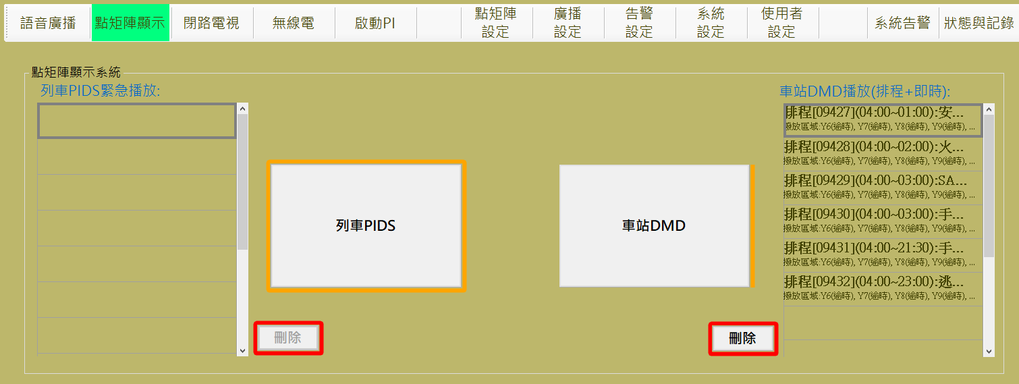

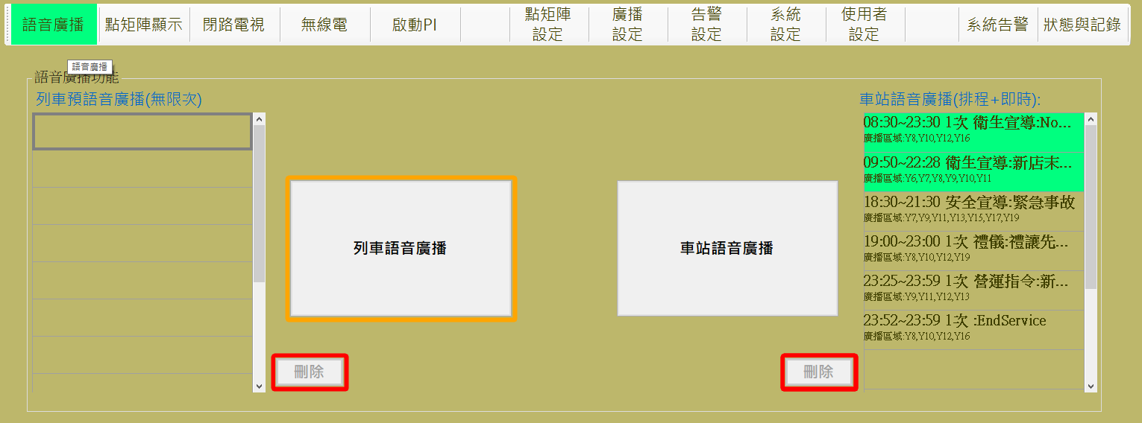

1. 啟動PI actived CM：

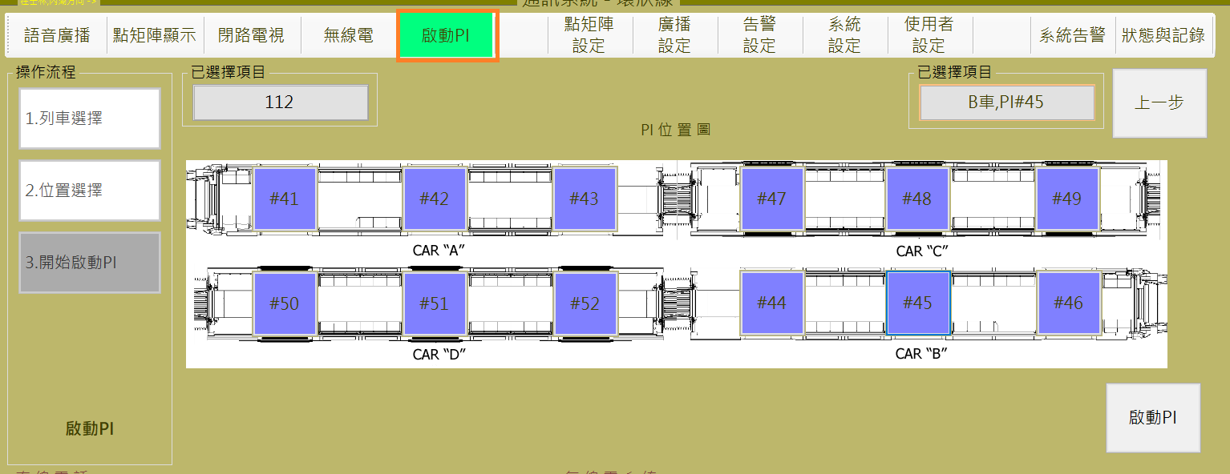

1. 告警 Alarm：
2. 設定 Setting：

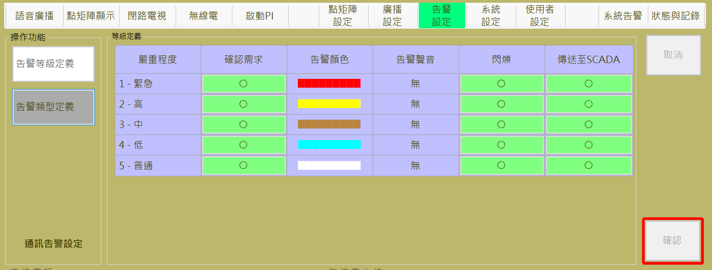

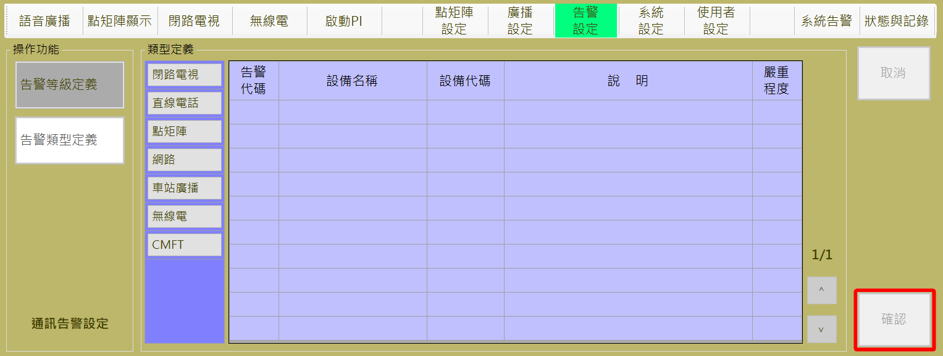

1. 查詢 Search：

查詢功能僅限制匯出與整合兩個按鈕。

Query function only limits the export and integration of two button.

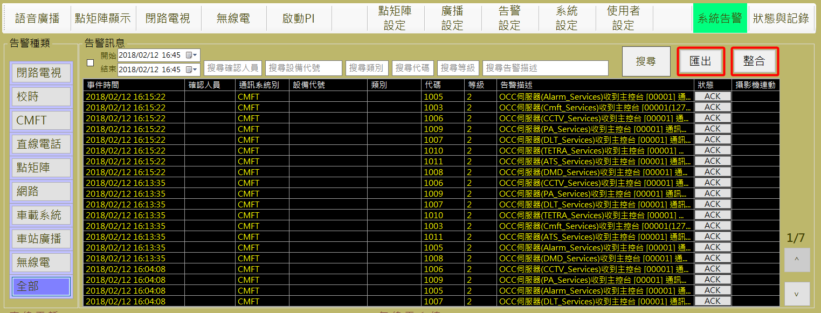

1. 系統 System：
2. 設定 Setting：

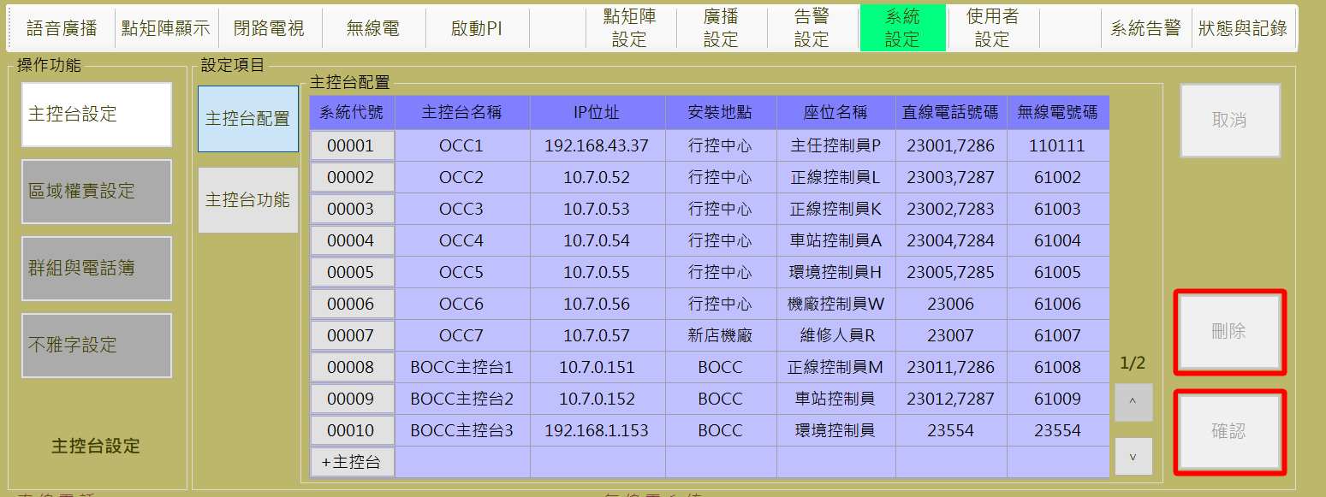

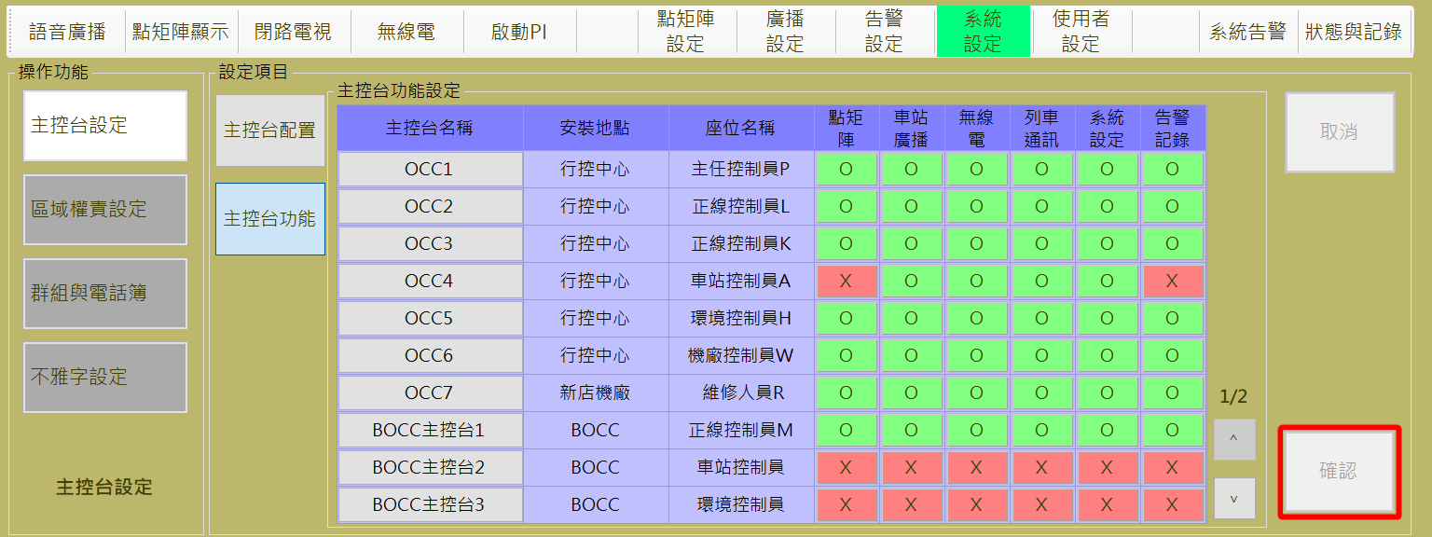

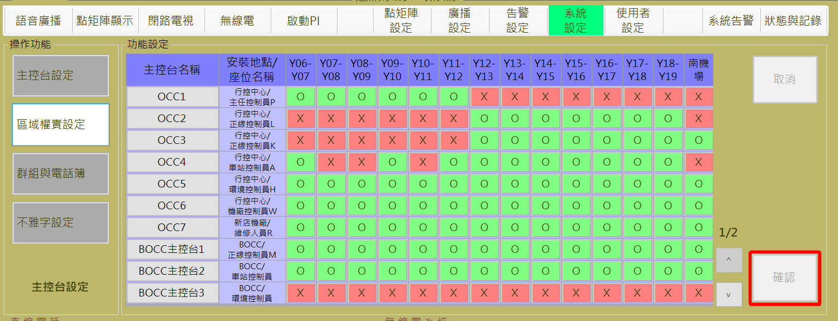

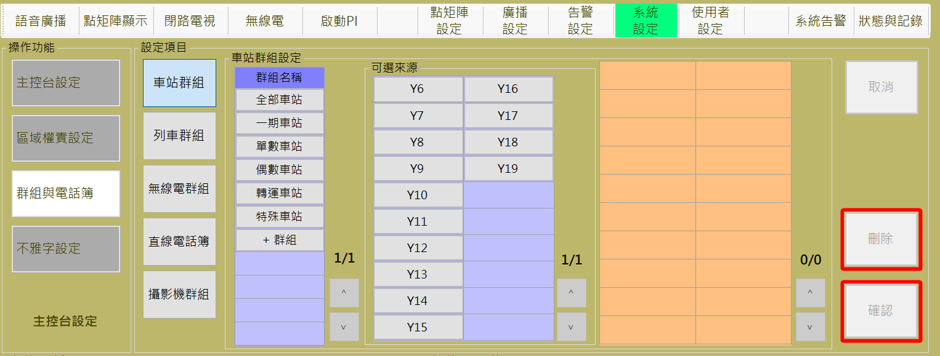

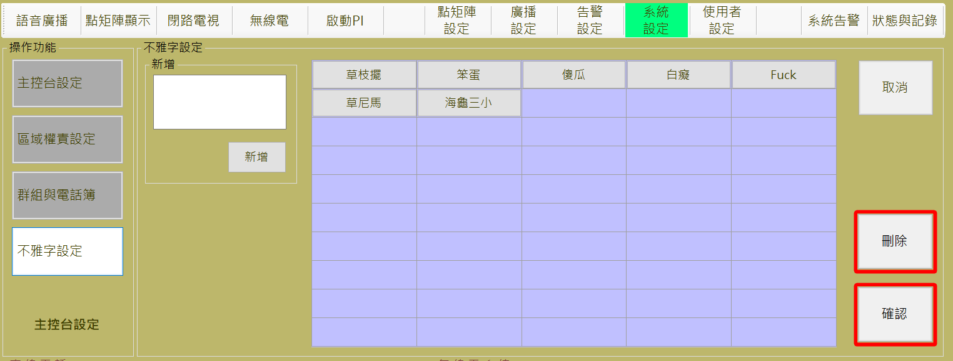

1. 查詢Search：

查詢功能僅限制匯出與整合兩個按鈕。

Query function only limits the export and integration of two button.

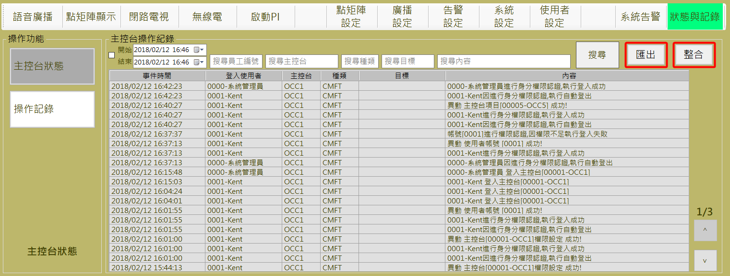

#### 使用者帳號管理User account management

**使用者帳號**管理作業 (如圖 4‑9) 主要是用來建立/刪除人員帳號，並設定/變更人員群組歸屬以及操作權限。授權部分，灰色X表示該使用者分類即不開放次權限，故分類中的帳號亦無法透過更改的方式開通此權限。綠色O表示此帳號擁有該權限，紅色X表示該權限在本分類裡是開通的，但該帳號的無法使用此功能。

**User Account Management** assignment (as Figure 4‑9)is used to establish /delete user account, assign the user classification, and change the account authority. Authorization part, gray X indicates that the category is disabled to this permission, so the authority of accounts in the classification can't be enable through changing the permissions. The green O means the account has the permission, the red X means the permission is enabled in this category, but this account can not use this function.

1. 查詢帳號權限相關資料：
2. 所屬分類：點選該帳號所歸屬的使用者分類， 如畫面中的”**分類名稱**”。
3. 分類成員：點選上一步驟的分類種類按鈕後，於分類成員表格可以看到所有該分類中的成員，如圖 4‑9 主任控制員字體顏色為藍色，表示目前選擇的分類為主任控制員得所有成員。
4. 帳號授權：點選分類成員表中任一欄位，如圖 4‑9帳號資料”系統編號00002員工編號0002姓名Anne”，該列字體顏色為藍色，表示目前檢視的授權權限為該帳號資料。
5. Query account permissions related information：
6. Classification：Click the user classification which account belongs to, as shown in the “**分類名稱(**category name)” .
7. Classified members：Click the category button in the previous step, all the members in the category can be seen in the category member table, as shown in Figure 4‑9, the director controller font color is blue, indicating that the currently selected category is all members of the director controller.
8. Account authorization：Click on any field in the classified member table, as shown in Figure 4‑9, account information “System ID 00002 employee number 0002 name Anne”, the font color of the row is blue, indicating that the currently authorized access is account-0002 information.

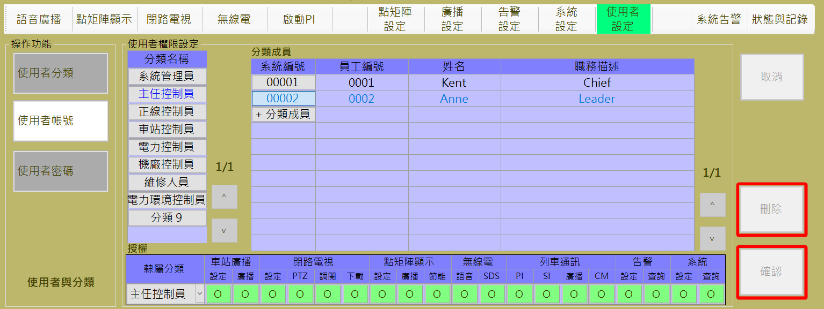

圖 4‑9: 使用者帳號檢視作業

Figure 4‑9: User account management view assignment

1. 設定帳號權限：
2. **系統編號**：按下分類成員表第一欄，即可對該帳號進行資料編輯，”**隸屬分類**”修改，與權限設定(後兩者於圖下方的授權表格中修訂)，如圖 4‑10。
3. **新增分類帳號**：操作人員可透過**系統編號**下方的 “**+分類成員**” 按鈕來建立新分類成員帳號，如圖 4‑10、圖 4‑11。
4. **確認：**”**確認**” 按鈕是用來儲存修改或新增的資料。
5. **取消：**”**取消**” 按鈕則是復原尚未儲存的設定值。
6. **刪除：**”**刪除**” 按鈕則是用來刪除指定的帳號。
7. Set the account permissions：
8. **System ID**：Press the first column of the classified member table to edit the account, modify the “**隸屬分類(**subordinate classification)”, and set permissions (the latter two are revised in the authorization table at the bottom of the figure), as shown in Figure 4‑10.
9. **New an account**：Operators can create a new classified member account by using the “**+分類成員(**+ Category Member)” button below the system ID, as shown in Figure 4‑10, Figure 4‑11.
10. **Confirm**：”**確認(Confirm)**” button is used to save the edited value or new account data.
11. **Cancel**：”**取消(Cancel)**” button is to restore the settings that have not been saved yet.
12. **Delete**： “**刪除(Delete)**” button is used to delete the specified account.

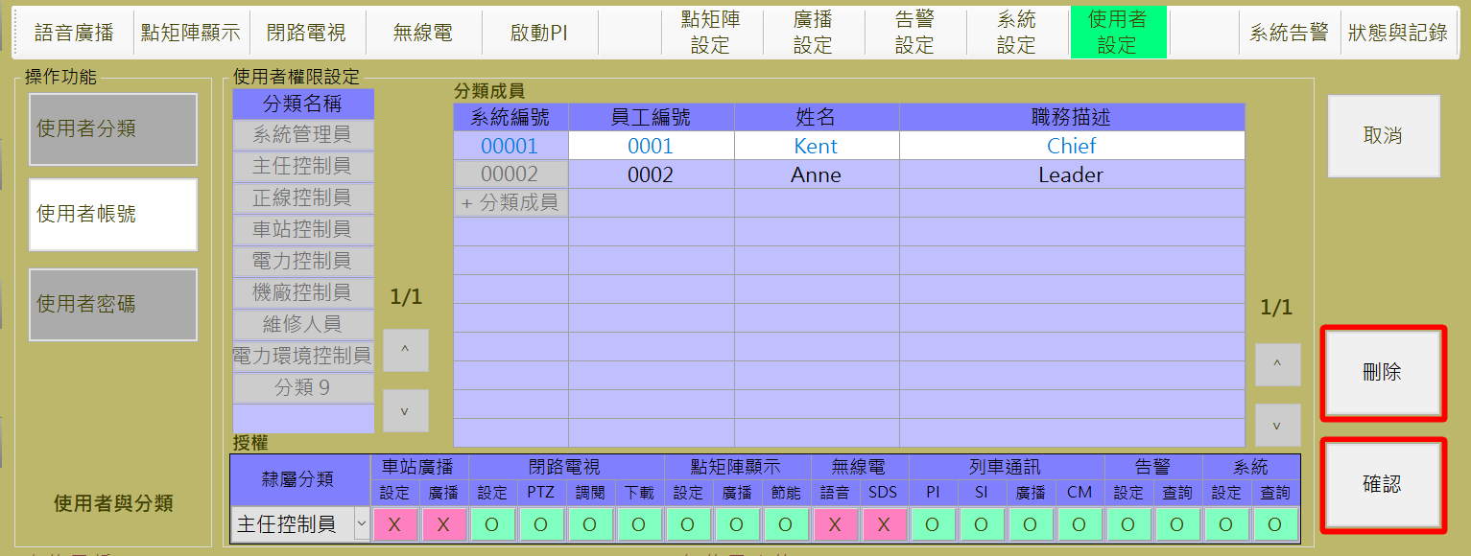

圖 4‑10: 使用者帳號編輯作業

Figure 4‑10: User account editing assignment

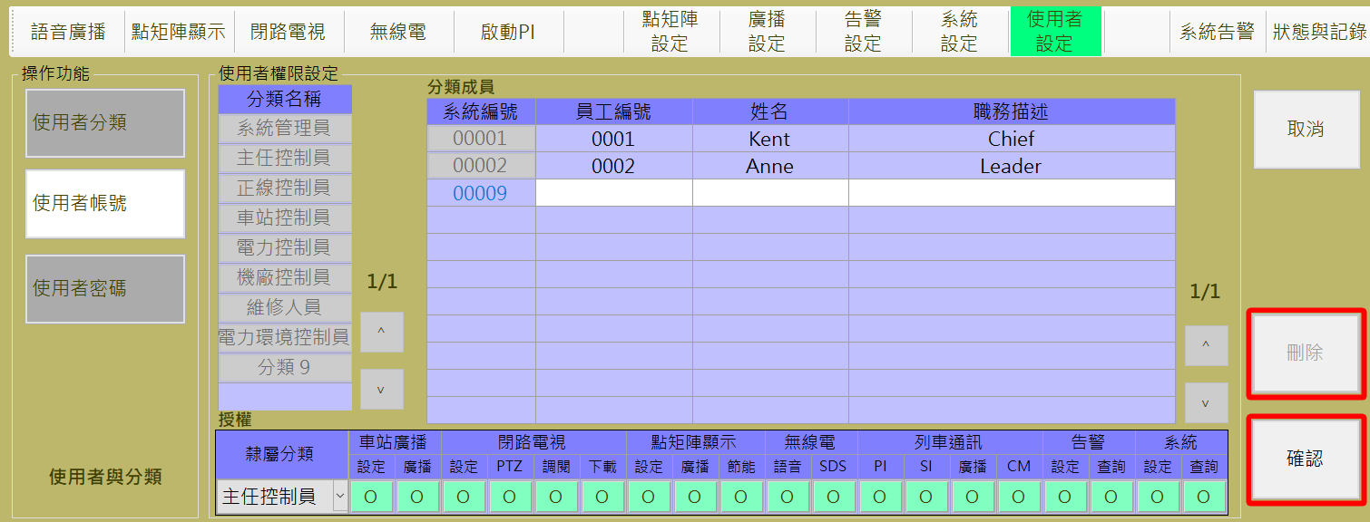

圖 4‑11: 新增使用者帳號作業

Figure 4‑11: Add a User account assignment

### 系統設定Basic System Setting

本作業主要是建立/調整相關系統的基本設定資料，含**主控台設定**、**列車語音通訊**設定、**群組與電話簿**設定及**不雅字設定**四個項目，預設作業是**主控台設定**作業。

This function is used to establish / adjust the related sub-system basic parameters. It include **Consoles Setting**, **Authority for Train Communication**,  **Group and DLT Book Setting** and I**ndecent Words Setting**. Default assignment is **Consoles Setting** page.

#### 主控台設定Console Setting

主控台設定作業內含兩個項目: **主控台配置**管理作業及**主控台功能**管理作業。進入主控台設定作業，預設作業項目是主控台配置管理作業。

Console Setting assignment include two sub-pages: **Console Configuration**  management and **Console Authority Setting** function. Enter Console Setting assignment, the default operation item is the Console Equipment Configuration process.

##### 主控台配置管理作業Console Equipment Configuration function

主控台配置管理作業主要是建立主控台名稱、主控台工作站固定IP、安裝地點、席位名稱、配置的直線電話號碼及無線電號碼，如圖 4‑12，但此畫面必須具有管理者權限的帳號才能進行作業。。

Console Equipment Configuration Magagement is used to establish a new Console or to edit the console information about name, IP address of the Console, installation site, seat name, the DLT number and tetra number assigned to the seat, as show in Figure 4‑12,But only administrator have the privilege to adjust these information.

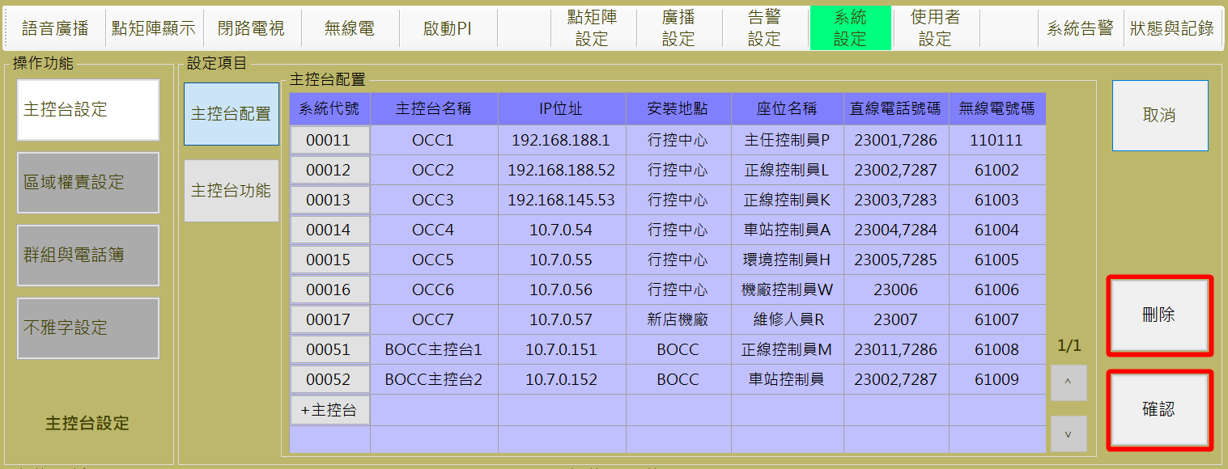

圖 4‑12: 主控台配置作業

Figure 4‑12: Console Equipment Configuration Function

1. 操作人員可透過**主控台配置**區塊內的**系統代號**欄位下方的 “**+主控台**” 按鈕來建立主控台及其相關資訊。
2. Operator can use the “**+主控台(**Add Console)” button at the “**系統代號(**System No)” field in Console Configuration block to build a new console and input the related information.

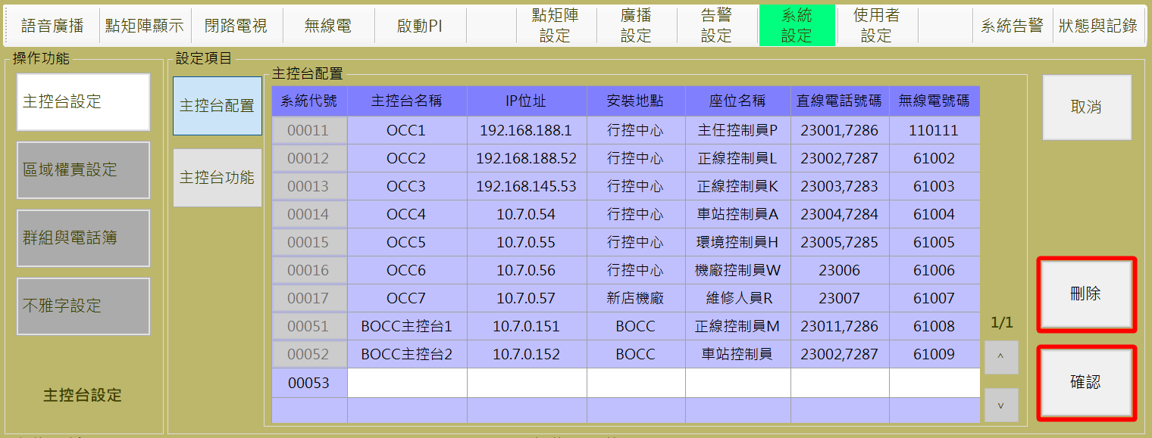

圖 4‑13: 新增主控台資訊作業

Figure 4‑13: New a Console Equipment Configuration Function

1. 編輯主控台資訊：
2. **編輯**：透過按下欲修改主控台的系統代號，該列將會進入反白的編輯模式，可以進行相關資訊修改。。
3. **儲存**：”**確認**” 按鈕是用來儲存設定值。
4. **取消：** “**取消**” 按鈕則是復原設定值。
5. **刪除：** “**刪除**” 按鈕則是用來刪除點選到的系統代號的主控台資訊。
6. To edit console information：.
7. **Edit**：press the system code you want to modify the console, the row will be whited for edit mode.
8. **Save**：Press “**確認**(Confirm) “ button can store the Setting result.
9. **Cancel**：”**取消**” (Cancel) button can recover the original Setting value.
10. **Delete**：”**刪除**” (Delete) button is used to delete a specified console information.

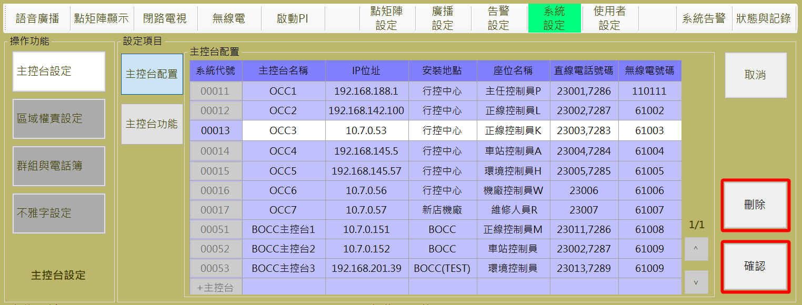

圖 4‑14: 編輯主控台資訊作業

Figure 4‑14: Adjust a Console Equipment Configuration Function

##### 主控台功能設定作業Console Authority Function Setting

主控台功能設定作業主要是設定每個主控台可操作的權限 (如圖 4‑15)。

Console Function Setting Function is used to set the authorities for each console as Figure 4‑15).

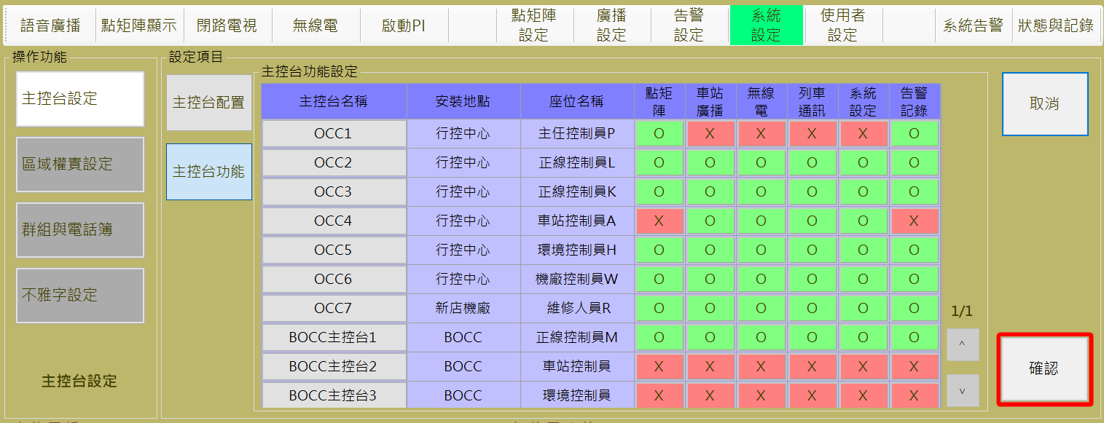

圖 4‑15: 主控台權限

Figure 4‑15: Console Authority

1. 編輯主控台功能資訊。
2. **編輯**：操作人員點選”主控台名稱”中欲修改的主控台，如圖 4 15，OCC6項目將呈現可編輯模式，供操作人員修正資料。
3. **儲存**：”**確認**” 按鈕是用來儲存設定值。
4. **取消：** “**取消**” 按鈕則是復原設定值。
5. To edit console information：.
6. **Edit**：The operator selects the console to be modified in the “console name”, as shown in Figure 4‑16, the OCC6 will display editable mode for the operator to correct the data.
7. **Save**：Press “**確認**(Confirm) “ button can store the Setting result.
8. **Cancel**：”**取消**” (Cancel) button can recover the original Setting value.

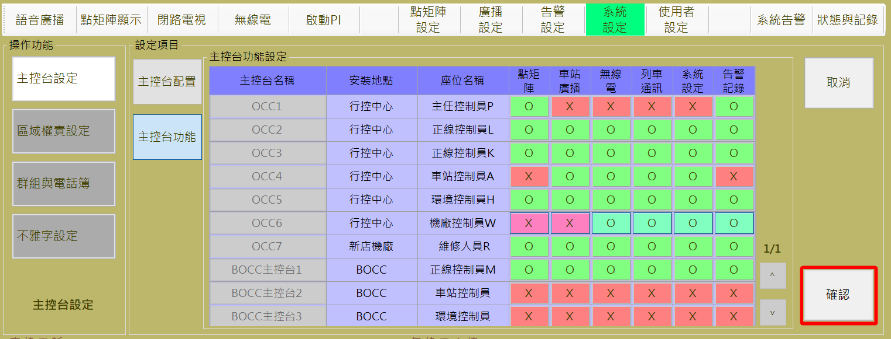

圖 4‑16: 主編輯控台權限作業

Figure 4‑16: Adjust a Console Authority Function

若該主控台沒有配置的某項主控台功能，表中為X，則該主控台不具備行駛該功能的權力，即使登入的使用者具備此權限能就無法行駛該功能，除了系統管理員群組內的帳號，該群組不受控主控台功能限制。

以下利用截圖顯示各種權限限制下的示意圖：

關閉點矩陣功能的主控台顯示畫面如圖 4‑17。點下點矩陣顯示，車站DMD與其刪除按鈕將無法被點選。

If the console is not configured with a console function, showed as the X on the table, the console does not have the power to run the function, even if the logged-in user has the permission to be able to run this feature, in addition to the system Account within the Admin group, this group is not restricted by the console function limitations.

The following screenshots show various restrictions under the authority of the diagram：

Turn off the DMD function of the console display screen shown in Figure 4‑17. Click the DMD display on function Bar, the station DMD and its delete button will not be clicked..

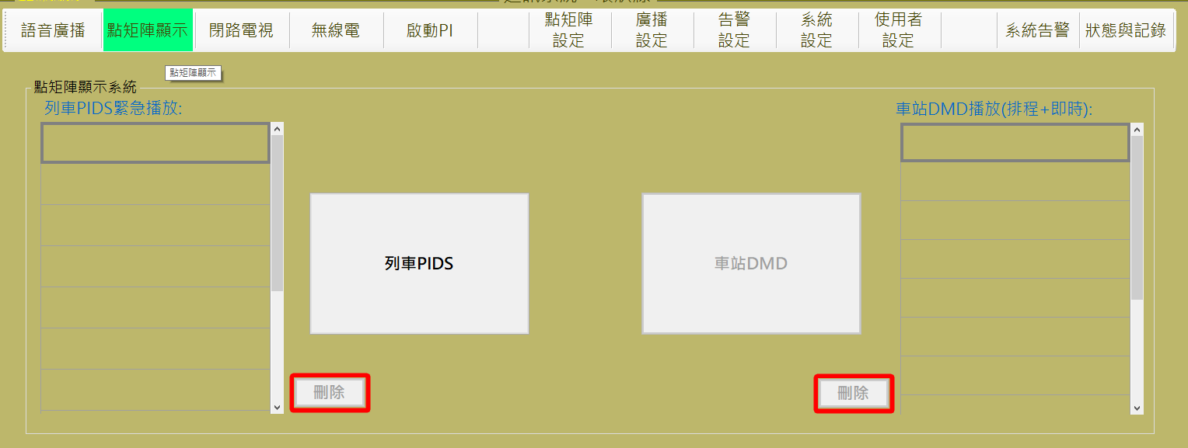

圖 4‑17: 不具備點矩陣功能的主控台

Figure 4‑17: The console that does not have the DMD function

點下語音廣播後，車站語音廣播與其刪除按鈕將無法被點選。

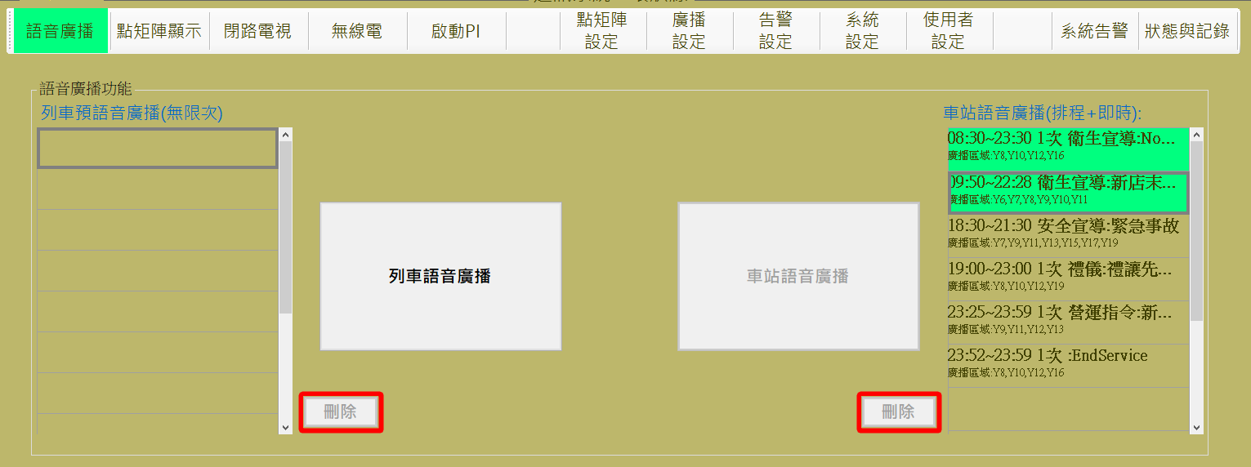

圖 4‑18: 不具備車站廣播的主控台

Figure 4‑18: The console that does not have the Station’s PA function

無線電功能若被限制，則上排無線電功能無法點選，但可以觀看無線電來電但無法進行接聽。

If the Tertra function is limited, Tertra function on the upper row can not click, but you can monitor the incoming call but can not answer the call.

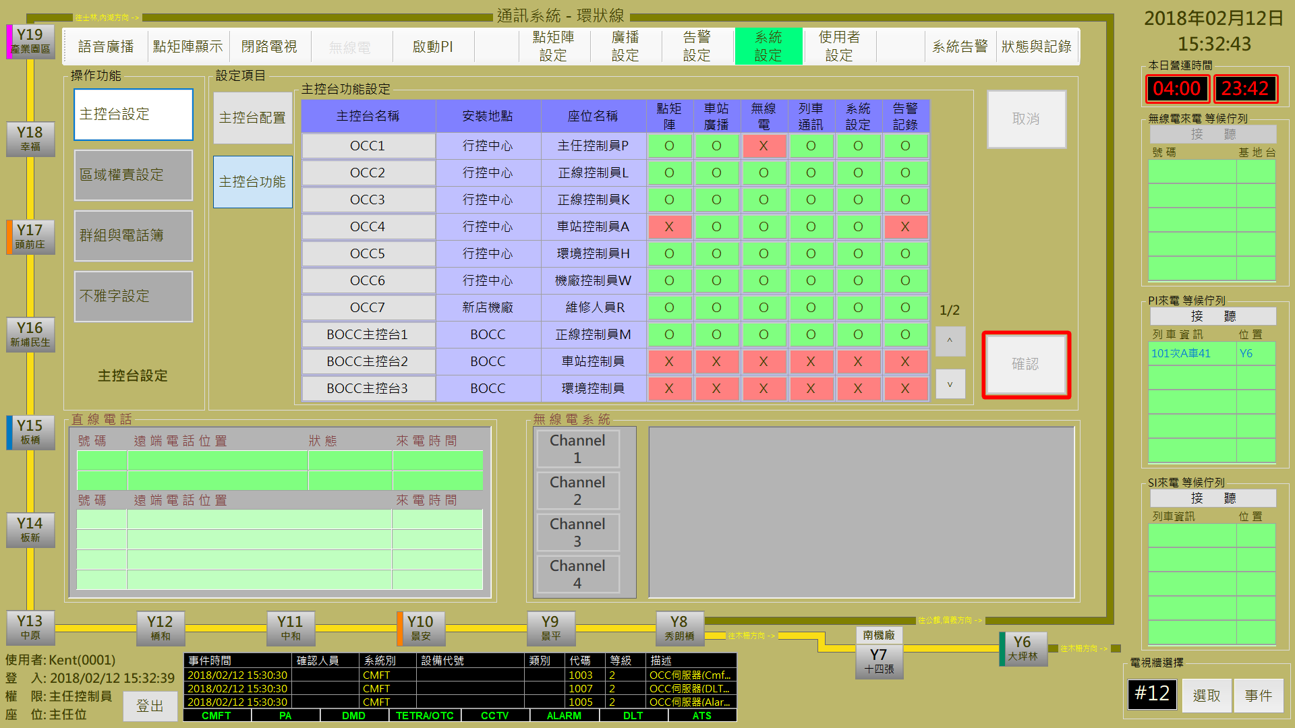

圖 4‑19: 不具備無線電能的主控台

Figure 4‑19: The console that does not have the Tetra function

列車功能若被限制，則上排啟動PI功能無法點選，但可以觀看PI/SI來電但無法進行接聽。語音廣播中的列車廣播與點矩陣顯示中的列車PIDS按鈕將呈現無法啟用狀態。

If the train function is limited, the PI function on the upper row can not be clicked, but you can monitor the PI / SI incoming call but can not answer the call. The train PIDS button in the train broadcast and dot matrix display in the voice broadcast will be rendered in an inactive state.

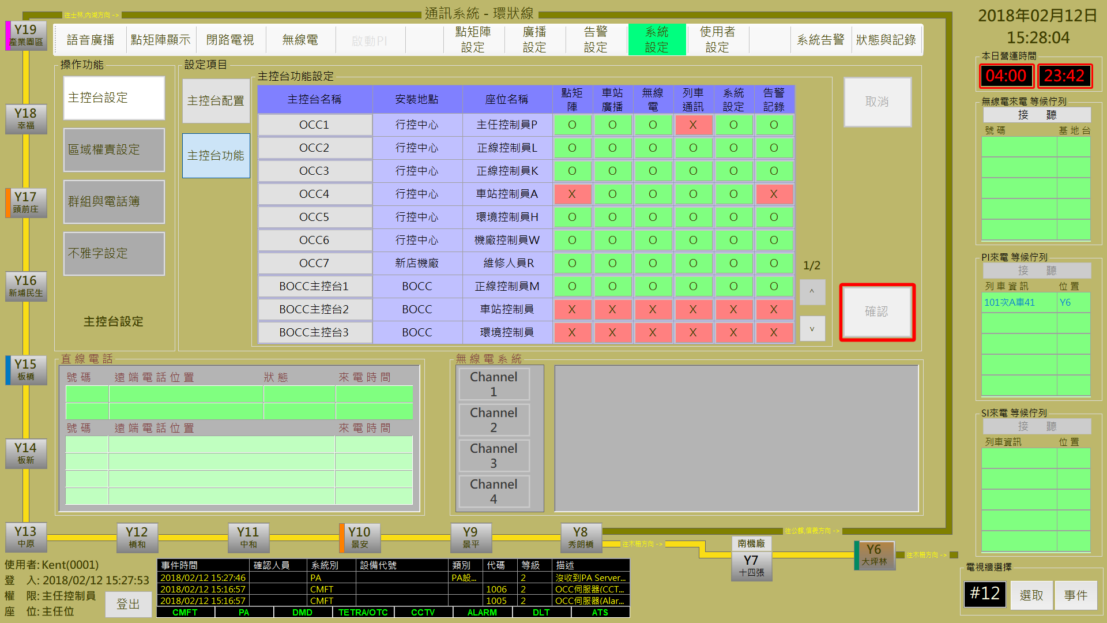

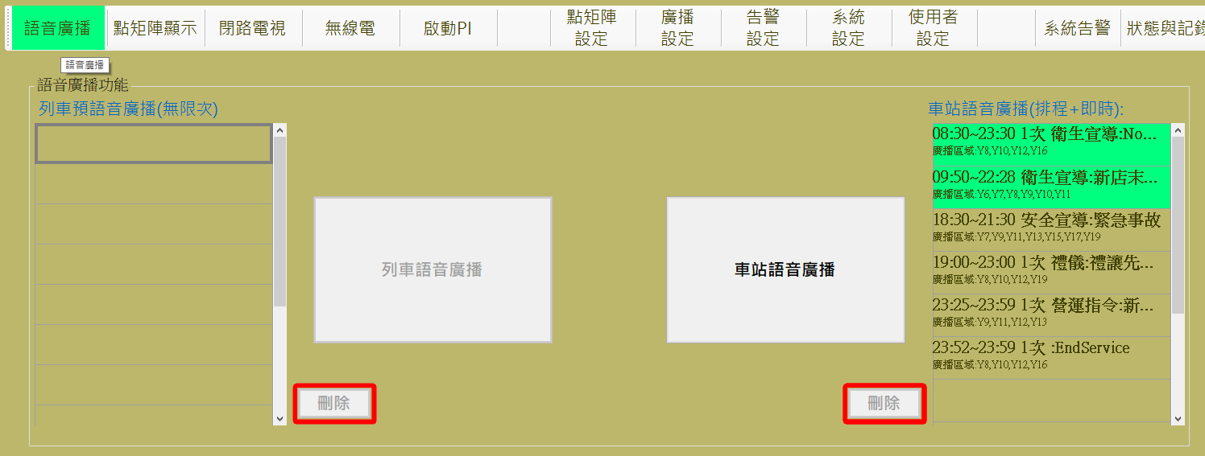

圖 4‑20: 不具備列車通訊功能的主控台

Figure 4‑20: The console that does not have the OTC function

系統設定功能若被限制，則上排系統設定與使用者設定無法點選

If the system setting function is limited, the upper system setting and the user setting can not be clicked

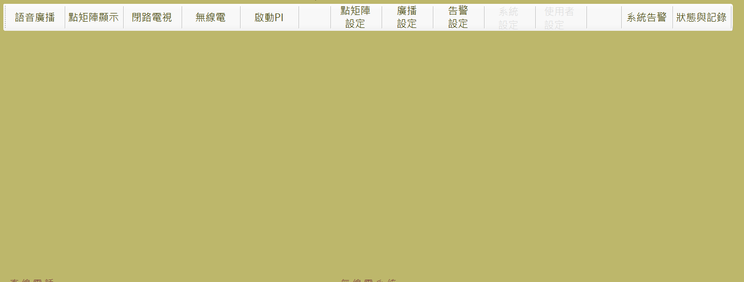

圖 4‑21: 不具備系統設定功能的主控台

Figure 4‑21: The console that does not have the System Setting function

告警紀錄功能若被限制，則上排告警設定、系統告警與狀態與記錄三個功能列按鈕無法點選，此外各車站按鈕點選後將呈現各車站相關告警功能也將被鎖住。

If the alarm and record function is limited, alarm setting, the system alarm and status and record, this three function column buttons on the upper row can not be clicked. In addition, each station button will display the relevant alarm function of each station will also be locked.

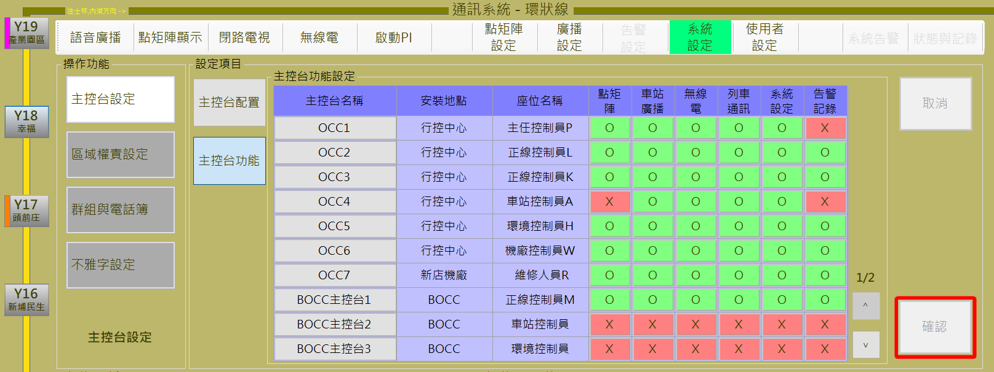

圖 4‑22: 不具備告警紀錄功能的主控台

Figure 4‑22: The console that does not have the Alarm And Log function

#### 區域權責設定Regional Authority and Responsibilities Setting

區域權責設定作業主要是設定主控台可控制那些行駛區域內的列車，如圖 4‑23。

Regional authority and responsibilities setting is mainly to set the authority for console to control which train in certain driving area，as Figure 4‑23.

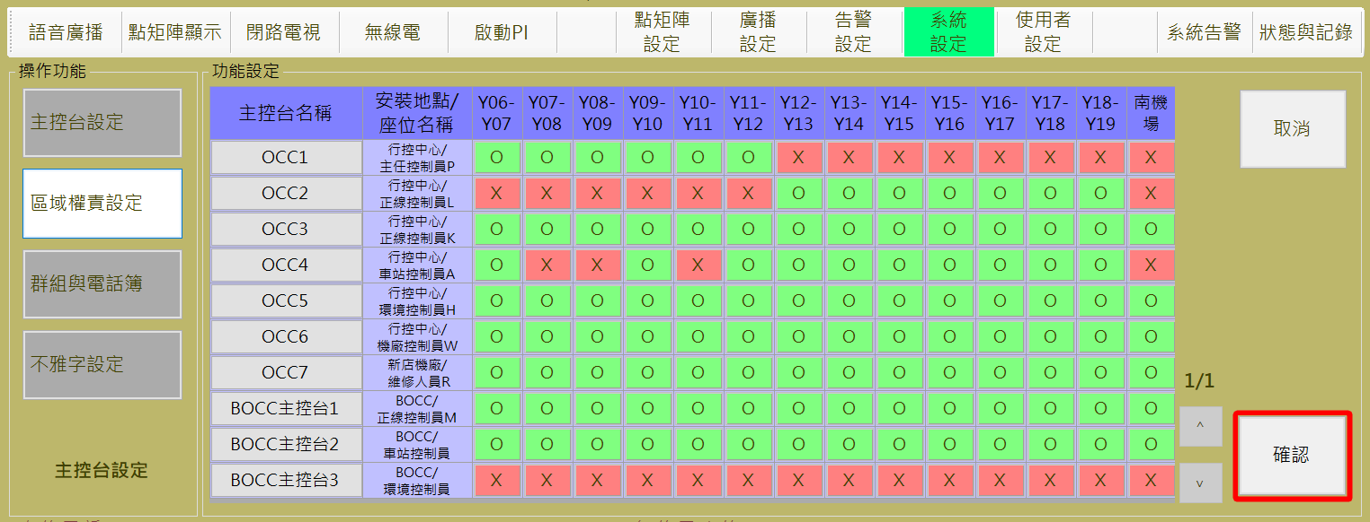

圖 4‑23: 區域權責設定

Figure 4‑23: Regional authority and responsibilities

1. 編輯區域權責：
2. **編輯**：作人員點選”主控台名稱”中欲修改的主控台，如圖 4‑24，OCC6項目將呈現可編輯模式，供操作人員修正資料，『O』表示該主控台含該區域的權責，『X』表示該主控台不含該區域權責，目前僅應用於列車對講機事件，若列車所屬位置歸屬某主控台權責範圍，則PI來電要求顯示為藍色，若列車所屬位置不歸屬某主控台權責範圍，則PI來電要求顯示為黑色。
3. **儲存**：”**確認**” 按鈕是用來儲存設定值。
4. **取消：** “**取消**” 按鈕則是復原設定值。
5. To Edit Regional authority and responsibilities setting：
6. **Edit**：The operator selects the console to be modified in the “console name”, as shown in Figure 4‑24, the OCC6 will display editable mode for the operator to correct the data,『O』means that the console contains the rights and responsibilities of the region, 『X』means the console does not contain the rights and responsibilities of the region, currently only applied to train intercom event, if the train belonging to a console belongs to the scope of authority, the PI Call request is displayed in blue, if the train belongs to a console does not belong to the scope of authority, the PI call request is displayed in black.
7. **Save**：Press “**確認**(Confirm) “ button can store the Setting result.
8. **Cancel**：”**取消**(Cancel) “ button can recover the original Setting value.

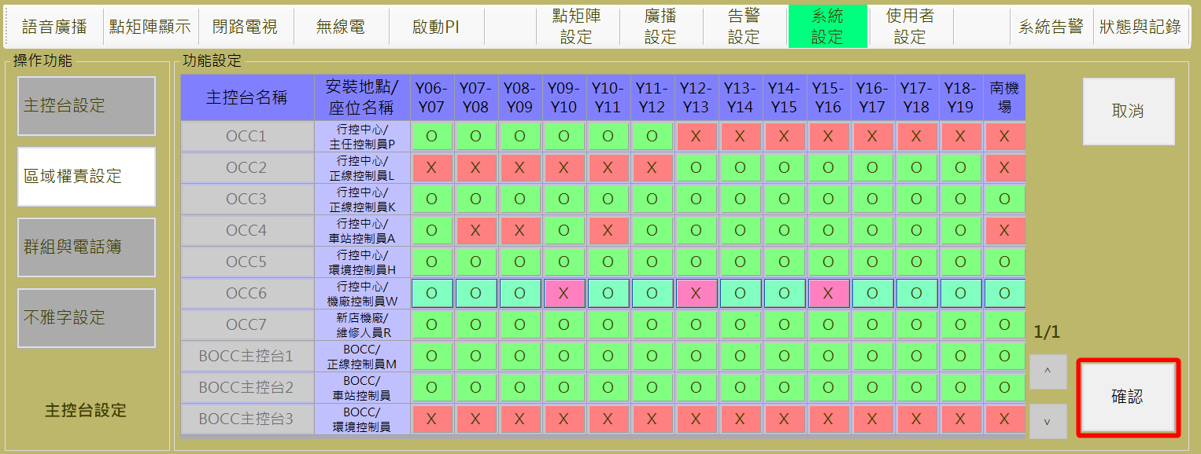

圖 4‑24: 區域權責編輯模式

Figure 4‑24: Edit Mode of Regional authority and responsibilities

#### 群組與電話簿設定 Group and DLT Book Setting

群組與電話簿設定作業含**車站群組**設定、**列車群組**設定、**無線電群組**設定、**直線電話簿**及**攝影機群組**設定五個作業項目。

Group and DLT Book Setting assignment includes **Station Group** Setting, **Train Group** Setting, **TETRA Group** Setting, **DLT Book** Setting and **Camera Group** Setting 5 items.

##### 車站群組設定 Station Group Setting

車站群組設定主要是建立/管理車站群組的處理作業。點選群組名稱內的表格，將於橘色區塊顯示該群組設定的車站，如圖 4‑25，轉運車站群組定義的車站為Y6、Y10、Y15、Y19。

Station group settings are mainly to establish / manage station group processing operations. Click the table in the group name, the station set in this group will be displayed in the orange area, as shown in Figure 4‑25.. The stations defined by the transfer station group are Y6, Y10, Y15 and Y19.

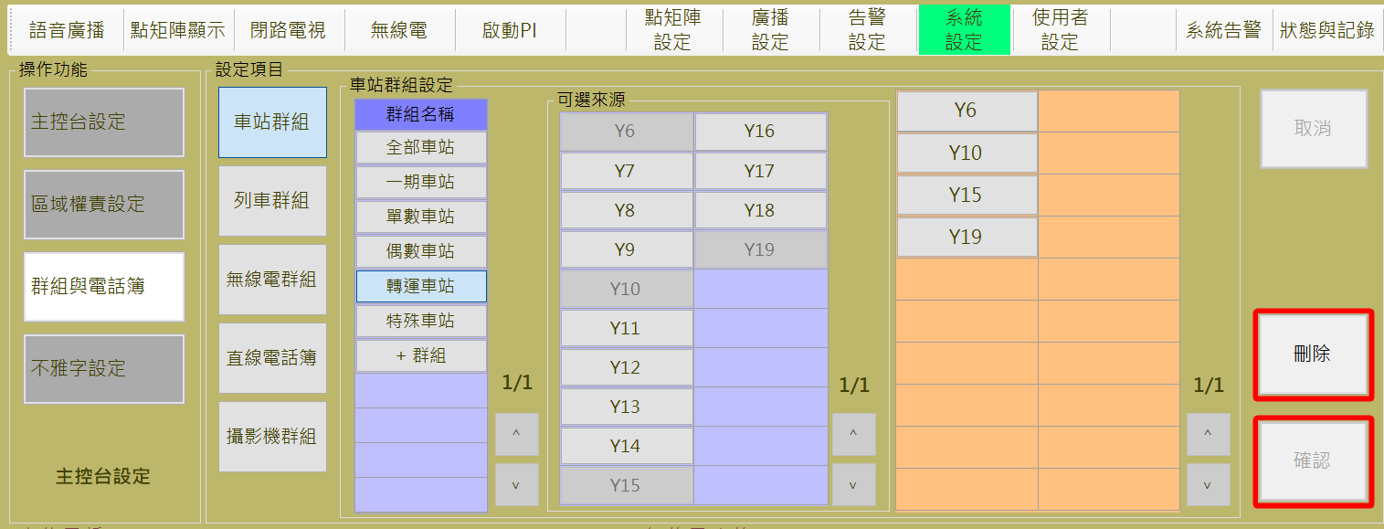

圖 4‑25: 車站群組顯示

Figure 4‑25: Station Group Display

1. **新增群組**：操作人員可透過**車站群組設定**區塊內的**群組名稱**欄位下方的 “**+群組**” 按鈕來建立新的車站群組並選取可用條件 (車站) 以建立新群組內容，如圖 4‑26。
2. **編修群組：**直接選取**群組名稱**欄位下方的既有車站群組，點選”**可選來源”**的紫色區域車站新增群組成員，或者點選橘色區域車站移除群組成員。
3. **儲存：**”**確認**” 按鈕是用來儲存新增或修改的群組資料。
4. **取消：**”**取消**” 按鈕則是復原設定值。
5. **刪除：**”**刪除**” 按鈕則是用來刪除**群組名稱**表格中點選到的群組。
6. **New Group**：Operator can use the “**+群組**(**Add Group**) “ button at the “**群組名稱**(**Group Name**) “ field in “**車站群組設定**(**Station Group Setting**) “ block to establish a new station group, as shown in Figure 4‑26.
7. **Adjust Group Members**：Select the group of existing stations group directly below the “**群組名稱(Group Name)**” field, click the station of “**可選來源(Optional source)** “at purple area to new a group member, or click the station at orange area to remove the group members.
8. **SAVE**：”**確認**(**Confirm**)”button can store the new group or edited data.
9. **Canel**：”**取消**(**Cancel**)”button can recover the original Setting value.
10. **Delete**：”**刪除**(**Delete**)”button is used to delete the group clicked at the “**群組名稱(Group Name)**” filed.

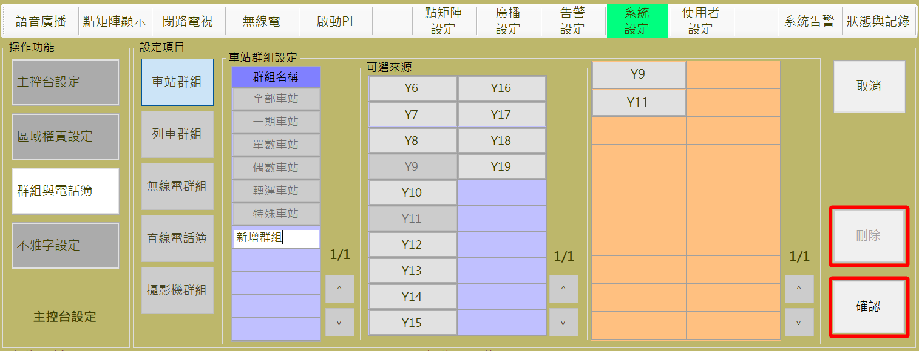

圖 4‑26: 車站群組設定作業

Figure 4‑26: Station Group Setting function

##### 列車群組設定 Train Group Setting

列車群組設定主要是建立/管理列車群組的處理作業。點選**群組名稱**內的表格，將於橘色區塊顯示該群組設定的列車條件，如圖 4‑27，營運列車群組定義的動態列車條件為通電中列車。

Train group settings are mainly to establish / manage train group processing operations. Click the table in the group name, the Dynamic Train Condition set in this group will be displayed in the orange area, as shown in Figure 4‑27. The dynamic train condition defined by the operation train group is the train that is power-on.

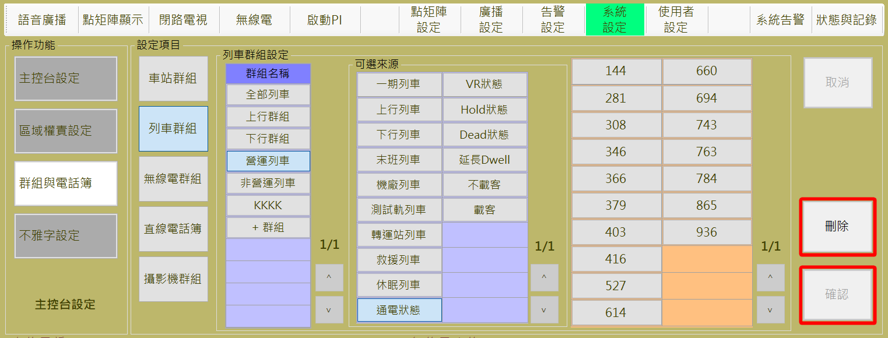

圖 4‑27: 列車群組顯示

Figure 4‑27: Train Group Display

1. **新增群組**：操作人員可透過**列車群組設定**區塊內的**群組名稱**欄位下方的 “**+群組**” 按鈕來建立新的車站群組並選取”**可選來源”**的列車條件以建立新群組內容，如圖 4‑28。
2. **編修群組：**直接選取**群組名稱**欄位下方的既有車站群組，點選”**可選來源”**的紫色區域列車條件新增群組條件，或者點選橘色區域車站移除群組條件。
3. **儲存：**”**確認**” 按鈕是用來儲存新增或修改的群組資料。
4. **取消：**”**取消**” 按鈕則是復原設定值。
5. **刪除：**”**刪除**” 按鈕則是用來刪除**群組名稱**表格中點選到的群組。
6. **New Group：**Operator can use the “+群組(Add Group)”button at the “群組名稱 (Group Name)” field in “車站群組設定(Train Group Setting) “ block to establish a new train group, as shown in Figure 4‑28.
7. **Adjust Group Members**：Select the group of existing train group directly below the **Group Name** field, click the train condition of “**可選來源(Optional source)** “at purple area to new a group condition, or click the train condition at orange area to remove the group condition.
8. **SAVE**：”**確認**(Confirm)”button can store the new group or edited data.
9. **Cancel**：”**取消**(Cancel)”button can recover the original Setting value.
10. **Delete**：”**刪除**(**Delete**)”button is used to delete the group clicked at the “**群組名稱(Group Name)**” filed.

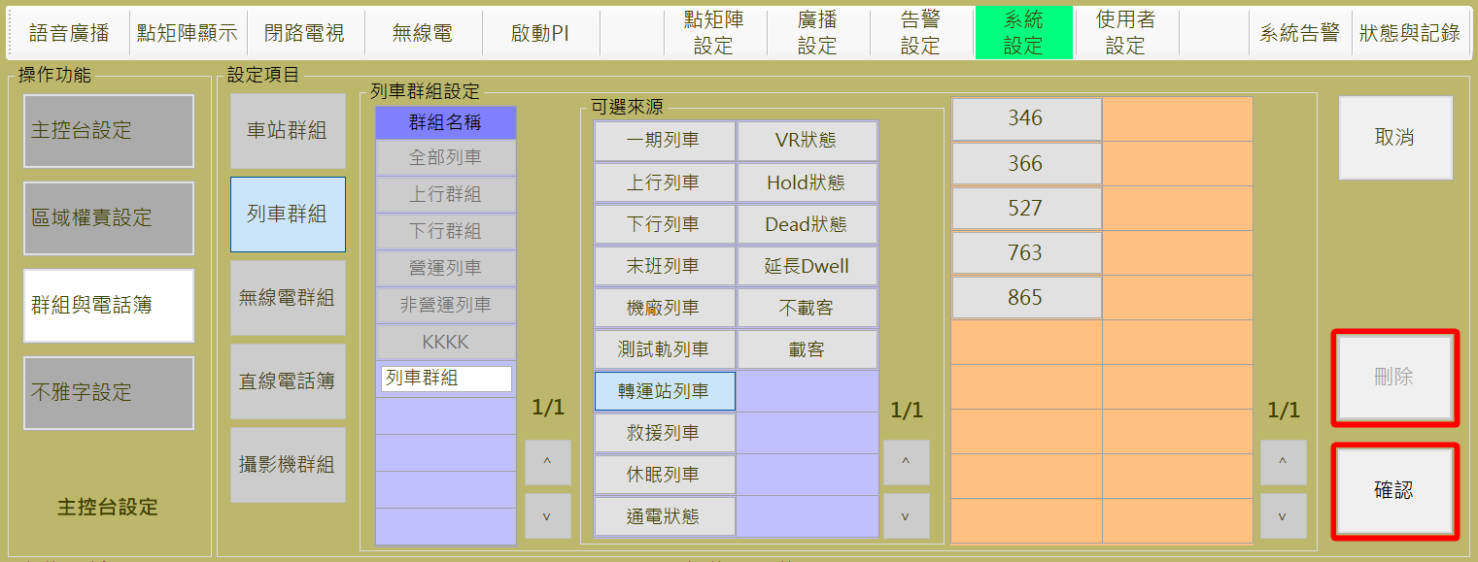

圖 4‑28: 列車群組設定作業

Figure 4‑28: Train Group Setting

##### 無線電群組設定 TETRA Group Setting

無線電群組設定主要是建立/管理無線電群組的處理作業。點選群組名稱內的表格，將於橘色區塊顯示該群組設定的無線電，如圖 4‑29，主任群組定義的無線電為104991、104992、161005、161006。

The Tetra setting is mainly to set up / manage the processing work of the Tetra Group. Click the table in the group name, the Tetra number set in this group will be displayed in the orange area, as shown in Figure 4‑29. The Tetra number defined by the master tetra group are 104991、104992、161005、161006.

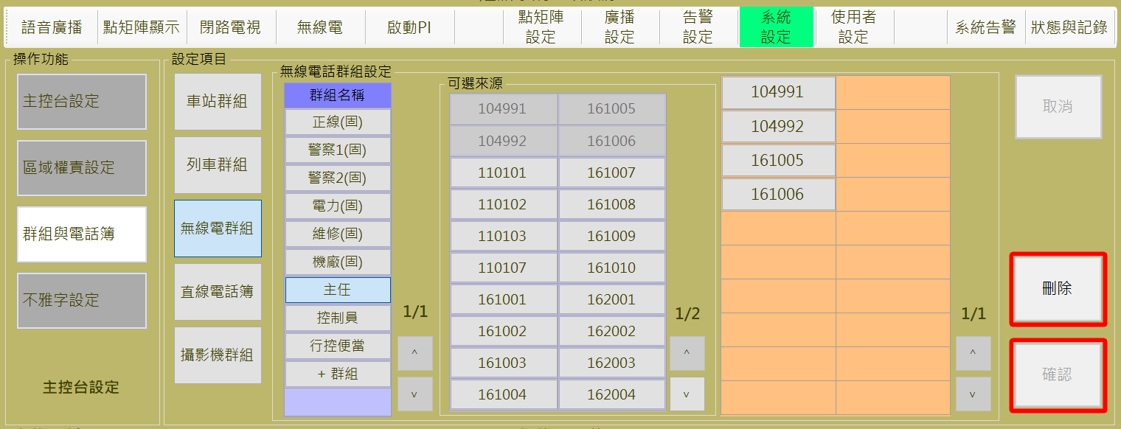

圖 4‑29: 無線電群組顯示

Figure 4‑29: TETRA Group Display

1. **新增群組**：操作人員可透過**無線電群組設定**區塊內的**群組名稱**欄位下方的 “**+群組**” 按鈕來建立新的車站群組並選取可用條件 (車站) 以建立新群組內容，如 圖 4‑30。
2. **編修群組：**直接選取**群組名稱**欄位下方的既有無線電群組，點選”**可選來源”**的紫色區域無線電新增群組成員，或者點選橘色區域無線電移除群組成員。
3. **儲存：**”**確認**” 按鈕是用來儲存新增或修改的群組資料。
4. **取消：**”**取消**” 按鈕則是復原設定值。
5. **刪除：**”**刪除**” 按鈕則是用來刪除**群組名稱**表格中點選到的群組。
6. **New Group**：Operator can use the “**+群組**(**Add Group)** “ button at the “**群組名稱(Group Name)** “ field in “**無線電群組設定**(**Tetra Group Setting**) “ block to establish a new tetra group, as shown in Figure 4‑30.
7. **Adjust Group Members**：Select the group of existing tetra group directly below the **Group Name** field, click the tetra number of “**可選來源(Optional source)** “at purple area to new a group member, or click the tetra number at orange area to remove the group members.
8. **SAVE**：”**確認**(**Confirm**)”button can store the new group or edited data.
9. **Cancel**：”**取消**(**Cancel**)”button can recover the original Setting value.
10. **Delete**：”**刪除**(**Delete**)”button is used to delete the group clicked at the “**群組名稱(Group Name)**” filed.

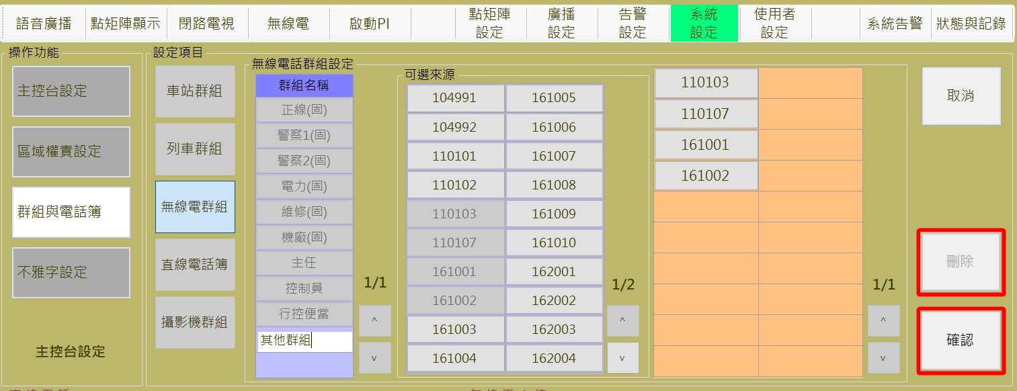

圖 4‑30: 無線電群組新增群組作業

Figure 4‑30: New a TETRA Group

##### 直線電話簿設定 DLT Book Setting

直線電話簿設定主要是建立/管理 車站/機廠直線電話的處理作業。點選直線電話部內的地點，將於”**群組成員**”區塊顯示該區域設定的電話與顯示名稱，如圖 4‑31，橋和(Y12)紀錄的電話為7791與23612的顯示名稱。

DLT phone book setting is mainly to establish / manage the station / depot DLT data processing operations. Click the spot in the DLT Book, the DLT number set in this group will be displayed in the “**群組成員(Group Member)**” area, as shown in Figure 4‑31. The DLT numbers defined by the 橋和(Y12) are the defined description of 7791and 23612 .

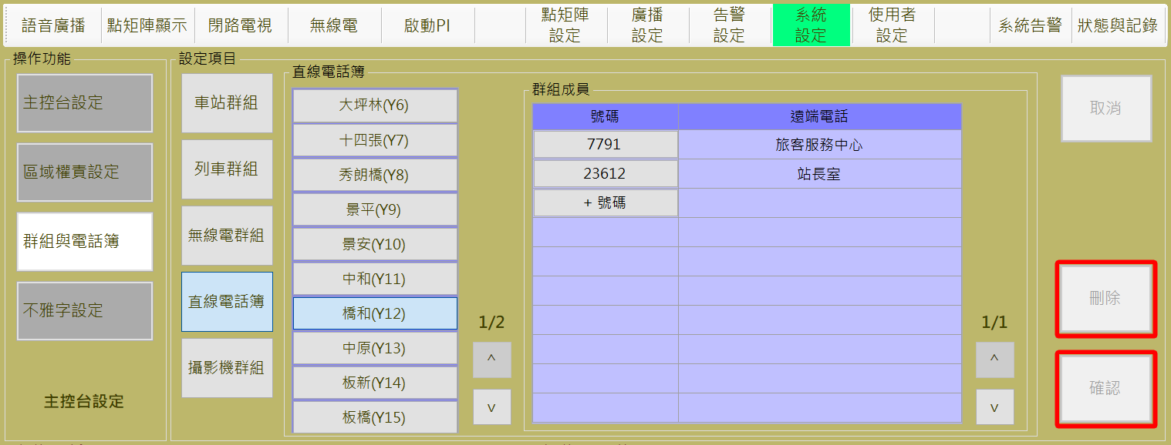

圖 4‑31: 直線電話簿顯示

Figure 4‑31: DLT Book Display

1. **新增電話號碼**：操作人員選擇某一地點後，透過**群組成員**區塊內的**號碼**欄位下方的”**+號碼**”按鈕來建立新的直線電話位置，如圖 4‑32。
2. **修改電話資料：**操作人員選擇某一地點後，透過**群組成員**區塊內的**號碼**欄位選取欲修改的電話進行編輯，同一支電話不能存在兩個地點。
3. **儲存：**”**確認**” 按鈕是用來儲存新增或修改的直線電話資料。
4. **取消：**”**取消**” 按鈕則是復原設定值。
5. **刪除：**”**刪除**” 按鈕則是用來刪除全組名稱表格中點選到的群組。
6. **New DLT Number**：Operator select a spot first, then use the “**+號碼**(**Add Number)** “ button at the “**號碼(Member)** “ field in “**群組成員(Group Member)** “ block to establish a new DLT member, as shown in Figure 4‑32.
7. **Adjust DLT data**：Operator select a spot first, then use the number button at the “**號碼(Member)** “ field in “**群組成員(Group Member)** “ block to adjust the DLT data.
8. **SAVE**：”**確認**(**Confirm**)”button can store the new DLT number or edited data.
9. **Cancel**：”**取消**(**Cancel**)”button can recover the original Setting value.
10. **Delete**：”**刪除**(**Delete**)”button is used to DLT row data clicked at the “**號碼(Member)** “ filed.

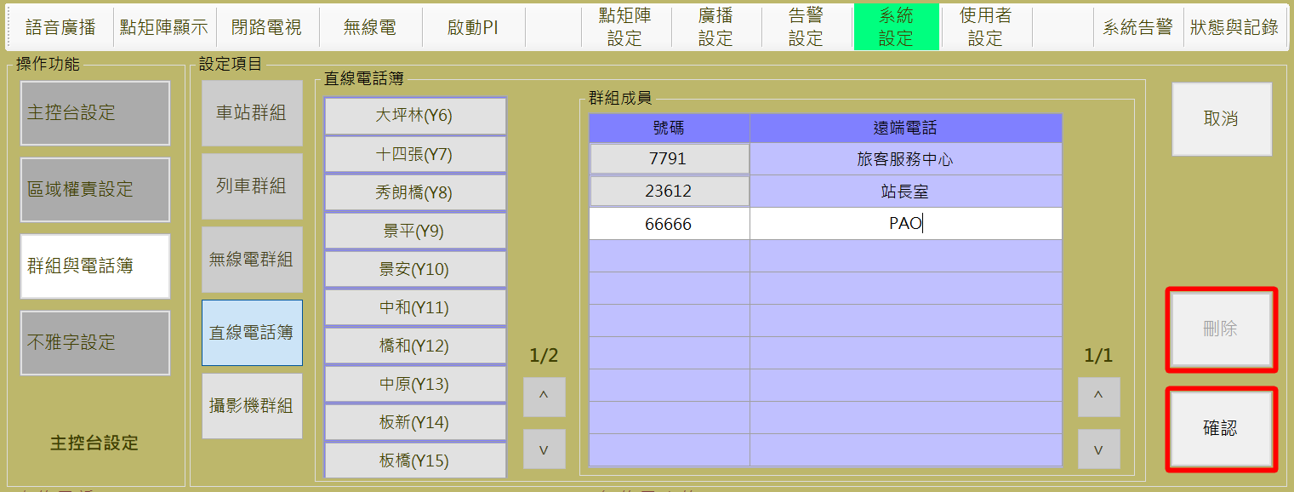

圖 4‑32: 直線電話簿設定作業

Figure 4‑32: DLT Book Setting

##### 攝影機群組設定 Cameras Group Setting

攝影機群組設定主要是建立/管理 電視牆的攝影機輪播群組樣本的設定作業。點選群組名稱內的表格，將於橘色區塊顯示該群組設定的無線電，如圖 4‑33，夜間種店定義的攝影機為圖中四個Y19站攝影機。

Camera Group Setting assignment is used to build/manage the specified CCTV samples playback and turns on the TV-Wall. Click the table in the group name, the Camera set in this group will be displayed in the orange area, as shown inFigure 4‑33. The 4 Cameras defined by the Night group are Settled at Y19.

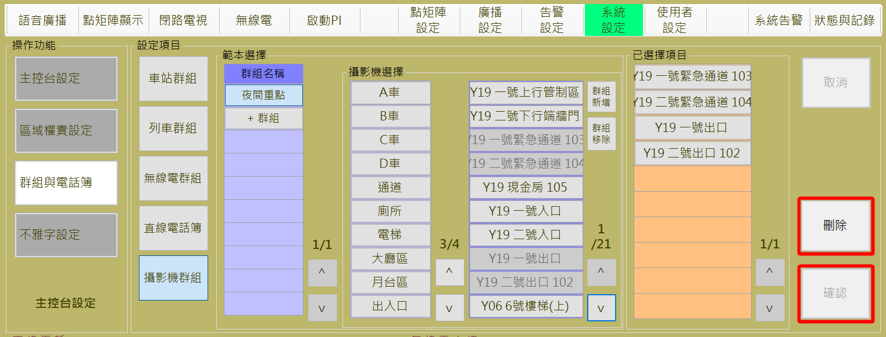

圖 4‑33: 攝影機群組顯示

Figure 4‑33: Camera Group Display

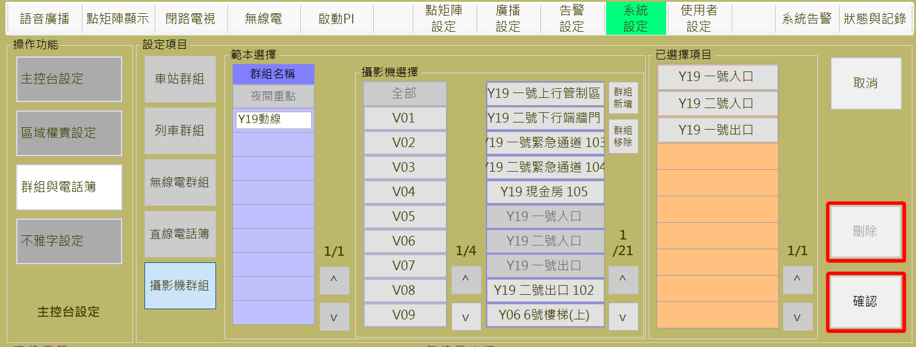

1. 圖 4‑34。
2. **編修群組：**直接選取**群組名稱**欄位下方的既有範本群組，點選”**攝影機選擇”**的紫色區域攝影機新增範本攝影機，或者點選橘色區域攝影機移除範本攝影機。其中攝影機選擇部分包含車站和列車的攝影機，因攝影機數量龐大，利用車站、列車，所在區域位置以及車廂等屬性分類，提供操作者達成快速篩選作業 。
3. **儲存：**”**確認**” 按鈕是用來儲存新增或修改的群組資料。
4. **取消：**”**取消**” 按鈕則是復原設定值。
5. **刪除：**”**刪除**” 按鈕則是用來刪除**群組名稱**表格中點選到的群組。
6. **New Group**：Operator can use the “**+群組(Add Group)**”button at the **“群組名稱 (Group Name)**” field in “**範本選擇( Sample Select)** “ block to establish a new sample group, as shown in Figure 4‑34.
7. **Adjust Group Members**：Select the group of existing sample group directly below the **Group Name** field, click the camera of “**攝影機選擇(Optional Camera)** “at purple area to new a camera member, or click the camera at orange area to remove the member. The camera selection section includes cameras for stations and trains. Due to the large number of cameras, all cameras could be classificated by stations, trains, location of the area, carriages.To provide the operator with a quick screening operation.
8. **SAVE**：”**確認**(Confirm)”button can store the new group or edited data.
9. **Cancel**：”**取消**(Cancel)”button can recover the original Setting value.
10. **Delete**：”**刪除**(**Delete**)”button is used to delete the group clicked at the “**群組名稱(Group Name)**” filed.



圖 4‑34: 攝影機群組設定作業

Figure 4‑34: Camera Group Setting

#### 不雅字設定Indecent Words Setting

不雅字設定主要是建立/管理DMD顯示內容的不雅字句排除項目的設定作業 (如 圖 4‑35)。

Indecent Words Setting assignment is used to build/manage the denied words which can not show on the DMD. (as Figure 4‑35).

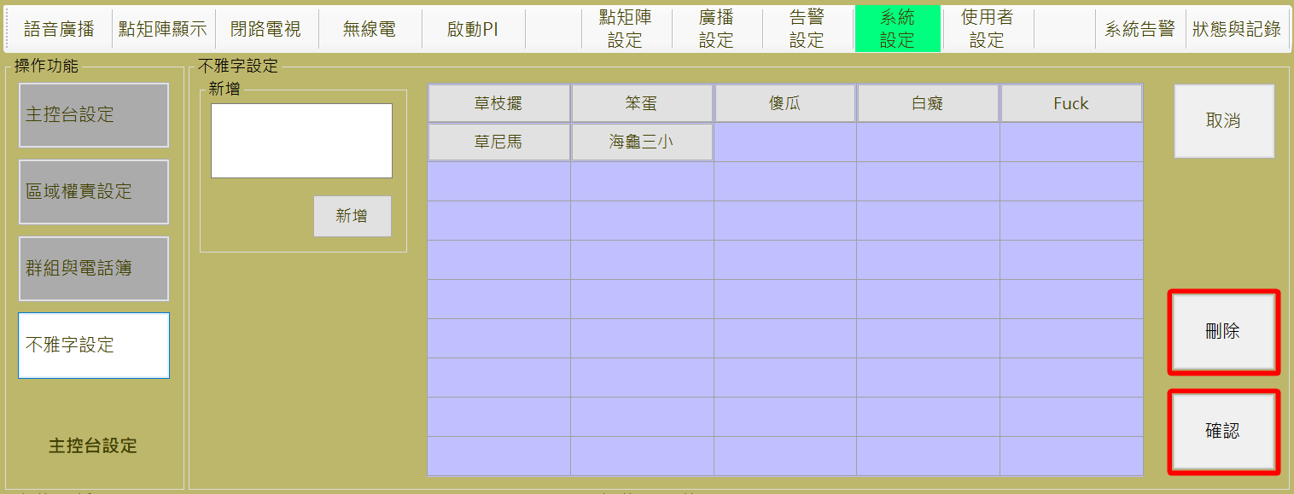

圖 4‑35: 不雅字新增作業

Figure 4‑35:New an Incent Words

1. **新增**：操作人員可透過**新增**區塊建立新的排除字句，如 圖 4‑35
2. **編輯：**如果要修改特定項目，直接點選該項目即可，如 圖 4‑36。
3. **儲存：**”**確認**” 按鈕是用來儲存新增或修改的群組資料。
4. **取消：**”**取消**” 按鈕則是復原設定值。
5. **刪除：**”**刪除**” 按鈕則是用來刪除點選到不雅字。
6. **New Group**：Operator can build a new words from the “**新增**” (Add New) block, as Figure 4‑35.
7. **Edit**：Edit specified item(s), just click the item(s) and edit, as Figure 4‑36.
8. **SAVE**：”**確認**(**Confirm**)”button can store the new word or edited data.
9. **Cancel**：”**取消**(**Cancel**)”button can recover the original Setting value.
10. **Delete**：”**刪除**(**Delete**)”button is used to delete the clicked item(s).

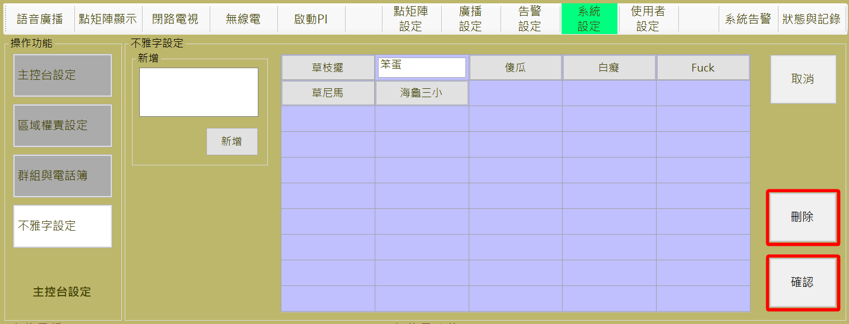

圖 4‑36: 不雅字修改作業

Figure 4‑36: Incent Words Edit

### 主控台狀態與記錄操作Console status and Logs monitoring

本章節含主控台狀態顯示及操作記錄查詢兩個次功能.

This chapter has two partition including status of Consoles and operation log information.

#### 主控台狀態資訊查詢Console Status Information Query

進入本作業畫面預設為**主控台狀態**資料頁 (如圖 4‑37)；表格內容會顯示各主控台名稱、席位名稱、目前操作人員資訊、監看電視牆號碼、DLT通話號碼、無線電手機通訊、列車通訊與車站廣播的狀態。

The default display page in this function is about **Console Status Information** (as Figure 4‑37). The contents of the table will display the each console name and seat name, current operator information, number of monitoring TV-wall, DLT calling numbers, tetra communication, OTC communication and station broadcasting status.

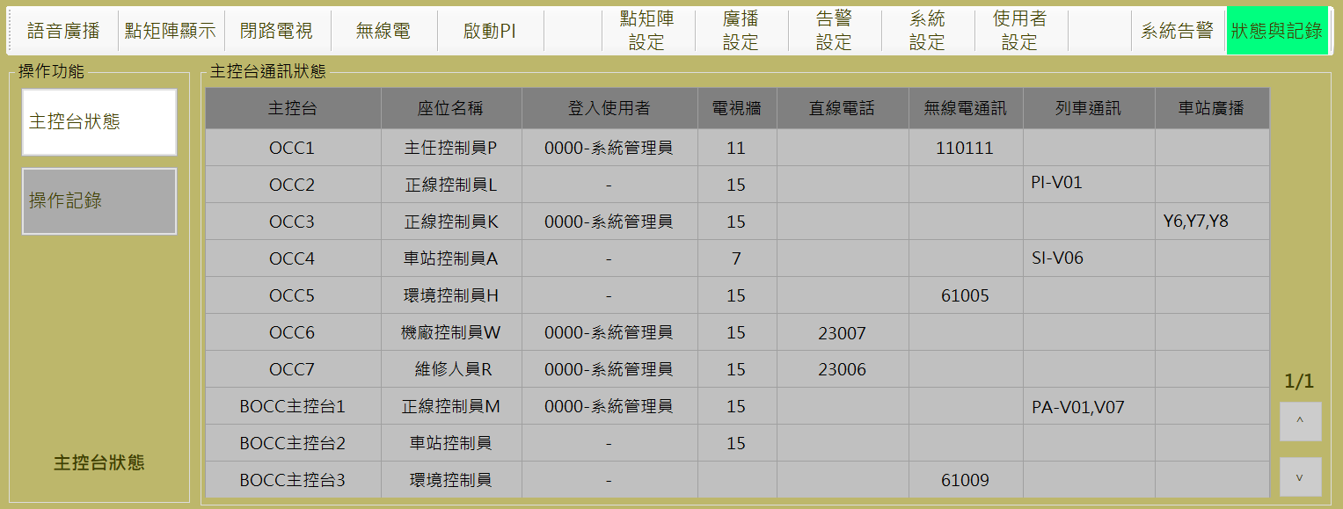

圖 4‑37: 主控台狀態資訊顯示

Figure 4‑37: Console status information display

1. 主控台：每個多功能通訊主控台設定的名稱。
2. 座位名稱：每個多功能通訊主控台定義的席位名稱。
3. 登入使用者：目前或者最後登入的使用者資訊。
4. 電視牆：監控螢幕正在播放的電視牆號碼。
5. 直線電話：目前正和席位通話的直線電話號碼。
6. 無線電通訊：目前正和席位通話的無線電號碼。
7. 列車通訊：該席位正在進行的列車通訊資訊，顯示為『通訊類型-目標列車號碼』，其中PI為乘客緊急對講機，SI為司機員對講機，以及PA表示目前正在對該列車廣播。
8. 車站廣播：若目前席位正在進行車站廣播，將會顯示廣播目標。
9. Console：The name of each CMFT Console.
10. Seat name： the name of responsibility attribution seat.
11. Login User：Current or Last Login User Information.
12. TV-Wall：The Number of corresponding TV-Wall
13. DLT：The Number of the Call online of DLT
14. Tetra ： The Number of the Call online of Tetra.
15. OTC：The Information about the PI/SI/PA communication of Train.
16. PA：The aims of the Broadcast of Stations

#### 系統操作記錄查詢與匯出System Operation Log Information Query And Export

操作人員可以看下『操作紀錄』按鈕(如下紅圓框)，切換為顯示**操作記錄資訊**資料頁面 (如圖 4‑38)

The operator can press the “Operation Record” button (the red circle below) to switch to the operation log information page (as Figure 4‑38).

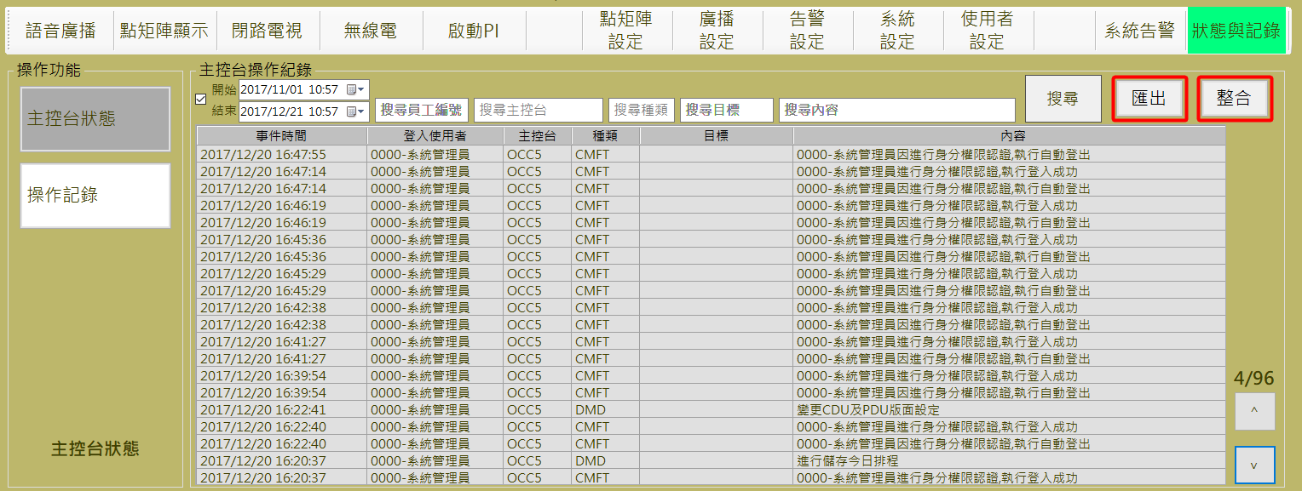

圖 4‑38: 主控台操作記錄顯示

Figure 4‑38: Console operation logs display

1. **搜尋：**操作人員可以輸入查詢條件後按下”**搜尋**”按鈕進行特定記錄查詢。系統提供依**時間區間**、**操作人員**、**主控台名稱**、**子系統種類**、**目標**及**作業內容**為查詢條件進行資料查詢。
2. **匯出：**操作人員可以按下 “**匯出**” 按鈕進行頁面資料匯出並轉存為 csv格式的檔案，以利後續資料處理。
3. **整合：**操作人員可以按下 “**整合**” 按鈕，將主控台操作紀錄與告警紀錄根據目前的搜尋條件進行整合後，轉存為 csv格式的檔案，以利後續資料處理。
4. **Search** ：The operator can input the query conditions and press the “**搜尋(**Search)” button for a specific record query. The system provides the query conditions according to the **Time Interval, Operator, Console Name, Subsystem Type, Target and Content**.
5. **Export** ： Operator can export the logs to csv type file through click the “**匯出**” (Export) button.
6. **Integrate** ： Operator can Integrate between operation log and alarm log, then export the integrated data and transfer to csv type file for the continuous process through click the “**整合**” (Integrate) button.

### 告警設定Alarm Setting

本作業含**告警等級定義**設定及**告警類型定義**設定兩個功能

This function include **alarm level define** and **alarm type define** two sub-functions

#### 告警等級定義Alarm Display Definition

告警等級定義作業主要是提供操作人員依其習慣調整不同等級的警報顯示方式 CMFT系統定義5種層級的警報，每種等級皆可設定其報警警示方式，如圖 4‑39，確認需求：該等級事件發生後是否須進行確認需求。

1. 告警顏色：CMFT系統總共提供五種顏色以供應警示表顯示的字體顏色，以及若該告警資訊中有相對車站位置，該車站按鈕閃爍顏色，如圖 4‑40。
2. 告警聲音：CMFT系統總共提供五種音效檔以供應警報響聲。
3. 閃爍：該等級警報資訊若有相對車站位置，該車站按鈕將會進行閃爍，直到該項報警由操作人員進行確認
4. 傳送至SCADA：該告警等級不進行傳送至SCADA功能。

Alarm Display Definition Setting assignment is mainly to provide operators according to their habits to adjust different levels of alarm display CMFT system defines five levels of alarm, each level can be set alarm severity, as shown in Figure 4‑39.

Confirm the demand: the level of events after the occurrence of whether there is a need to confirm.

1. Alarm Color: A total of five colors are provided by the CMFT system to supply the font color displayed at the alarm list, and if there is a relative station position in the alarm information, the station button blinks in color, as shown in Figure 4‑40.
2. Audible alarm sound: The CMFT system provides a total of five sound effects to supply the alarm sound.
3. Blinking: If the level alarm information relative to the station location, the station button will flash until the alarm is confirmed by the operator
4. Sent to SCADA: This alarm level is not sent to the SCADA function.

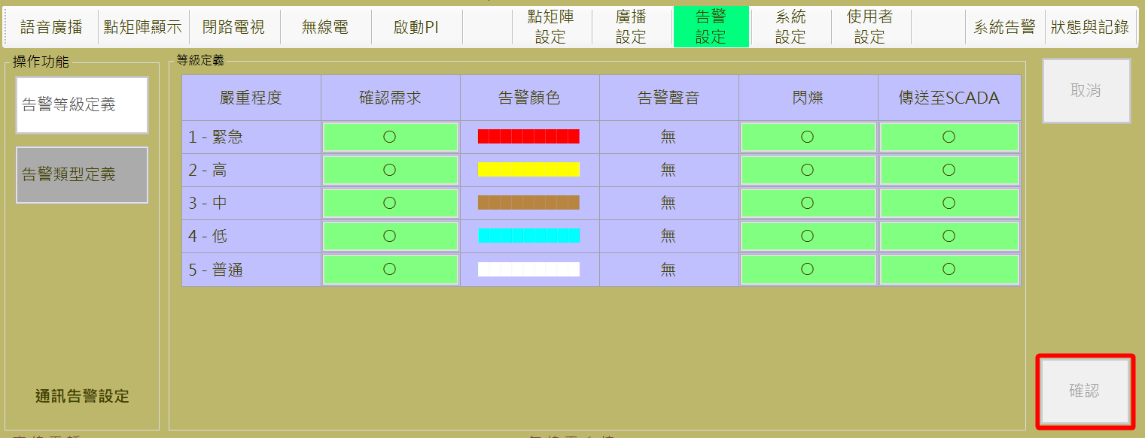

圖 4‑39: 告警等級定義設定作業

Figure 4‑39: Alarm Level Define Setting assignment

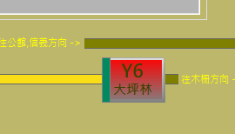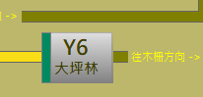

圖 4‑40: 車站相關告警閃爍示意圖

Figure 4‑40: Station-related alarm flashing schematic

1. 編輯告警等級定義資訊：
2. **編輯**：透過按下欲修改項目，該列將會進入編輯模式，可以進行相關資訊修改。
3. **儲存**：”**確認**” 按鈕是用來儲存設定值。
4. **取消：** “**取消**” 按鈕則是復原設定值。
5. To edit Alarm Display Definition information：
6. **Edit**：press the system code you want to modify the console, the cell will be modified
7. **Save**：Press “**確認**(Confirm) “ button can store the Setting result.
8. **Cancel**：”**取消**” (Cancel) button can recover the original Setting value.

#### 告警類型定義Alarm Level Definition

告警類型定義設定作業主要是提供操作人員為相關次系統設備所發出的警報，定義其警報等級，使觸發相對應的警示方式 (如圖 4‑41)。CMFT系統目前定義的所有告警資訊表如附件四。

Alarm Level Definition Setting assignment is used for operator to define the alarm level for each controlled sub-system equipment, so that the triggering corresponding warning mode (as Figure 4‑41). All alarm information tables currently defined by the CMFT system are shown in Annex III.

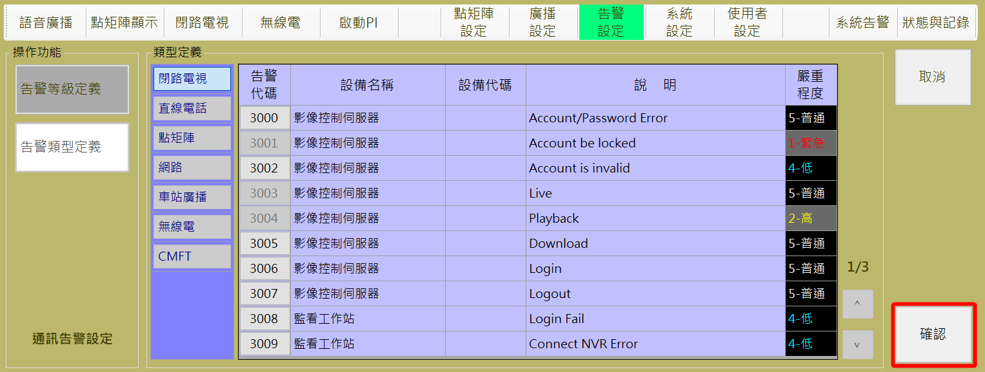

圖 4‑41: 告警類型定義設定作業

Figure 4‑41: Alarm Level Define Setting assignment

警報類型依本系統定義為固定項目，操作人員可選取**類型定義**區塊內第一行的項目以取得相關設備資訊，為其設定/變更警報等級。”**確認**” 按鈕是用來儲存設定值；”**取消**” 按鈕則是復原設定值。

There are fixed items for alarm type in CMFT system. Operator should choose alarm type at the the 1PPPPstPPPP column in “**類型定義**” (Type Define) block to get all the equipment information and setup/change the alarm level for specified one. “**確認**” (Confirm) button can store the Setting result. “**取消**” (Cancel) button can recover the original Setting value.

1. 編輯告警類型定義資訊：
2. **編輯**：透過按下欲修改列第一欄-**告警代碼**按鈕，該列將會進入編輯模式，如圖 4‑41，其最後一欄**嚴重程度**反灰即表示與目前設定不同，其中顏色反應為目前各等級定義的顯示顏色。
3. **儲存**：”**確認**” 按鈕是用來儲存設定值。
4. **取消：** “**取消**” 按鈕則是復原設定值。
5. To edit console information：
6. **Edit：**Press the column you want to modify the first column - alarm code (**告警代碼**) button, the column will enter the edit mode, as shown in Figure 4-34, the last column-Alarm Level(**嚴重程度)** become the gray background color, that is mean different from the current settings, in which the font color reaction is defined for the current level Display color
7. **Save**：Press “**確認**(Confirm) “ button can store the Setting result.
8. **Cancel**：”**取消**” (Cancel) button can recover the original Setting value.

### 系統告警System Alarm Logs monitoring

本作業主要是提供主控台人員查看系統警報處理狀況並進行必要的處理及回應 (如圖 4‑42)。進入本功能頁面，系統預設是調取當日所有的告警記錄。

This function is used to monitor system alarm logs and do the necessary process. (as Figure 4‑42). Enter this page, the system default is to recall all alarm records on the day.

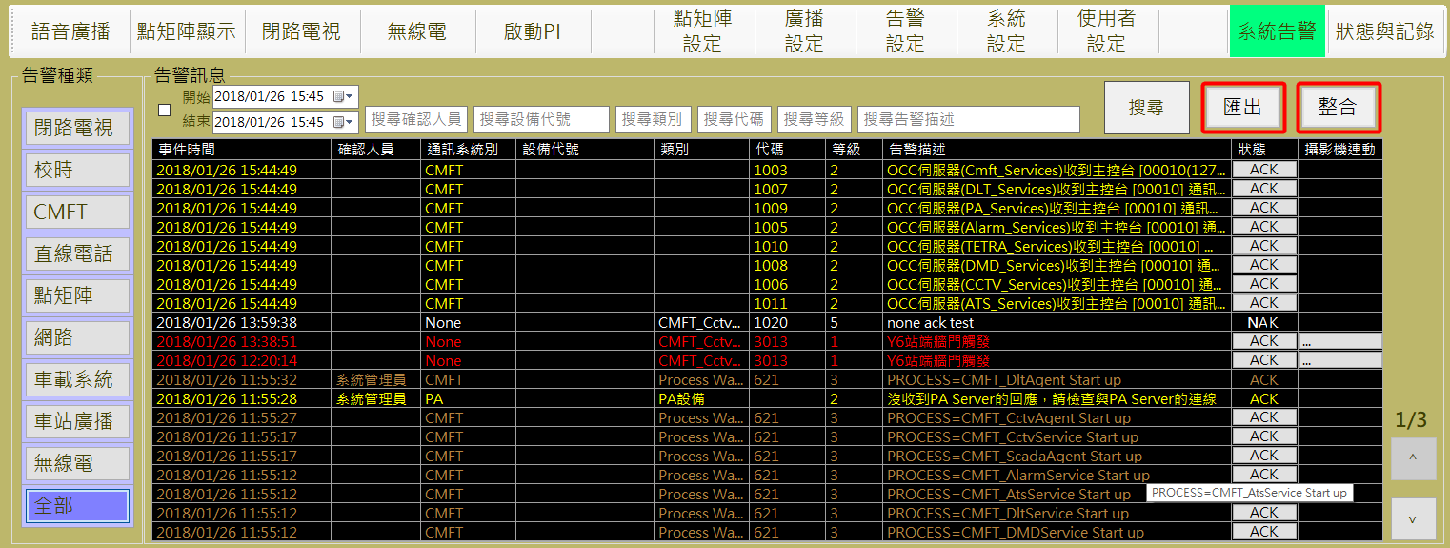

圖 4‑42: 警報記錄查詢處理作業

Figure 4‑42: Alarm Logs monitor and process mode

1. 操作人員可以透過左方列出的告警種類列表，或者上方的搜尋條件輸入框，進行告警資料搜尋、匯出與操作紀錄整合等功能。
2. **告警種類**：操作人員可以透過按下告警種類列表直接指定查詢特定子系統警報記錄。
3. **搜尋：**操作人員可以輸入查詢條件後按下”**搜尋**”按鈕進行特定記錄查詢。系統提供依**時間區間**、**操作人員**、**主控台名稱**、**子系統種類**、**目標**及**作業內容**為查詢條件進行資料查詢。
4. **匯出：**操作人員可以按下 “**匯出**” 按鈕進行頁面資料匯出並轉存為 csv格式的檔案，以利後續資料處理。
5. **整合：**操作人員可以按下 “**整合**” 按鈕，將主控台操作紀錄與告警紀錄根據目前的搜尋條件進行整合後，轉存為 csv格式的檔案，以利後續資料處理。
6. Operators can directly query and record specific alarm records through the list of alarm types listed on the left or the conditional query input on the top.
7. Subsystem：Operators can also directly query certain subsystem alarm records through the list of alarm types listed on the left.
8. **Search**：The operator can input the query conditions and press the “**搜尋(**Search)” button for a specific record query. The system provides the query conditions according to the **Time Interval, Operator, Console Name, Subsystem Type, Target and Content**.
9. **Export：**Operator can export the logs to csv type file through click the “**匯出**” (Export) button.
10. **Integrate**：Operator can Integrate between operation log and alarm log, then export the integrated data and transfer to csv type file for the continuous process through click the “**整合**” (Integrate) button.
11. 主控台人員可以由表格中『狀態』一欄，進行該警報處理機制：
12. **ACK按鈕**：表示尚未處理的報警事件。
13. **一般文字ACK**：表示操作員已處理的報警事件，並且於『確認人員』欄位註記進行確認人員的操作員資訊。
14. **一般文字NAK**：表示不需要操作員進行確認動作。
15. Console staff can be in the form of “status” column, the alarm handling mechanism：
16. **ACK button**: Indicates an unhandled alarm event.
17. **General text ACK**: Indicates the alarm event that the operator has processed, and annotates the operator information for confirming personnel in the “確認人員(Confirm personnel)” field.
18. **The general text NAK** : Indicates that no operator is required to confirm the alarm.
19. 當告警事件來自於消防主機，將會啟動”攝影機連動”一欄，若操作員按下按鈕，會將該告警相關攝影機投放到主畫面右下角指定且非15與16號的電視牆上，若右下角的電視牆為15或16號，則會跳出警示視窗，不能進行攝影機連動功能，若針對同一個電視牆按下多個攝影機連動按鈕，則會在指定的電視牆上累加相關的攝影機清單並且以輪播方式進行。
20. When the alarm event comes from the Fire Engine Server, the “(攝影機連動)Camera Linkage” column will be activated. If the operator presses the button, the video of cameras those are related the alarm will be projected to the wall specified in the lower right corner of the main screen, except 15 and 16. If the lower right corner of the TV-Wall is 15 or 16, it will pop up warning window, and interrupt the camera-link function. Besides, the same TV-Wall to press multiple camera linkage button at the TV-Wall, then the cameras related each event will accumulate in camera list of the the specified TV-Wall ,and all cameras list will be carousel.

### 廣播設定 Public Address Setting

本作業含**預錄語音、語音排程、播放設備**及**廣播時段調整**四個功能

This function include **Pre-Recorded Audio, Broadcast Schedule Setting, Broadcast Equipment Assign** and **BROADCAST PARTITION SETTING** four sub-functions

#### 預錄語音 Pre-recorded Audio

預錄語音設定作業主要是提供操作人員與此畫面編輯語音檔提示內容，以及歸屬該語音檔的群組設定 (如圖 4‑46)，於播放時可以節省選取檔案時間。

##### 列車上使用之預錄語音 Pre-recorded Audio on the Train

所有列車上之語音音檔皆不會儲存於CMFT系統，CMFT系統只透過語音清單列表(xml檔案)進行可選取的音檔ID同步，並且提供畫面顯示xml中音檔提示內容。

All audio files on the train will not be stored in the CMFT system. The CMFT system only allows the synchronization of the

optional audio files through the xml file list, and provides the display of the audio contents in xml.

每次進行列表更新時，必須到機房將最新版本的列車語音清單xml檔案透過CMFT Server軟體進行匯入，如圖 4‑44。匯入xml檔案後，還需透過更新語音清單按鈕，將相關服務重新啟動，如圖 4‑45。

For update, operator must import the latest version of the train xml file list through the CMFT Server software, as shown in Figure 4‑44.After importing the xml file, but also need to click the update button to restart the relevent service to update the list, as shown in Figure 4‑45.

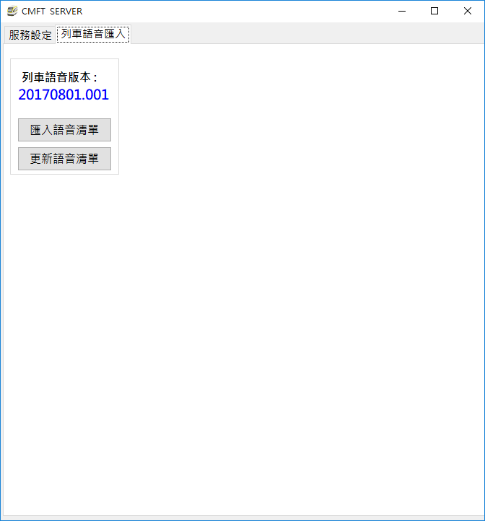

圖 4‑43: CMFT伺服器上預錄語音清單設定作業(列車)

Figure 4‑43: Pre-recorded Audio List Setting assignment on CMFT Server (Train)

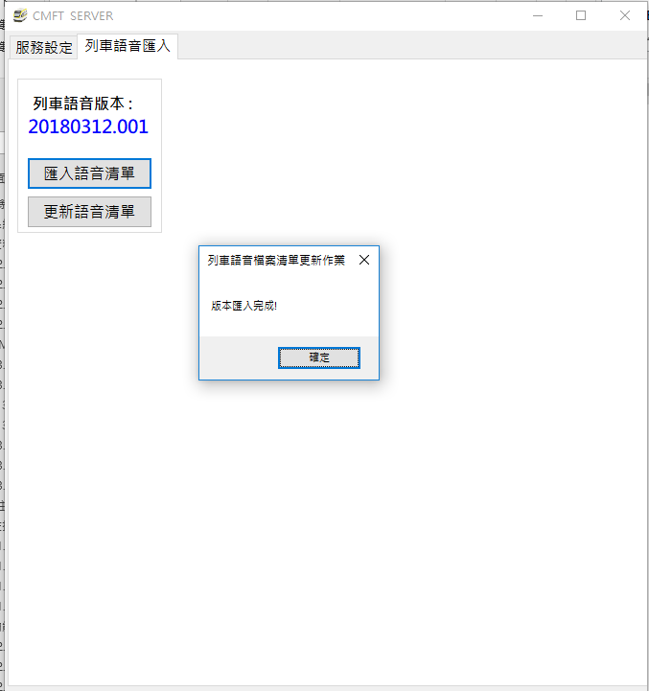

圖 4‑44: CMFT伺服器上列車預錄語音清單檔案匯入完成示意圖

Figure 4‑44: Import Pre-recorded Audio List for Train on CMFT Server Sucessfully Diagram

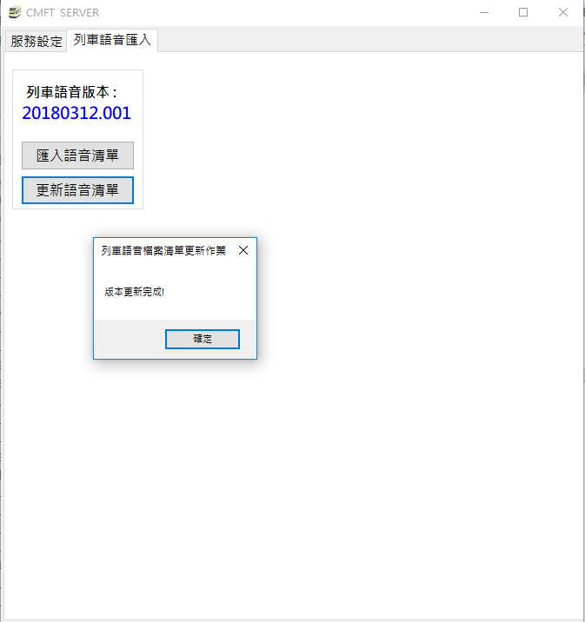

圖 4‑45: CMFT伺服器上列車預錄語音清單更新完成示意圖

Figure 4‑45: Update Pre-recorded Audio List for Train on CMFT Server Diagram

##### 車站使用之預錄語音 Pre-recorded Audio for Station

所有”車站”使用之語音資料皆來自PA 主機，CMFT系統沒有新增與刪除語音檔的權限，但可以進行群組標籤的新增和刪除。

All the audio data for the Station Broadcast come from the PA server, CMFT system can’t have the rights to increase and delete the audio. In addition, operator can increase and delete the group catalog.

預錄語音檔將會固定在凌晨三點與PA主機進行音檔同步作業，若音檔有異動則會進行下載，CMFT系統可以修訂來自PA主機賦予該音檔的名稱，預錄語音內容說明以及設定群組標籤。音檔載入時間，8組語音檔32個檔案約14.2MB，約三秒內下載完成。

The pre-recorded audio file will be updated at three o'clock AM for audio synchronization with the PA Server. If the audio file changes, the pre-recorded audio file will be downloaded. The CMFT system can modify the name assigned by the PA Server to the file, pre-recorded audio content description, and set the group tab. Audio file loading time, for 8 files 32 files using14.2MB disk space, is takes three seconds to download completed.

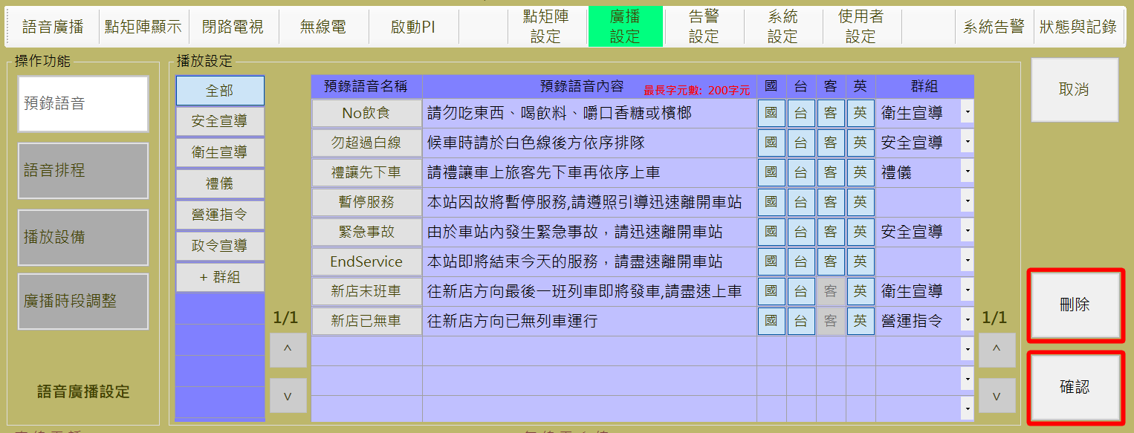

圖 4‑46: 預錄語音設定作業(車站)

Figure 4‑46: Pre-recorded Audio Setting assignment(Station)

1. 群組標籤設定，如圖 4‑47：
2. **新增：**操作人員可透過**播放設定**區塊內的**群組**下方第一行的 “**+群組**” 按鈕來建立新的語音群組與群組名稱。
3. **儲存**：”**確認**” 按鈕是用來儲存設定值。
4. **取消：** “**取消**” 按鈕則是復原設定值。
5. **刪除：** “**刪除**” 按鈕則是用來刪除點選到的群組，原群組中的音檔將歸建為無群組分類。
6. Group Catalog Setting, as shown in Figure 4‑47：.
7. **Add :** The operator can create a new voice group and group name by press the "+群組(Group)" button on the first line below the group in the setting block.
8. **Save**：Press “**確認**(Confirm) “ button can store the Setting result.
9. **Cancel**：”**取消**” (Cancel) button can recover the original Setting value.
10. **Delete**：”**刪除**” (Delete) " is used to delete the selected group, the members on the group will be into a groupless classification.

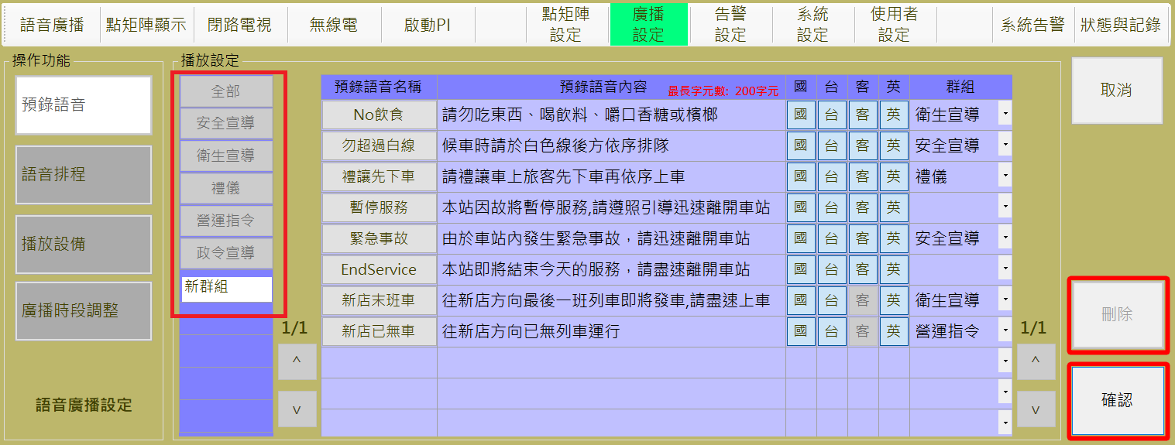

圖 4‑47: 預錄語音群組設定作業(車站)

Figure 4‑47: Pre-recorded Audio Group Setting assignment(Station)

1. 預錄語音提示內容與群組設定，如圖 4‑48
2. **編輯：**操作人員可透過按下預錄語音檔表格中第一欄 “**預錄語音名稱**” 按鈕，進行預錄語音檔的編輯，包含編輯語音檔名稱、提示內容與群組分類。
3. **儲存**：”**確認**” 按鈕是用來儲存設定值。
4. **取消：** “**取消**” 按鈕則是復原設定值。
5. **刪除：** “**刪除**” 按鈕則是用來刪除點選到的群組，原群組中的音檔將歸建為無群組分類。
6. To edit Pre-recorded audio information, as shown in Figure 4‑48：.
7. **Editing** : The operator can enter the editing mode by pressing the "**預錄語音名稱(**Pre-record audio name)" button in the first column of the pre-recorded audio file table, to edit the information including audio file name, tips and group classification.
8. **Save**：Press “**確認**(Confirm) “ button can store the Setting result.
9. **Cancel**：”**取消**” (Cancel) button can recover the original Setting value.
10. **Delete**：”**刪除**” (Delete) " is used to delete the selected group, the original group of audio files will be built into a groupless classification

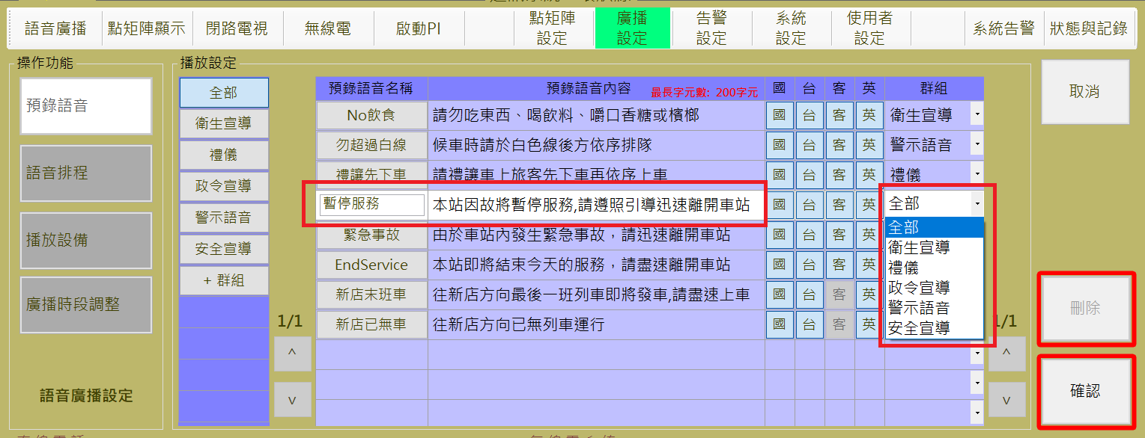

圖 4‑48: 預錄語音音檔設定作業(車站)

Figure 4‑48: Pre-recorded Audio file Setting assignment(Station)

#### 語音排程 PA Schedule Setting

語音排程設定作業主要是提供操作人員設定定時語音播放處理。

每日凌晨四點，CMFT系統會自動載入上周中同一天最後設定的排程資料，進行當日排程作業，如圖 4‑49為例，可於前七日排程預覽表格中預覽上一個星期五的排程，同時自動仔入至今日排程表個中，CMFT系統每日循環時間定義為當日凌晨四點至隔日凌晨四點。

PA Schedule Setting assignment is used for operator to Setting the PA schedule broadcast.

At 4 am every day, the CMFT system will automatically load the last scheduled schedule information of the same day in the last week and schedule the day's homework. For example, as shown in Figure 4‑49, preview can be previewed in the schedule of the first 7 days Last Friday's schedule, while automatically enrolled into today's schedule, the CMFT system daily cycle time is defined as 4:00 the same day to 4:00 the next day.

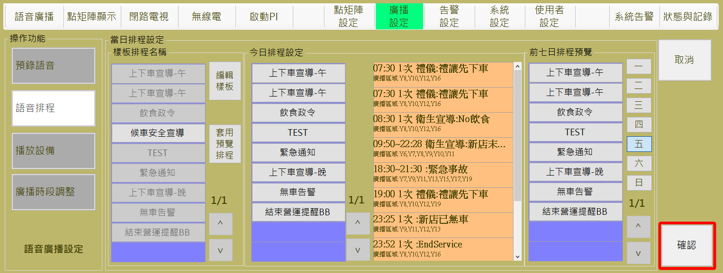

圖 4‑49: 語音排程

Figure 4‑49: PA schedule

##### 今日排程設定 Daily Schedule Setting

1. 操作人員可參考“**前七日排程預覽**”區塊內的排程建立當日排程，按下一到日的日期按鈕會帶出該星期最後的排程資訊，如圖 4‑50，操作人員可透過**排程名稱**區塊內的的 “**套用預覽排程**” 按鈕來複製所選擇的前七日預覽排程 (如圖 4‑51)。
2. 今日排程清單編輯：
3. 新增單一排程：點選“**樣板排程名稱**”表格中的任一樣板，將新增至“**今日排程設定**”。
4. 刪除單一排程：點選“**今日排程設定**”表格中的任一排程項目，將自“**今日排程設定**”表格中移除，並且在“**樣板排程名稱**”表格中復原該項目。
5. 設定排程至伺服器：
6. **儲存**：”**確認**” 按鈕是用來儲存今日排程設定值。
7. **取消：** “**取消**” 按鈕則是復原今日排程設定值。
8. The operator may refer to the scheduled schedule for the schedule in the "**前七日排程預覽(**Preview Schedule from the same day last week)" block. Pressing the date button on the next day will bring out the last scheduled schedule information for the week, as shown in Figure 4‑50. The operator can Through the Schedule Name block within the "Apply Preview Schedule" button to copy the selected seven-day preview schedule (Figure 4‑51).
9. Today's schedule list edit:

(1) Add a single item: click on any of the templates in the “**樣板排程名稱**(template schedule name)" table, will be added to the "**今日排程設定(**today's schedule settings)" table.

(2) Delete a single item: Click on any of the schedule items in the "**今日排程設定(**Today Schedule Settings)" table, it will be removed from the "**今日排程設定(**Today Schedule Settings)" table, and recover it on the "**樣板排程名稱**(template schedule name)" table

1. Schedule Setting to Server：
2. **Save**：**確認**(Confirm) “ button can store the Setting result.
3. **Cancel**：”**取消**” (Cancel) button can recover the original Setting value.

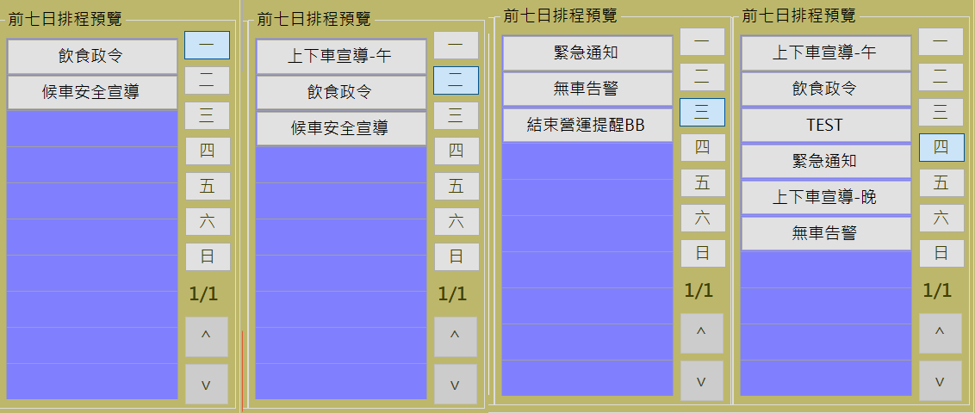

圖 4‑50: 前七日排程預覽示意圖

Figure 4‑50: The first seven days schedule preview diagram

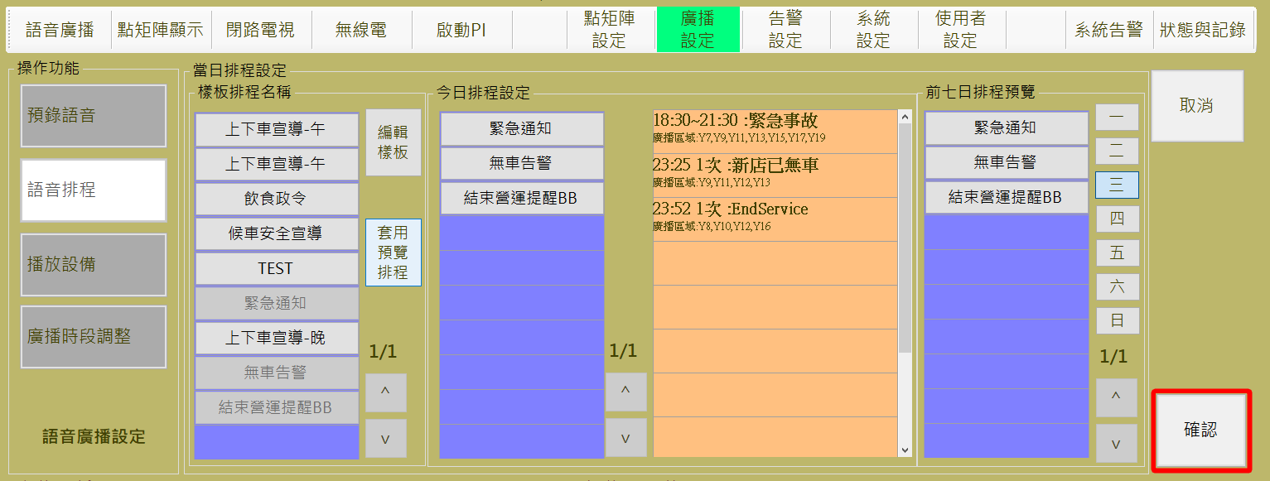

圖 4‑51: 語音排程內容設定作業

Figure 4‑51: PA schedule Setting assignment

##### 排程樣板設定Schedule Template Setting

操作人員如果要修改排程內容，可以按 “**編輯樣版**” 鈕，進入修改語音排程畫面 (如圖 4‑52)。

操作人員可透過**排程樣版**區塊內的 “**回到排程設定**” 按鈕結束編輯作業並回到語音排程設定頁面。

Operator can use “**編輯樣版**” (Edit Sample) bottom switch to the broadcast schedule edit mode (as Figure 4‑52).

Operator can use the “**回到排程設定**” (Back to Previous Page) button in “**排程樣版**” (Template Schedule) block to finish the edit process and back to the Schedule Setting page.

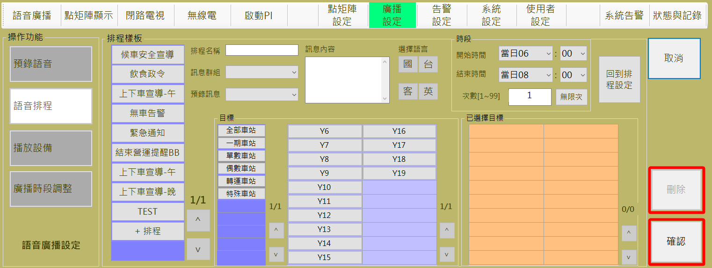

圖 4‑52: 排程樣板設定畫面

Figure 4‑52: Schedule template setting Page

1. 樣板設定操作:
2. **新增：**操作人員可透過**排程樣版**區塊內第一行的 “**+群組**” 按鈕來建立新的樣板，設定樣板名稱、廣播音檔、觸發對象、 觸發時間與次數等，如圖 4‑53。
3. **編輯：**點選”**排程樣版**”表格中的樣板，可進行樣板名稱、廣播音檔、觸發對象、 觸發時間與次數的修改。
4. **儲存：**”**確認**” 按鈕是用來儲存樣板設定值。
5. **取消：** “**取消**” 按鈕則是復原樣板設定值。
6. **刪除：**”**刪除**” 按鈕則是用來刪除指定排程樣板。
7. Template Setting :
8. **Add：**Operator can use the “**+群組**” (Add Group.) button at the 1PPPPstPPPP column in “**排程樣版**” (Template Schedule) block to build a new schedule template, and edit the contents including name, audio file, targets, trigger timing and frequency, as shown in Figure 4‑53.
9. **Edit：**Press the cell of the ”**排程樣版(Schedule Template)**” Table , to edit the contents including name, audio file, targets, trigger timing and frequency.
10. **Save：**”**確認(Confirm)**” button can store the template setting result。
11. **Cancel：** “**取消(Cancel)**” button can recover the original Setting value。
12. **Delete：**”**刪除(Delete)**” button is used to delete a specified template。

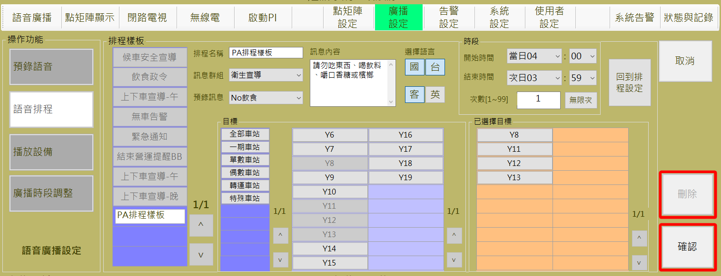

圖 4‑53: 新增排程樣板畫面

Figure 4‑53: Add a new Schedule template setting Page

#### 播放設備控制設定 Broadcast equipment Control Setting

播放設備控制設定作業主要是設定允許進行語音播放處理的主控台 (如圖 4‑54)。

Broadcast Equipment Control Setting assignment is used for assigning the consoles which are allowed to progress broadcast related operation (as Figure 4‑54).

1. **Save：**”**確認(Confirm)**” button can store the template setting.
2. **Cancel：** “**取消(Cancel)**” button can recover the original Setting value。

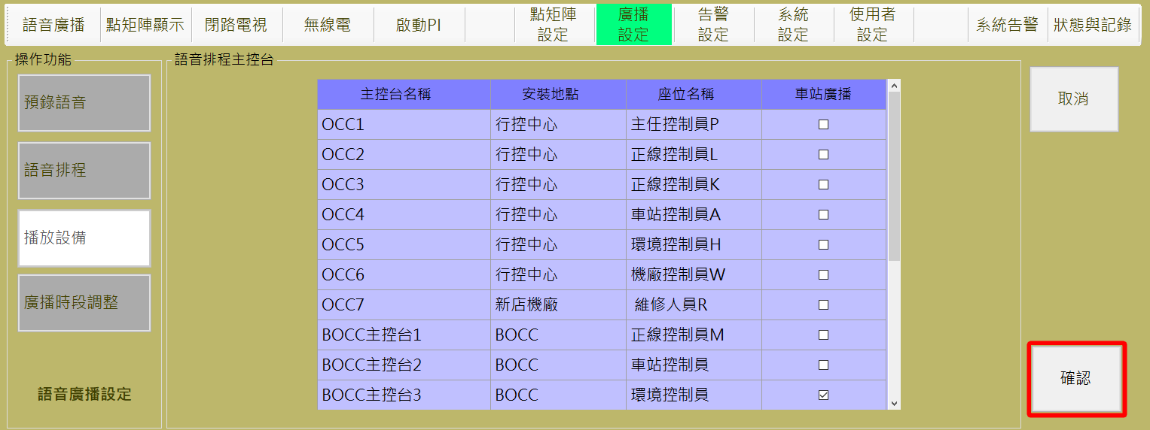

圖 4‑54: 播放設備控制設定作業

Figure 4‑54: Broadcast Equipment Control Setting assignment

#### 廣播時段調整 Public Address Partition Adjust

為了符合環保噪音法規，且能在不同條件下達成廣播效果，廣播時段調整頁面提供可以針對不同時間進行廣播時段音量等級設定(如圖 4‑55)。

In order to comply with environmental noise regulations, and to avoid the broadcast effect in different conditions, Public Address Partition Adjust assignment provide the function to distinguish different time for the broadcast volume level settings. (as Figure 4‑55).

1. 時段設定定義
2. 時段循環區間為每日凌晨四點至隔日凌晨三點五十九分
3. 廣播時段設定分成以下三種：
   1. 尖峰時段。
   2. 離峰時段。
   3. 夜間時段。
4. 檢視目前已存在的設定
5. 先選擇要檢視的車站。
6. 點選要檢視的星期日。
7. 設定清單將自動帶出目前時段設定。
8. 編輯各站每日的廣播時段設定
9. 先選擇要編輯的車站和編輯的日期。
10. 設定清單將自動帶出目前時段設定。
11. 於時段設定中，選擇開始結束時間。
12. 於時段設定中，三種模式擇一。
13. 按下『>』表示新增到設定清單，按下『<』表示自設定清單移除。
14. **儲存**：”**確認**” 按鈕是用來儲存設定值。
15. **取消：** “**取消**” 按鈕則是復原設定值。
16. Definition
17. The cycle time range is from 4am daily to 3.59am next morning
18. The broadcast time setting is divided into the following three types::
    1. Peak Time.
    2. Off-Peak Time.
    3. Night Time.
19. View existing settings
20. First, Click station button.
21. Click to view the weekday
22. The setting list will automatically display current time setting for the one day of the specification station.
23. Edit the station's daily broadcast time settings

(1) first select the station to edit and edit the date.

(2) The setting list will automatically bring out the current time setting.

(3) In the time zone setting, select the start end time.

(4) in the time setting, three modes choose one.

(5) Press ">" to add to the list of settings, press "<" to delete from the list of settings.

(6) Save: "Confirm" button is used to save the setting value.

(7) Cancel: "Cancel" button is to restore the setting value.

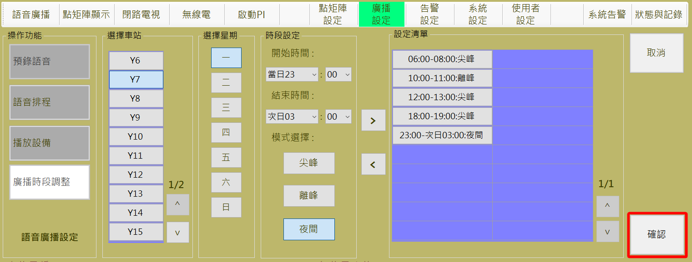

圖 4‑55: 廣播時段調整作業

Figure 4‑55: Public broadcast time periods adjust assignment

### 語音廣播 PUBLIC ADDRESS

本作業含**列車語音廣播**控制**、車站語音廣播**控制二個操作項目 (如圖 4‑56)。

This function include **Broadcast on Train PA** and **Broadcast on Station PA** two operation items (as Figure 4‑56).

所有的列車無限次(緊急)語音廣播設定內容會列在**列車站語音廣播**功能項目左方的 “**列車預錄語音廣播**” 列表內，所有的車站語音廣播排程設定內容則會列在**車站語音廣播**功能項目的右方，以供參考。系統允許操作人員選取非預定排程項目後，使用刪除按鈕將之移除。

表格內顯示為綠色底的資料為現在正在播放的語音事件，來自排程的事件為黑色字體，來自主控台端操作員手動下達的事件為紫色字體。當滑鼠移到該表格上可以語音廣播詳細的資訊，包含時間設定語音檔案及廣播區域。

All the car(s) emergency broadcast schedule(s) will list at the left side of “**列車語音廣播**” (Train PA) function button and the Broadcast on Station schedule(s) will list at the right side of “**車站語音廣播**” (Station PA) function button for reference. Operator can select the non-scheduled items and use the “**刪除**” (Delete) button to stop and remove them from the list.

The cell shown in green background is the speech event currently playing, events from the schedule are black fonts, events manually dispatched from the console console operator are purple fonts. When the mouse is moved to this cell, detailed information displayed, including the time-set audio file name and the broadcast area.

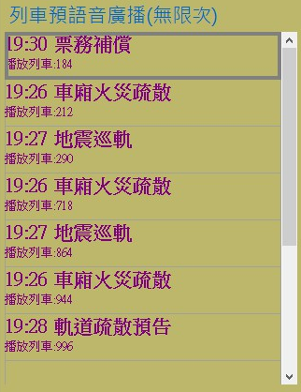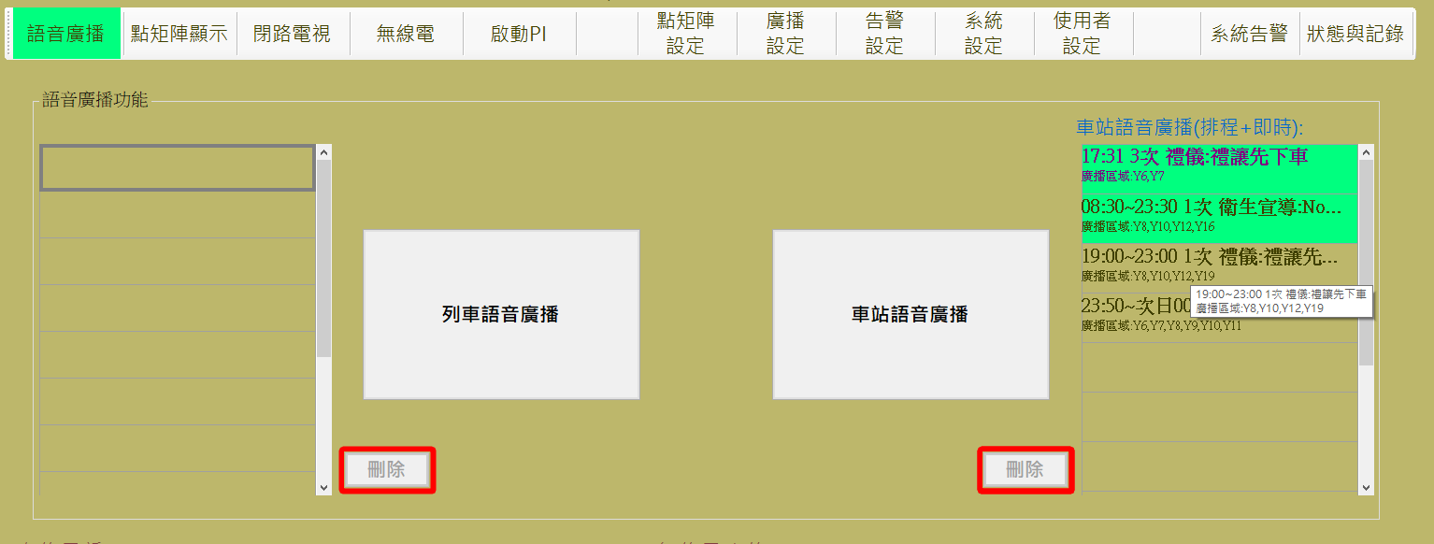

圖 4‑56: 語音通訊控制操作主頁

Figure 4‑56: Main page of Public Address operation

#### 列車語音廣播控制 Broadcast For Train

進行本作業，請依 “**選擇目標對象**→**廣播方式及內容**→**開始播放**” 三個步驟進行。

列車廣播播放的優先權為：緊急>ATS訊息>一般>基底。

Progress this function, please follow “**Select Targets →Select Broadcast Source→Start Broadcast**” the three steps to operate.

The priority of train broadcast is: Emergency> ATS Messages> General> Base

##### 步驟1選擇目標對象 Step 1 Select Targets

操作人員於本程序內選取欲進行廣播的**列車** (可多選) (如圖 4‑57)，來源區域中的深紫色表格為自訂群組，點選後將自動帶入目前符合該群組條件的列車於已選擇項目的橘色表格中，亦可於淺紫色表格中將目標列車點選至橘色表格，若項目已存在橘色表格，則淺紫色表格中，該列車呈現無法點擊狀態，若點擊橘色表格中的單元格，則表示取消選取該列車，由橘色表格中移除，並啟用淺紫色表格內的單元格。

選取完成後，請按 “**下一步**” 按鈕進行下一步驟，如果要變更作業項目，請按 “**上一步**” 按鈕回功能主頁。

Operator select the Train(s) in this step (as). The operator selects the train to be broadcast (multiple choice) (as shown in Figure 4‑57) within this program. The dark purple table in the source area is a custom group, click the cell will automatically imported the eligible trains matching the group's criteria into the orange table of selected items, as well as click the cell in the light purple table, the train can be selected into the orange table, if the train already exists in the orange form, the train in the light purple table is the disabled status; Clicking on the cell in the orange table means that the train is deselected, removed from the orange table, and the cell in the light purple table is enabled.

After selection complete, please click “**下一步**” (Next Step) button to next step. If want to change operation item, please click “**上一步**” (Last Step) button back to the operation main page.

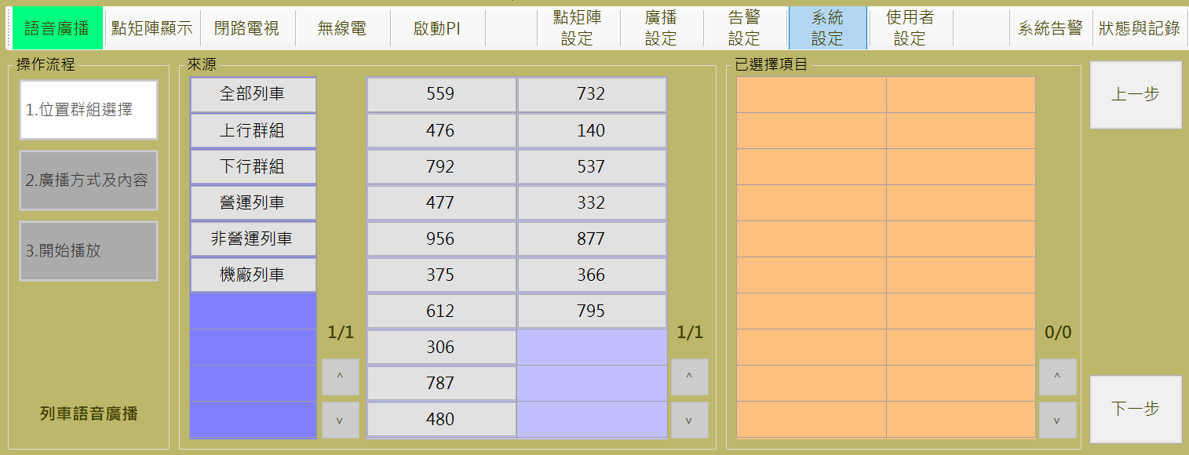

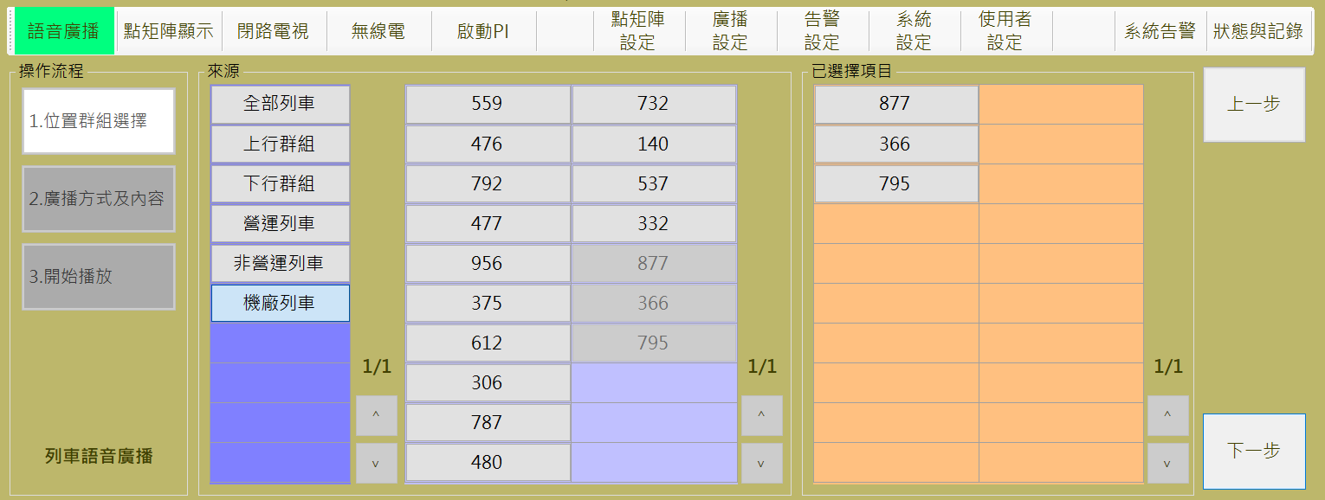

圖 4‑57: 列車語音廣播控制 步驟1 (位置群組選擇)

Figure 4‑57: Broadcast on Train control step 1 (Select train)

##### 預錄廣播與即時廣播 Pre-record Broadcast and Real-time Broadcast

操作人員可選擇播放**預錄廣播**或**即時廣播**，分別說明如后:

Operator can select **pre-record broadcast** or **real-time broadcast** for broadcasting. Operation will be descripted as below:

###### 播放預錄廣播處理 Pre-record Message broadcast Process

**步驟2:** 操作人員點選 “**廣播方式及內容**” 區的 “**預錄廣播**” 頁簽後，可開啟播放預錄廣播操作頁面 (也是預設作業)。然後選擇準備播放的內容，深紫色表格為預錄廣播分類群組，點選群組後將自動於淺紫色表格中帶入該群組內的預錄廣播成員，橘色表格顯示為最終選取的預錄音檔，表格下方為預錄音檔的說明，再選擇**語言**及**播放次數**設定，按 “**播放**” 開始進行播放處理，按 “ **上一 步**” 回前一操作頁面(如圖 4‑58)

**Step 2:** Operator select “**預錄廣播**” (Pre-record Broadcast) tab in “**廣播方式及內容**” (Select Content and Language) block to open pre-record message Setting page (This is default operation page also). And then select the content you want to play. The dark purple table is the pre-recorded audio classification group. Clicking on the group automatically brings the pre-recorded audio members in the group into the light purple table, and the orange table is displayed as the last selected Pre-recorded files, the table below the pre-recorded file description, and then select the language and playback times set, press "play" to start playing process, press the "back" to the previous operation page (as Figure 4‑58).

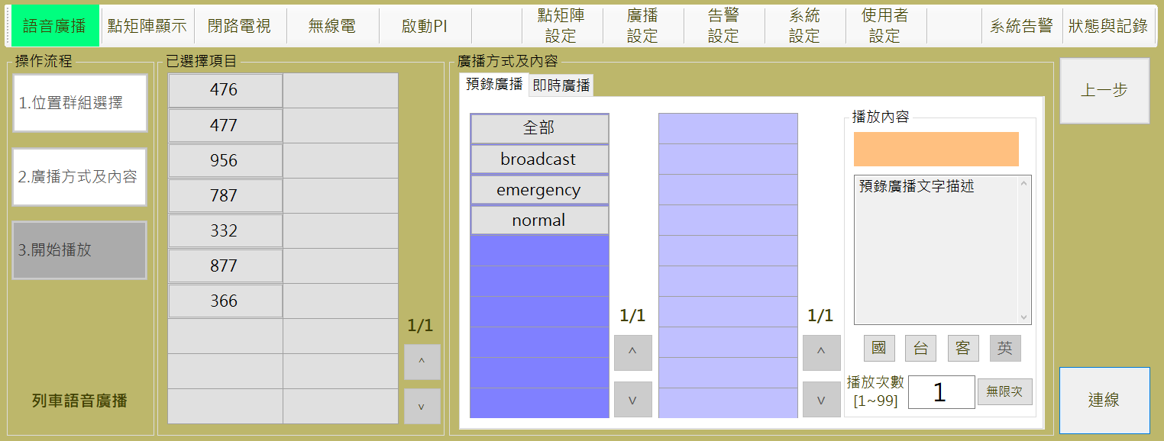

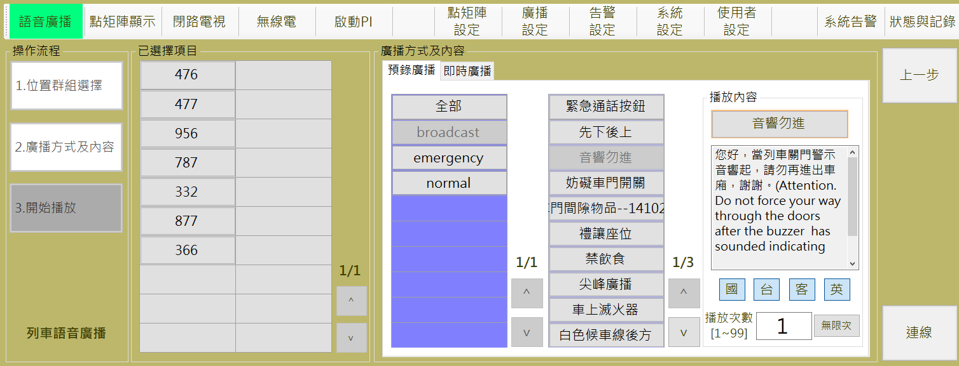

圖 4‑58: 預錄廣播廣播設定

Figure 4‑58: Pre-record message broadcast Setting

**步驟3:**系統開始播放時會先連接指定列車，如果正常會在 “**已選擇項目**”的指定列車會顯示 “**連線**” 狀態，否則會顯示 “**失敗**”(如圖 4‑59)。

結束作業請按 “**結束**” 按鈕，當按下此按鈕後，無論訊息是否結束都將傳送刪除指令結束該訊息的播放。

。

若有連線失敗的情況，系統提供 “**重試**” 功能，可以再次嘗試傳送設定訊息。

**Step 3:** When system start to broadcast, it will try to connect to specified car(s). If success, it will response “ **連線**” (Connect) status in the car(s) table of “**已選擇項目**” (Selected Car) block. Otherwise, it will show “**失敗**” (Failed) status (as Figure 4‑59).

To finish this operation, please click “**結束**” (Close) button.

Additional function button “**重試**” (Retry) is provided for message resend

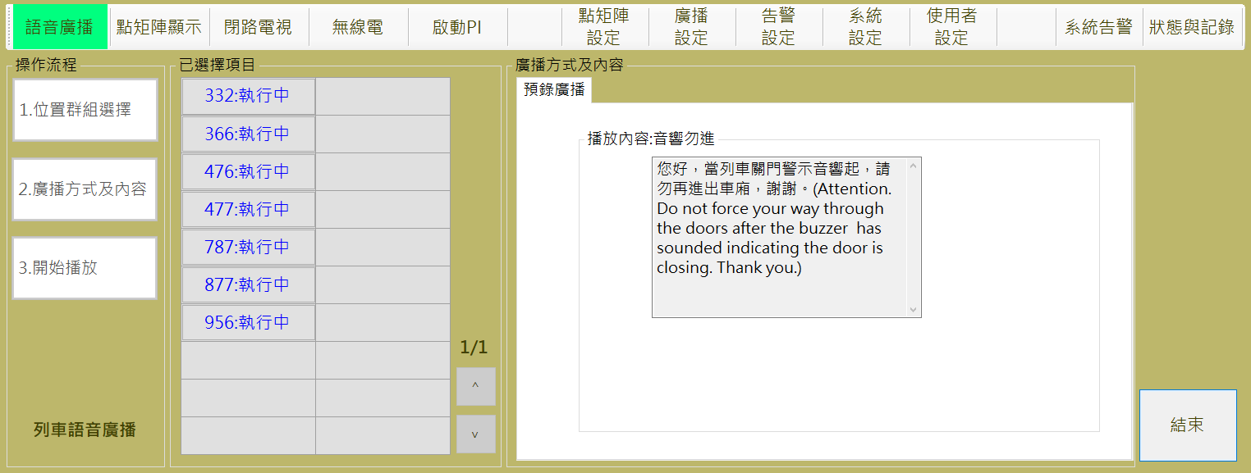

圖 4‑59: 預錄廣播播放結果回報

Figure 4‑59: Pre-record message broadcast result

###### 即時廣播處理 Real-time Broadcast Process

**步驟2:** 操作人員點選 “**廣播方式及內容**” 區的 “**即時訊息**” 頁簽後，可開啟播放即時廣播操作頁面。按 “**播放**” 開始進行播放處理，按 “ **上一步**” 回前一操作頁面(如圖 4‑60)

**Step 2:** Operator select “**即時廣播**” (Real-time Broadcast) tab in “**廣播方式及內容**” (Select Content and Language) block to open real-time broadcast page. After operation finish, please click “**播放**” (Start) button to progress remote message display program. Click “**上一步**” (Last Step) button back to the last step (as Figure 4‑60).

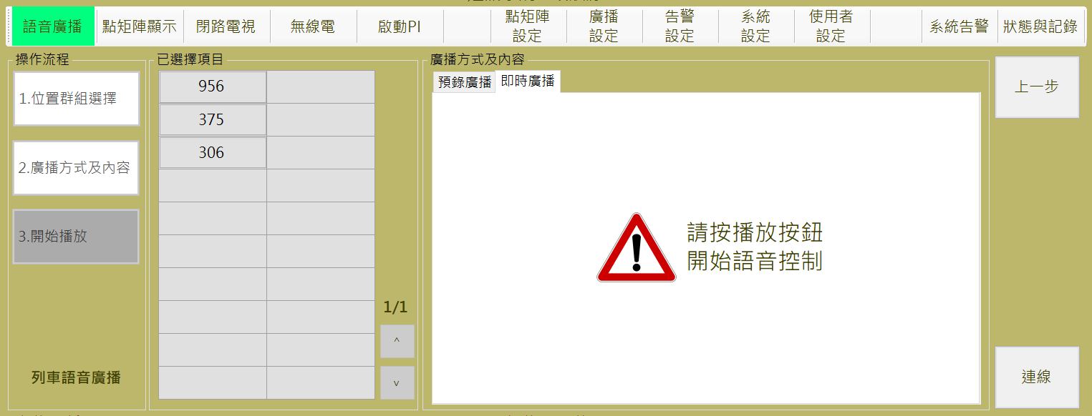

圖 4‑60: 列車口語廣播操作1

Figure 4‑60: Oral broadcast for train operation operation 1

操作人員按 “**播放**” 後，系統會自動生成**列車廣播群組**，並開啟無線電列車廣播群組頻道如圖 4‑62，即可直接廣播。按 “**結束通訊**” 可關閉無線頻道，結束廣播。

When operator click “**播放**” (Start) button, system will auto-create the “**列車廣播**” (Broadcast on Train) radio group and radio channel to progress car(s) broadcast, as shown in Figure 4‑62. Click “ **結束通訊**” (Stop Communication) button can stop broadcast and release this radio channel.

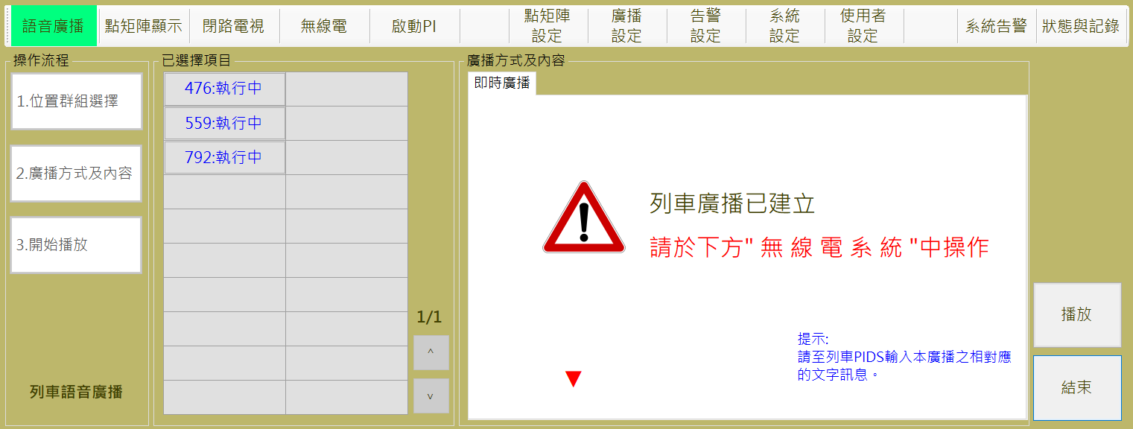

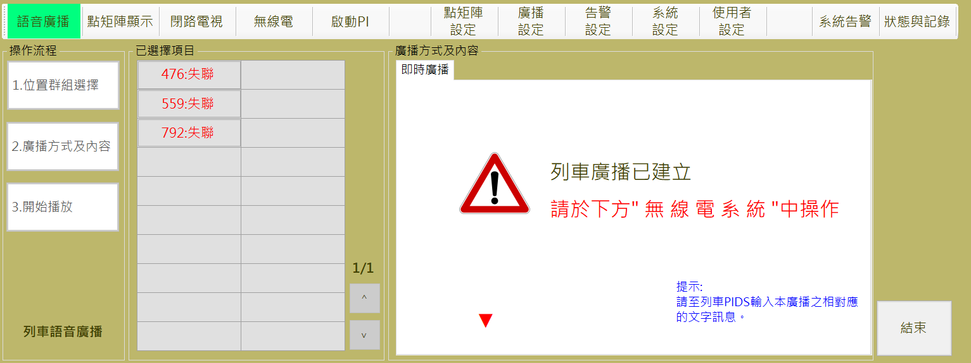

圖 4‑61:口語廣播面盤操作2

Figure 4‑61: Oral broadcast for train operation operation 2

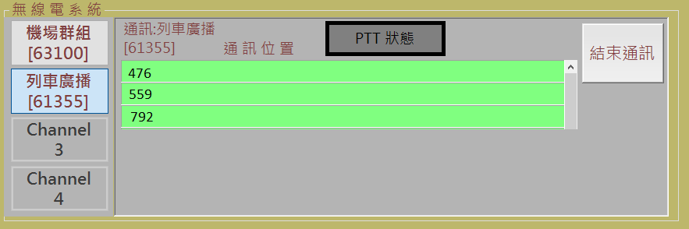

圖 4‑62:口語廣播面盤操作

Figure ‑: Oral broadcast on panel operation

#### 車站語音廣播控制 Broadcast on Station Control

進行本作業，請依 “**選擇目標對象**→**廣播方式及內容**→**開始播放**” 三個步驟進行。

Progress this function, please follow “**Select Targets →Select Broadcast Source→Start Broadcast**” the three steps to operate.

.

車站廣播播放的優先權為：PAO>消防主機>行控中心。

The priority of station broadcast is: PAO> Fire Host> OCC

##### 步驟1選擇目標對象 Step 1 Select Targets

操作人員於本程序內選取欲進行廣播的**車站**(可多選) (如圖 4‑63)，來源區域中的深紫色表格為自訂群組，點選後將自動帶入目前符合該群組條件的列車於已選擇項目的橘色表格中，亦可於淺紫色表格中將目標列車點選至橘色表格，若項目已存在橘色表格，則淺紫色表格中，該列車呈現無法點擊狀態，若點擊橘色表格中的單元格，則表示取消選取該列車，由橘色表格中移除，並啟用淺紫色表格內的單元格。

選取完成後，請按 “**下一步**” 按鈕進行下一步驟，如果要變更作業項目，請按 “**上一步**” 按鈕回功能主頁。

Operator select the Station(s) in this step (as). The operator selects the train to be broadcast (multiple choice) (as shown in as Figure 4‑63) within this program. The dark purple table in the source area is a custom group, click the cell will automatically imported the eligible trains matching the group's criteria into the orange table of selected items, as well as click the cell in the light purple table, the train can be selected into the orange table, if the train already exists in the orange form, the train in the light purple table is the disabled status; Clicking on the cell in the orange table means that the train is deselected, removed from the orange table, and the cell in the light purple table is enabled.

After selection complete, please click “**下一步**” (Next Step) button to next step. If want to change operation item, please click “**上一步**” (Last Step) button back to the operation main page.

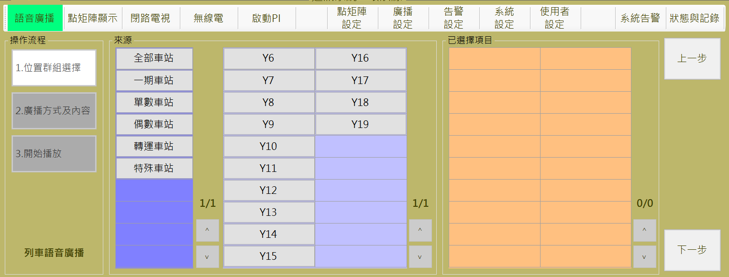

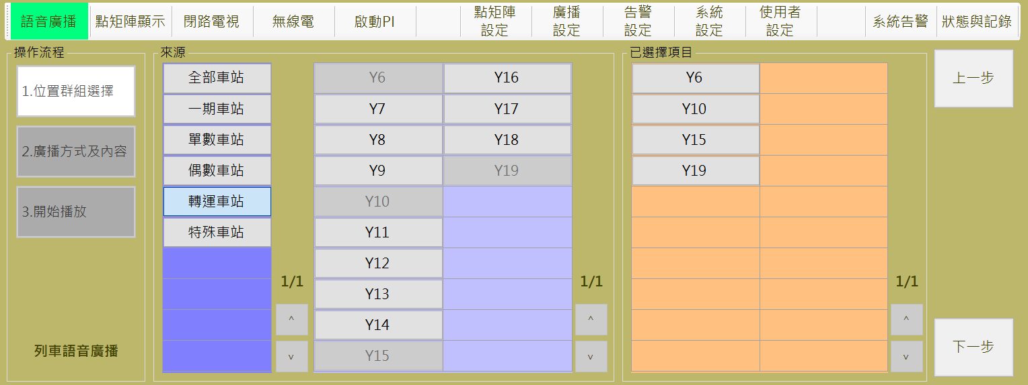

圖 4‑63: 車站語音廣播控制 步驟1 (位置群組選擇)

Figure 4‑63: Broadcast on Station control step 1 (Select Station)

##### 預錄廣播與即時廣播 Pre-record Broadcast and Real-time Broadcast

操作人員可選擇播放**預錄廣播**或**即時廣播**，分別說明如后:

Operator can select **pre-record broadcast** or **real-time broadcast** for broadcasting. Operation will be descripted as below:

###### 播放預錄廣播處理 Pre-record Message broadcast Process

**步驟2:** 操作人員點選 “**廣播方式及內容**” 區的 “**預錄廣播**” 頁簽後，可開啟播放預錄廣播操作頁面 (也是預設作業)。然後選擇準備播放的內容，完成**語言**及**播放次數**設定，按 “**播放**” 開始進行播放處理，按 “ **上一 步**” 回前一操作頁面(如圖 4‑64)

**Step 2:** Operator select “**預錄廣播**” (Pre-record Broadcast) tab in “**廣播方式及內容**” (Select Content and Language) block to open pre-record message Setting page (This is default operation page also). Then select message, set **language** and the **broadcast times** to complete operation. After operation finish, please click “**播放**” (Start) button to progress remote message broadcast program. Click “**上一步**” (Last Step) button back to the last step (as Figure 4‑64).

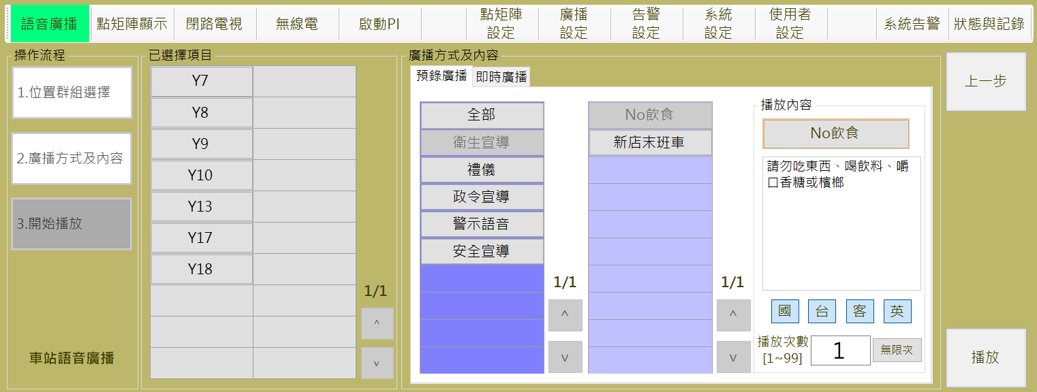

圖 4‑64: 預錄廣播廣播設定

Figure 4‑64: Pre-record message broadcast Setting

**步驟3:**系統開始播放時會先連接指定車站取得廣播控制，在 “**已選擇項目**”的指定車站顯示 “**連線中**” 狀態，取得成功則顯示“**成功**”，否則會顯示失敗原因如 “**佔用**”或“**連線無回應**”(如圖 4‑68)。

結束作業請按 “**結束**” 按鈕，。

已選擇項目中有一個未成功取得播放控制權時，右邊會出現“**重試**”與“**播放**”按鈕，重試會將失敗車站再次詢問廣播控制權，播放則只與目前已經取得廣播控制權的車站進行車站廣播。

若全部取得控制權成功將自動進行播放

**Step 3:** When system start to broadcast, it will try to connect to specified station(s).First, it will response “ **連線中**” (Connecting) status in the selected table of “**已選擇項目**” (Selected Item) block, then If connect successfully, it will response “ **成功**” (success) status, otherwise, it will show failed reason“**佔用**” (Occupied) or “**連線無回應**” (no response) status (as Figure 4‑68). To finish this operation, please click “**結束**” (Close) button. Additional function button “**重試**” (Retry) is provided for message resend

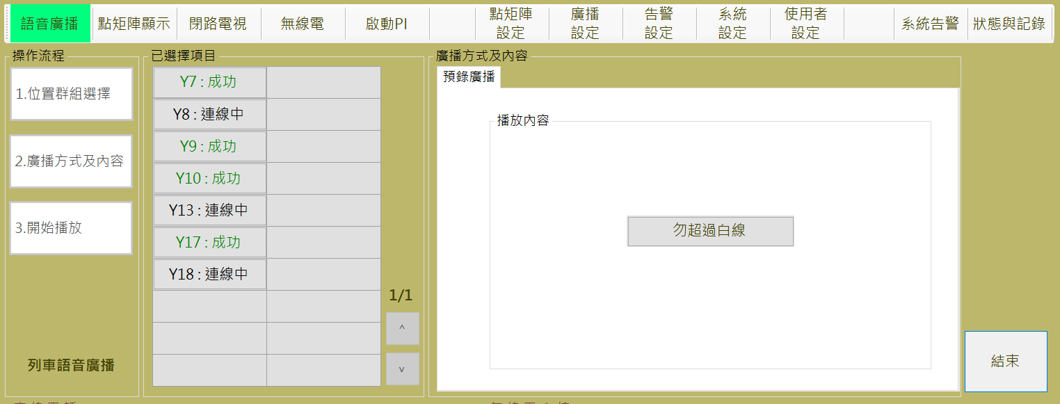

圖 4‑65: 取的控制權中

Figure 4‑65:Get the playback right Process

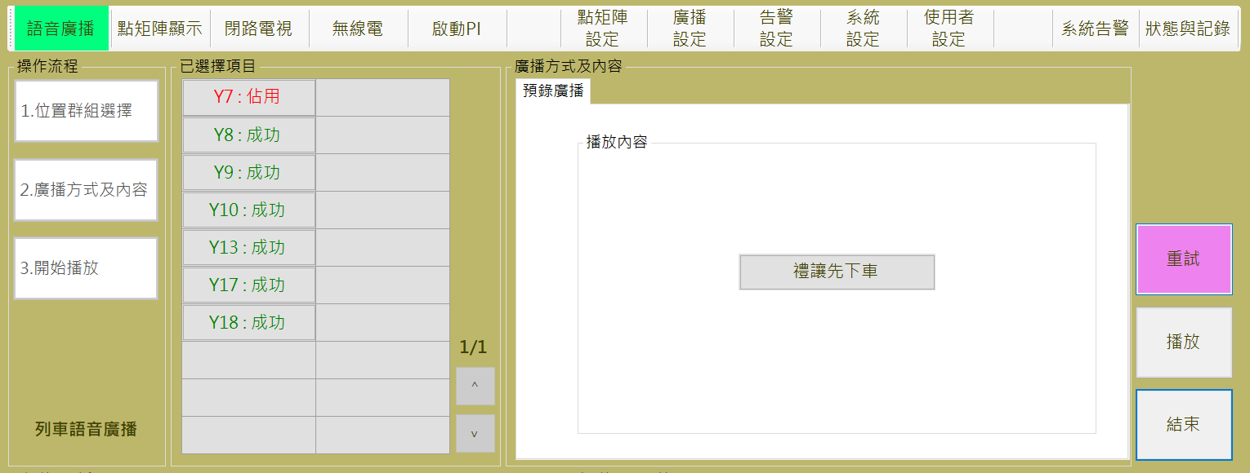

圖 4‑66:非所有目標皆取得控制權

Figure 4‑66:Not all the playback right to be gotten Successful

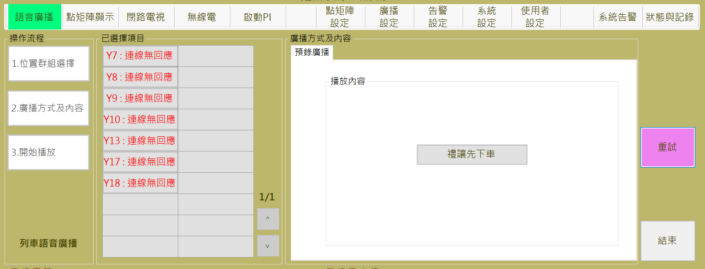

圖 4‑67: 因無法連線取得控制權失敗

Figure 4‑67:Get the playback right failed due disconnect

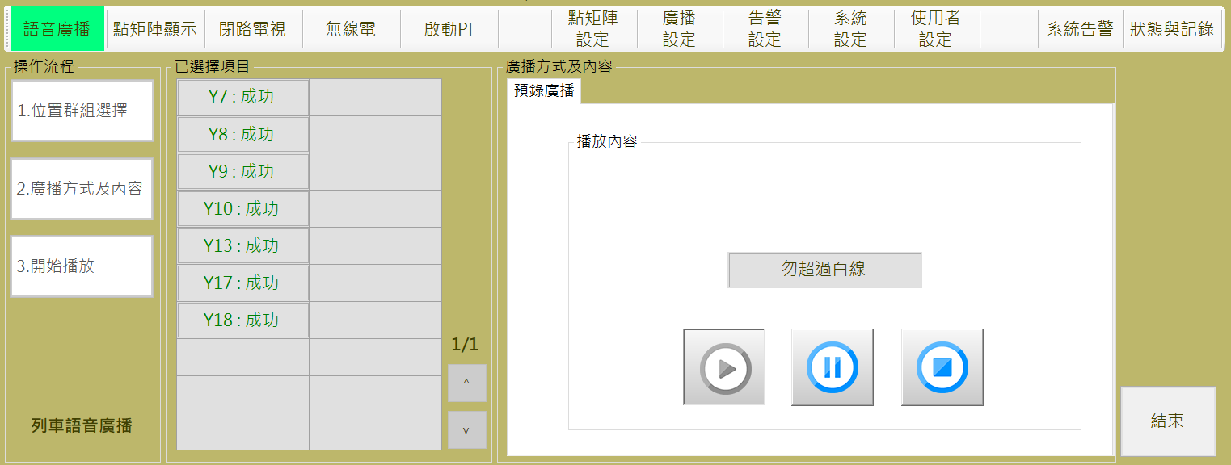

圖 4‑68: 預錄廣播播放結果回報

Figure 4‑68: Pre-record message broadcast result

訊息播放過程中,可隨時按暫停▍▍ 或 █ 按鈕終止訊息播放。

During message broadcasting, operator can click ▍▍Interrupt 或 █ stop to control the playback.

全部播放完畢後，若需要重新播放，可以直接按下，在控制權尚未式放下直接重新播放。

After all the playback, if you need to re-play, you can press directly, in the control of the way down and re-play

###### 即時廣播處理 Real-time Broadcast Process

**步驟2:** 操作人員點選 “**廣播方式及內容**” 區的 “**即時訊息**” 頁簽後，可開啟播放即時廣播操作頁面。按 “**播放**” 開始進行播放處理，按 “ **上一步**” 回前一操作頁面(如圖 4‑69)

**Step 2:** Operator select “**即時廣播**” (Real-time Broadcast) tab in “**廣播方式及內容**” (Select Content and Language) block to open real-time broadcast page. After operation finish, please click “**播放**” (Start) button to progress remote message display program. Click “**上一步**” (Last Step) button back to the last step (as Figure 4‑69).

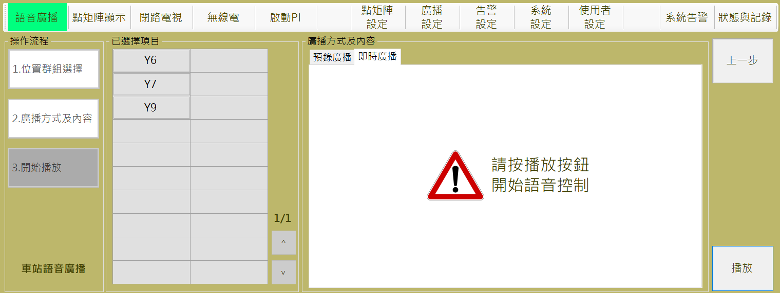

圖 4‑69: 車站口語廣播操作

Figure 4‑69: Oral broadcast for station operation

即時廣播會透過PA系統進行，操作人員按 “**播放**” 後，即可直接廣播。

Real-time broadcast work through PA system. Operator click “**播放**” (Start) button and directly use PA equipment to broadcast.

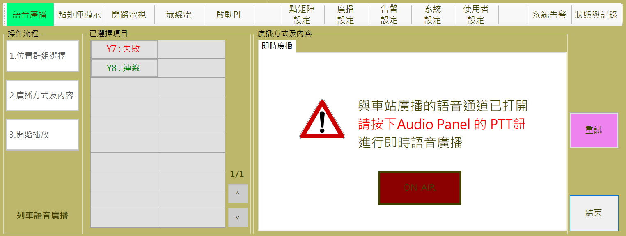

圖 4‑70:口語廣播面盤操作

Figure 4‑70: Oral broadcast on panel operation

### 點矩陣設定 DMD Program Assign

本作業含**ATS訊息、預錄訊息、訊息排程**及**顯示模式設定**四個功能

This function include **ATS Message Display Setting, Pre-record Message Management, DMD Message Schedule Setting** and **DMD Display Mode Setting** four sub-functions

#### ATS訊息 ATS Message Display Setting

ATS訊息設定主要是提供操作人員設定CMFT系統接收到各種情況的ATS訊息後，於CMFT系統自動推播至大廳或月台顯示器展示的相關文字資訊(如圖 4‑71)。

ATS message setting is to provide operators to set the relevant text information on the CDU or PDU when the the CMFT system receive the variety of ATS messages. (as Figure 4‑71).

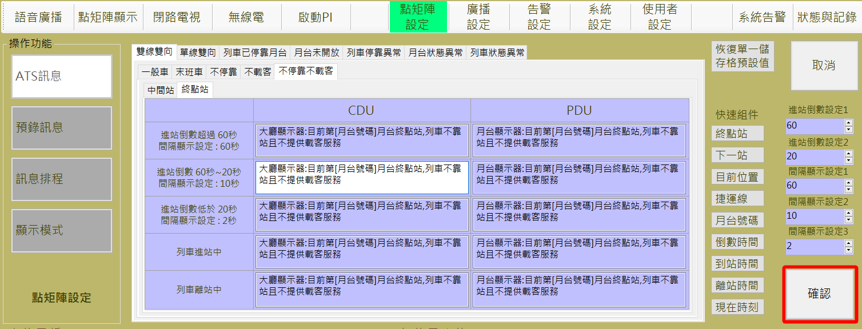

圖 4‑71: ATS訊息設定作業

Figure 4‑71: ATS message display Setting assignment

##### 組件與變數Components and Variable

如圖 4‑71畫面中，快速組件與變數可提供操作者在建置文字時，方便應用於設定的顯示文字。

As shown in Figure 4‑71, the quick components and variables can be used by the operator to conveniently set the displayed text when building the text.

1. 快速組件：當操作者須於文字中置入和訊息相關的參數時，可利用組件進行文字參數編譯，如圖 4‑71畫面中，文字訊息中置入的組件前後會有中括號[ ]顯示為組件參數。目前訊息提供的組件如下：
2. 終點站：每一個班次本次運行的終點站。
3. 下一站：該列車觸發顯示器所在車站的下一個停靠站。
4. 目前位置：該列車目前所在的軌道與站體間的位置。
5. 捷運線：即環狀線代碼。
6. 月台號碼：該列車觸發顯示器所在的月台的代表號
7. 倒數時間：列車到站前的倒數計時，如2分鐘後或30秒後。
8. 到站時間：ATS訊息提供的列車到站時間。
9. 離站時間：ATS訊息提供的列車離站時間。
10. 現在時刻：點矩陣文字顯示的時間
11. Quick component: When the operator has to place the message-related parameters in the text, the component can be used to compile the text parameters. For example, in Figure 4‑71, the components placed in the text message will have brackets [] Display as component parameters. The current message provides the following components:
12. Terminal Station: The terminal station of this shift for the train schedule.
13. Next stop: This train triggers the next stop of the station where the monitor is located.
14. Current Location: The location of the train's current orbital position.
15. MRT line: the loop line code.
16. Platform number: The number of the platform on which the train triggers the display
17. countdown time: The countdown before the arrival of the train, such as 2 minutes or 30 seconds later.
18. Arrival time: The arrival time for train arrived station for ATS message timetable.
19. Departure time: The departure time for train denatured station for ATS message timetable.
20. Current Time : The time when the text displayed moment
21. 參數設定：
22. 進站倒數設定1：列車進站倒數時間在此設定值之前皆使用”間隔顯示設定1”的秒數設定，進行倒數時間計算與推播時間，例如圖 4‑71畫面中，[進站倒數超過60秒]，意即倒數時間大於60秒以上的倒數設定將參考”間隔顯示設定1”=[60]秒，每60秒進行一次訊息推播。
23. 進站倒數設定2：列車進站倒數時間在進站倒數設定與在此設定值皆使用”間隔顯示設定2”的秒數，進行倒數時間計算與推播時間，例如圖 4‑71畫面中，[進站倒數60~20秒]，意即倒數時間介於60~20秒間，倒數設定將參考”間隔顯示設定2”=[10]秒，每10秒進行一次訊息推播。
24. 間隔顯示設定1：列車進站倒數時間大於”進站倒數設定1”時，訊息推播頻率為此設定值。
25. 間隔顯示設定2：列車進站倒數時間介於”進站倒數設定1”與”進站倒數設定2”間，訊息推播頻率為此設定值。
26. 間隔顯示設定3：列車進站倒數時間小於”進站倒數設定2”，訊息推播頻率為此設定值。
27. Parameter Setting：
28. Arrival countdown setting 1: When the arrival time is exceed this settled value, The frequency of message broadcast is "frequency setting 1", Example： As in Figure 4‑71, [進站倒數超過60秒], means that when Arrival countdown is over than 60 second, the The frequency of message broadcast is 60 second.
29. Arrival countdown setting 2: When the arrival time is between Arrival countdown setting 1 and this settled value, the frequency of message broadcast is "frequency setting 2", Example： As in Figure 4‑71, [進站倒數60~20秒], means that when Arrival countdown is between 20 to 60 second, the The frequency of message broadcast is 60 second
30. frequency setting 1：When the arrival time is over than “Arrival countdown setting 1”, The frequency of message broadcast is this value.
31. frequency setting 2：When the arrival time is between “Arrival countdown setting 1” and “Arrival countdown setting 2”, the frequency of message broadcast is this settled value.
32. frequency setting 3：When the arrival time is less than “Arrival countdown setting 2”, The frequency of message broadcast is this value.
33. 編輯模式
34. **編輯：**選擇第一頁籤，共有七種列車事件，分別為雙線雙向(如圖 4‑72)、單線雙向(如圖 4‑73)、列車已停靠月台(如圖 4‑74)、月台未被開放(如圖 4‑75)、列車停靠異常(如圖 4‑76)、月台狀態異常(如圖 4‑77)、列車狀態異常(如圖 4‑78)，再選擇第二頁簽條件如一般車，末班車或者不停靠不載客組合，以及起始站或非起始站，第三頁籤則包含，中間站、終點站或者兩輛列車已停靠、一輛列車已停靠等，點選以上列車情況與對應站等條件頁籤後，可對對應表單中的文字進行編輯，點擊表格呈現白色底即可進行文字輸入。
35. **儲存**：”**確認**” 按鈕是用來儲存設定值。
36. **取消：** “**取消**” 按鈕則是復原設定值。
37. Edit Mode
38. **Edit**：Select the first page sign, a total of seven train events, respectively, two-lane two-way (e.g. Figure 4‑72),, single two-way (e.g. Figure 4‑73), the train has docked on the platform (e.g. Figure 4‑74), the platform is not open (e.g. Figure 4‑75), the train stops abnormally (e.g. Figure 4‑76), the platform status is abnormal (e.g. Figure 4‑77), the train status is abnormal (e.g. Figure 4‑78), and then select the second page sign, train mission conditions, such as general shift, The last shift or non-stop passenger and non-loading combination, as well as the starting or non-starting station, the third page sign contains, intermediate station, terminal or two trains have been docked, a train has been docked, click on the above train conditions With the corresponding station and other conditions tab page, you can edit the text in the corresponding form, click on the table, the cell shows the white background color, then operator can input or alter the message.
39. **Save**：Press “**確認**(Confirm) “ button can store the Setting result.
40. **Cancel**：”**取消**” (Cancel) button can recover the original Setting value.

##### 雙線雙向 Double Lines Double Directions

正常情況下環狀線營運分為上下行兩個方向，由兩個軌道兩個月台各自負責列車進站離站資訊。操作員可根據一般車，末班車或者不停靠不載客組合以及點矩陣所在車站屬性中間站或終點站，進行相關訊息編輯，如下圖：

Under normal circumstances, the operation of the loop line is divided into two directions up and down, from the two tracks two platform are responsible for the train arrival and departure information. The operator can edit the relevant arrival and departure information, according to the general shift, the last shift, non-stop and non-loading combination, then DMD location-station properties of the middle station or terminal, as shown below ：

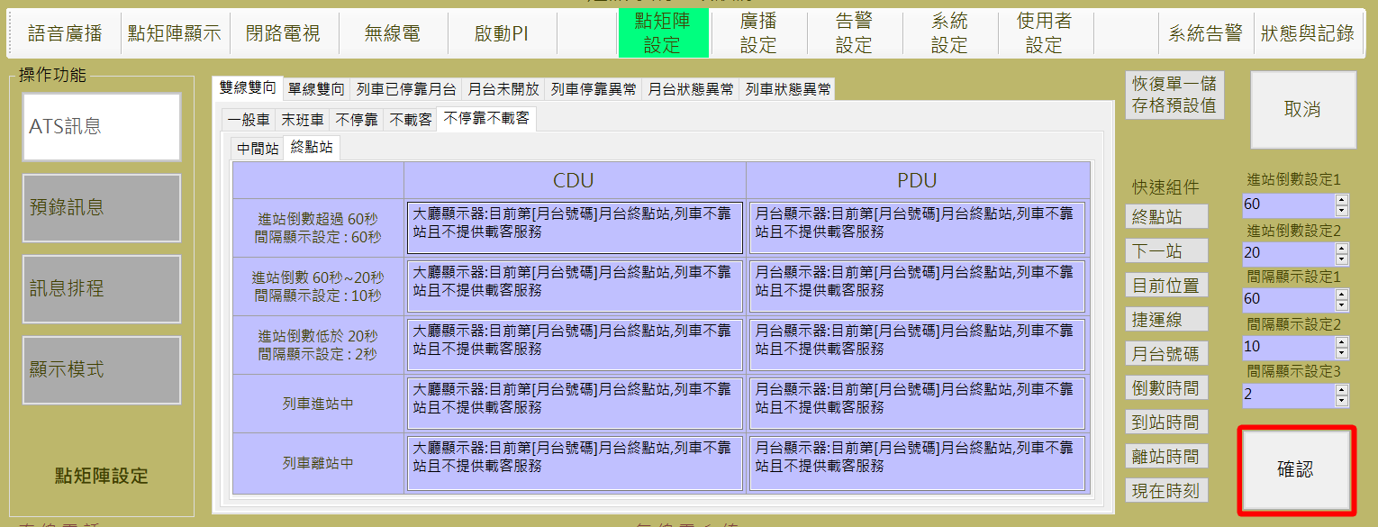

圖 4‑72: ATS訊息雙向雙向設定作業

Figure 4‑72: ATS message display Double Direction Double Line Setting

##### 單線雙向 Single Line Double Direction

軌道或月台異常情況下，車站月台可能關閉一側僅由一側月台負責上下行兩個行進方向的列車進站服務，此為單軌道線進行上下行雙向營運。操作員可根據一般車，末班車或者不停靠不載客組合以及點矩陣所在車站屬性中間站或終點站，進行相關訊息編輯，如下圖：

In the case of an abnormal orbit or platform, the station platform may be closed on one side. The only platform is responsible for the train up-direction and down-direction services on both directions. This is a two-way uplink and downlink operation for a single track. The operator can edit the relevant arrival and departure information, according to the general shift, the last shift, non-stop and non-loading combination, then DMD location-station properties of the middle station or terminal, as shown below ：

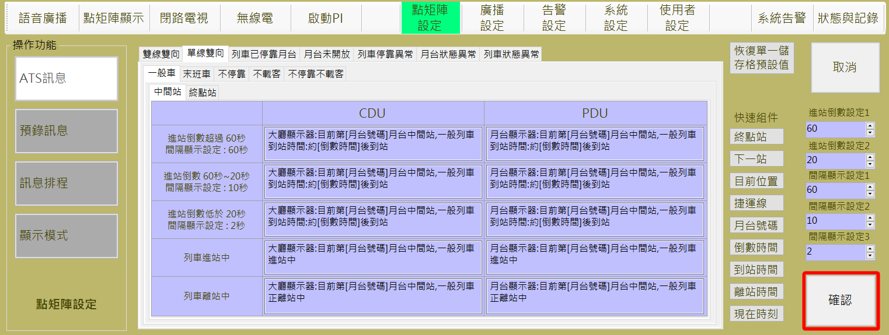

圖 4‑73: ATS訊息單線雙向設定作業

Figure 4‑73: ATS message display Double Direction Single Line Setting

##### 列車已停靠月台 Train has docked on the platform

此設定主要提供列車因為調度關係在月台等候發車的情況，以及兩個月台同時都有列車等候同一方向的發車時點矩陣訊息顯示資訊。操作員可根據起始站兩輛列車或一輛列車停靠，以及非起始站 ，進行相關訊息編輯，如下圖：

This setting mainly provides information when trains are waiting for departure on the platform. Because of the dispatching relationship and on the departure time of the trains waiting for the same direction on both platforms. According to the stop at the starting station two trains or a train stop, as well as non-start station, operator can edit the relevant information, as shown below：

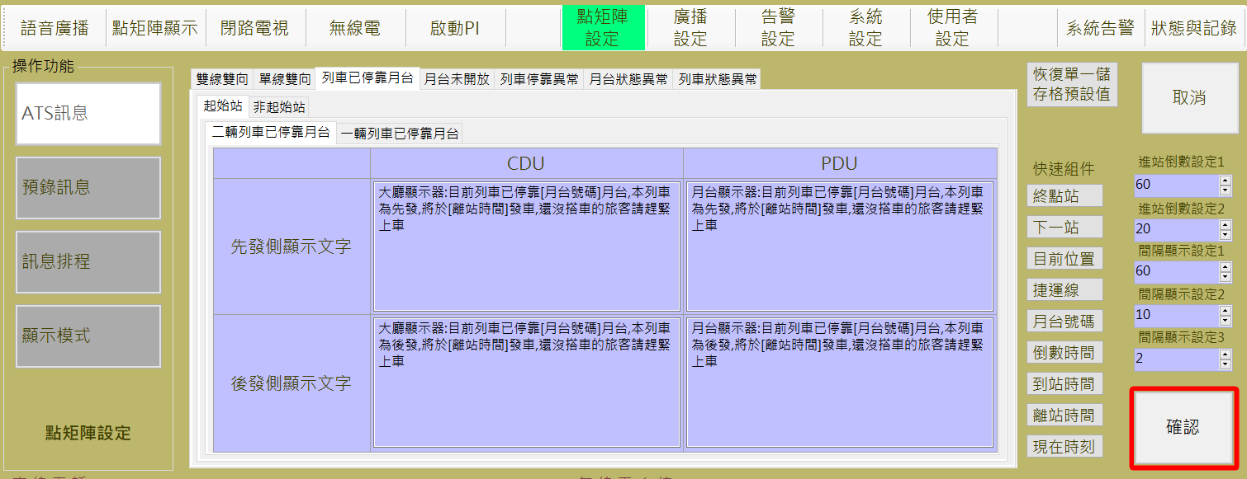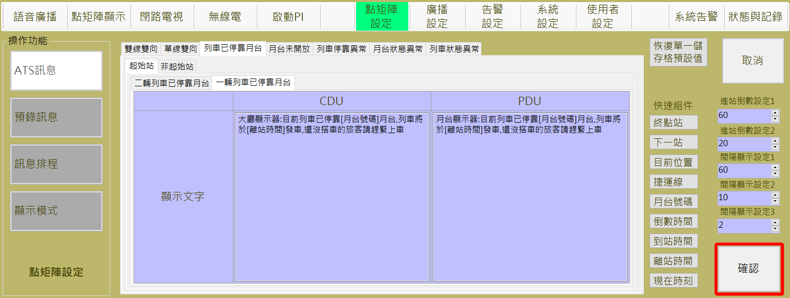

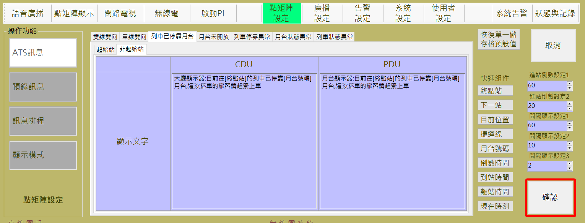

圖 4‑74: 列車已停靠設定作業

Figure 4‑74: The train has been docked to set the job

##### 月台未開放 Platform Closed

異常情況下，車站月台可能關閉一側月台不提供營運服務。操作員可輸入相關訊息警示乘客，如下圖：

Under abnormal circumstances, the platform of the station may be closed on one side of the platform without providing services. The operator can edit the relevant message to alert passengers, as shown below:

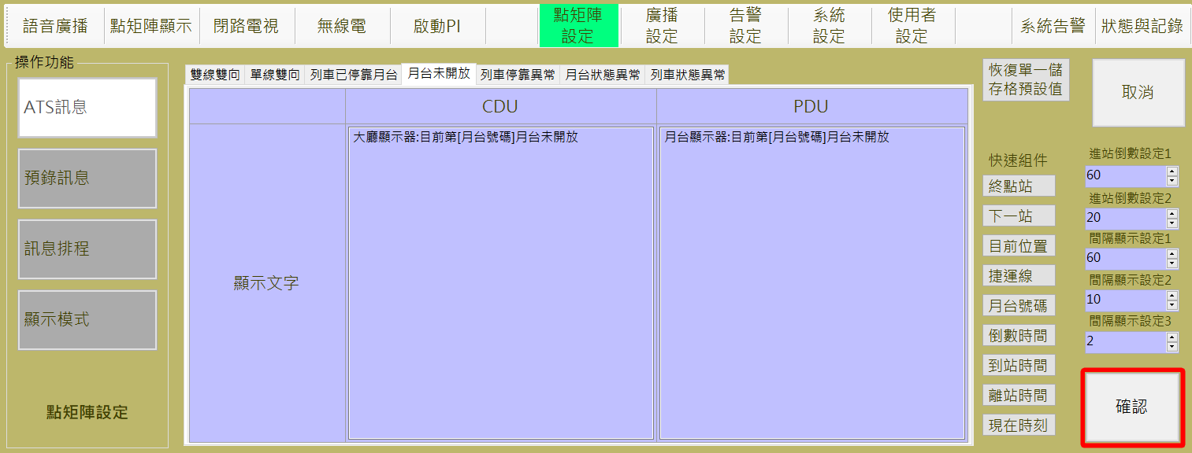

圖 4‑75: 月台未開放設定作業

Figure 4‑75: Platform is not open to set the job

##### 列車停靠異常Train Berthing Error

ATS偵測到列車停靠異常情況下，會發出相關訊息，包含此列車停靠異常後的處置方式，嘗試重停或者不進行重停。操作員可輸入相關訊息警示乘客，如下圖：

When the ATS detects that the train stops abnormally, it will send the message, including the disposal method after the train stops abnormally, trying to Berth or no Berth. The operator can edit the relevant message to alert passengers, as shown below:

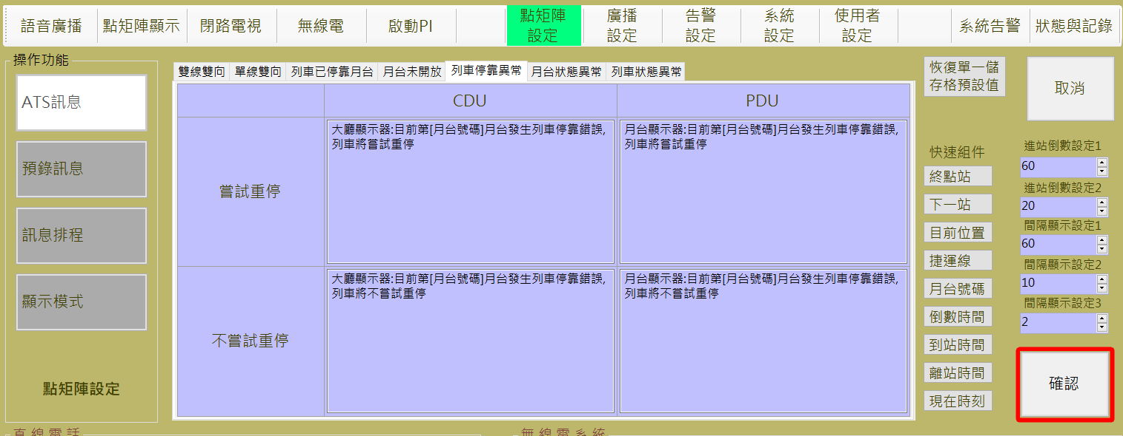

圖 4‑76: 列車停靠異常設定作業

Figure 4‑76: Train stop abnormal setting job

##### 月台狀態異常 Abnormal Status of the Platform

ATS偵測到月台狀態異常情況下，會發出相關訊息。操作員可輸入相關訊息警示乘客，如下圖：

When the ATS detects that the platform status is abnormal, it will send the message. The operator can edit the relevant message to alert passengers, as shown below:

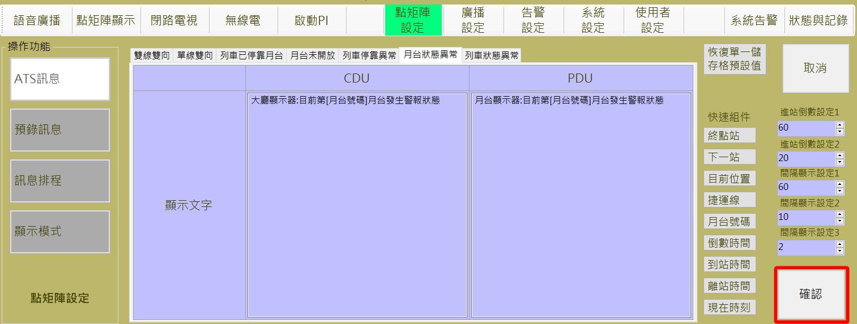

圖 4‑77: 月台狀態異常設定作業

Figure 4‑77: Platform status error setting job

##### 列車狀態異常Abnormal Status of the Train

ATS偵測到列車停靠異常情況下，會發出相關訊息。操作員可輸入相關訊息警示乘客，如下圖：

When the ATS detects that the status of the train is abnormal, it will send the message. The operator can edit the relevant message to alert passengers, as shown below:

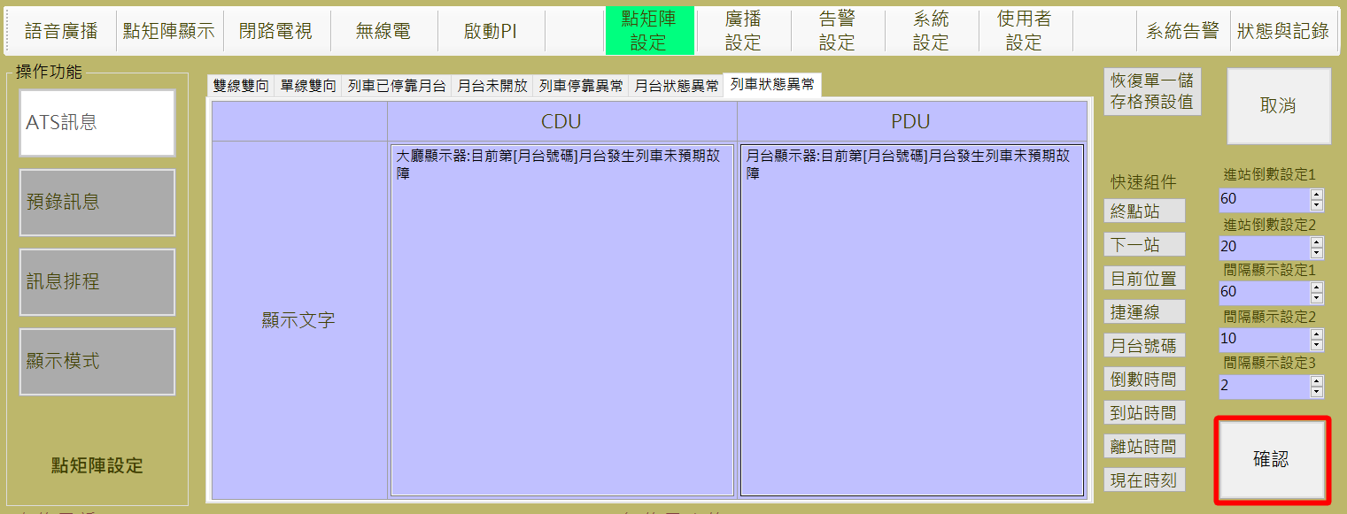

圖 4‑78: 列車狀態異常設定作業

Figure 4‑78: Train status is abnormal setting job

#### 預錄訊息管理 Pre-record Message Management

預錄訊息管理作業主要是提供操作人員規劃DMD顯示訊息設定，含群組分類及建立/修改顯示內容處理 (如圖 4‑79)。

Pre-record Message Management assignment is used to build/update the DMD display message content and message group (as Figure 4‑79).

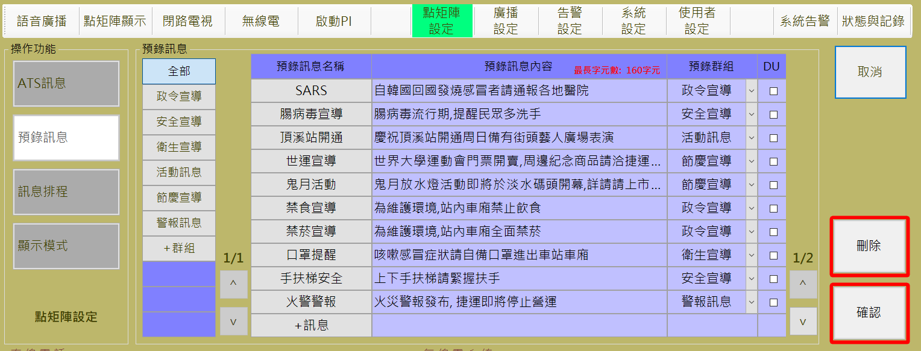

圖 4‑79: 預錄訊息管理作業

Figure 4‑79: Pre-record message Management assignment

1. 群組標籤設定，如圖 4‑80：
2. **新增：**操作人員可透過**群組**表格下方第一行的 “**+群組**” 按鈕來建立新的語音群組與群組名稱。
3. **儲存**：”**確認**” 按鈕是用來儲存設定值。
4. **取消：** “**取消**” 按鈕則是復原設定值。
5. **刪除：** “**刪除**” 按鈕則是用來刪除點選到的群組，原群組中的訊息將歸建為無群組分類。
6. Group Catalog Setting, as shown in Figure 4‑80：.
7. **Add :** The operator can create a new group and group name by press the "+群組(Group)" button on the first line below the group table in the setting block.
8. **Save**：Press “**確認**(Confirm) “ button can store the Setting result.
9. **Cancel**：”**取消**” (Cancel) button can recover the original Setting value.
10. **Delete**：”**刪除**” (Delete) " is used to delete the selected group, the original group of messages will be built into a groupless classification

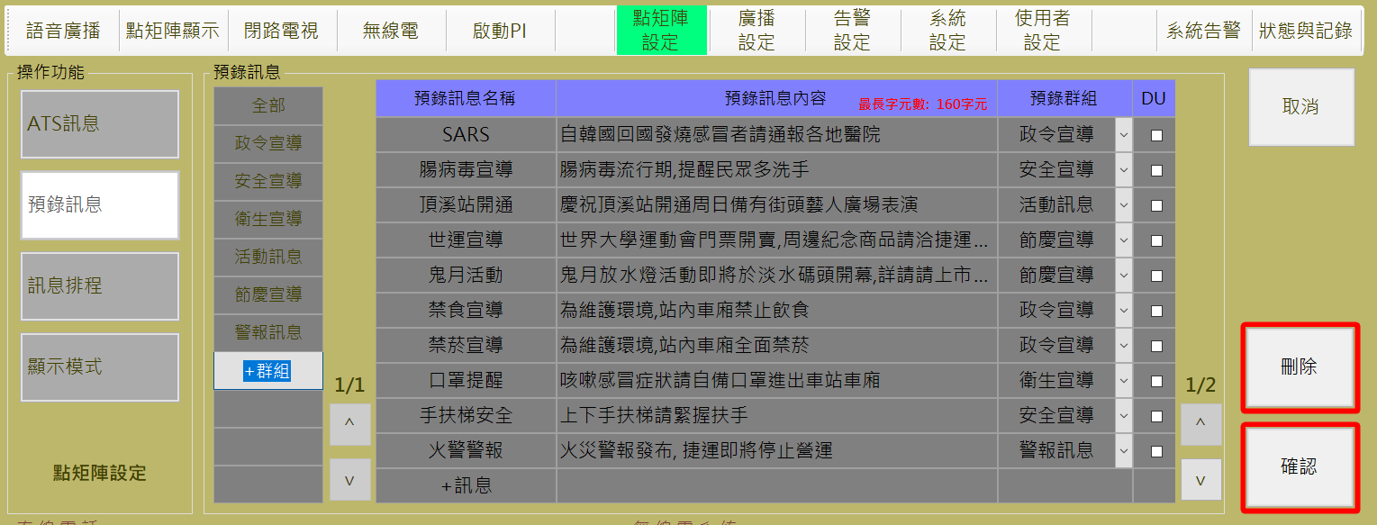

圖 4‑80: 新增點矩陣預錄訊息群組

Figure 4‑80: Add a DMD Group diagram

1. 預錄語音提示內容與群組設定，如圖 4‑81，其中DU預存訊息最多為15則，勾選大於15則時會出現警示訊息拒絕存取：
2. **新增：**操作人員可透過**預錄訊息**表格中第一欄”**預錄訊息名稱**”下方第一行的 “**+訊息**” 按鈕來建立新的預錄訊息，包含訊息名稱、顯示內容、所屬群組以及是否為DU預存訊息。
3. **編輯：**操作人員可透過按下預錄語音檔表格中第一欄 “**預錄語音名稱**” 按鈕進入預錄訊息編輯模式，資訊包含
4. 修正訊息名稱。
5. 顯示內容。
6. 所屬群組。
7. 是否為DU預存訊息。
8. **儲存**：”**確認**” 按鈕是用來儲存設定值。
9. **取消：** “**取消**” 按鈕則是復原設定值。
10. **刪除：** “**刪除**” 按鈕則是用來刪除點選到的群組，原群組中的音檔將歸建為無群組分類。
11. To edit Pre-recorded audio information, as shown in Figure 4‑81, beside DU stored messages up to 15, check more than 15 will appear when the warning message denied access：
12. **Add :** The operator can create a new message name by press the "+**訊息**(Message)" button on the first line below the pre-recorded message table, including the name of the message, the content of the display, group classification, and whether the message is stored for the DU.
13. **Editing** : The operator can enter the pre-message editing mode by pressing the "Pre-recorded voice name" button in the first column of the pre-recorded message table, including
14. the name of the message to be amended.
15. the contents of the message.
16. group classification.
17. whether the message is stored for the DU.
18. **Save**：Press “**確認**(Confirm) “ button can store the Setting result.
19. **Cancel**：”**取消**” (Cancel) button can recover the original Setting value.
20. **Delete**：”**刪除**” (Delete) " is used to delete the selected group, the members on the group will be into a groupless classification

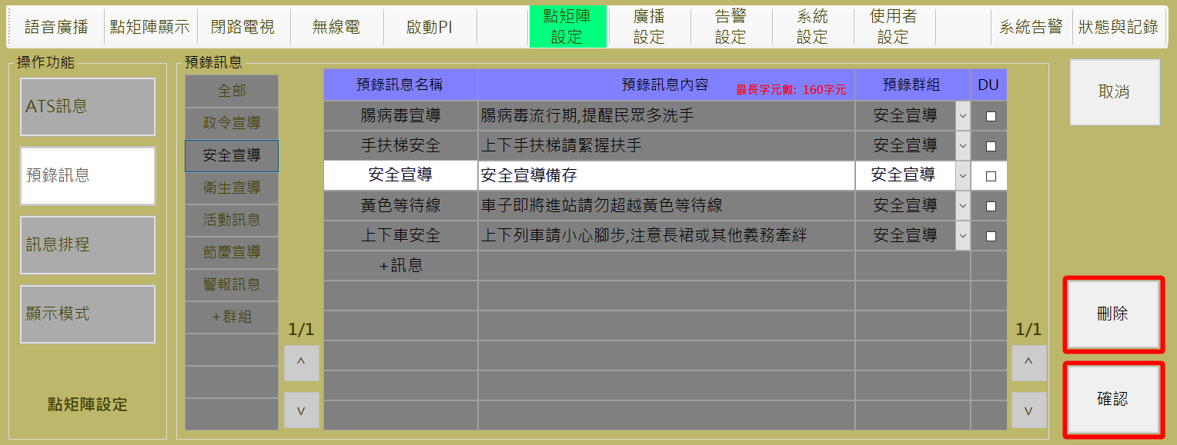

圖 4‑81: 預錄訊息編輯作業

Figure 4‑81:To edit Pre-record message assignment

#### 訊息排程設定 DMD Message Schedule Setting

點矩陣排程設定作業主要是提供操作人員設定定時語音播放處理。

每日凌晨四點，CMFT系統會自動載入上周中同一天最後設定的排程資料，進行當日排程作業，如圖 4‑82為例，可於前七日排程預覽表格中預覽上一個星期五的排程，同時自動仔入至今日排程表個中，CMFT系統每日循環時間定義為當日凌晨四點至隔日凌晨四點。

DMD Schedule Setting assignment is used for operator to Setting the DMD schedule broadcast.

At 4 am every day, the CMFT system will automatically load the last scheduled schedule information of the same day in the last week and schedule the day's homework. For example, as shown in Figure 4‑82, preview can be previewed in the schedule of the first 7 days Last Friday's schedule, while automatically enrolled into today's schedule, the CMFT system daily cycle time is defined as 4:00 the same day to 4:00 the next day.

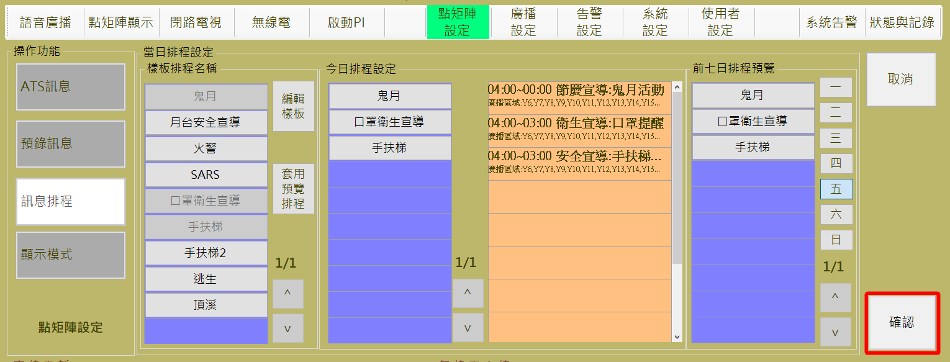

圖 4‑82: 訊息排程內容設定作業

Figure 4‑82: DMD message display schedule Setting assignment

##### 今日排程設定 Daily Schedule Setting

1. 操作人員可參考“**前七日排程預覽**”區塊內的排程建立當日排程，按下一到日的日期按鈕會帶出該星期最後的排程資訊，如圖 4‑83，操作人員可透過**排程名稱**區塊內的的 “**套用預覽排程**” 按鈕來複製所選擇的前七日預覽排程 (如圖 4‑84)。
2. 今日排程清單編輯：
3. 新增單一排程：點選“**樣板排程名稱**”表格中的任一樣板，將新增至“**今日排程設定**”。
4. 刪除單一排程：點選“**今日排程設定**”表格中的任一排程項目，將自“**今日排程設定**”表格中移除，並且在“**樣板排程名稱**”表格中復原該項目。
5. 設定排程至伺服器：
6. **儲存**：”**確認**” 按鈕是用來儲存今日排程設定值。
7. **取消：** “**取消**” 按鈕則是復原今日排程設定值。
8. The operator may refer to the scheduled schedule for the schedule in the "**前七日排程預覽(**Preview Schedule from the same day last week)" block. Pressing the date button on the next day will bring out the last scheduled schedule information for the week, as shown in Figure 4‑83. The operator can Through the Schedule Name block within the "Apply Preview Schedule" button to copy the selected seven-day preview schedule (Figure 4‑84).
9. Today's schedule list edit:

(1) Add a single item: click on any of the templates in the “**樣板排程名稱**(template schedule name)" table, will be added to the "**今日排程設定(**today's schedule settings)" table.

(2) Delete a single item: Click on any of the schedule items in the "**今日排程設定(**Today Schedule Settings)" table, it will be removed from the "**今日排程設定(**Today Schedule Settings)" table, and recover it on the "**樣板排程名稱**(template schedule name)" table

1. Schedule Setting to Server：
2. **Save**：**確認**(Confirm) “ button can store the Setting result.
3. **Cancel**：”**取消**” (Cancel) button can recover the original Setting value.



圖 4‑83: 前七日排程預覽示意圖

Figure 4‑83: The first seven days schedule preview diagram

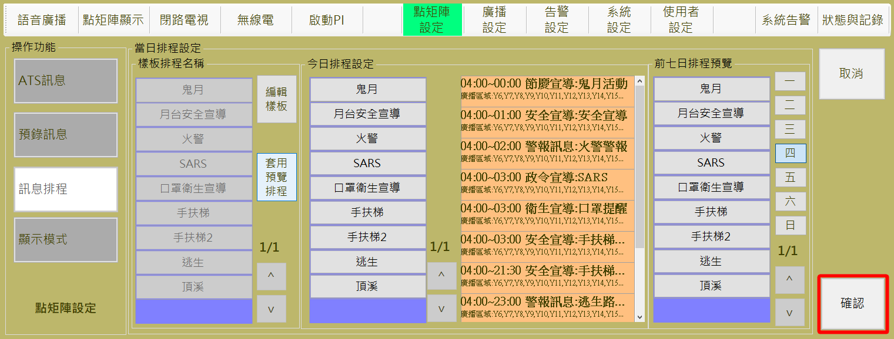

圖 4‑84: 點矩陣排程內容設定作業

Figure 4‑84: DMD schedule Setting assignment

##### 排程樣板設定Schedule Template Setting

操作人員如果要修改排程內容，可以按 “**編輯樣版**” 鈕，進入修改語音排程畫面 (如圖 4‑85)。

操作人員可透過**排程樣版**區塊內的 “**回到排程設定**” 按鈕結束編輯作業並回到語音排程設定頁面。

Operator can use “**編輯樣版**” (Edit Sample) bottom switch to the broadcast schedule edit mode (as Figure 4‑85).

Operator can use the “**回到排程設定**” (Back to Previous Page) button in “**排程樣版**” (Template Schedule) block to finish the edit process and back to the Schedule Setting page.

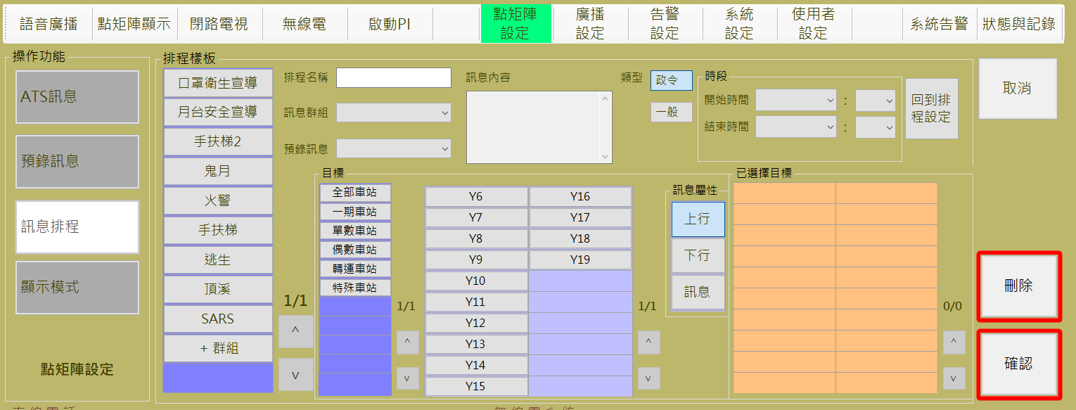

圖 4‑85: 排程樣板設定畫面

Figure 4‑85: Schedule template setting Page

1. 樣板設定操作:
2. **新增：**操作人員可透過**排程樣版**區塊內第一行的 “**+群組**” 按鈕來建立新的樣板，設定樣板名稱、廣播音檔、觸發對象、 觸發時間與次數等，如圖 4‑86。
3. **編輯：**點選”**排程樣版**”表格中的樣板，可進行樣板名稱、廣播音檔、觸發對象、 觸發時間與次數的修改。
4. **儲存：**”**確認**” 按鈕是用來儲存樣板設定值。
5. **取消：** “**取消**” 按鈕則是復原樣板設定值。
6. **刪除：**”**刪除**” 按鈕則是用來刪除指定排程樣板。

Template Setting :

1. **Add：**Operator can use the “**+群組**” (Add Group.) button at the 1PPPPstPPPP column in “**排程樣版**” (Template Schedule) block to build a new schedule template, and edit the contents including name, audio file, targets, trigger timing and frequency, as shown in Figure 4‑86.
2. **Edit：**Press the cell of the ”**排程樣版(Schedule Template)**” Table , to edit the contents including name, audio file, targets, trigger timing and frequency.
3. **Save：**”**確認(Confirm)**” button can store the template setting result。
4. **Cancel：** “**取消(Cancel)**” button can recover the original Setting value。
5. **Delete：**”**刪除(Delete)**” button is used to delete a specified template。

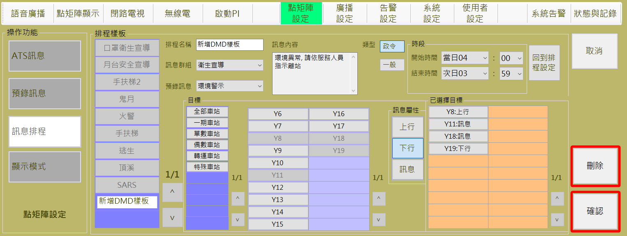

圖 4‑86: 新增點矩陣排程樣板畫面

Figure 4‑86: Add a new DMD Schedule template setting Page

#### 顯示模式設定 Display Mode Setting

顯示模式設定作業主要是提供操作人員設定車站內大廳顯示器與上下行月台顯示器訊息顯示方式(如圖 4‑87)。

操作人員可直接選取車站，進行單一車站大廳顯示器與上下行月台顯示器顯示模式設定。亦可利用圖中提供的按鈕功能進行多站設定。

圖中最底部”CDU目前版面樣式”與”PDU目前版面樣式”，將會根據編輯結果呈現顯示器文字顏色預覽效果，其中灰色格表示設定為特殊規範停駐顯示單元，白色格表示為一般文字訊息顯示單元用。

Display Mode Setting assignment is used for operator to Setting the DMD message display mode of CDU and PDU in station(s) (as Figure 4‑87).

Operators can directly select the station for a single station CDU and PDU mode settings. You can also use the button function provided in the figure for multi-station setting.

All settings must be confirmed by pressing the button , then system will do the the monitor configuration settings.

At the bottom of the figure, " CDU目前版面樣式(CDU Current Layout Style)" and " PDU目前版面樣式(PDU Current Layout Style)" will display the monitor preview according to the editing result.

Display text color preview effect, in which the gray grid that set to a special specification docking display unit, the white grid that is used for general text message display unit.

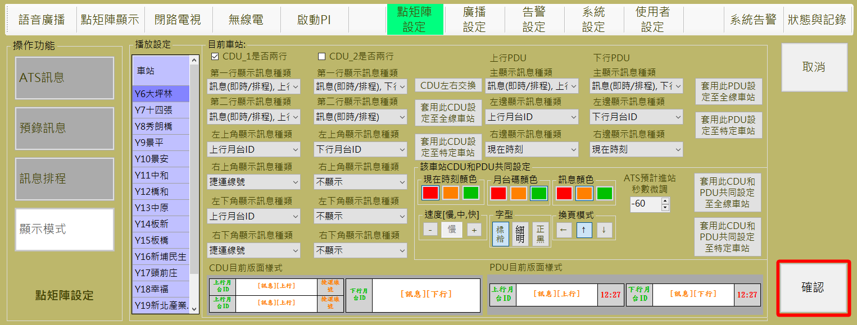

圖 4‑87: DMD 訊息顯示模式設定作業

Figure 4‑87: DMD message display mode Setting assignment

1. 一般文字訊息顯示單元：
2. **訊息(即時/排程)：**來自排程設定或操作員發送的即時訊息。
3. **上行**：根據ATS訊息中與上行列車相關的資訊。
4. **下行：**根據ATS訊息中與上行列車相關的資訊。
5. **隨文字時間：** 若勾選此選項，則時間資料會跟隨(1)~(3)播放訊息之後。
6. General text message display unit：.
7. **Message (Manual / Scheduled):** message from the schedule settings or instantly inputted by the operator.
8. **Up Track**：According to the ATS message about uplink train related information.
9. **Down Track**：According to the ATS message about downlink train related information.
10. **Time Followed Message**：”**刪除**” (Delete) " is used to delete the selected group, the original group of audio files will be built into a groupless classification
11. 特殊規範停駐顯示單元：

可以針對CDU四個角落以及PDU前後兩端指定特殊顯示資料。

1. **不顯示：**不設定資料下，CDU右上與右下皆無設定特殊規格則一般訊息將從顯示器最前端開始配置，左上左下同理。PDU若前端或後端無設定特殊規格，則一般訊息將從顯示器最前端開始配置或者顯示至最後端。
2. **現在時刻**：顯示設定的區域顯示現在時刻。
3. **捷運線號：** 顯示環狀線捷運線代碼。
4. **上下行月台ID：** 顯示該月台定義的月台代碼。
5. Special specifications on Specified corner the display unit：

Specify the special display data for the 4 corners of CDU and front and rear parts of PDU

1. **No Display** : No setting information, if CDU upper right and lower right are not set special specifications, the general information is displayed from the front of the monitor configuration, as well as left and down corners. If no special specifications are set for the front or rear of the PDU, the general message will be configured from the front of the monitor or displayed to the rear.
2. **Current Time**：Displayed the set area shows the current time.
3. **Line Code**：Displayed the Number of MRT line.
4. **The Platform ID of Up track or Down Track**：Displayed the platform ID of Up track or Down Track.
5. 顯示設定：
6. 顏色:文字種類區分為現在時刻月台碼顏色以及訊息，可針對三種資料進行顯示顏色設定，目前提供的顏色為琥珀，綠色與紅色三種。
7. 速度：針對跑馬燈文字顯示速度提供快、中、慢三種選項，可將滑鼠移到｢速度｣文字上將顯示快、中、慢的字數移動數據。
8. 字型：提供標楷體、細明體以及正黑體等三種字形供使用者設定。
9. 換頁模式：←↑↓，各表示跑馬燈文字流動方式為項左進，向上翻或向下翻。
10. Display Setting:
11. Color: The text type is divided into the current time and the platform code and the message. The currently provided colors are amber, green and red to set the three kind text types.
12. Speed: the fast, medium, and slow speed options for message display flow. You can move the mouse to the “Speed” text to display word count movement data for the the fast, medium, and slow meanings.
13. Font：Provides three types of fonts for the user: DFKai-sb, MingLiU, and Microsoft JhengHei.
14. Page change mode: ← ↑↓, each means that the scrolling mode of the marquee text is left entry, scroll up or down.
15. 按鈕功能：
16. CDU左右交換” 按鈕：將CDU_1與CDU_2設定進行交換。
17. ”套用此CDU設定至全線車站” 按鈕：將目前正在設定的CDU訊息屬性，配置進行全線車站複製，套用相同設定。
18. ”套用此CDU設定至特定車站” 按鈕：將目前正在設定的CDU訊息屬性，根據所選的車站進行複製，套用相同設定。
19. ”套用此PDU設定至全線車站” 按鈕：將目前正在設定的PDU訊息屬性，進行全線車站複製，套用相同設定。
20. ”套用此PDU設定至特定車站” 按鈕：將目前正在設定的CDU訊息屬性，根據所選的車站進行複製，套用相同設定。
21. ”套用此CDU和PDU共同設定至全線車站” 按鈕：將目前正在設定的CDU和PDU共同設定，如顏色相關設定、字型、跑馬燈速度、換頁方式以及ATS進站微調秒數等配置，進行全線車站複製，套用相同設定。
22. ”套用此CDU和PDU共同設定至特定車站” 按鈕：將目前正在設定的CDU和PDU共同設定，如顏色相關設定、字型、跑馬燈速度、換頁方式以及ATS進站微調秒數等配置，根據所選的車站進行複製，套用相同設定。
23. **儲存並執行至DU上**：所有在畫面進行的設定修改，必須按下”**確認**” 按鈕後，才會有CMFT系統下達指令至DCU伺服器上進行DU配置。
24. **取消：** “**取消**” 按鈕則是畫面數據將恢復原設定值，與DCU服務器上的配置相同。
25. Button Function：.
26. **Swap Right And Left Setting For CDU** : Swap CDU_1 and CDU_2 settings..
27. "**Apply this CDU to all stations**" button: Copy the CDU message properties currently settled, configure to all stations, to apply the same settings.
28. "**Apply this CDU to specific stations**" button: Copy the CDU message properties currently settled, configure to specific stations, to apply the same settings.
29. "**Apply this PDU to all stations**" button: Copy the PDU message properties currently settled, configure to all stations, to apply the same settings.
30. "**Apply this PDU to specific stations**" button: Copy the PDU message properties currently settled, configure to specific station, to apply the same settings.
31. "**Apply the Common Setting of CDU and PDU to all stations**" button: Copy the currently settled PDU common setting, including text color, font type, speed of text display and the direction of changing page configure to all stations, to apply the same settings.
32. "**Apply the Common Setting of CDU and PDU to specific stations** " button: Copy the currently settled PDU common setting, including text color, font type, speed of text display and the direction of changing page configure to specific stations, to apply the same settings..
33. **Save and execute to DU**: All settings modified on the screen should be sent by the CMFT system to the DU configured on the DCU server after pressing the "確認(Confirm)" button.
34. **Cancel**: Press "取消(Cancel)" Button, the screen will recover the original settled value as same as the configuration on DCU server.

### 點矩陣顯示 DMD Control

本作業含**列車PIDS**控制**、車站DMD**控制二個操作項目 (如圖 4‑88)。

This function include **Car PIDS Control** and **Station DMD Control** two operation items (as Figure 4‑88).

所有的列車PIDS緊急播放設定內容會列在**列車站語音廣播**功能項目左方的 “**列車PIDS緊急播放**” 列表內，所有的車站DMD排程設定內容則會列在”**車站DMD播放”**功能項目的右方，以供參考。系統允許操作人員選取非預定排程項目後，使用刪除按鈕將之移除，特別是列車PIDS緊急訊息為最高權限的播放若沒有經過釋放，則該列車將由緊急播放清單無限循環。

表格內顯示為綠色底的資料為現在正在播放的語音事件，來自排程的事件為黑色字體，來自主控台端操作員手動下達的事件為紫色字體。當滑鼠移到該表格上可以語音廣播詳細的資訊，包含時間設定語音檔案及廣播區域。

All the car(s) broadcast schedule(s) will list at the left side of “**列車語音廣播**” (Train PA) function button and the Broadcast on Station schedule(s) will list at the right side of “**車站語音廣播**” (Station PA) function button for reference. Operator can select the non-scheduled items and use the “**刪除**” (Delete) button to stop and remove them from the list, especially train PIDS emergency message for the highest authority of the broadcast, if not released, the train will be an infinite loop from the emergency playlist.

The cell shown in green background is the speech event currently playing, events from the schedule are black fonts, events manually dispatched from the console console operator are purple fonts. When the mouse is moved to this cell, detailed information dispalyed, including the time-set ,audio file name and the broadcast area.

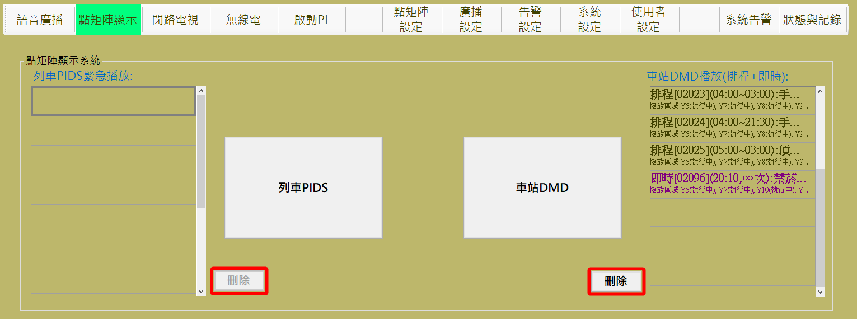

圖 4‑88: 點矩陣顯示器控制操作主頁

Figure 4‑88: Main page of DMD operation

#### 列車PIDS控制 Car PIDS Control

進行本作業，請依 “**選擇目標對象**→**廣播方式及內容**→**開始播放**” 三個步驟進行。

Progress this function, please follow “**Select Targets →Select Content and Display Mode →Start Display**” the three steps to operate.

列車點矩陣播放的優先權為：緊急>ATS訊息>一般>基底

其中基底訊息為當PIDS於固定時間內沒有收到任何指令，即啟動基底訊息播放。

The playing priority of PIDS is: emergency> ATS message> general> ordinance> basement

The base message is that when the PIDS does not receive any instruction within a fixed time, the base message playback is started.

##### 步驟1選擇目標對象 Step 1 Select Targets

操作人員於本程序內選取欲進行點矩陣訊息的列車 (可多選) (如圖 4‑89)，來源區域中的深紫色表格為自訂群組，點選後將自動帶入目前符合該群組條件的列車於已選擇項目的橘色表格中，亦可於淺紫色表格中將目標列車點選至橘色表格，若項目已存在橘色表格，則淺紫色表格中，該列車呈現無法點擊狀態，若點擊橘色表格中的單元格，則表示取消選取該列車，由橘色表格中移除，並啟用淺紫色表格內的單元格。

選取完成後，請按 “下一步” 按鈕進行下一步驟，如果要變更作業項目，請按 “上一步” 按鈕回功能主頁。

Operator select the Train(s) in this step (as). The operator selects the train to play DMD message (multiple choice) (as shown in Figure 4‑91) within this program. The dark purple table in the source area is a custom group, click the cell will automatically imported the eligible trains matching the group's criteria into the orange table of selected items, as well as click the cell in the light purple table, the train can be selected into the orange table, if the train already exists in the orange form, the train in the light purple table is the disabled status; Clicking on the cell in the orange table means that the train is deselected, removed from the orange table, and the cell in the light purple table is enabled.

After selection complete, please click “下一步” (Next Step) button to next step. If want to change operation item, please click “上一步” (Last Step) button back to the operation main page.

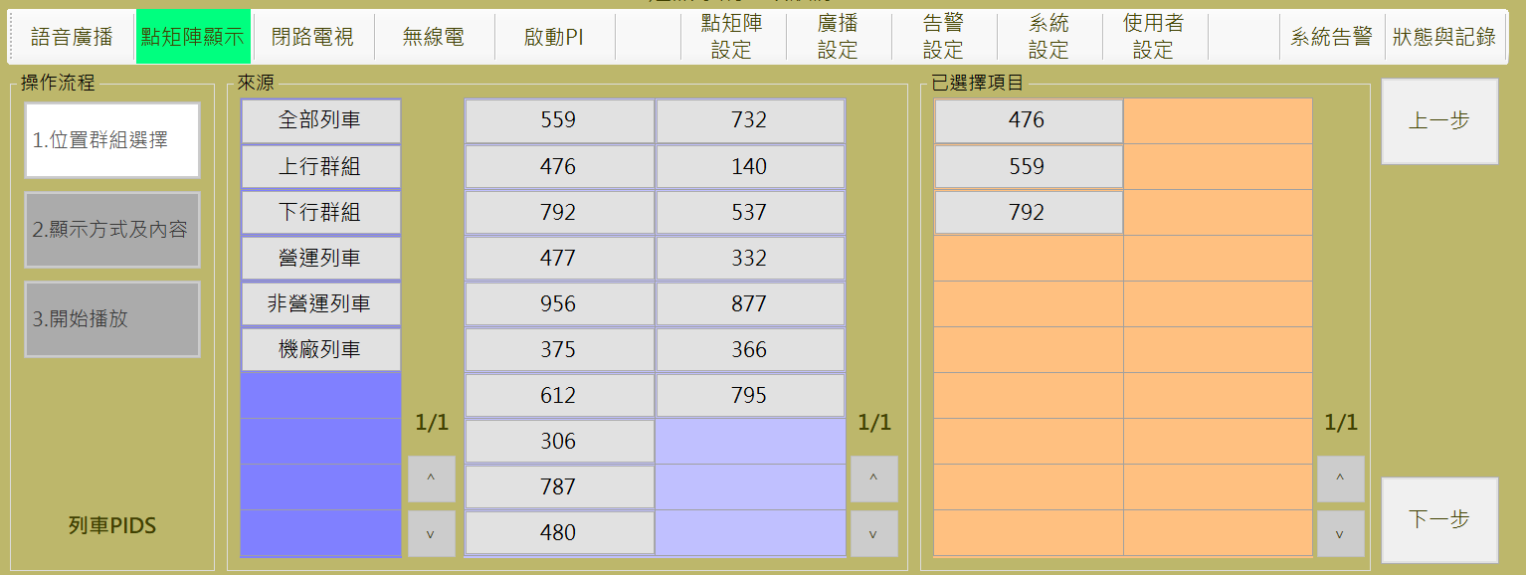

圖 4‑89: 列車PIDS控制 步驟1 (位置群組選擇)

Figure 4‑89: Car PIDS control step 1 (Select Location)

##### 預錄訊息與即時訊息 Pre-record Message and Real-time Message

操作人員可選擇播放**預錄訊息**或**即時訊息**，分別說明如后:

Operator can select to display pre-record message or real-time message. Operation will be descripted as below:

###### 播放預錄訊息處理 Pre-record Message Display Process

**步驟2:** 操作人員點選 “**廣播方式及內容**” 區的 “**預錄訊息**” 頁簽後，可開啟播放預錄訊息操作頁面 (也是預設作業)。然後選擇準備播放的訊息，完成類型及播放次數設定，按 “**播放**” 開始進行播放處理，按 “ **上一 步**” 回前一操作頁面(如圖 4‑90)

**Step 2:** Operator select “**預錄訊息**” (Pre-record Message) tab in “**廣播方式及內容**” (Select Content and Display Mode) block to open pre-record message display Setting page (This is default operation page also). Then select message, set message type and the display times to complete operation. After operation finish, please click “**播放**” (Start) button to progress remote message display program. Click “**上一步**” (Last Step) button back to the last step (as Figure 4‑90).

如果**訊息類型**選取 “**緊急**”，顯示次數預設是 “**∞**” ，但是可以變更。

If **message type** is “**緊急**” (Emergency), the default display times is “**∞**” (unlimited) but can be changed.

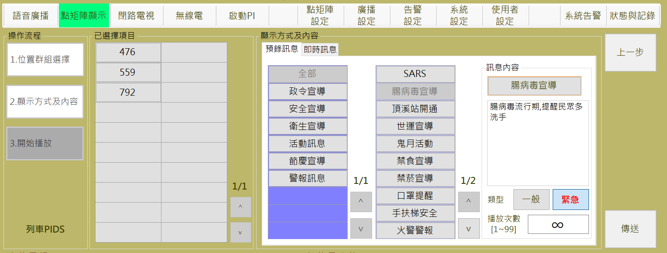

圖 4‑90: 預錄訊息播放操作

Figure 4‑90: Pre-record message display operation

**步驟3:**系統開始播放時會先連接指定車載系統，，在 “**已選擇項目**” 的列車上顯示“**執行中**“，若成功發送訊息，將顯示 “**成功**” 狀態，否則會顯示失敗理由：如“**失聯**”(如圖 4‑91)。結束作業請按 “**結束**” 按鈕。

**Step 3:** When the system starts to play, it will be connected to the designated vehicle system first, and "**執行中(**Running)" will be displayed on the train of “**已選擇項目**(Selected Items)". If the message is successfully sent, the status of "**成功**”(Success)" will be displayed Otherwise, it will show the failed reason, ex “**失聯**” (Disconnected) status(as Figure 4‑91). To end the job, press the "End" button.

will response “**成功**” (Success) status in the station(s) and equipment(s) table of block. Otherwise, it will show the failed reason, ex “” (Disconnected) status. To finish this operation, please click “**結束**” (Close) button.

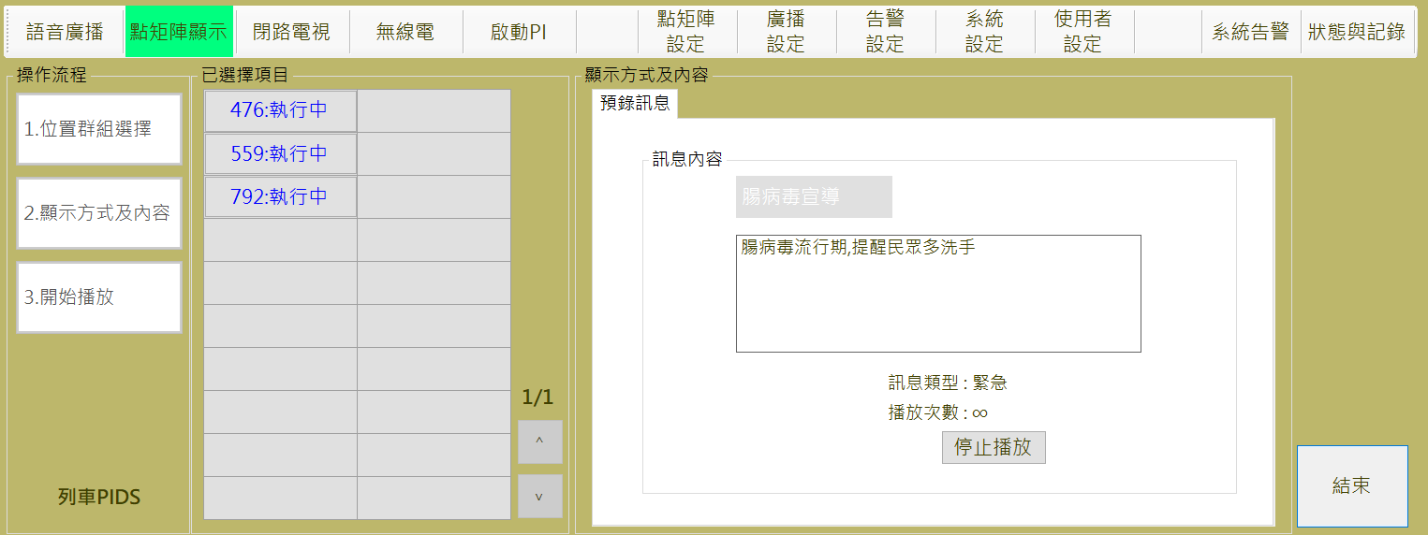

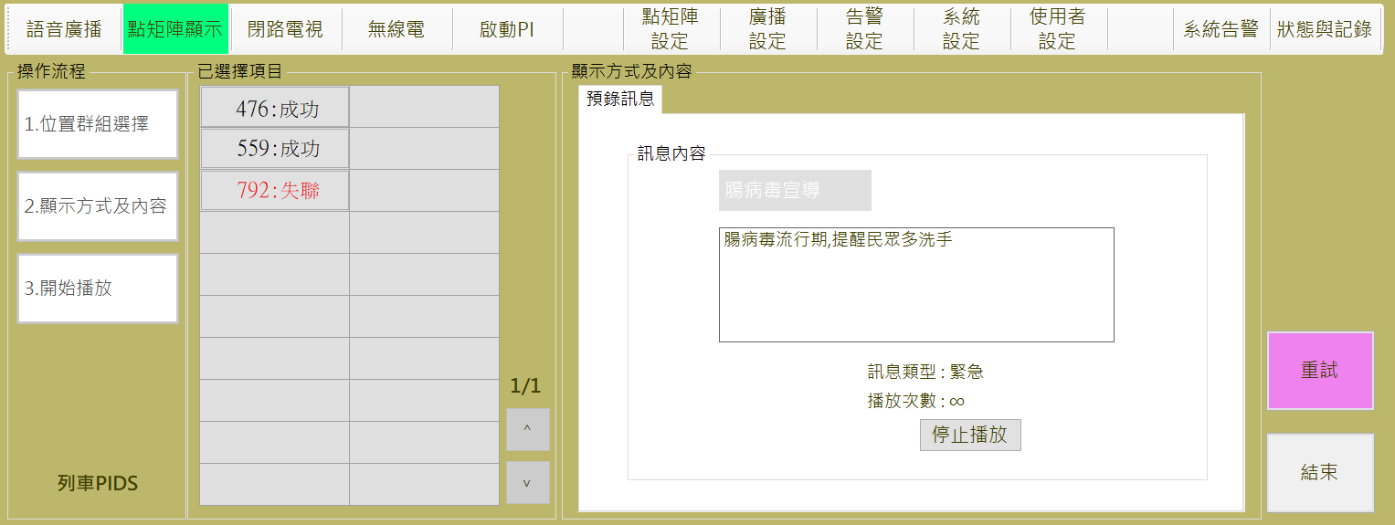

圖 4‑91: 預錄訊息播放結果回報

Figure 4‑91: Pre-record message display result

###### 播放即時訊息處理 Real-time Message Display Process

**步驟2:** 操作人員點選 “**廣播方式及內容**” 區的 “**即時訊息**” 頁簽後，可開啟播放即時訊息操作頁面。然後輸入準備播放的訊息，完成類型及播放次數設定後，按 “**播放**” 開始進行播放處理，按 “ **上一步**” 回前一操作頁面(如圖 4‑92)

**Step 2:** Operator select “**即時訊息**” (Real-time Message) tab in “**廣播方式及內容**” (Select Content and Display Mode) block to open real-time message display Setting page. Then input the message content, set message type and the display times to complete operation. After operation finish, please click “**播放**” (Start) button to progress remote message display program. Click “**上一步**” (Last Step) button back to the last step (as Figure 4‑92).

類型若為”緊急”播放次數會自動帶入 “**∞**”，UUUU表示無限播放UUUU。

The default display times for real-time message is “**∞**” (unlimited) but can be changed.

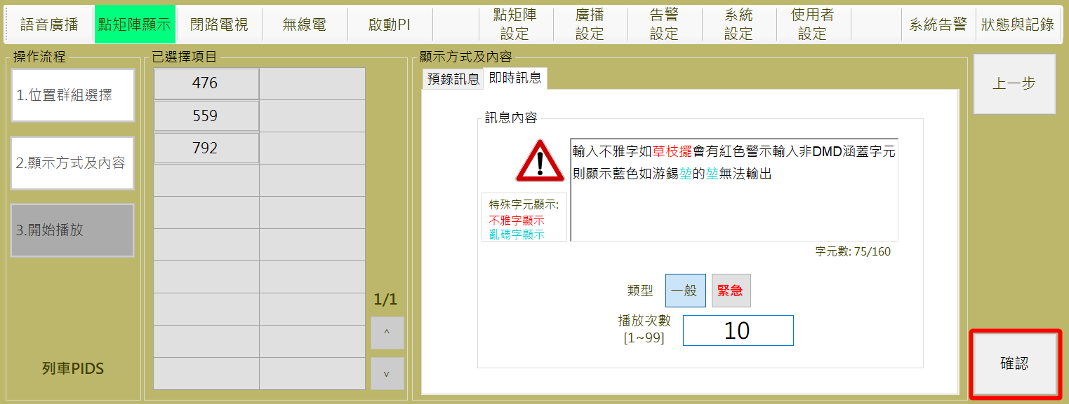

圖 4‑92: 播放即時訊息操作

Figure 4‑92: Display real-time message operation

**步驟3:**系統開始播放時會先連接指定車站系統，如果正常會在 “**已選擇項目**”的指定車站及設備上顯示 “**成功**” 狀態，否則會顯示 “**失敗**”(如圖 4‑93)。

結束作業請按 “**結束**” 按鈕。

系統另外提供 “**重試**” 功能，可以再次嘗試傳送設定訊息。

**Step 3:** When system start to display message, it will try to connect to specified station(s) system. If success, it will response “**成功**” (Success) status in the station(s) and equipment(s) table of “**已選擇項目**” (Selected Station) block. Otherwise, it will show “**失敗**” (Failed) status (as Figure 4‑93). To finish this operation, please click “**結束**” (Close) button. Additional function button “**重試**” (Retry) is provided for message resend

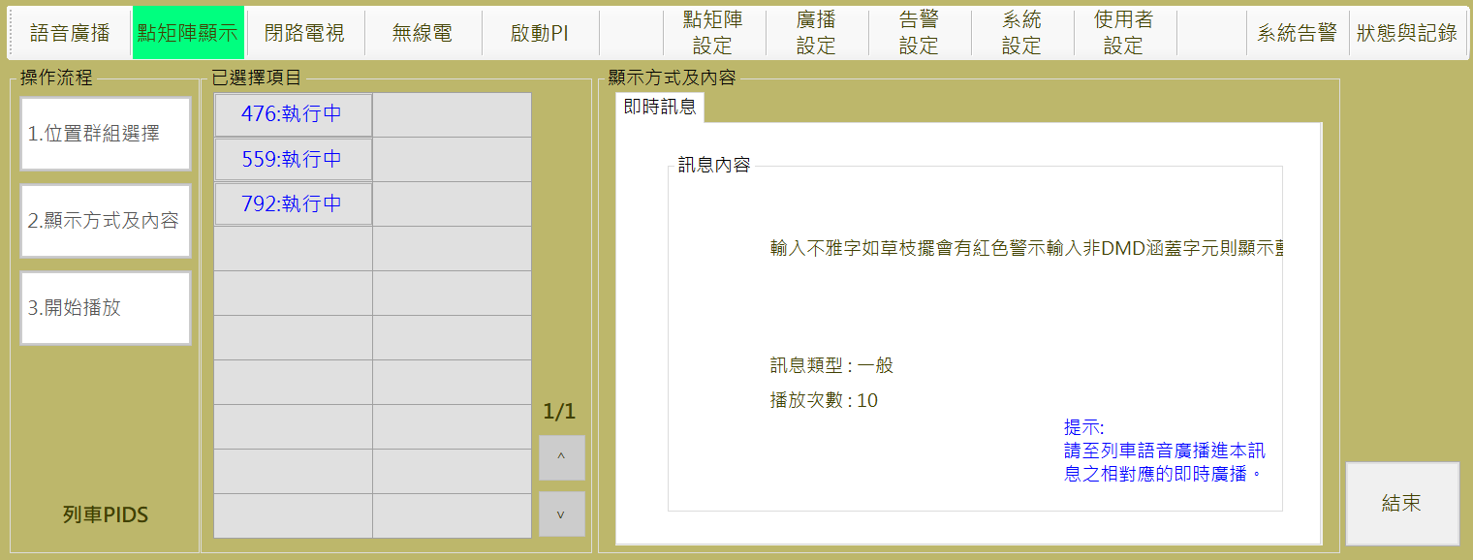

圖 4‑93: 即時訊息播放結果回報

Figure 4‑93: Real-time message display result

#### 車站DMD控制 Station DMD Control

進行本作業，請依 “**選擇目標對象**→**廣播方式及內容**→**開始播放**” 三個步驟進行。

Progress this function, please follow “**Select** Position **→Select Broadcast Source→Start Display**” the three steps to operate.

車站點矩陣播放的優先權為：緊急>ATS訊息>一般>政令>基底

其中基底訊息為當DU於固定時間內沒有收到任何DCU主機指令，即啟動基底訊息播放。

The priority of station point matrix playing is: emergency> ATS message> general> ordinance> basement

The base message is that when the DU does not receive any DCU host instruction within a fixed time, the base message playback is started.

###### 步驟1選擇目標對象 Step 1 Select Targets

操作人員於本程序內選取欲進行廣播的**車站**(可多選) (如圖 4‑94

圖 4‑95: 車站DMD 步驟1-2 (目標對象選擇)

Figure 4‑95: Station DMD control step 1-2 (Select Station)，來源區域中的深紫色表格為自訂群組，點選後將自動帶入目前符合該群組條件的列車於已選擇項目的橘色表格中，亦可於淺紫色表格中將目標列車點選至橘色表格，若項目已存在橘色表格，則淺紫色表格中，該列車呈現無法點擊狀態，若點擊橘色表格中的單元格，則表示取消選取該列車，由橘色表格中移除，並啟用淺紫色表格內的單元格。

選取完成後，請按 “**下一步**” 按鈕進行下一步驟，如果要變更作業項目，請按 “**上一步**” 按鈕回功能主頁。

Operator select the Station(s) in this step (as). The operator selects the train to be broadcast (multiple choice) (as shown in as Figure 4‑94) within this program. The dark purple table in the source area is a custom group, click the cell will automatically imported the eligible trains matching the group's criteria into the orange table of selected items, as well as click the cell in the light purple table, the train can be selected into the orange table, if the train already exists in the orange form, the train in the light purple table is the disabled status; Clicking on the cell in the orange table means that the train is deselected, removed from the orange table, and the cell in the light purple table is enabled.

After selection complete, please click “**下一步**” (Next Step) button to next step. If want to change operation item, please click “**上一步**” (Last Step) button back to the operation main page.

系統開始播放時會先連接指定車站系統，由淺紫色表格中可見DCU主機連線狀態。

When the system starts playing, it will connect to the designated station system first, and the connection status of the DCU host computer can be seen from the light purple table.

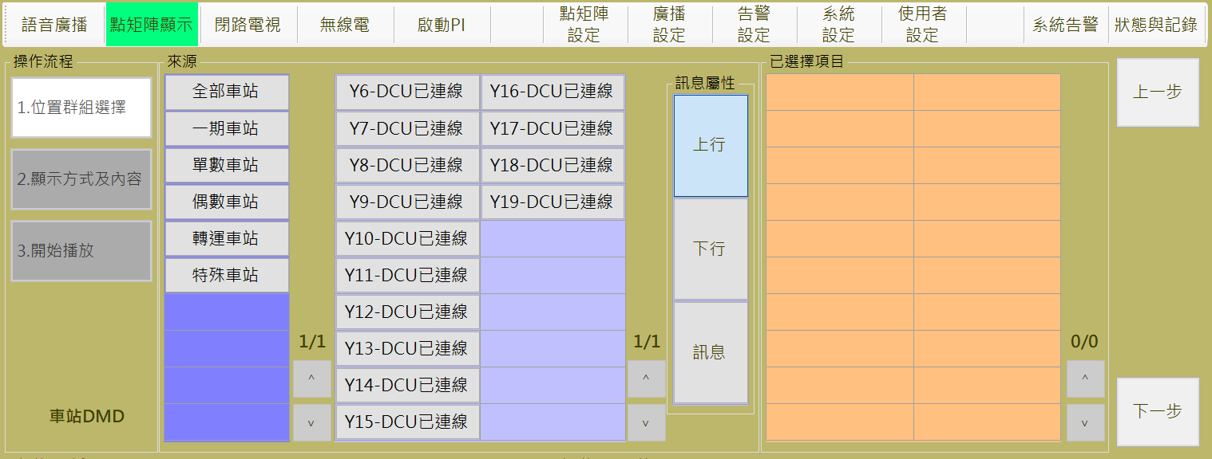

圖 4‑94: 車站DMD 步驟1-1 (目標對象選擇)

Figure 4‑94: Station DMD control step 1-1 (Select Station)

因CDU，PDU設置上的差異，拋送訊息時必須先設定訊息屬性

訊息屬性：

上行：ATS訊息中上行軌列車相關的資訊。

下行：ATS訊息中下行軌列車相關的資訊。

訊息：一般訊息輸入。

Due to different configuration in CDU, PDU settings, message attributes must be set when messages are thrown

Message Properties:

Upstream: ATS messages related to up-and-going railcars.

Downstream: ATS messages related to down-track railcars.

Message: General message by manually typing.

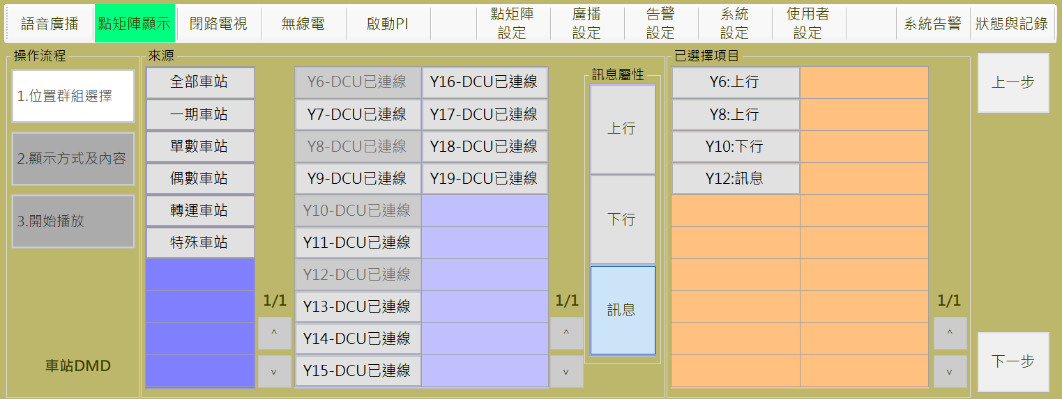

圖 4‑95: 車站DMD 步驟1-2 (目標對象選擇)

Figure 4‑95: Station DMD control step 1-2 (Select Station)

##### 預錄訊息與即時訊息 Pre-record Message and Real-time Message

操作人員可選擇播放**預錄訊息**或**即時訊息**，分別說明如后:

Operator can select to display pre-record message or real-time message. Operation will be descripted as below:

###### 播放預錄訊息處理 Pre-record Message Display Process

**步驟2:** 操作人員點選 “**廣播方式及內容**” 區的 “**預錄訊息**” 頁簽後，可開啟播放預錄訊息操作頁面 (也是預設作業)。然後選擇準備播放的訊息，完成類型及播放次數設定，按 “**播放**” 開始進行播放處理，按 “ **上一 步**” 回前一操作頁面(如圖 4‑96)

**Step 2:** Operator select “**預錄訊息**” (Pre-record Message) tab in “**廣播方式及內容**” (Select Content and Display Mode) block to open pre-record message display Setting page (This is default operation page also). Then select message, set message type and the display times to complete operation. After operation finish, please click “**播放**” (Start) button to progress remote message display program. Click “**上一步**” (Last Step) button back to the last step (as Figure 4‑96).

如果訊息**類型**選取 “緊急”，顯示次數預設是 “∞”。

If message type is “緊急” (Emergency), the default display times is “∞” (unlimited).

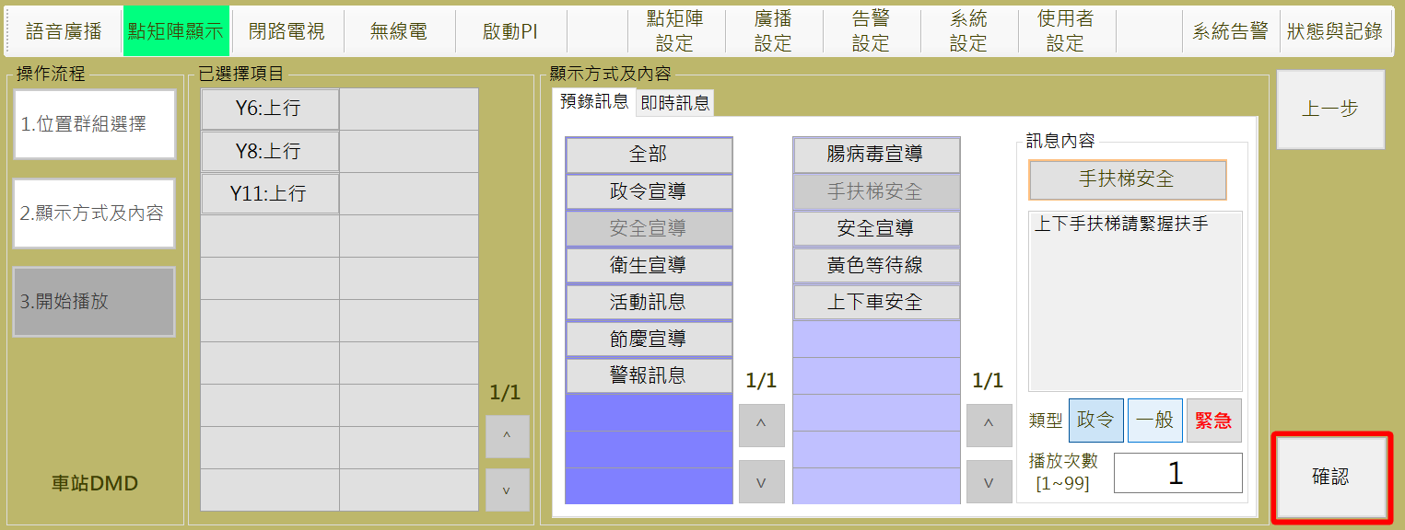

圖 4‑96: 預錄訊息播放操作

Figure 4‑96: Pre-record message display operation

**步驟3:**如圖 4‑97在 “**已選擇項目**” 的指定車站及設備上顯示成功狀態，順序如下:

已送DCU：已經傳送指令至DCU主機執行中。

執行中：DCU主機回送正在執行中。

播放完畢：表示該則訊息於該車站已經播放結束。

另外，當執行失敗或傳送失敗，會顯示 “**失敗**”狀態。

結束作業請按 “**結束**” 按鈕，當按下此按鈕後，無論訊息是否結束都將傳送刪除指令結束該訊息的播放。

當全部資料執行結束或全部失敗後，可以按下“**重試**”，再次嘗試重送DCU主機。**Step 3:** As shown in as Figure 4‑97, the successful status is displayed on the designated station in "Selected Items" Table, in the following order:

已送DCU (DCU sent): Command has been sent to the DCU host executing.

執行中(In progress): DCU host loopback is in progress.

播放完畢(Completed): Indicates that the message has been played at the station.

In addition, the "**失敗(**failed)" status is displayed when the execution fails or the transfer fails.

To end the job, press the "**結束(**End)" button To end the job, press the "**結束(**End)" button, When you press this button, no matter the end of the message will send a delete command to end the message playback.

.

After all the data has been executed or all failed, press "**重試(**Retry)" and try again to send DCU host again.

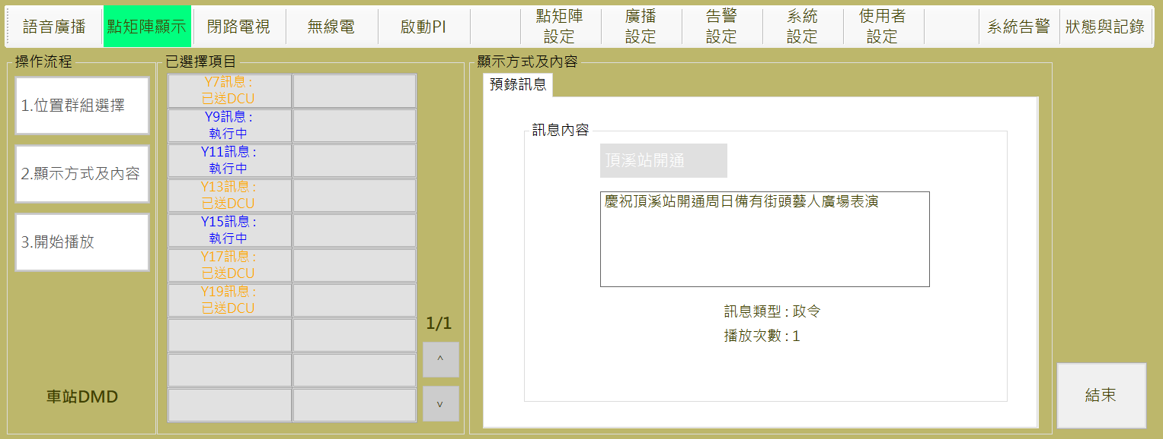

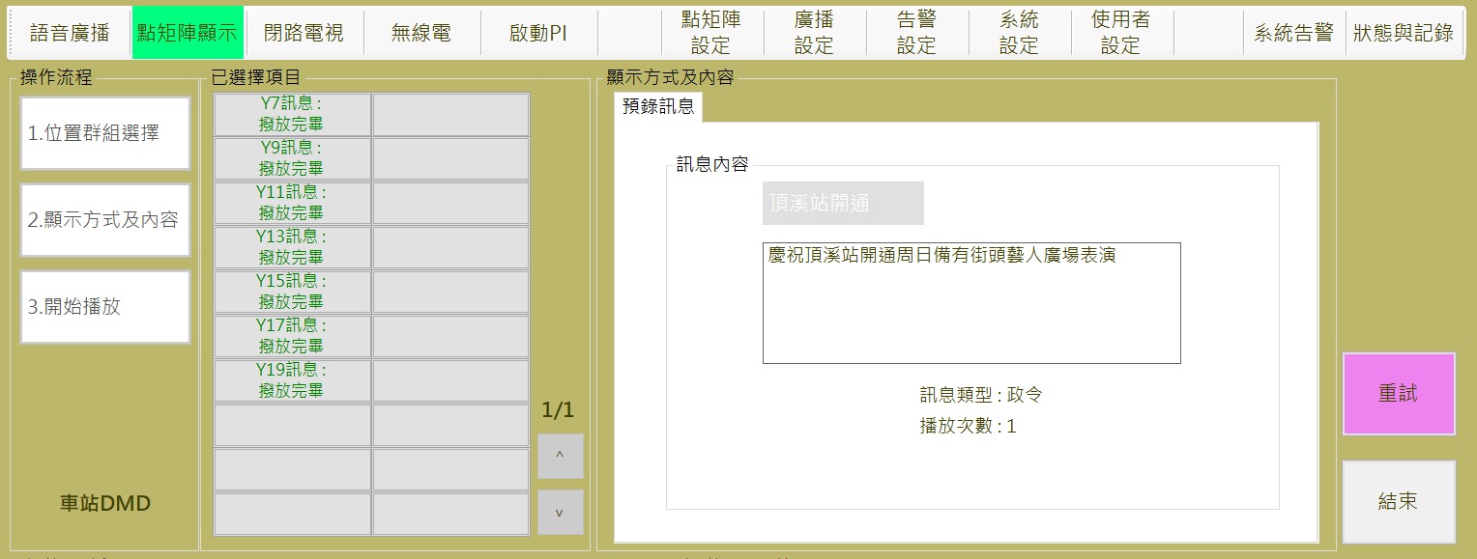

圖 4‑97: 預錄訊息播放結果回報

Figure 4‑97: Pre-record message display result

###### 播放即時訊息處理 Real-time Message Display Process

**步驟2:** 操作人員點選 “**廣播方式及內容**” 區的 “**即時訊息**” 頁簽後，可開啟播放即時訊息操作頁面。然後輸入準備播放的訊息，完成類型及播放次數設定後，按 “**播放**” 開始進行播放處理，按 “ **上一步**” 回前一操作頁面(如圖 4‑98)

**Step 2:** Operator select “**即時訊息**” (Real-time Message) tab in “**廣播方式及內容**” (Select Content and Display Mode) block to open real-time message display Setting page. Then input the message content, set message type and the display times to complete operation. After operation finish, please click “**播放**” (Start) button to progress remote message display program. Click “**上一步**” (Last Step) button back to the last step (as Figure 4‑98).

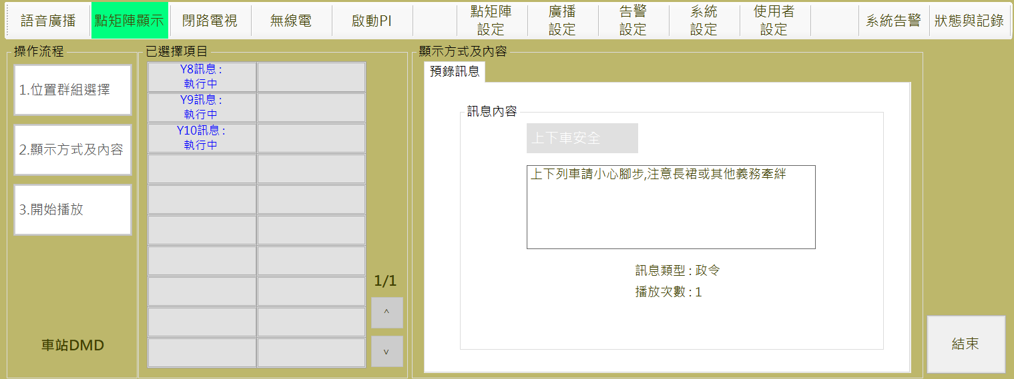

圖 4‑98: 播放即時訊息操作

Figure 4‑98: Display real-time message operation

**步驟3:** 在 “**已選擇項目**” 的指定車站及設備上顯示成功狀態，順序如下:

已送DCU：已經傳送指令至DCU主機執行中。

執行中：DCU主機回送正在執行中。

播放完畢：表示該則訊息於該車站已經播放結束。

另外，當執行失敗或傳送失敗，會顯示 “**失敗**”狀態。

結束作業請按 “**結束**” 按鈕，當按下此按鈕後，無論訊息是否結束都將傳送刪除指令結束該訊息的播放。

當全部資料執行結束或全部失敗後，可以按下“**重試**”，再次嘗試重送DCU主機。**Step 3:** As shown in as Figure 4‑97, the successful status is displayed on the designated station in "Selected Items" Table, in the following order:

已送DCU (DCU sent): Command has been sent to the DCU host executing.

執行中(In progress): DCU host loopback is in progress.

播放完畢(Completed): Indicates that the message has been played at the station.

In addition, the "**失敗(**failed)" status is displayed when the execution fails or the transfer fails.

To end the job, press the "**結束(**End)" button, When you press this button, no matter the end of the message will send a delete command to end the message playback.

After all the data has been executed or all failed, press "**重試(**Retry)" and try again to send DCU host again.

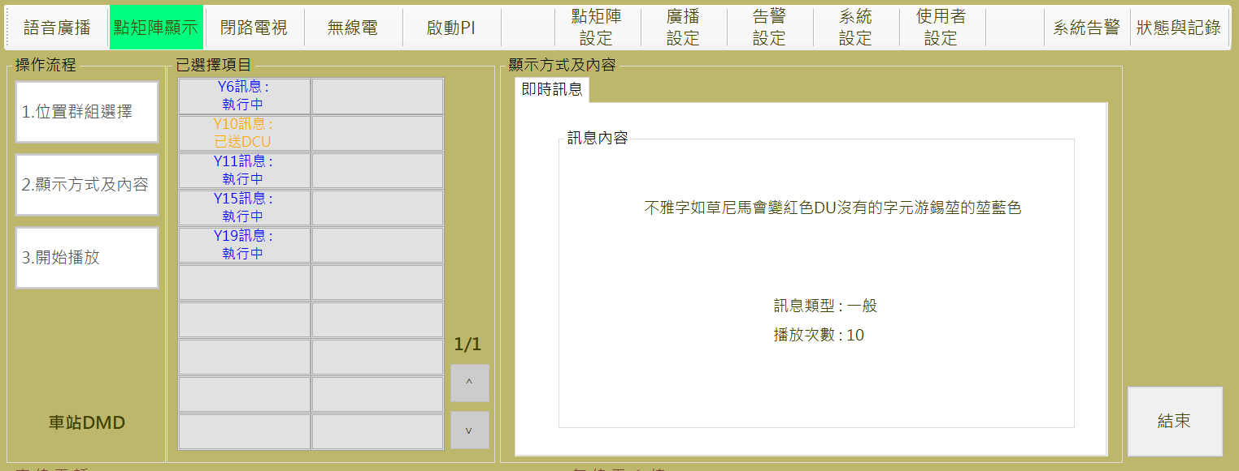

圖 4‑99: 即時訊息播放結果回報

Figure 4‑99: Real-time message display result

### 閉路電視 CCTV Monitoring

本作業含**歷史影像調閱、PTZ攝影機控制、即時影像設定**三個操作項目 (如圖 4‑100)。

This function include **Historical Image Review, PTZ Camera Control** and **Real-tIme Image Setting** three operation items (as Figure 4‑100).

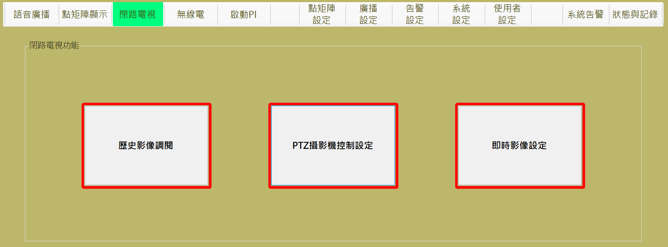

圖 4‑100: 閉路電視操作主頁

Figure 4‑100: Main page of CCTV operation

#### 歷史影像調閱 Historical Image Review

進行本作業，請依 “**攝影機選擇**→**預覽與下載**” 二個步驟進行。

Progress this function, please follow “**Select Camera →PreViewAndDownload**” the three steps to operate.

##### 選擇攝影機 Choosing Camera

操作人員先透過**車站**列表選擇車站，再選擇**攝影機選擇**列表的攝影機群組，所選 的攝影機群組會和原有已在播放的攝影機一起顯示在**已選擇項目**的列表內 (如圖 4‑101)，至多可以選四個攝影機，於下一個步驟中進行預覽。Operator select station in the “**車站**” (Station List) table first, then select the camera group in the “**攝影機選擇**” (Camera Group) table. The selected camera will list in the “**已選擇項目**” (Selected Camera) block together with the already selected cameras (as Figure 4‑101), up to four cameras can be selected for preview in the next step.

操作人員可以在**攝影機選擇**列表的攝影機群組內，使用 “**群組新增**” 功能建立新群組；或 “**群組刪除**” 功能刪除指定群組。

Operator can use “**群組新增**” (Add Group) button in “**攝影機選擇**” (Camera Group ) block to build new group or using “**群組刪除**” (Delete Group) button to delete a specified group.

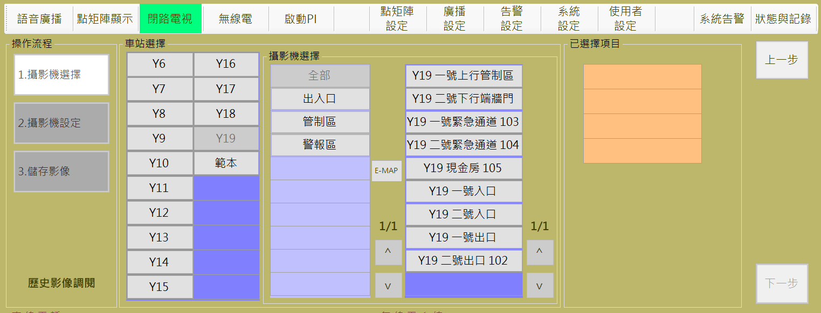

圖 4‑101:選取攝影機

Figure 4‑101: camera selection

##### 使用E-MAP設定攝影機 Using E-MAP Choosing Camera

操作人員也可以用**攝影機選擇**區塊內的 “**E-MAP**” 功能，進行攝影機選擇處理。

Operator can use “E-MAP” button to progress cameras selection.

本作業會結合現場平面圖，以方便操作人員選擇要加入監控的攝影機。操作人員可於平面圖上直接點選攝影機進行選取或移除，選取結果會加入右側的**已選擇項目區塊**列表內。(如圖 4‑102)

This assignment will combine the floor plan to provide operator to choose cameras more easily.Operator can click the camera show on floor plan to select or remove. Select result will show in the list of “**已選擇項目**” (Selected List) block (as Figure 4‑102).

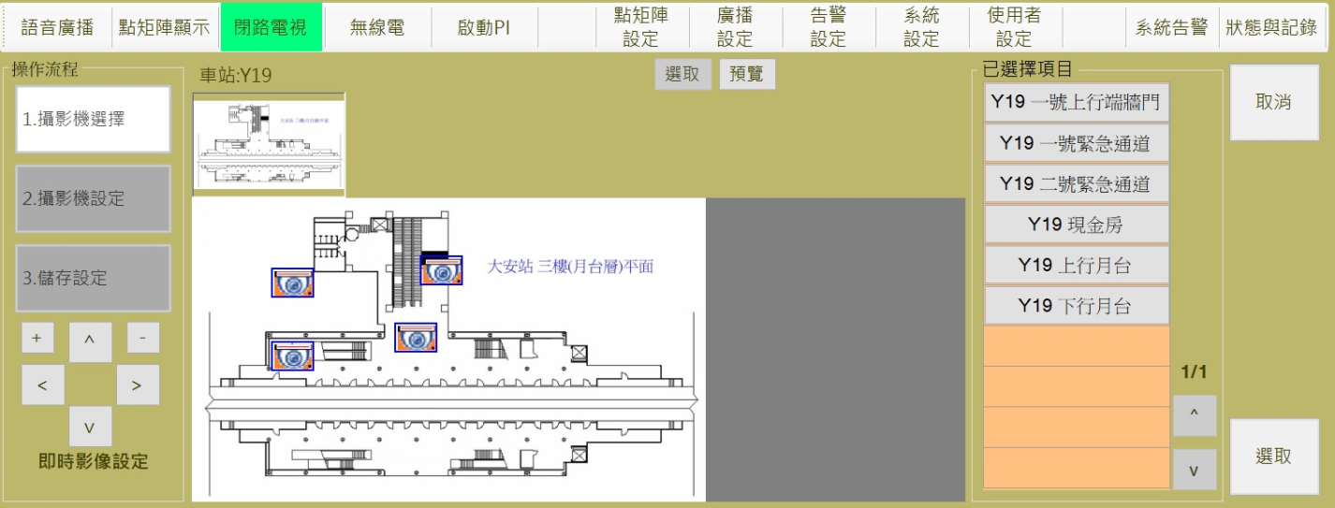

圖 4‑102: 使用E-MAP 選取攝影機

Figure 4‑102: Using E-MAP function for camera selection

確認選取後，請按 “**選取**” 按鈕進行下一步驟，如果要放棄操作，請按 “**取消**” 按鈕回前一個操作頁面。

After selection confirmed, please click “**選取**” (Confirm) button to next step. If want to abort operation, please click “**取消**” (Cancel) button back to last page.

##### 儲存影像 Record Image

儲存影像前，可透過下圖功能預覽歷史影像，至多可選擇四個攝影機透過四分割進行預覽，若僅單選一個攝影機，則如圖 4‑104左圖，為單一分割視窗。如下圖提供單一預覽視窗歌的影像播放操作功能。選擇視頻開始時間，按下"確認"按鈕，預覽視頻將開始播放。

Before saving the video, operator can preview the historical video through the function of the video below. Up to four cameras can be previewed through the four-segment preview. If only one camera is selected, as shown in Figure 4‑104 and left, single-split window. The following figure provides each single preview window video playback operation function. Select video start time, press "confirm" button, preview video will start playing.

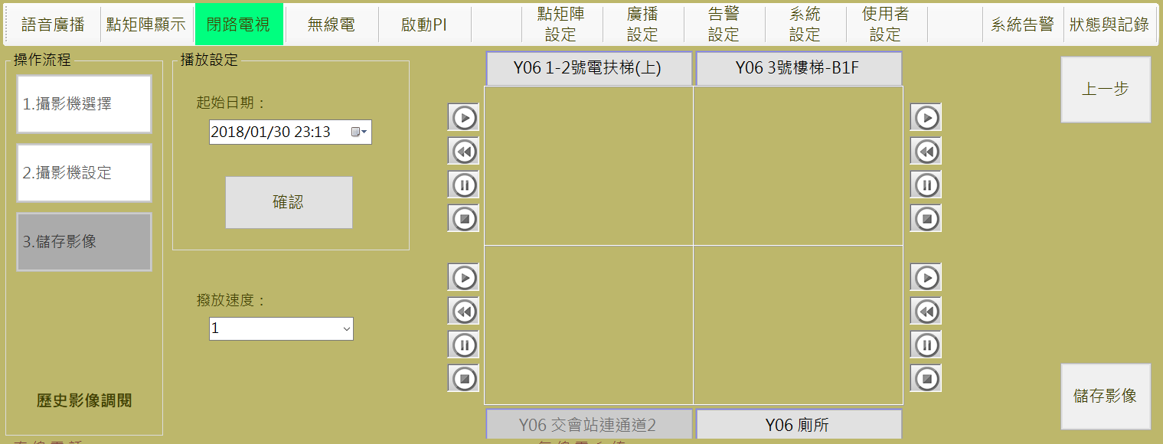

圖 4‑103: 歷史影像檢視設定

Figure 4‑103: Historical video review Setting

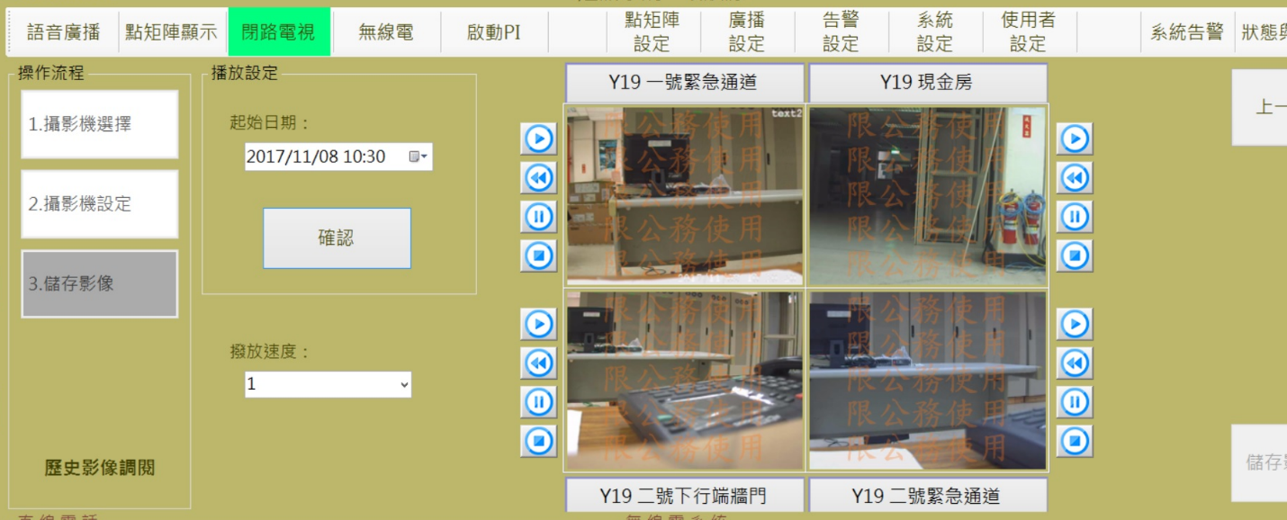 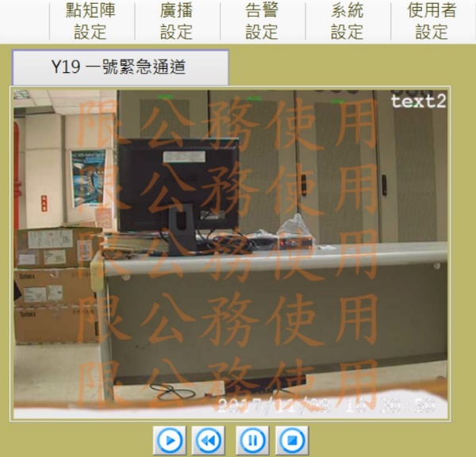

圖 4‑104: 歷史影響四分割(多選)與一分割(單選)影像含浮水印檢視畫面

Figure 4‑104: The historical video of four (multiple choice) and a split screen with Watermark view deployment

操作人員於下圖中可設定影像檔開始與結束的下載時間設定，亦可再檢視調播影像內容確認後，可按 “**下載**” 按鈕將影像另外存檔(如圖 4‑105)。

其中限公務使用為固定之浮水印，另可輸入申請單位，於下載的影像中置入相關資訊如圖 4‑105中第二行的字體。

The operator can set the download time setting of the start and end of the image file in the following figure. Also, operator can click**下載**”“ (Download) button to store the replay video as independent file after review confirm (as Figure 4‑105).

The limited official use of the fixed floating watermark, the other can input the applicant, in the downloaded video into the relevant information such as the second line in Figure 4‑105.

操作人員可按 “**上一步**” 按鈕回前一個設定頁面。

如果要結束操作，請按 “**結束**” 按鈕。

Operator can use “**上一步**” (Last Step) button to Last step or use “**結束**” (Close) button to complete this operation.

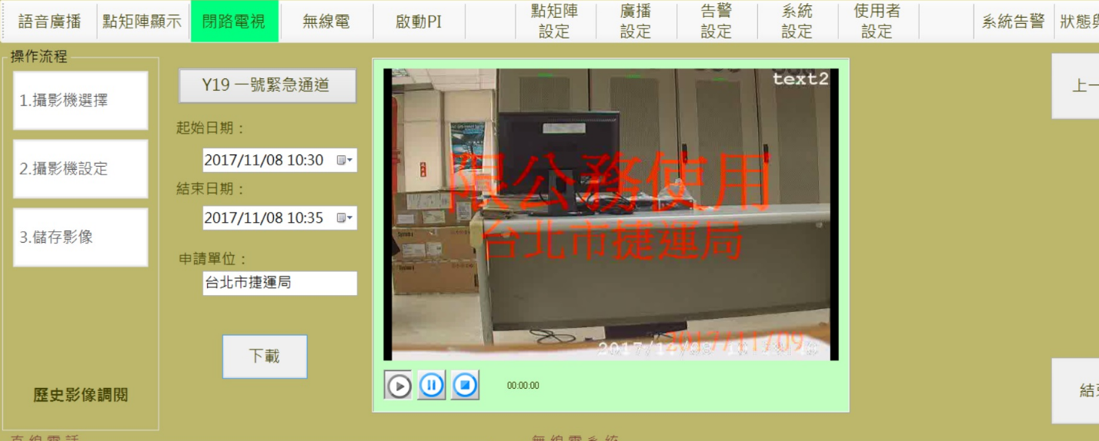

圖 4‑105: 攝影機檢視影像下載儲存

Figure 4‑105: Camera images review and download

操作人員可按 “**上一步**” 按鈕回前一個設定頁面。

如果要結束操作，請按 “**結束**” 按鈕。

Operator can use “**上一步**” (Last Step) button to Last step or use “**結束**” (Close) button to complete this operation.

#### PTZ攝影機控制 PTZ Camera Control

本頁面用來進行球型攝影機的方向控制與錄像縮放距離，並且展示即時修改的攝影狀態。

This page is used to control the direction and zoom distance for PTZ camera, and display photographic status at the instantly modified

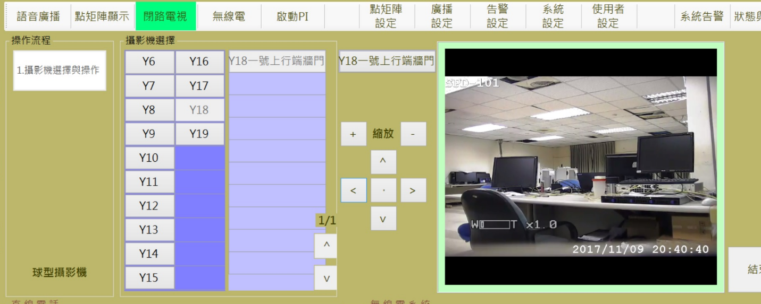

圖 4‑106: 球型攝影機操作設定

Figure 4‑106: The PTZ Setting

操作人員於PTZ操作業面中先進行攝影機選擇。攝影機選擇區域，將自動篩選含蓋球型攝影機的群組，當點選群組後將會顯示該群組內的所有球型攝影機清單。點選欲操控的攝影機如畫面中的橘色表格處，當影像顯示時表示連結成功，可以透過頁面中的上[↑]、下[↓]、左[←]、右[→]與縮[+]、放[-]等按鈕進行設定。

Operator must select the camera first on PTZ operation form。In Camera selection area, it will automatically filter the groups including the PTZ camera, and all PTZ camera of the group will display in list. Click the desired camera on the camera table, the camera will be shown on the orange table. When the image shows, it means that the link is successful. Operator can control the PTZ by the buttons including Up[↑], Down[↓], Right[←], Left[→], Zoom In [+] and Zoom Out [-] functions.

#### 即時影像設定 Real-time Image Setting

電視牆影像可以分成三個等級來顯示，顯示優先權為事件清單>手動清單>預設清單。清單說明如下

事件清單為事件發生時，將事件相關攝影機連動至指定電視牆播放：

1. 電視牆#1 ~ #14 =>操作員可選擇電視牆#1~#14進行車站消防主機告警訊息連動鎖定作業。
2. 電視牆#15、#16 =>當有列車事件發生，含PI.SI.CN通訊等，將自動連動相關攝影機至電視牆#15、#16。

手動清單為操作員透過主控台進行輪播清單配置，分三種屬性，不同的屬性提供不同的攝影機選擇範圍：

1. 車站。
2. 機廠與測試軌。
3. 列車。

預設清單表示該電視牆目前無手動設定的輪播清單，也沒有事件對應的攝影機清單，此時根據以下原則輪播預設的攝影機：

1. 電視牆#1-#11 =>進行所有車站攝影機輪播。
2. 電視牆#12 =>進行所有轉轍器攝影機輪播。
3. 電視牆#13、#14 =>進行所有機廠固定式攝影機與進入機廠的所有列車攝影機(含測試軌)輪播。
4. 電視牆#15、#16 =>進行所有可通訊之列車上攝影機輪播。

TV-Wall images can be divided into three levels to display the priority of the event list> manual list> default list. These lists are as follows

The event list is from event trigger, the event related camera is linked to the specified TV-Wall to play:

(1) TV-Wall # 1 ~ # 14 => The operator can select the TV-Wall # 1 ~ # 14 to carry out the interlocking playback operation for the station fire alarm message.

(2) TV-Wall # 15, # 16 => When there is a train incident, including PI.SI.CN communication, it will automatically connect the relevant cameras to the TV-Wall # 15 and # 16.

Manual list for the operator through the console for rotation list configuration, divided into three properties, different properties provide different camera options:

(1) station.

(2) Machine factory and test track.

(3) train.

The preset list shows that there is no carousel list manually set in the TV-Wall at present and there is no camera list corresponding to the event. In this case, the preset camera is rotated according to the following principle:

(1) TV-Wall # 1- # 11 => Carousel all cameras which are defined at stations.

(2) TV-Wall # 12 => Carousel all cameras which are defined as switcher.

(3) TV-Walls # 13, # 14 => Carousel all factory fixed cameras and all train cameras which are at Depot (including test tracks).

(4) TV-Wall # 15, # 16 => Carousel on all actived trains.

若要設定手動清單, 請依 “**電視牆選擇**→**攝影機選擇**→**輪播設定**” 三個步驟進行。

Progress this function, please follow “**Select TV from TV-Wall→Select Camera →Display Setting**” the three steps to operate.

##### 步驟1電視牆選擇 Step 1 Select TV from TV-Wall

操作人員由**電視牆選擇**區塊內選取**電視編號**，系統會在**播放清單**列表內帶出該電視正在播放的影像清單 (如圖 4‑107)，深紫色表頭欄位將顯示此清單為預設清單或手動清單或事件清單。

選擇電視牆後，接著選擇手動清單屬性，如圖 4‑107畫面右方，三種屬性按鈕分別為**”車站**”、”**機場與測試軌**”、”**列車**”。

選取完成後，請按 “**下一步**” 按鈕進行下一步驟，如果要變更作業項目，請按 “**上一步**” 按鈕回操作主頁。清除**播放清單**列表請按 “**取消鎖定**” 鈕。

Operator select the display TV No. from the “**電視牆選擇**” (TV-Wall Selection) block, system will show the camera list in the “**播放清單**” (DIsplay List) block (Figure 4‑107), The dark purple header field will display this list as a default list or a manual list or list of events.

Select the TV-Wall, then select the manual inventory properties, as shown in Figure 4‑107 screen to the right, the three properties buttons are "**車站(station)**", "**機場與測試軌(Depot and test track)**", "**列車(train)**".

After selection complete, please click “**下一步**” (Next Step) button to next step. If want to change operation item, please click “**上一步**” (Last Step) button back to the operation main page. To clear the selected camera, please click “**取消鎖定**” (Cancel Selection) button.

本畫面除了選擇電視牆進行手動清單建置，亦可於電視牆號按鈕或攝影機清單表按下要鎖定的攝影機，清單中綠色文字的攝影機為目前正在播放的攝影機，並且對照左上、右上、左下、右下，顯示攝影機對應的位置為1、2、3、4。

若要取消攝影機鎖定，繼續維持清單輪播狀態，則按”取消鎖定”按鈕。

當有事件發生，如圖 4‑96，表頭顯示為事件清單，並且提供解除事件清單的按鈕，若按下”解除事件清單”按鈕後，該電視牆就會回歸至手動或預設清單。

In addition to selecting the TV-Wall to set up the manual list, you can also press the camera wall button or camera list to lock the camera. The green text camera in the list is the currently playing camera, and control the upper left, upper right, lower left , Lower right, showing the corresponding camera position 1,2,3,4.

To cancel the camera lock and keep the list carousel, press the "Unlock" button.

When an event occurs, as shown in Figure 4‑108, the header is displayed as an event list, and a button for releasing the event list is provided. If the "Release Event List" button is pressed, the TV-Wall will return to the manual or default list.

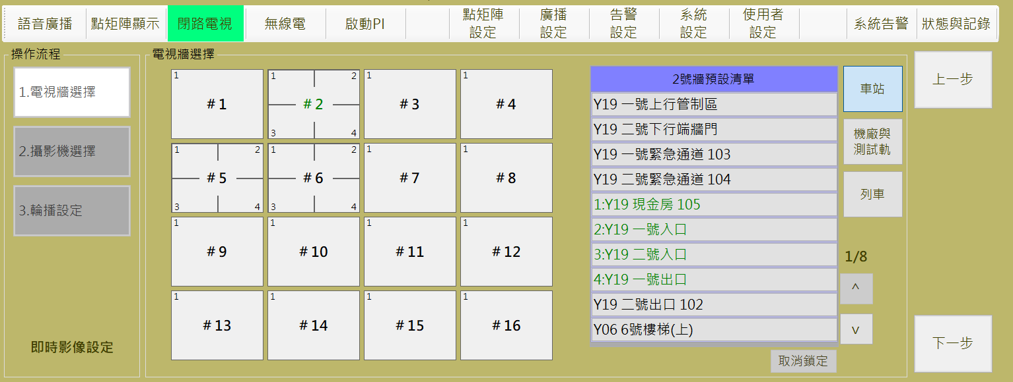

圖 4‑107: 閉路電視操作步驟1 (電視牆選擇)

Figure 4‑107: CCTV operation step 1 (TV-Wall Select)

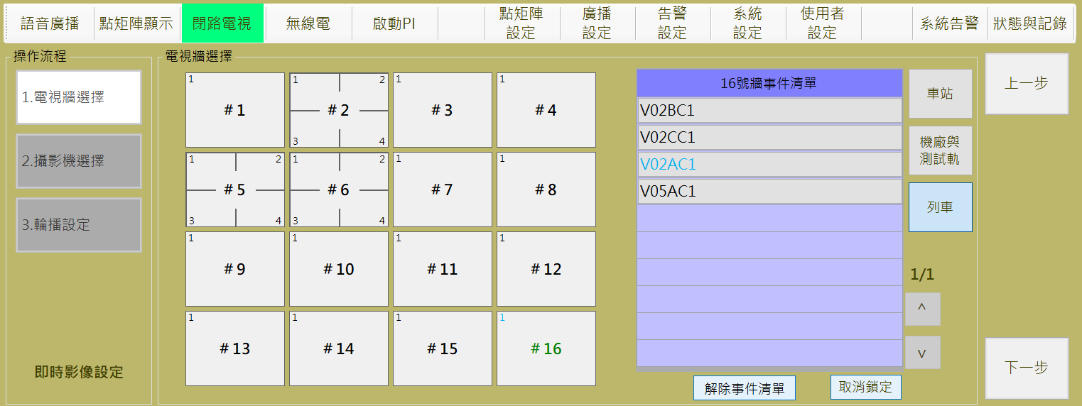

圖 4‑108: 事件清單與解除事件清單

Figure 4‑108: Event List and Release Event List

##### 步驟2攝影機選擇Step 2 Select Camera

車站屬性：

操作人員先透過車站列表選擇車站，再選擇攝影機選擇列表的攝影機群組，所選的攝影機群組會和原有已在播放的攝影機一起顯示在已選擇項目的列表內 (如圖 4‑109)

。確認選取後，請按 “下一步” 按鈕進行下一步驟，如果要變更播放電視，請按 “上一步” 按鈕回前一個操作頁面。

Operator select station in the “**車站**” (Station List) table first, then select the camera group in the “**攝影機選擇**” (Camera Group) table. The selected camera will list in the “**已選擇項目**” (Selected Camera) block together with the already selected cameras (as Figure 4‑109). After selection confirmed, please click “**下一步**” (Next Step) button to next step. If want to change TV, please click “**上一步**” (Last Step) button back to the TV select page.

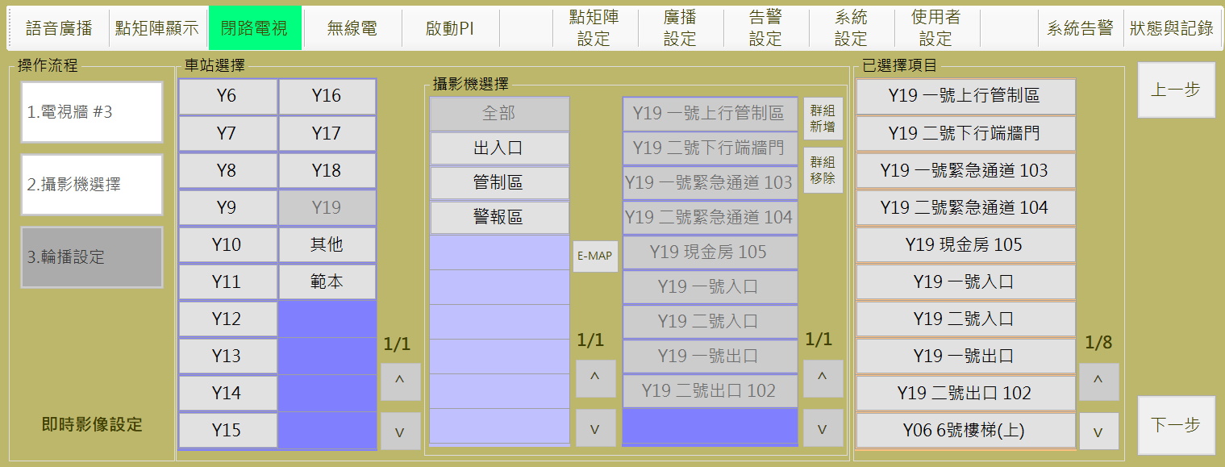

圖 4‑109: 閉路電視操作步驟2 –車站(攝影機選擇)

Figure 4‑109: CCTV operation step 2-Station (Select Camera)

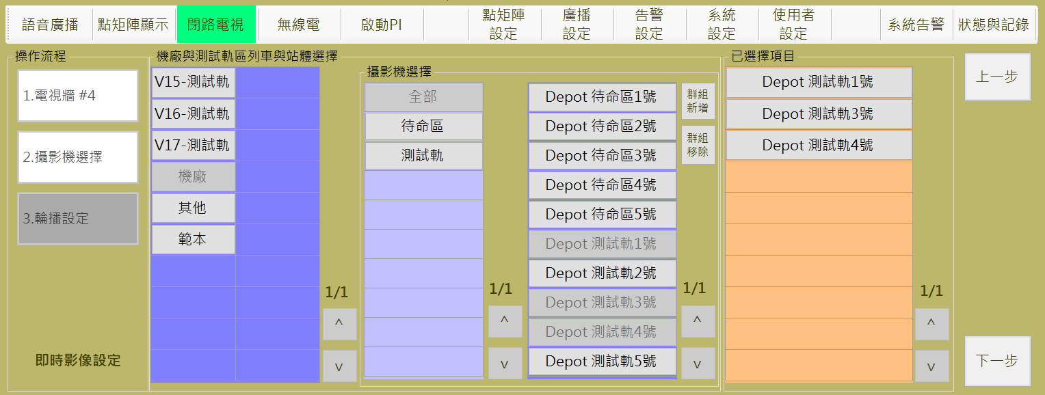

圖 4‑110: 閉路電視操作步驟2 –機場與測試軌(攝影機選擇)

Figure 4‑110: CCTV operation step 2-Depot and Test Track (Select Camera)

操作人員可以在**攝影機選擇**列表的攝影機群組內，使用 “**群組新增**” 功能建立新群組；或 “**群組刪除**” 功能刪除指定群組。

Operator can use “**群組新增**” (Add Group) button in “**攝影機選擇**” (Camera Group ) block to build new group or using “**群組刪除**” (Delete Group) button to delete a specified group.

操作人員也可以用**攝影機選擇**區塊內的 “**E-MAP**” 功能，進行攝影機選擇處理。詳細操作方式請參考4.2.10.1.2節 “**使用E-MAP設定攝影機**”

Operator can use “E-MAP” button to progress cameras selection. Detail operation description please refer section **3.2.10.1.3 “Using E-MAP Choosing Camera”.**

##### 步驟3輪播設定 Step 3 Display by Turns Setting

操作人員可於本頁面設定**輪播間隔時間**及**畫面顯示方式** (全螢幕或四分割)。

按 “**確認**” 鈕完成設定後，指定電視牆會開始依選取的攝影機進行播放。

按 “**結束**” 鈕完成操作 (如圖 4‑111)。

此步驟若帶入為空清單表示取消手動清單，若也無事件清單則將回歸預設清單的攝影機輪播。

Operator can set display time and select TV-Wall display mode (full screen or by quarter) for camera images display by turn.

When operator click “**確認**” (Confirmed) button, specified TV-Wall will begin to work according to the Setting conditions.

When operator click “**結束**” (Close) button to finish operation (as Figure 4‑111).

If this step is blank, cancel the manual list. If there is no event list, it will return to the preset list camera rotation.

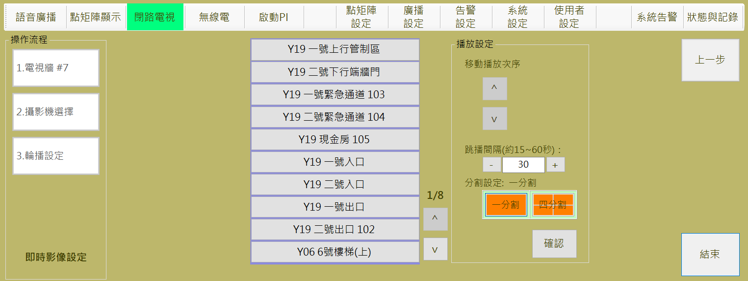

圖 4‑111: 閉路電視操作步驟3 (輪播設定)

Figure 4‑111: CCTV operation step 3 (Display by Turns Setting)

#### 監控螢幕電視牆指定

每個主控台旁接配置一個19吋螢幕，可以透過CMFT主控台設定和一個電視牆進行影像同步，如圖 4‑112畫面右下角，電視牆選擇框中，黑色底白色數字，該數字即表示目前同步的電視牆號。

按下選取按鈕後，將出現畫面如圖 4‑113，可以進行同步電視牆牆號的切換作業。

同時，若告警視窗中的告警事件資訊帶有攝影機連動資訊，如圖 4‑112，此時操作者按下連動按鈕後，將會根據該主控台目前的電視牆號，將連動的攝影機加入該電視牆的播放清單，若該電視牆已經為事件清單，則此事件攝影機將累加至清單中，若該電視牆非事件清單，則會建立一個新的事件清單進行輪播，車站告警事件不能指定到15與16牆號 ，若此時監控螢幕指定的電視牆號為15或16牆號，則會跳出警示，無法執行聯動作業。

Each console is configured with a 19-inch screen next to the CMFT console for video synchronization with a TV-Wall, as shown in the lower-right corner of the picture in Figure 4‑112. The black and white numbers in the TV-Wall selection box Said the current synchronization of the TV-Wall.

Press the select button, the screen will appear as shown in Figure 4‑113, you can sync the wall switch jobs.

At the same time, if the alarm event information in the alarm window is linked with the camera linkage information, as shown in Figure 4‑112, the operator will press the linkage button to add the linked camera to the current TV-Wall of the console. If the TV-Wall is already an event list, the event camera will be added to the list. If the TV-Wall is not a list of events, a new list of events will be created for carousel.

In addition, the station alarm event can not be specified To 15 and 16 TV-Wall if at this time monitor the screen specified TV-Wall number is 15 or 16, it will pop up a warning, unable to perform linkage operations.

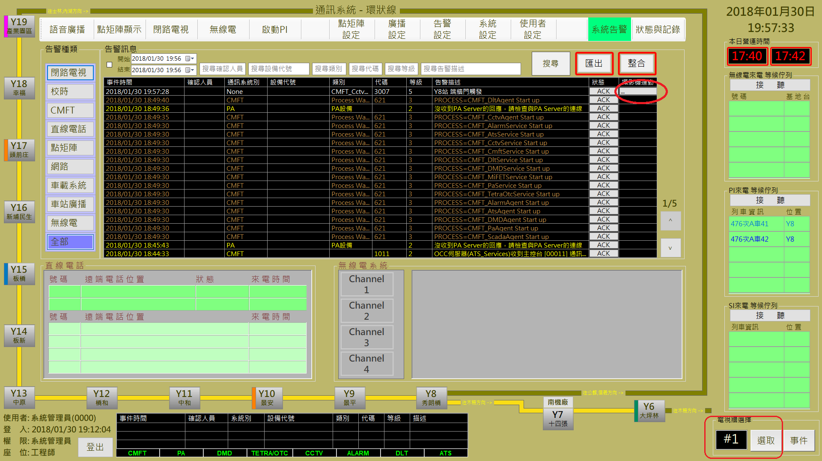

圖 4‑112: 主畫面監控螢幕選取與顯示

Figure 4‑112: Main screen monitor selection and display

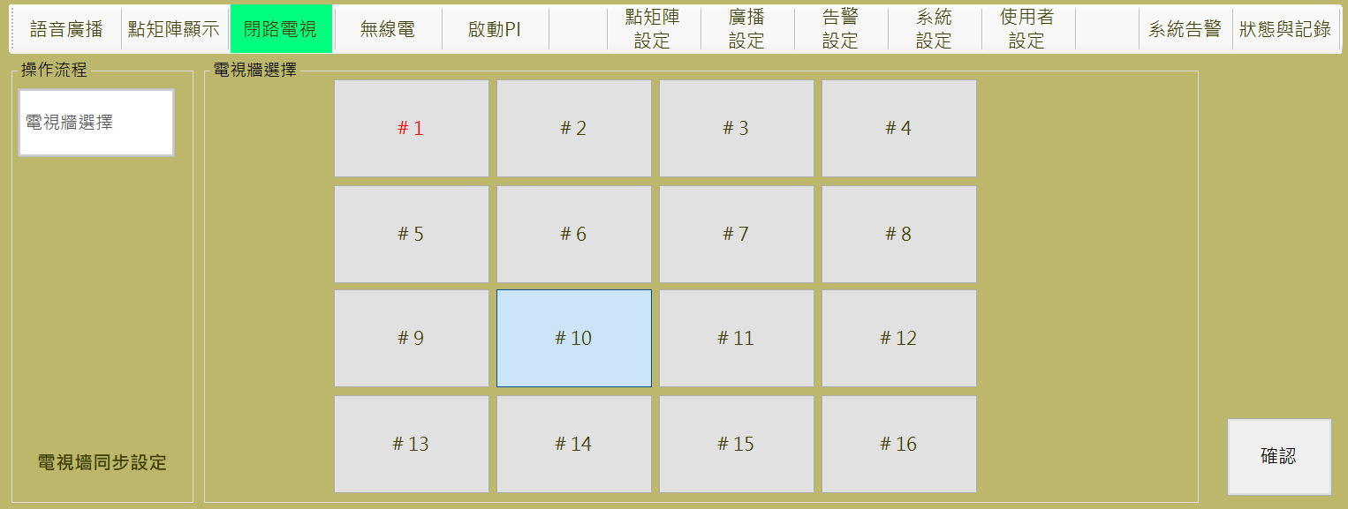

圖 4‑113:監控螢幕選取操作

Figure 4‑113: screen monitor selection operation

#### 列車事件

列車事件總共為以下12種，前三種來源為列車OTC系統，其他訊息來源為ATS系統觸發：

1. 乘客緊急通訊
2. 司機員對講機通訊
3. 車廂PI動態啟動
4. 站間停車
5. 偵煙器啟動
6. 拉下緊急疏散裝置
7. 車門異常開啟
8. 車載控制器連結失敗
9. 車門內部把手被拉下
10. 列車車門因障礙物阻塞
11. 障礙物偵測器觸發
12. 脫軌偵測器觸發

There are 12 train accidents in total, the first three sources are OTC systems, and the other sources are ATS triggers:

(1) Passenger emergency communication

(2) driver intercom communication

(3) car PI dynamic start

(4) stop between stations

(5) Smoke detector activated

(6) Pull down the emergency evacuation device

(7) Door open abnormally

(8) Car controller connection failed

(9) The door handle is pulled down

(10) train door obstruction due to obstruction

(11) obstacle detector trigger

(12) Derailment detector trigger

當有列車事件觸發時，將會根據以下原則將該事件中指定車廂的第一號攝影機影像投影到15或16牆牆面：

僅有列車通訊事件時(前三項)，15或16牆皆會同時存在事件攝影機並且錯開輪播。

僅ATS來源的列車告警事件，將只會在16牆進行事件清單輪播。

若同時存在ATS與OTC來源事件，則ATS事件將投影在16牆，OTC事件投影在15牆。

When a train incident triggers, the first camera image of the designated carriage in the incident will be projected onto the 15 or 16 wall surface according to the following principles:

Only in the case of a train communication event (the first three items), an event camera is present at both the 15 or 16 walls and the carousel is staggered.

Only ATS-derived train alarm events will only rotate on Event 16 in the wall.

If there are both ATS and OTC source events, the ATS event will be projected on 16 walls and the OTC event will be projected on 15 walls.

ATS事件有兩種狀態，分別為已觸發和已解除(灰色)，狀態來源為ATS訊息資料。

OTC事件有三種狀態，分別為等待中(紅色)、通話中、 以及已掛斷(灰色)。

按鈕功能如下，

1. 鎖定：點擊灰底事件格，當事件底色為黃色表示目前正鎖定該事件的攝影機。
2. 解鎖：點擊黃底已鎖定事件格，表示解除該事件攝影機鎖定，電視牆將進行事件清單輪播。
3. 解除：兩個表格第一欄的解除按鈕。按下解除後該事件將會從清單中移除。

There are two states for ATS events, triggered and deactivated (gray), and the status source is ATS messages.

OTC events have three states, waiting in line (red), on the call, and hung up (gray).

Button function is as follows

1. Lock: Click on the gray event cell, when the event is yellow to indicate the camera is currently locking the event.
2. Unlocked: Click on the yellow box to lock the event grid, said the lifting of the event the camera lock, the video wall will rotate the event list.
3. Release: two tables in the first column of the release button. Press to lift the event will be removed from the list.

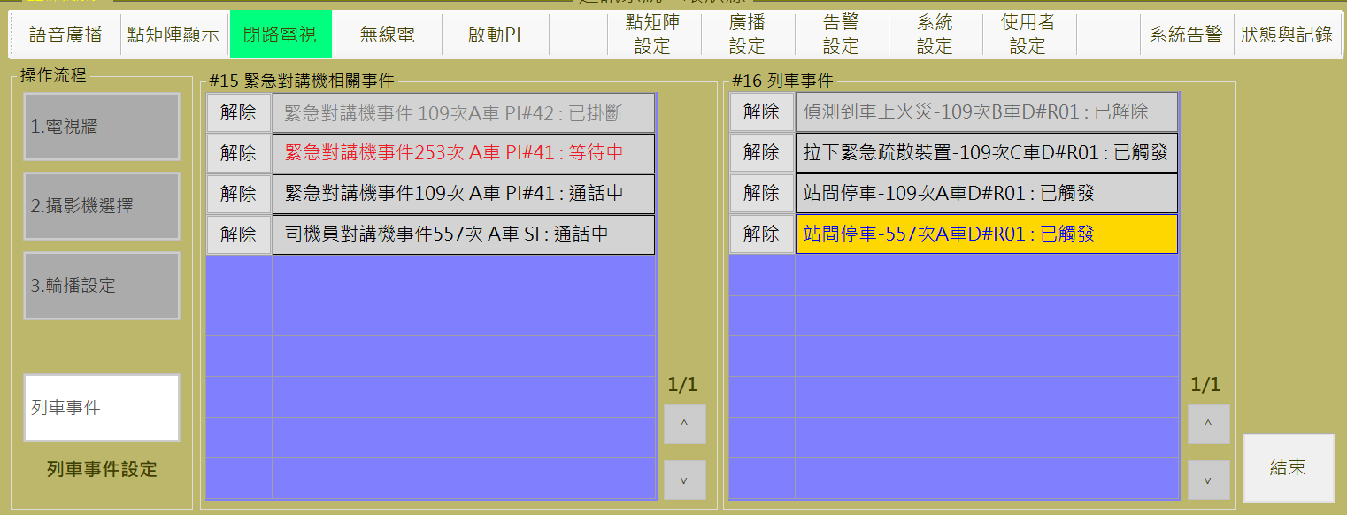

圖 4‑114:監控螢幕選取操作

Figure 4‑114: screen monitor selection operation

### 無線電 TETRA Communication

本作業含**群組呼叫、個別呼叫、撥號盤**三個操作項目 (如圖 4‑115)。

This function include **Group Call, Single Call** and **Dial** three operation items (as Figure 4‑115).

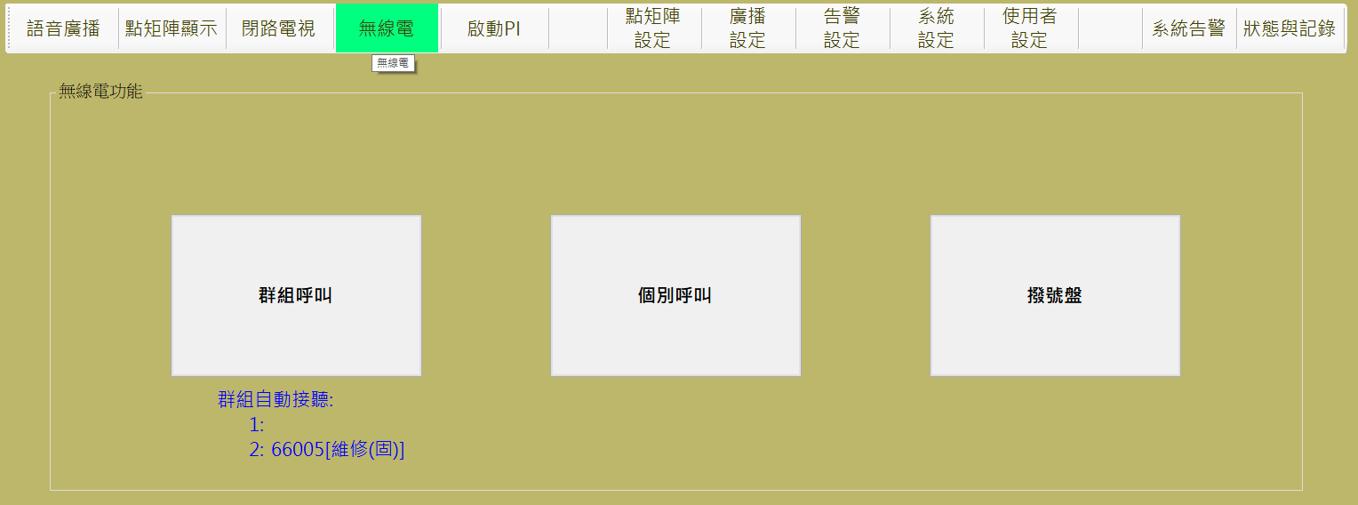

圖 4‑115: 無線電操作主頁

Figure 4‑115: Main page of TETRA Communication operation

#### 無線電群組呼叫操作 TETRA Group Call Operation

進行本作業，請依 “**項目選擇**→**通訊方式及內容**→**開始通訊**” 三個步驟進行。

Progress this function, please follow “**Select Group→Setting Communication →Start Communication**” the three steps to operate.

##### 步驟1項目選擇Step 1 Select Group

操作人員由**來源**列表內選取**通訊群組**，選取結果會顯示在**已選擇項目**區塊內 (如圖 4‑116)。選取完成後，請按 “**下一步**” 按鈕進行下一步驟，如果要變更作業項目，請按 “**下一步**” 按鈕回操作主頁。

Operator can select the TETRA group from the list in “**來源**” (Group Source) block. Selection result will show in the “**已選擇項目**” (Chosen Items) block. (as Figure 4‑116). After selection complete, please click “**下一步**” (Next Step) button to next step. If want to change operation item, please click “**上一步**” (Last Step) button back to the operation main page.

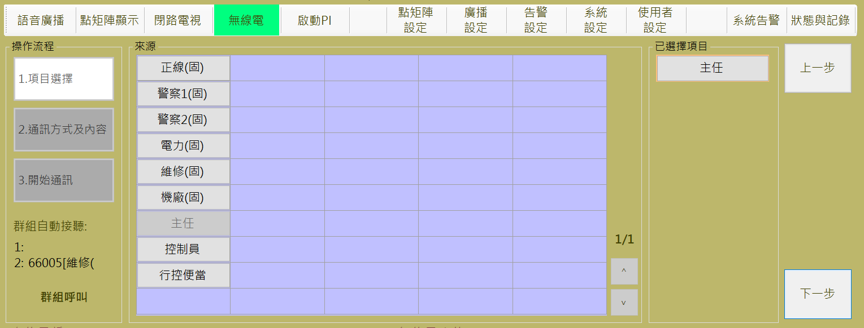

圖 4‑116: 無線電操作步驟1 (項目選擇)

Figure 4‑116: TETRA Communication operation step 1 (Select Group)

##### 步驟2通訊方式及內容Step 2 Setting Communication

操作人員可以透過**通訊方式**區塊的選項，選擇使用**語音通訊**或**傳簡訊**方式來建立通訊模式 (如圖 4‑117)。確認通訊方式後，請按 “**通訊**” 按鈕進行下一步驟，如果要變更通訊群組，請按 “**上一步**” 按鈕回前一個操作頁面。

Operator can select using **audio** or **send** **message** mode for communication in “**通訊方式**” (communication mode) block.. (as Figure 4‑117). After communication mode confirmed, please click “**通訊**” (communication) button to next step. If want to change communication group, please click “**上一步**” (Last Step) button back to the item select page.

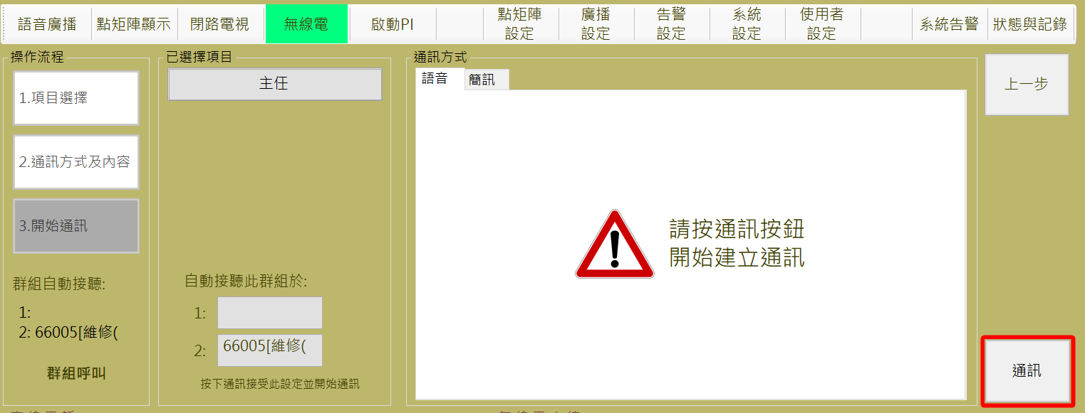

圖 4‑117: 無線電操作步驟2 (通訊方式及內容)

Figure 4‑117: TETRA Communication operation step 2 (Setting communication)

CMFT系統提供2個可**自動接聽**的通訊群組設定參數，操作人員可以在這個頁面的**自動接聽群組**項目，自動群組僅限固定群組，點擊變更其設定內容。

CMFT system provides two parameter for auto-receive group. Operator can click items in “**自動接聽群組**” (Auto-receive groups) block to change.

##### 步驟3開始通訊Step 3 Start Communication

如果通訊頻道可以正常建立，操作人員會看到系統顯示操作結果如圖 4‑118。如果想停止通訊，請按 “**無線電頻道明細區**” 的 “**結束通訊**” 按鈕停止通訊。如果想結束本次操作，請按 “**結束**” 按鈕結束本次操作 (停止操作不代表同時停止通訊，兩者為獨立功能)。

If the system work well, operator will see the result as Figure 4‑118. If want to stop communication, please click the “**結束通訊**” (Stop Communication) button in the “**無線電頻道明細**” (Audio Channel Detail) block to stop communication. If want to stop operation, please click “**結束**” (Close) button to finish operation (stop operation does not mean stop record, they are independent functions to each other).

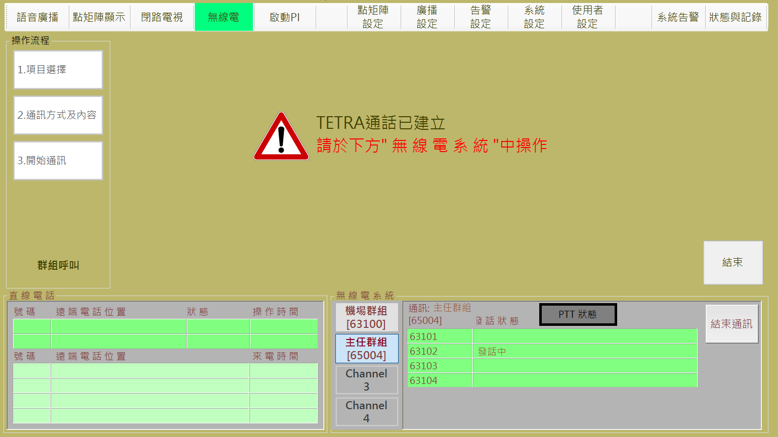

圖 4‑118: 無線電操作步驟3 (開始通訊)

Figure 4‑118: TETRA Communication operation step 3 (Start communication)

#### 無線電個別呼叫操作 TETRA Single Call Operation

進行本作業，請依 “**項目選擇**→**通訊方式及內容**→**開始通訊**” 三個步驟進行。

Progress this function, please follow “**Select TETRA No. →Setting Communication →Start Communication**” the three steps to operate.

##### 步驟1項目選擇Step 1 Select TETRA No.

操作人員由**來源**列表內選取**無線電編號** (允許多選)，選取結果會顯示在**已選擇項目**區塊內 (如圖 4‑119)。選取完成後，請按 “**下一步**” 按鈕進行下一步驟，如果要變更作業項目，請按 “**上一步**” 按鈕回操作主頁。

Operator can select the TETRA No.(s) from the list in “**來源**” (TETRA No. Source) block. Selection result will show in the “**已選擇項目**” (Chosen Items) block. (as Figure 4‑119). After selection complete, please click “**下一步**” (Next Step) button to next step. If want to change operation item, please click “**上一步**” (Last Step) button back to the operation main page.

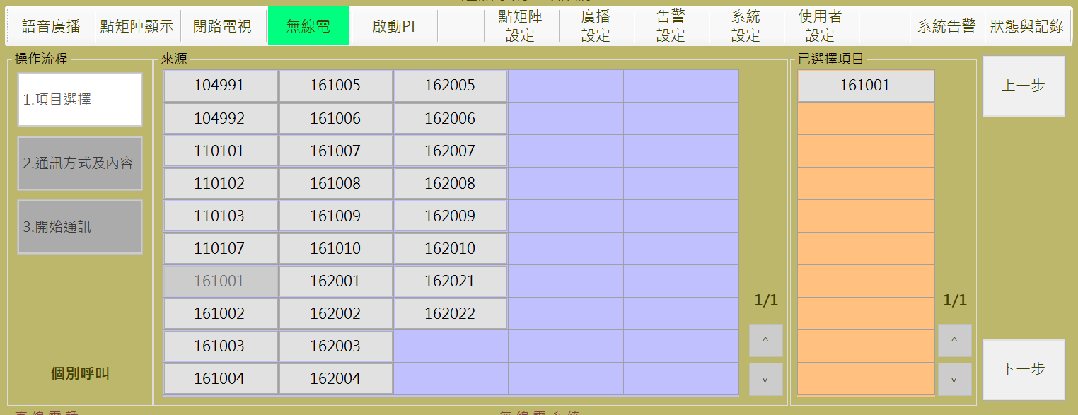

圖 4‑119: 無線電個別呼叫操作項目選擇單一門號

Figure 4‑119: TETRA Communication Single operation Select one

##### 步驟2通訊方式及內容Step 2 Setting Communication

本步驟操作方式同群組呼叫模式，請參考群組呼叫步驟2說明，。

This step is similar group call, please refer group call step 2 and no more repeat here.

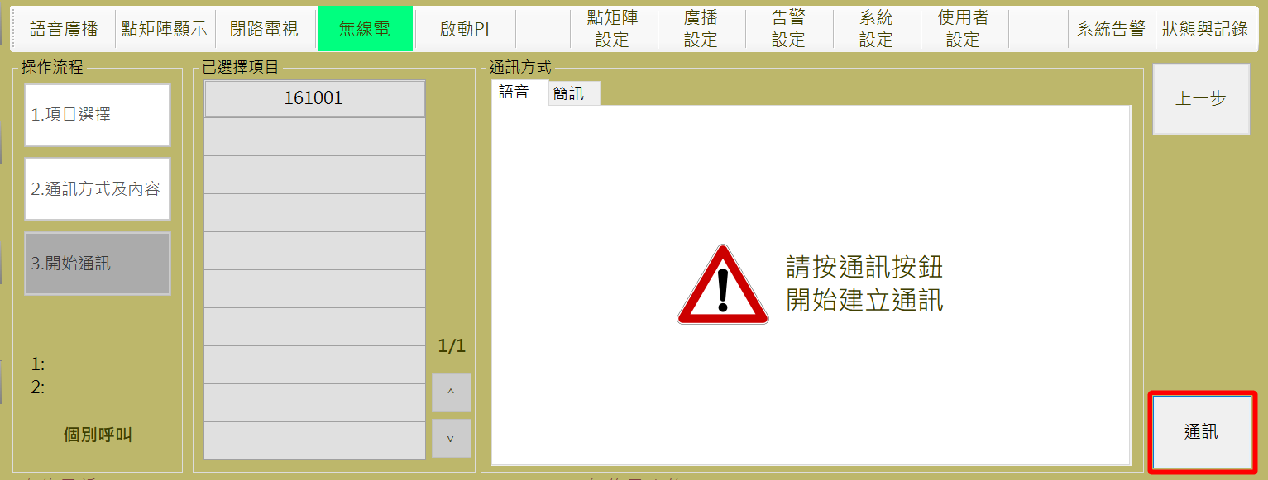

圖 4‑120: 無線電操作步驟2 (通訊方式及內容)

Figure 4‑120: TETRA Communication operation step 2 (Setting communication)

##### 步驟3開始通訊Step 3 Start Communication

如果通訊頻道可以正常建立，操作人員會看到系統顯示操作結果如圖 4‑121。如果想停止通訊，請按 “**無線電頻道明細區**” 的 “**結束通訊**” 按鈕停止通訊。如果想結束本次操作，請按 “**結束**” 按鈕結束本次操作 (停止操作不代表同時停止通訊，兩者為獨立功能)。

If the system work well, operator will see the result as Figure 4‑121. If want to stop communication, please click the “**結束通訊**” (Stop Communication) button in the “**無線電頻道明細**” (Audio Channel Detail) block to stop communication. If want to stop operation, please click “**結束**” (Close) button to finish operation (stop operation does not mean stop record, they are independent functions to each other).

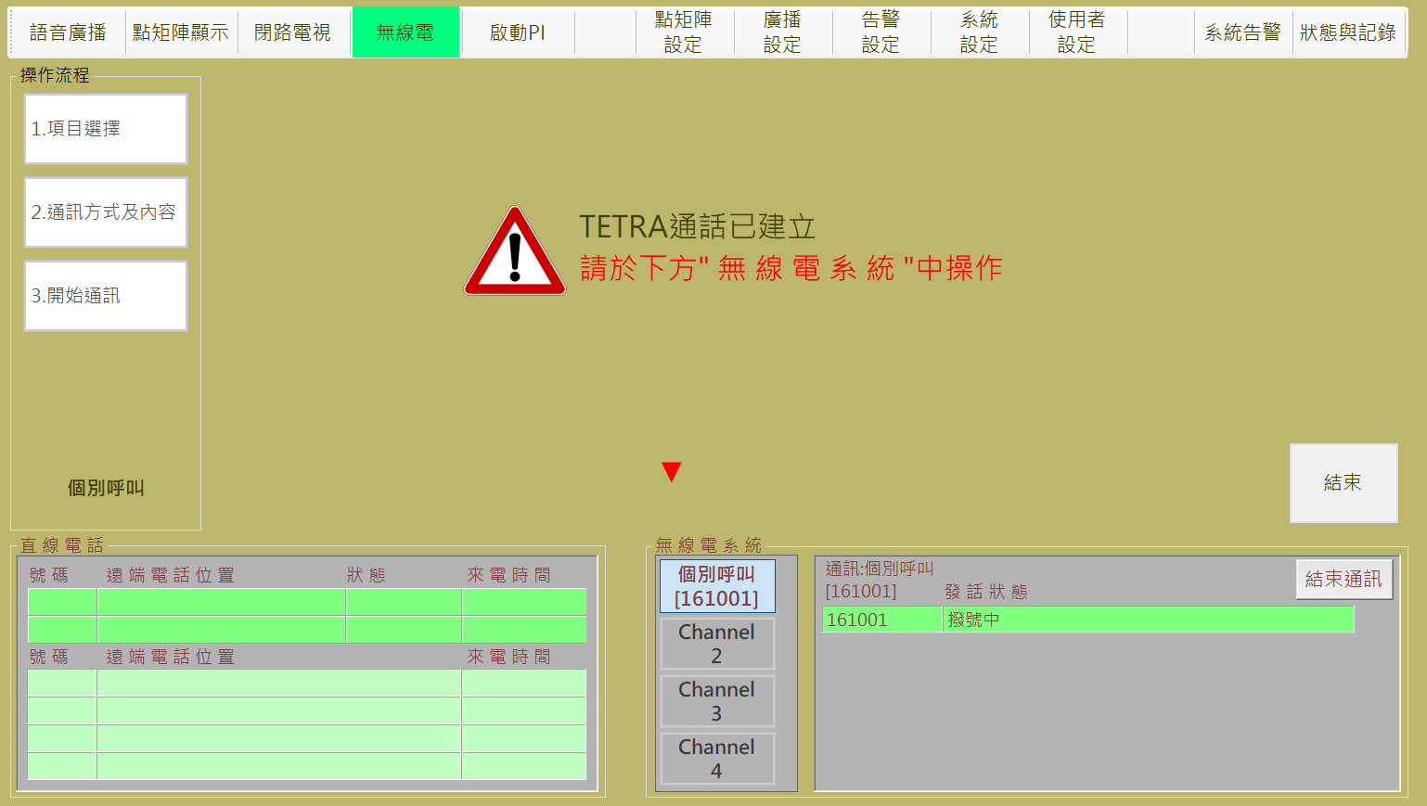

圖 4‑121: 無線電操作步驟3 (開始通訊)

Figure 4‑121: TETRA Communication operation step 3 (Start communication)

操作人員如果選取多個號碼，系統會自動產生**臨時群組**，依群組通訊方式進行通訊。

If operator select several TETRA No. in this operation, system will auto-create the **temple group** for group communication.

#### 撥號盤操作 TETRA Dial Operation

進行本作業，請依 “**項目選擇**→**通訊方式及內容**→**開始通訊**” 三個步驟進行。

Progress this function, please follow “**Dial →Setting Communication →Start Communication**” the three steps to operate.

##### 步驟1撥號Step 1 Dial

操作人員由**撥號盤**直接鍵入無線電號碼 (如圖 4‑124)。號碼輸入後，請按 “**下一步**” 按鈕進行下一步驟，如果要變更作業項目，請按 “**上一步**” 按鈕回操作主頁。

Operator directly key in the TETRA No. from the dial (as **錯誤! 找不到參照來源。**). When complete, please click “**下一步**” (Next Step) button to next step. If want to change operation item, please click “**上一步**” (Last Step) button back to the operation main page.

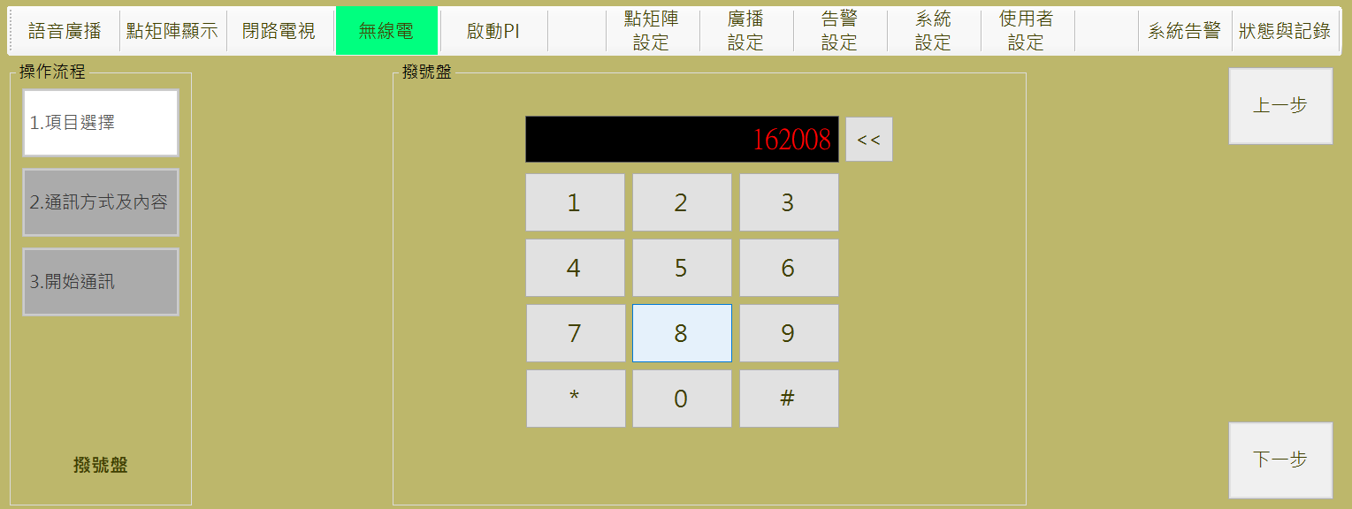

##### 步驟2通訊方式及內容Step 2 Setting Communication

操作人員可以透過**通訊方式**區塊的選項，選擇使用**語音通訊**或**傳簡訊**方式來建立通訊模式 (如圖 4‑122)。確認**傳簡訊**通訊方式後，請按 “**通訊**” 按鈕進行下一步驟如，如果要變更通訊群組，請按 “**上一步**” 按鈕回前一個操作頁面。

Operator can select using audio or send message mode for communication in “通訊方式” (communication mode) block.. (as Figure 4‑122). After communication mode confirmed, please click “通訊” (communication) button to next step. If want to change communication group, please click “上一步” (Last Step) button back to the item select page.

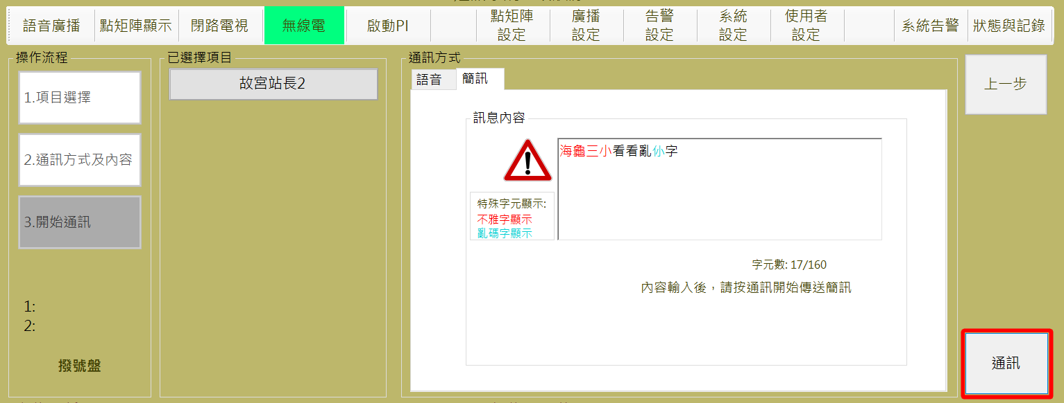

圖 4‑122: 無線電傳送簡訊2

Figure 4‑122: Tetra Transfer the Message 2(type msg)

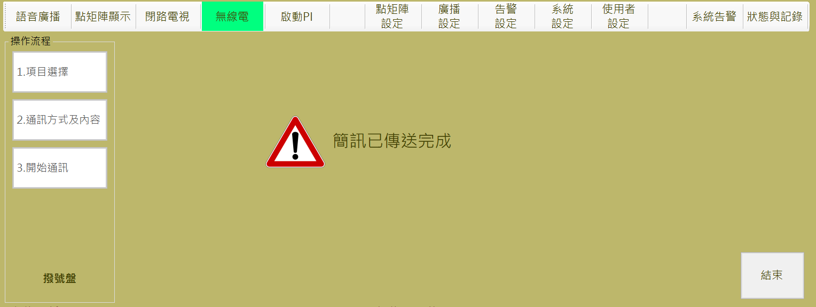

圖 4‑123: 無線電船傳送簡訊結果

Figure 4‑123: Tetra Transfer the Message Result

### 啟動Actived PI

進行本作業，請依 “**選擇列車**→**選擇位置**→**啟動PI**” 三個步驟進行。

Progress this function, please follow “**Select train→Select PI→Actived PI**” the three steps to operate.

**步驟1** **列車選取**: 操作人員每次只能選取一台列車 (如圖 4‑124)。車輛選取完成後，請按 “**下一步**” 按鈕進行下一步驟

**Step 1 Select Train**: Operator can select only one car every time (as Figure 4‑124). After selection complete, please click “**下一步**” (Next Step) button to next step.

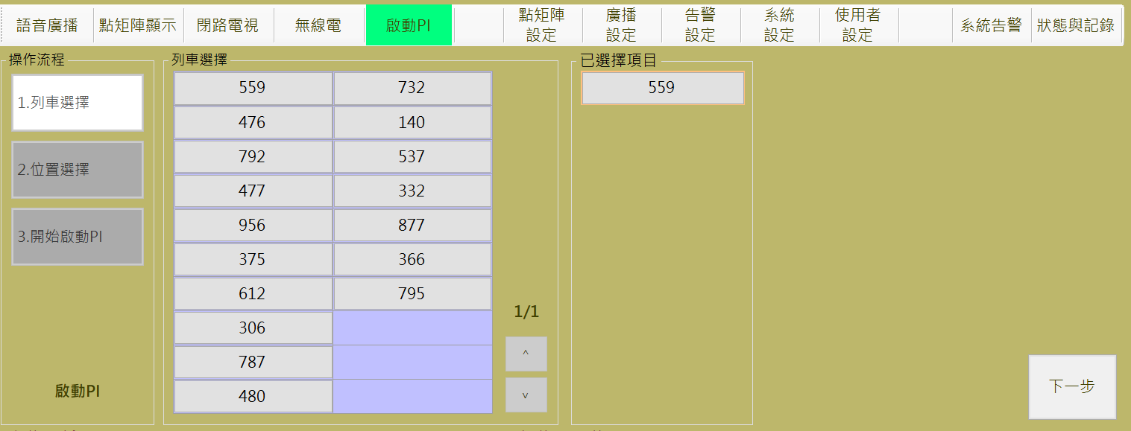

圖 4‑124: 列車收音操作程序1 (列車選取)

Figure 4‑124: Voice monitoring of passenger movement operation step 1 (select train)

**步驟2** **位置選取**: 操作人員選取**列車緊急電話**位置 (如圖 4‑125)。選取結果會顯示在 “**已選擇項目**” 區塊內，選取完成後；請按 “**啟動PI**” 按鈕進行下一步驟。如果想換車，請按 “**上一步**” 按鈕回前一步驟。

**Step 2 Select PI**: Operator shall select one **PI** (as Figure 4‑125). Selection result will show in the “**已選擇項目**” (Choose Result) block. After selection complete, please click “**啟動PI**” (Actived PI) button to next step. If operator want to change car, please click “**上一步**” (Last Step) button back to last step.

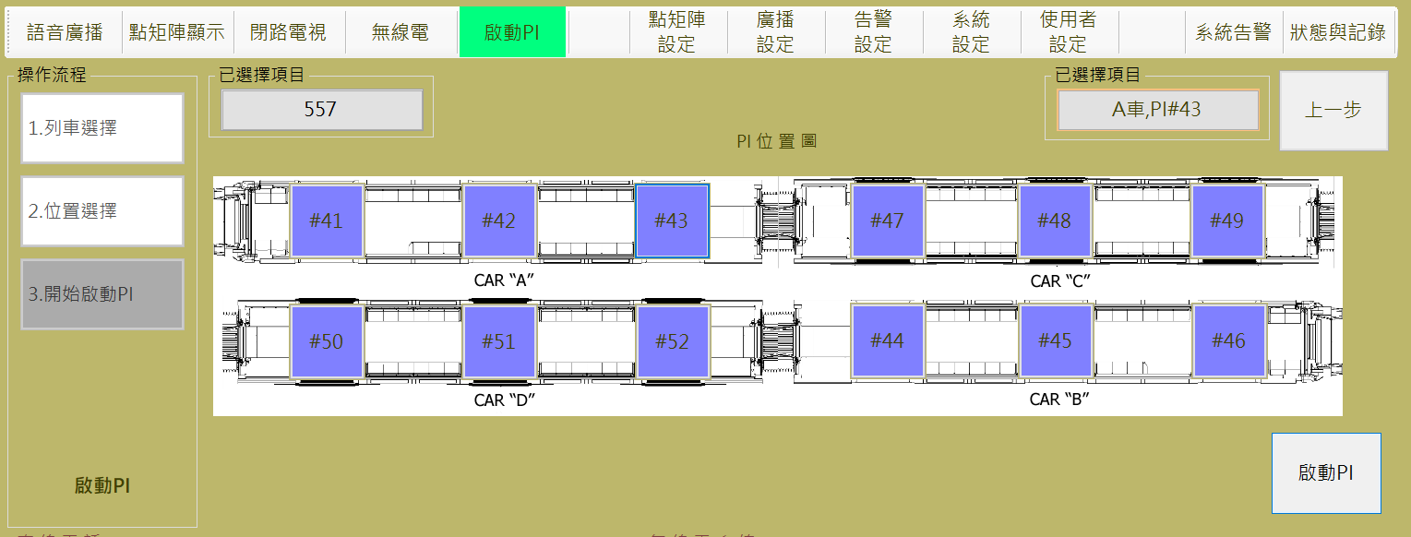

圖 4‑125: 列車收音操作程序2 (選取PI位置)

Figure 4‑125: Voice monitoring of passenger movement operation step 2 (select PI)

**步驟3** **開始收音**: 如果通訊頻道可以正常建立，操作人員會看到系統顯示操作結果如圖 4‑126。

**Step 3 Start Record**: If the system work well, operator will see the result as Figure 4‑126.

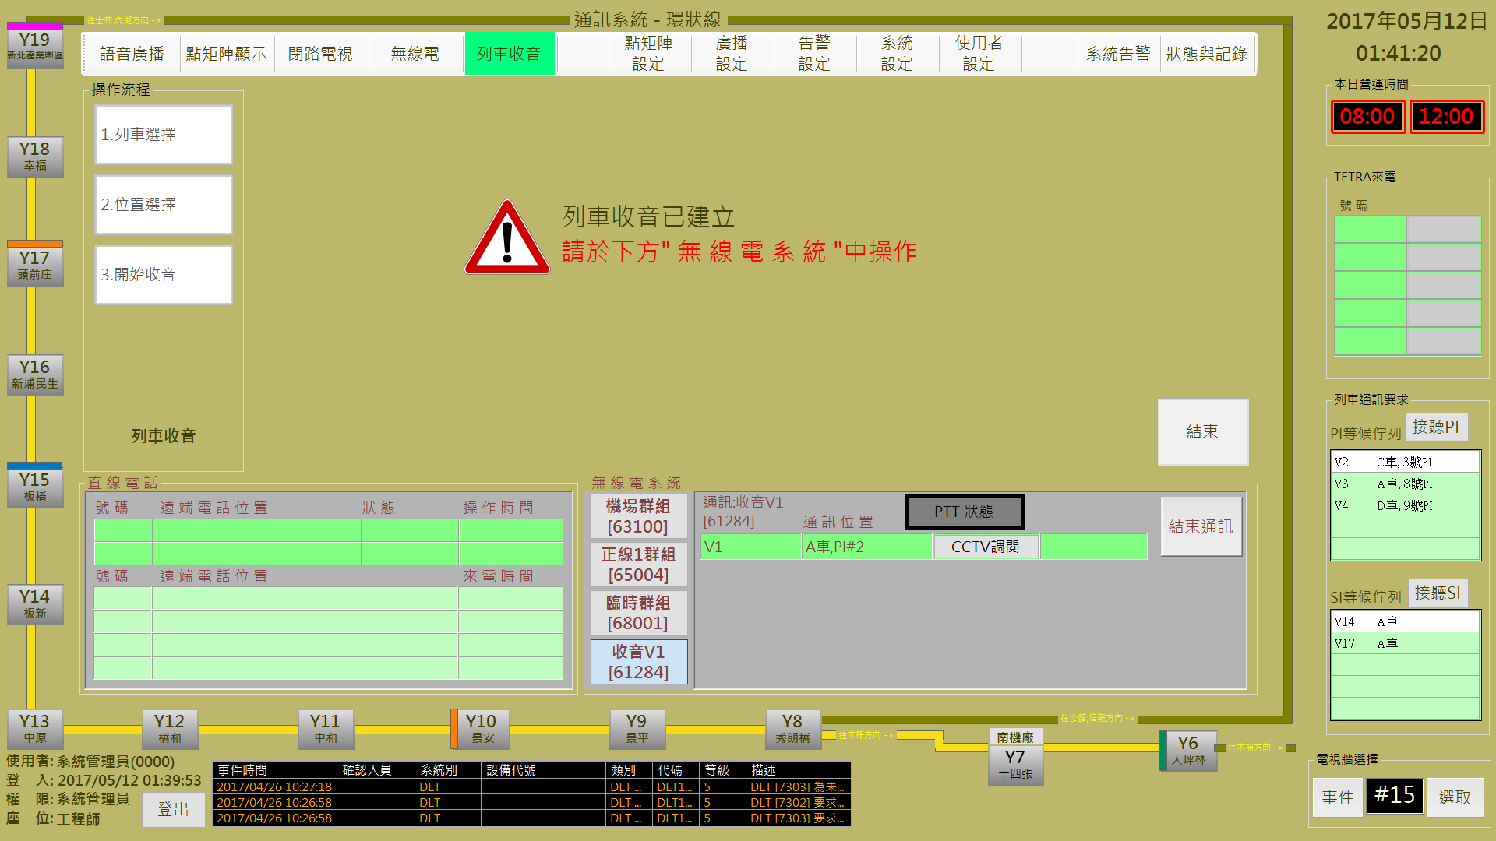

圖 4‑126: 列車收音操作程序3 (開始收音)

Figure 4‑126: Voice monitoring of passenger movement operation step 3 (Start Record)

錄音期間，操作人員可以透過 “**無線電頻道明細區**” 的 “**CCTV調閱**” 按鈕調閱CCTV關聯影像進行同步監控。如果想停止錄音，請按 “**無線電頻道明細區**” 的 “**結束通訊**” 按鈕停止錄音。如果想結束本次操作，請按 “**結束**” 按鈕結束本次操作 (停止操作不代表同時停止錄音，兩者為獨立功能)。

During the recording time, operator can use the “**CCTV調閱**” (Play CCTV) button in the “**無線電頻道明細**” (Audio Channel Detail) block to open the related CCTV image for monitoring same time. If want to stop record, please click the “**結束通訊**” (Stop Communication) button in the “**無線電頻道明細**” (Audio Channel Detail) block to stop record. If want to stop operation, please click “**結束**” (Close) button to finish operation (stop operation does not mean stop record, they are independent functions to each other).

## 無線電話事件處理 TETRA Call Event Process

無線電呼叫事件含TETRA/PI/SI呼叫事件，事件會顯示在CMFT的 “**TETRA來電**” / “**列車通訊要求**” 的事件列表內，”**TETRA來電**” 的第一列為緊急呼叫會以紅色顯示 (如圖 4‑127)。

Radio call events include TETRA call, PI call and SI call. Events will show in the event list of “**TETRA來電**” (TETRA Call) and “**列車通訊要求**” (Car Radio Call) block within CMFT monitor page. The 1PPPPstPPPP raw of “**TETRA來電**” (TETRA Call) is emergency call, will show with red color (as Figure 4‑127).

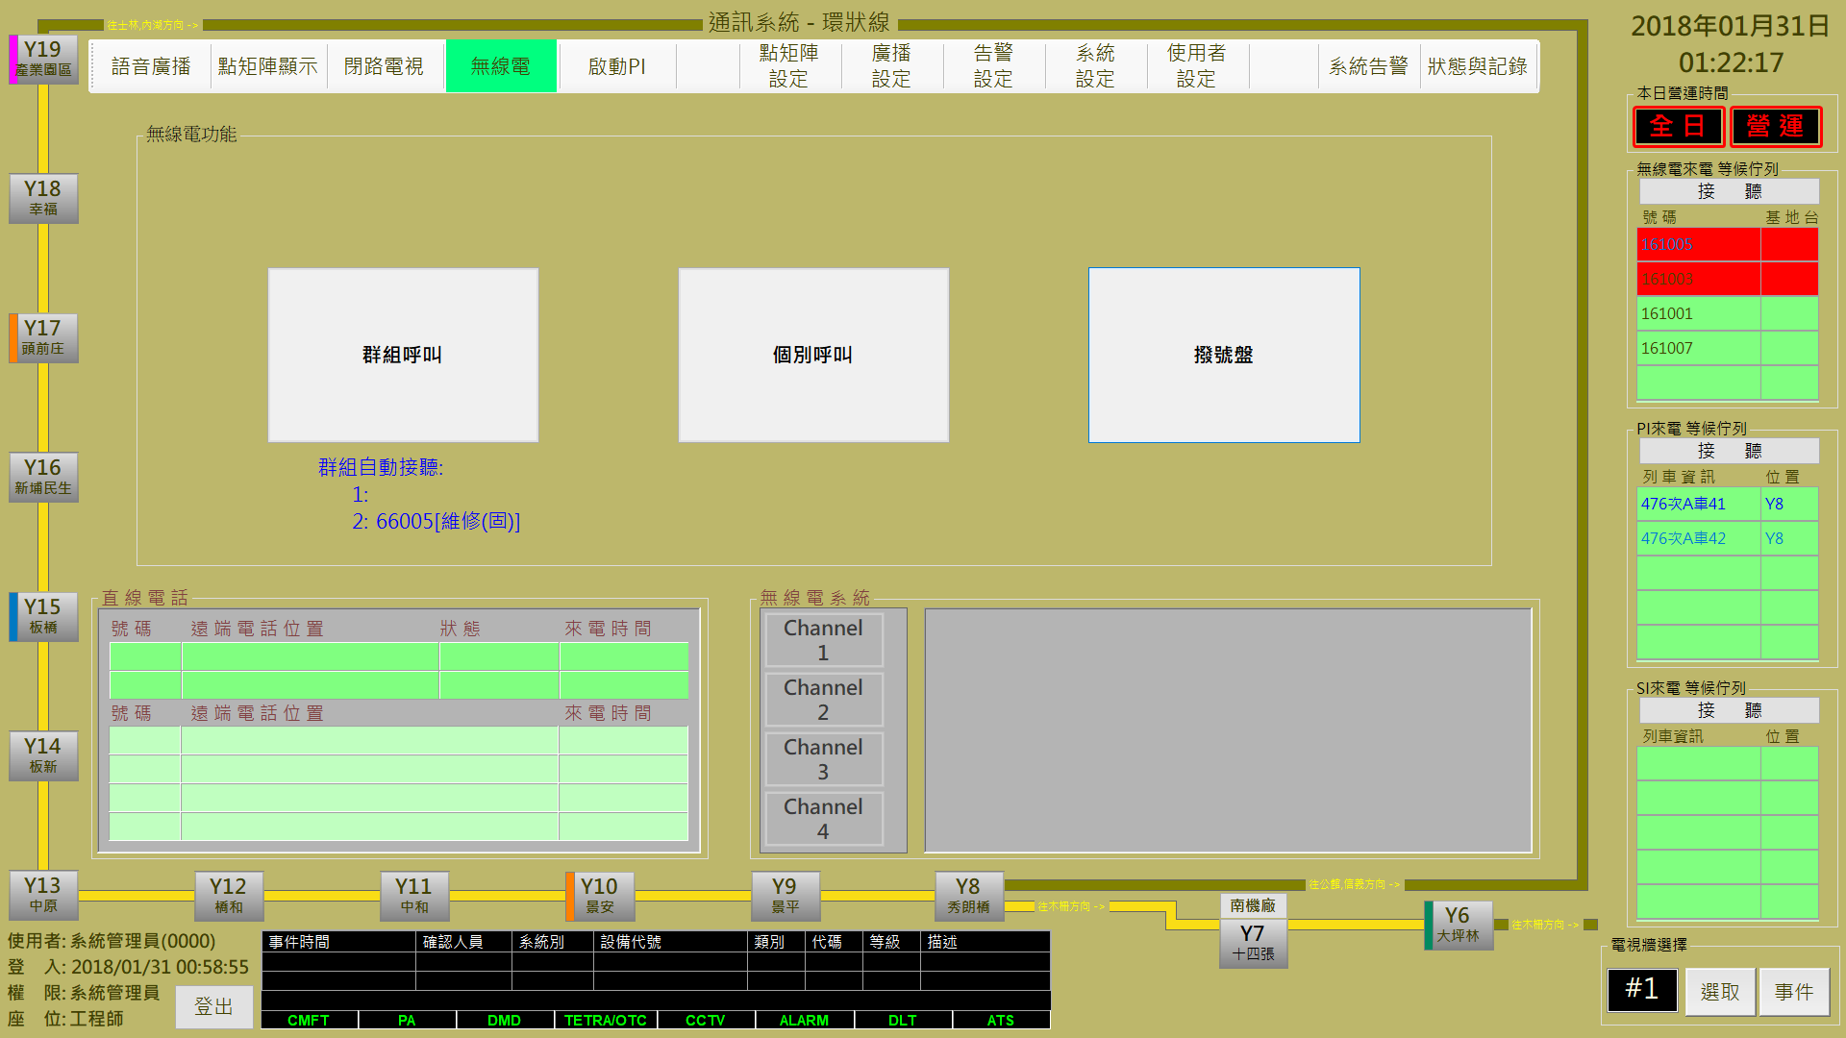

圖 4‑127: TETRA 呼叫事件

Figure 4‑127: TETRA call events

### TETRA 事件接聽 TETRA Call Receive

操作人員可以點擊TETRA呼叫列表中的事件進行接聽，系統會開啟指定接聽的無線電頻道 (如圖 4‑128)。無線電頻道開啟後，請由無線電通話設備進行雙方通話，已接聽的事件同時會自列表中移除。

無線電呼叫中，若為緊急來電，則會呈現底色為紅色的單元格，緊急來電永遠會顯示在表格中最上方。

Operator can click the event of “**TETRA來電**” (TETRA Call) to receive and process. Once operator has received TETRA call, system will create the radio channel for specified TETRA No.. (as Figure 4‑128). After radio channel created, operator should use radio equipments to start communication. Received event will be removed from the TETRA call list.

In a radio call, if an emergency call arrives, a cell with a red background color will appear and an emergency call will always appear at the top of the table.

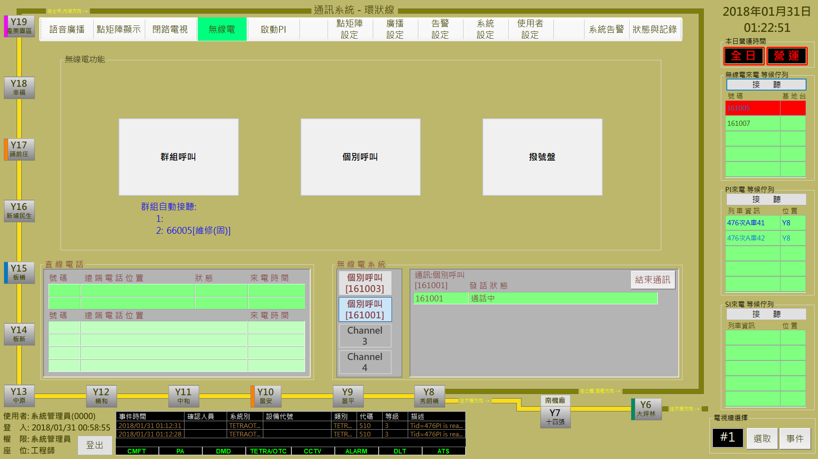

圖 4‑128: TETRA 呼叫接聽

Figure 4‑128: TETRA call events receive

### PI/SI 事件接聽 PI/SI Call Receive

PI/SI 的來電皆會進入右手邊的等候佇列，其中若列車所在位置非此主控台負責的權責區域，則來電字體為黑色，若屬於權責區域內則來電字體為深藍色，操作人員先選擇要接聽的對講機，已點選的對講機為淺藍色，點擊 “**接聽**” 按鈕，系統確定能與該列車建立語音通道，即從等候佇列區移至接聽主控台的無線電頻道盤上。

PI / SI calls will enter the waiting queue on the right hand side, where if the train is not responsible for the responsibility of the console area, the incoming call font is black, if the area belongs to the power of responsibility, the incoming call font is dark blue, The operator first selects the intercom to be answered, the intercom selected is light blue, and clicks the "answer" button, the system determines that a voice channel can be established with the train, then moves the whole intercoms of the train from the waiting queue area to the radio channel panel of the console.

同一台列車僅能與行控中心建立一個語音通道，故當接聽某一列車的PI後，則會自動將該台列車所有的PI都從右邊的等候佇列，移至新建的頻道中，操作員可從無線電系統面盤中的”**加入通話**”按鈕，將該通PI混音至目前的語音通道。礙於硬體限制，至多只能進行三通PI混音，若是要接聽其他的PI就必須將該頻道結束通話後，為被接聽的PI將回歸至PI等候佇列，再透過接聽流程重新建立語音通道。

The same train can only set up a voice channel with the control center, so when operator picks up the PI of a certain train, this console automatically moves the PI of the train from the waiting queue on the right to the new channel,

and the operator can mix the other PI at the same train into the current voice channel by ”**加入通話(**adding a call)” button from the radio system panel. Due to hardware limitations, at most, only three-way PI mixing can be performed. If you want to answer other PIs, you must end the call. After the call is answered, the PIs will return to the PI waiting queue and re-establish through the answering process Voice channel.

“**CCTV調閱**”按鈕表示在15或16牆電視牆上，進行該事件的攝影機鎖定。

“**CCTV調閱**(CCTV Investigate)” button indicates that the camera was locked on the 15 or 16 wall TV wall.

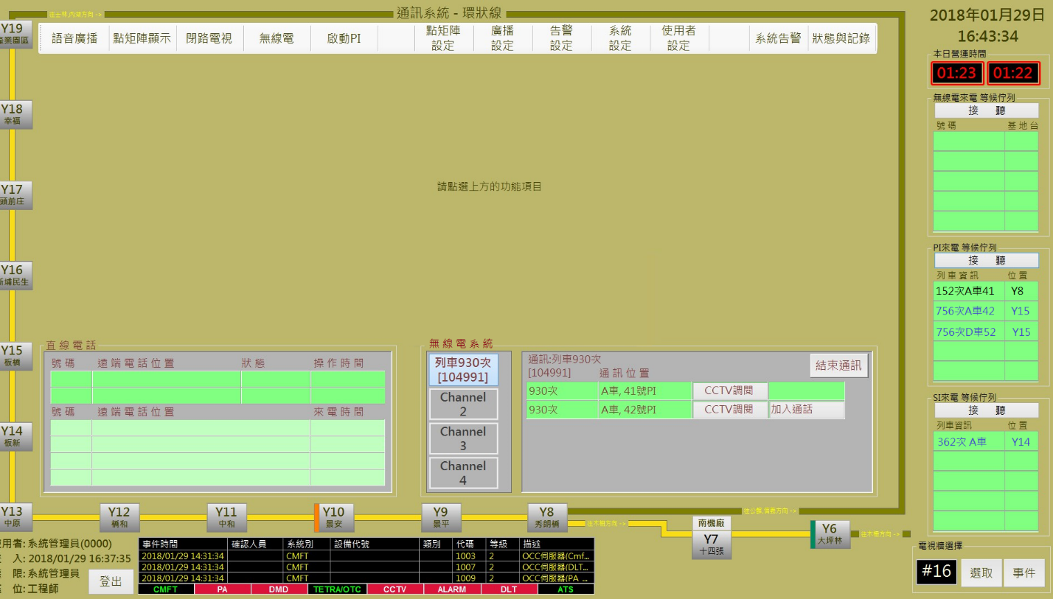

圖 4‑129: PI/SI來電與接聽示意圖

Figure 4‑129: PI / SI incoming and outgoing calls

## DMD節能時間設定DMD Power Save Time Setting

DMD節能時間設定主要是在設定DMD的訊息顯示時段。操作人員可以點擊系統主頁的 “**本日營運時間**” 的顯示時間，開啟設定頁面 (如圖 4‑130) 後，進行調整。”**確認**” 按鈕是用來儲存設定值；”**取消**” 按鈕則是復原設定值。

DMD power save time Setting is used to set the DMD work time. Operator can click the displayed time of “**本日營運時間**” (System Service Time) block to open the Setting page (as Figure 4‑130) and progress system service time Setting. “**確認**” (Confirm) button can store the Setting result. “**取消**” (Cancel) button can recover the original Setting value.

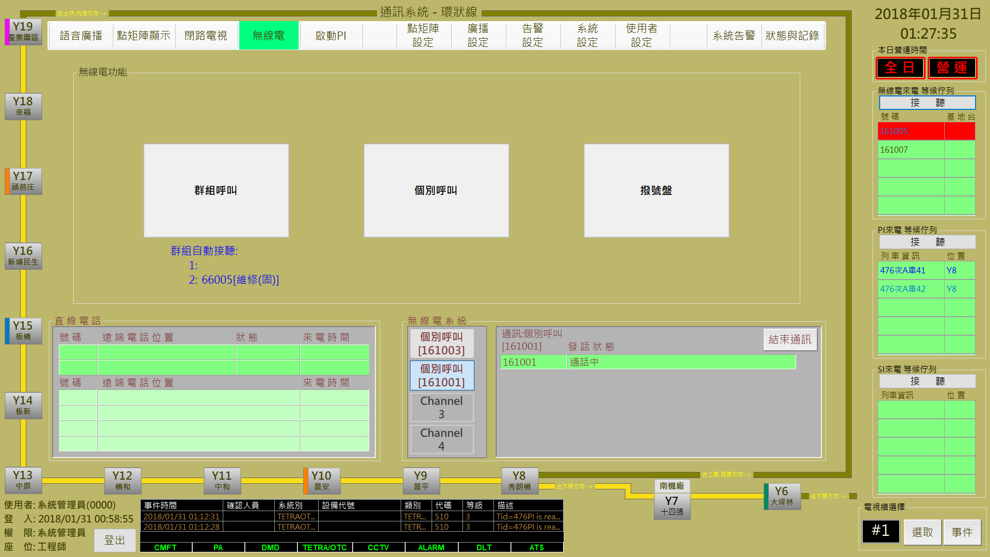

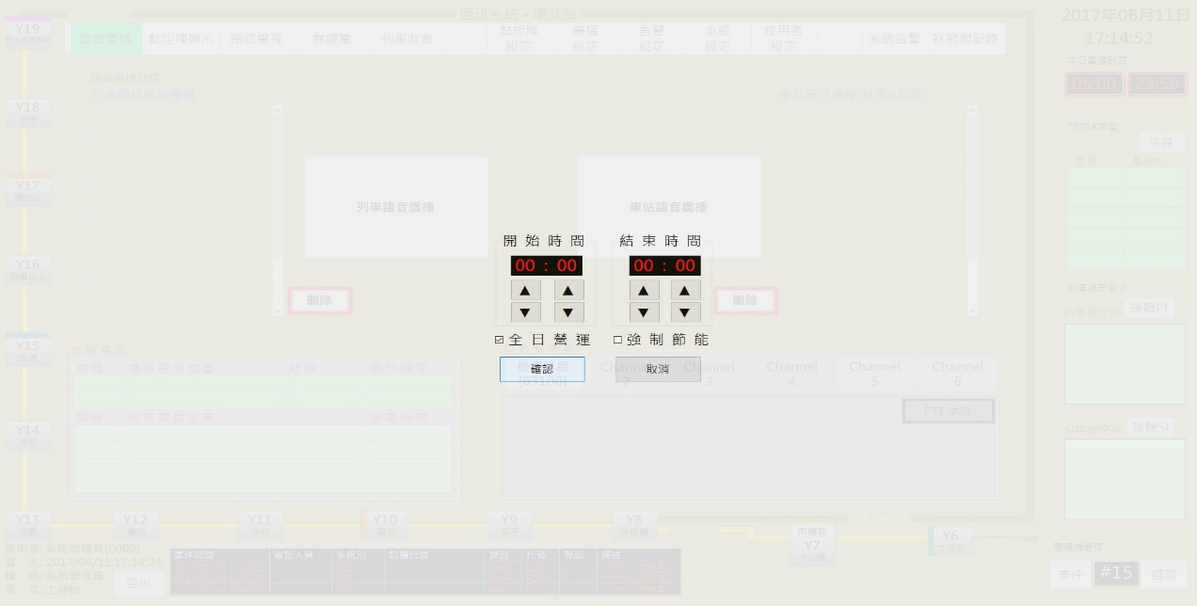

v

圖 4‑130: 系統營運時間設定

Figure 4‑130: System service time Setting

## 直線電話顯示DLT Events Process

話務整合服務流程：

DLT Integration Flow:

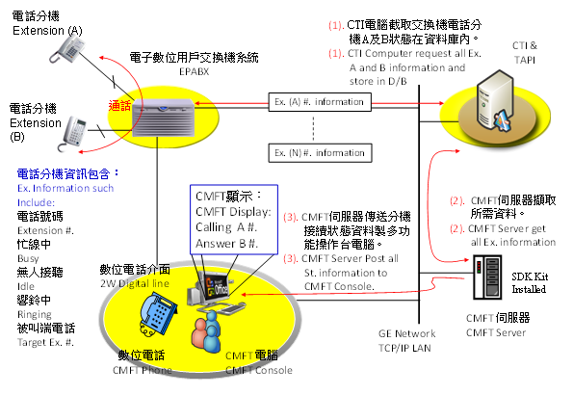

圖 4‑131: DLT話務整合流程

Figure 4‑131: DLT Integration Flow

CMFT主控台僅提供直線電話的以下功能：

1. 顯示詳細的目前通話狀態及內容。（包含：發話端 ID、來電位置、通話狀態和來電時間）
2. 顯示詳細的新來電（含進佇列者）內容。（包含：發話端 ID、來電位置和來電時間）
3. 顯示三方通話時的狀態。（深綠部份拉成兩列，超過時右側會顯示捲軸）
4. 顯示20通佇列內電話。（淺綠色部份顯示五行，超過時右側會顯示捲軸）

The CMFT console provides only the following features of a direct line telephone：

1. Show the status and content of talk process.( Including calling source ID, location, conversation status, and calling time.)
2. Show the detailed new calling and wating calling.( Including calling source ID, location, and calling time.)
3. Show the detailed about the conference call. (The dark green part is drawn into two columns. When it is over, the scroll will be displayed on the right side.)
4. Show the up to 20 hold-on calling on quenue.( The light green part is drawn into five columns. When it is over, the scroll will be displayed on the right side.)

CMFT軟體不提供下列功能：

1. 從畫面操作直線電話（Ex：接聽、掛斷）。

CMFT Console don’t provides the following features：

1. Can’t operate the DLT from CMFT Console software(Ex: answer call or hang up)

直線電話簿設定：

1. 設定底層號碼顯示於CMFT主控台上的位置與顯示名稱。

DLT Book Setting:

1. Set the position and display name of the phone number displayed on the CMFT console.

### 直線電話按鈕功能簡介DLT Function button Introduction

直線電話系統提供的數位電話機型號為M3904數位電話機，如下圖所示：

The digital telephone model provided by DLT system is the M3904 digital telephone, as shown in the following figure

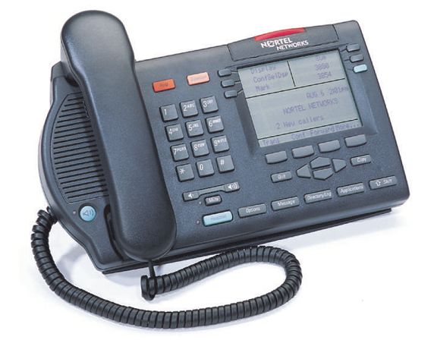

圖 4‑132: M3904數位電話機

Figure 4‑132: M3904 digital telephone

M3904數位話機按鍵說明，如下圖所示：

M3904 Digital phone button description, as shown in the figure below

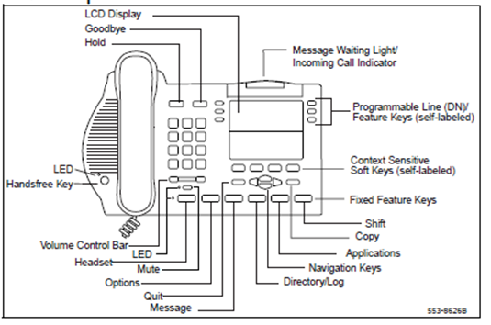

* + 顯示螢幕 (LCD Display)：顯示系統日期及時間、來話方之分機號碼或姓名以及撥出的號碼。

LCD Display: Displays the system date and time, the extension number or name of the caller, and the dialed number.

* + 留言/來話指示燈 (Message Waiting Light/Incoming Call Indicator)：個人語音信箱有留言時或有來話時指示燈將會亮起。

The indicator will light when there is a message in the personal voicemail or there is an incoming call.

* + 掛斷鍵 (Goodbye)：按掛斷鍵即可結束通話。

Press the hang up key to end the call.

* + 保留鍵 (Hold)：通話中按保留鍵可以保留該通來話。

Press the Hold button to keep the conversation during a call.

* + 音量控制鍵 (Volume Control Bar)：調整聽筒及內建喇叭之音量。

Adjust the volume of the handset and built-in speakers.

* + 免持聽筒鍵 (Handsfree Key)：免持聽筒模式切換。

Hands-free mode switch.

* + 靜音鍵 (Mute)：靜音模式切換。

Silent mode switching.

* + 耳機切換鍵 (Headset)：使用耳機通話。

Use the headset to call.

* + 選項鍵 (Options)：啟動話機設定操作功能。

Activate phone set operation function.

* + 離開 (Quit)：離開話機設定操作功能。

Quit phone set operation function.

* + 留言功能鍵 (Message)：使用留言功能。

Use voice message function.

* + 電話號碼簿/記錄鍵 (Directory/Log)：使用電話號碼簿及檢視通話記錄。

Use Phone Book and view the call history.

* + 話機間留言鍵 (Applications)：使用話機間文字留言功能。

Use text message function

* + 複製鍵 (Copy)：將公司電話簿複製到個人電話簿。

To Copy the company book to personal book.

* + 移位鍵 (Shift)：切換到第二層功能鍵。

Switch to second floor.

* + 動態功能鍵 (Context Sensitive Soft Keys (self-labeled含標籤))：動態功能鍵，如轉接(Trans)，會談(Conf)等。

Dymanic function, example transfer or conference call.

### 直線電話狀態即時顯示 The Status Display From DLT Event

**直線電話**通話處理部份由直線電話設備操控，CMFT 系統可以結合設備處理狀況顯示進度於 “**狀態**” 欄位，如果通話結束，事件會自列表內移除。

**DLT communication** controlled by DLT equipment. CMFT System can access the equipment progress status and response in the event list “**狀態**” (Status) field . When DLT communication finish, the related events will be removed.

直線電話事件會顯示在CMFT的 “直線電話” 區的事件列表內，列表分為本席位處理中 (上半部深綠色表格) 及等候佇列中 (下半部淺綠色表格) 兩個部份 (如圖 4 131)。

**DLT call events** will show in the event list of “**直線電話**” (DLT Call) block within CMFT monitor page. Table is separated two parts : one is **processing** (Upper Deep Green Table), and the other one is **waiting** **queue** (Lower Light Green Table) (as Figure 4‑133).

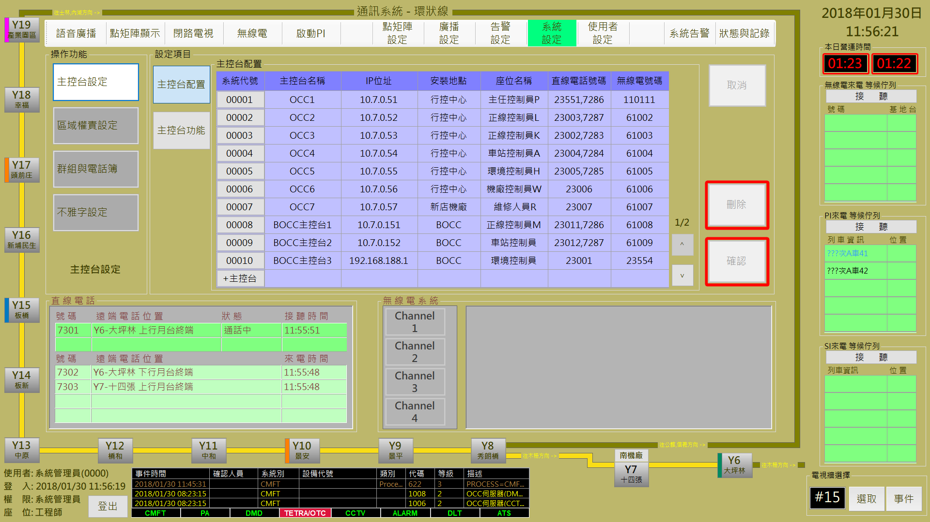

圖 4‑133: DLT 呼叫

Figure 4‑133: DLT call events

等候佇列中的電話為全部席位的主控台都可見，原則上根據來電時間排列，但從等候佇列中提取，全部的席位響鈴後都未接聽，則會回歸等候佇列重新排隊。

本席位處理中為該主控台正在通訊的電話，包含以下狀態，

響鈴中：DLT來電時，席位響鈴尚未接聽。

撥號中：席位撥號至其他電話

通話中：席位上已經接通電話。

保留：當席位上要接通其他電話或進行三方通話前的撥號，會先保留目前正在通話的電話。

The call waiting in the queue for all the seats of the console can be seen, in principle, according to the call time, but extracted from the queue, all the seats did not answer after ringing, it will return to queue waiting to re-queue.

This call is currently being processed by this station for communication with this station and contains the following status,

響鈴中(Ringing): Seats ring has not answered yet when DLT calls.

撥號中(In dialing): Seats dial to other phone

通話中(Talking): The phone is already connected to the seat.

保留(Reserved): When you want to connect another phone or make a three-way call before dialing, the phone that is currently on the call will be reserved first.

### 直線電話紀錄顯示 DLT Process Log

主畫面僅顯示即時直線電話狀態，若要查詢過往DLT紀錄可以從狀態與紀錄功能列中，點選操作紀錄，可觀看所有的操作紀錄如圖 4‑134

The main screen only shows the status of the real-time DLT event. If you want to check past DLT records, you can select from the status and record function column, then click the operation record, and you can view all the operation records as shown as Figure 4‑134.

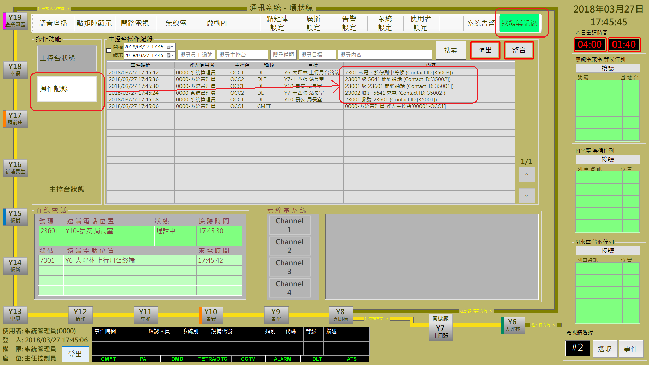

圖 4‑134: 操作紀錄

Figure 4‑134:Ooeration Record

要搜尋DLT相關，可於搜尋種類中輸入DLT，再於搜尋內容輸入要查詢的電話號碼如圖 4‑135，或者於搜尋目標內輸入相關車站或位置如圖 4‑136，操作紀錄將如表中顯示，可更明確觀看DLT來電、去電、轉接或三方通話的過程。

To search for DLT related record, input DLT in search category textbox, then enter the number in the search content textbox as shown in Figure 4‑135, or enter the relevant station or location in the search target textbox as shown in Figure 4‑136. The operation record will be displayed as shown in the table, it can be more detail for DLT event record, including phone call, outgoing calls, transfer or three-party call process.

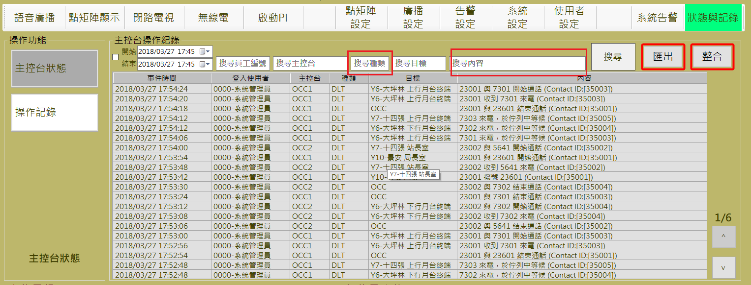

圖 4‑135: DLT+電話號碼23001相關操作紀錄

Figure 4‑135: Ooeration Record by DLT+ Phone Number 23001 Search

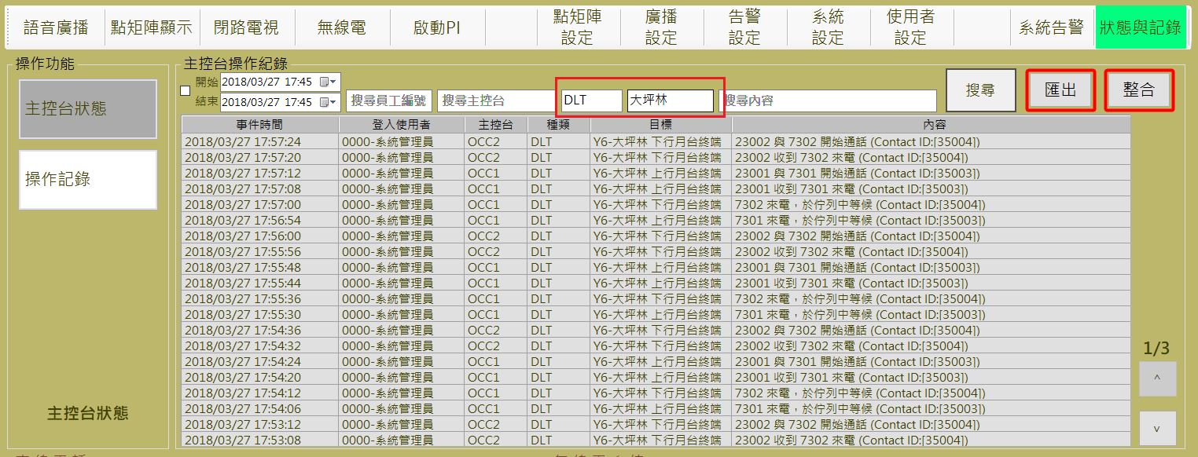

圖 4‑136: DLT+大坪林相關操作紀錄

Figure 4‑136: Ooeration Record by DLT+ 大坪林 Search